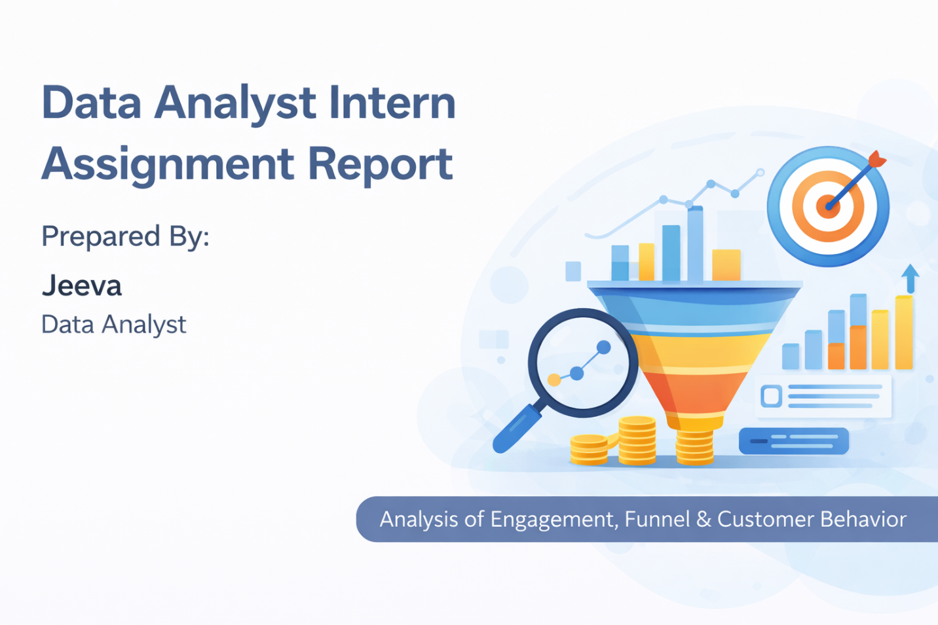

1. Introduction
This report presents an analysis of user engagement, purchase conversion funnel, and customer purchasing behavior over a two-week period.
The objective of this assignment is to clean raw datasets, build analytical metrics, and derive actionable insights using structured data modeling and visualization techniques.
Three datasets were provided:
- Events Data
- Orders Data
- Customers Data

2. Data Preparation
Before performing analysis, the following data cleaning steps were executed:
- Converted event_date and order_date into proper date formats.
- Removed duplicate records from Orders and Customers datasets.
- Filtered only valid orders (order_status = "Valid").
- Standardized user_id and customer_id fields for accurate data relationships.
- Corrected column naming inconsistencies.
These steps ensured data consistency, accuracy, and reliability for analysis.

3. Funnel Analysis
To evaluate how user engagement translates into purchases, the following metrics were calculated:
- Total unique users who triggered events
- Total unique users who placed valid orders
- Conversion Rate
Conversion Rate Formula
Conversion Rate = Users with Valid Orders ÷ Users with Events
A daily time-series analysis was conducted to compare:
- Daily Active Users
- Daily Ordering Customers
This helped identify trends in engagement and purchase behavior over time.

4. Customer Behavior Analysis
Orders data was joined with customer data to analyze purchasing patterns based on:
- Acquisition Channel
- City
Revenue was aggregated to determine which acquisition channel generates the highest sales performance.
This provides insight into which marketing channels are most effective in driving revenue.

5. Key Insight
The analysis reveals that one acquisition channel contributes significantly higher revenue compared to others.
This indicates that customers acquired through this channel demonstrate stronger purchasing behavior and higher revenue contribution.

6. Assumptions
- user_id corresponds to customer_id
- Only valid orders were considered for revenue analysis
- Duplicate records were removed before calculations

7. Conclusion
This analysis demonstrates the direct relationship between user engagement and purchasing activity.
By structuring a clear conversion funnel and evaluating revenue contribution by acquisition channel, valuable insights can be derived to improve marketing effectiveness and conversion performance.
The structured approach ensures analytical transparency, data accuracy, and business relevance.

