Topic 2-A1

Saving:

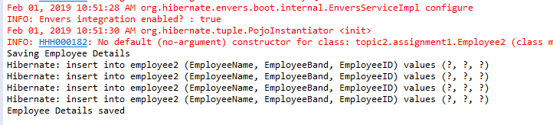

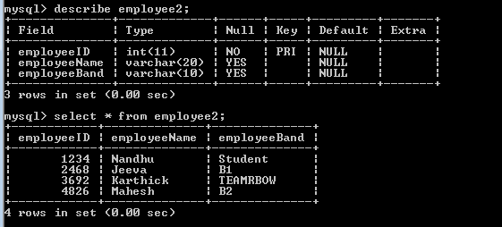

Delete:

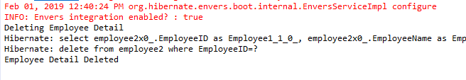

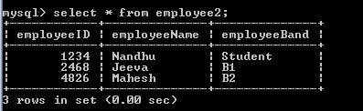

Update:

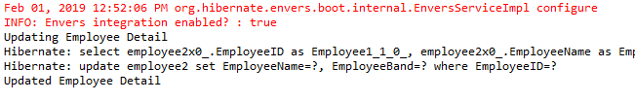

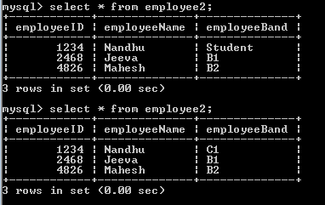

List all the Employees:

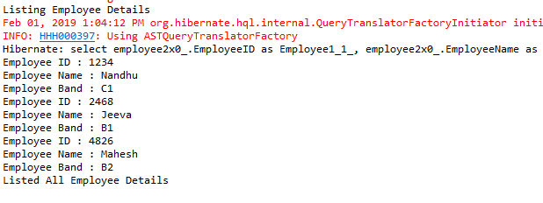

Topic2-A2

Insertion based on condition



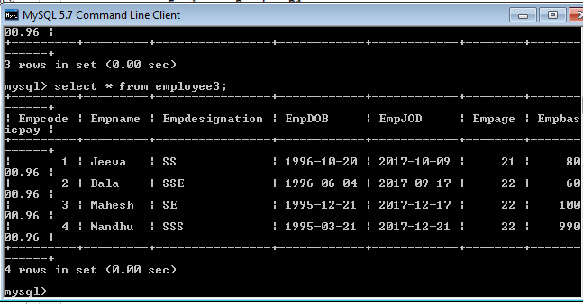

Deletion based on empcode

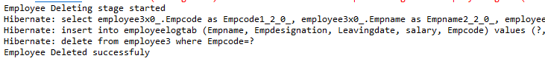

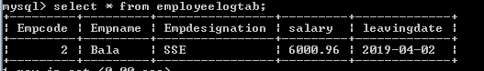

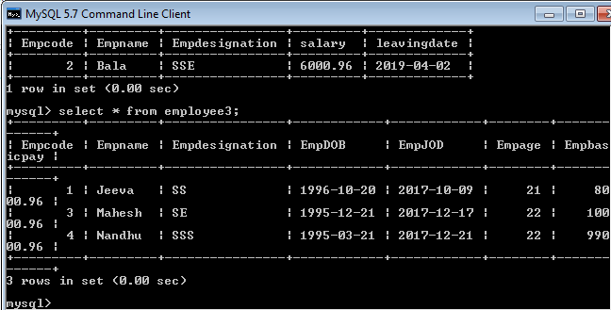

Topic3- A1:

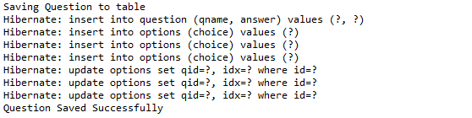

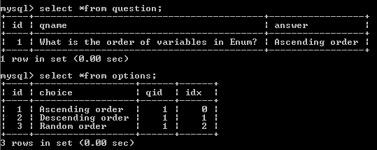

Topic4-A1:

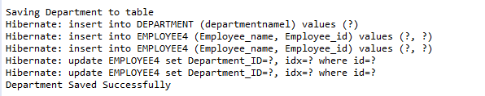

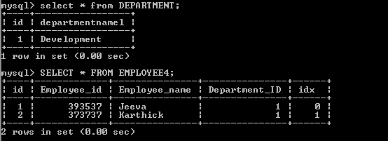

Topic4-A2:

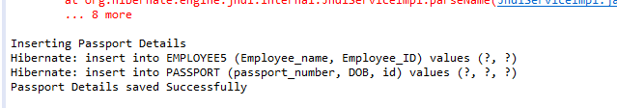

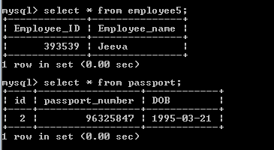

Topic4:A3

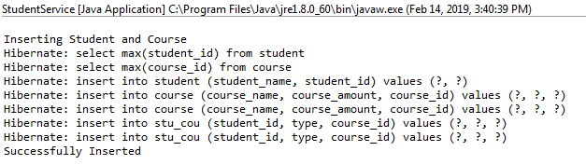

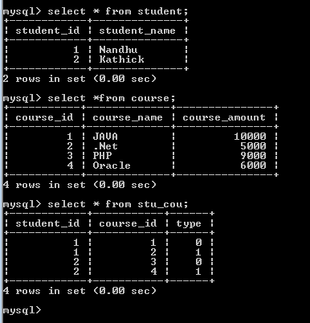

Topic 5:

Adding Car Details

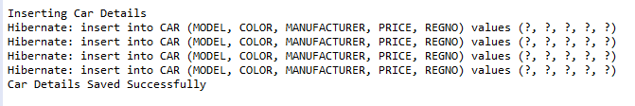

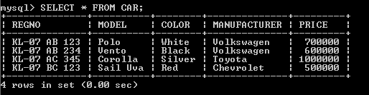

Listing Car table:

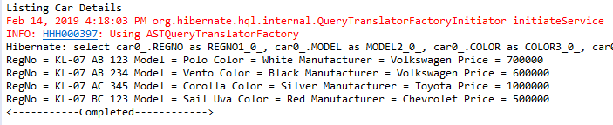

Listing Car starting With V:

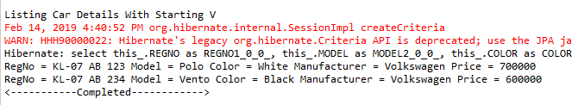

Listing Car by Entered Reg No:

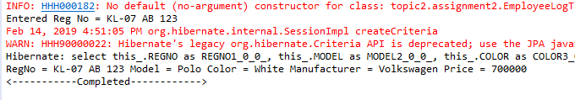

Listing Car which are less than 6Lacs:

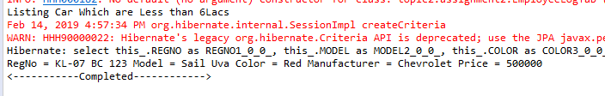

TOPIC6:A1 (Table per subclass Approach)

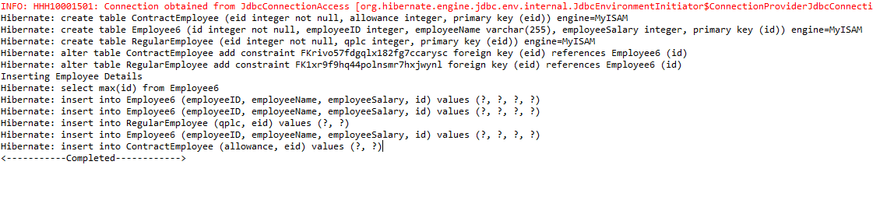

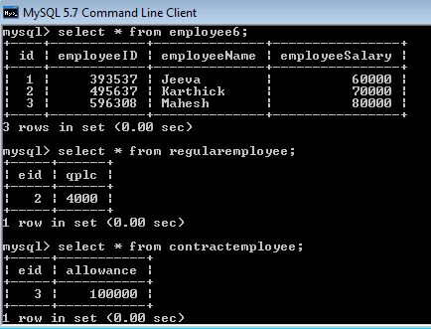

Topic6: A2 (Table per hierarchy Approach)

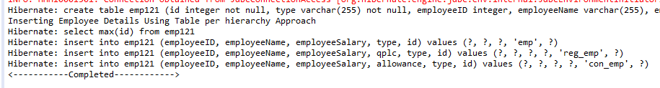

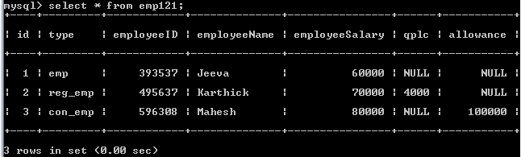

Topic6: A3 (Table per concrete class Approach)

