Hybrid AI (LLM + Rules)
Hybrid AI combines probabilistic Large Language Models with deterministic rule-based architectures, allowing the integration of flexible natural language capabilities with strict algorithmic requirements. In this architecture, rule-based components can serve as a means of enforcement such that the outputs of the LLM conform to certain logical constraints or rules of code execution. This is very useful in domains where hallucination and “thinking outside the box” are not desired, and strict algorithmic safety checks are needed.

Neuromorphic / Biosignal Based Adaptation
Neuromorphic biosignal adaptation is the use of hybrid brain-inspired architectures to process continuous streams of biosignal data such as EEG brain waves or EMG muscular signals, to continuously self-modify and adapt to evolving conditions. Spiking neuron circuits can process these continuous data streams with extremely low power consumption down to the level of single spikes. Such a dynamic adaptation is useful for the design of responsive bionic limbs or other human-facing devices that constantly adjust their behavior according to incoming signals from the user.
For our AI learning platform for neurodivergent students, the most viable option would be to use Hybrid AI as the core technology. This would involve combining one or more foundational language models via API with handcrafted rules and instruction-based methods. The LLMs would be used for their capacity to simplify language, provide step-by-step guidance through the educational material, and operate in various modes from outlines to straightforward explanations. Meanwhile, the rule-based part would be utilized to enforce best practices for students with ADHD, autism, and dyslexia. Such an approach would be safer and more transparent than using a single standalone model while still providing high-level performance. Moreover, it would promote the platform’s educative potential by better structuring the information according to the needs of the users. Overall, the hybrid approach would be the most innovative, as the competing AI learning platforms do not use it yet.
As for Deep Learning and Neuromorphic approaches, they can be explored in the future but do not possess immediate viability. The former direction would be perfect for the task, as it would allow the platform to process natural language with exceptional accuracy. However, it requires more data and time to train an appropriate model, which is not conducive to a proof-of-concept prototype. As for the latter, its viability is even lower, as it would require additional peripherals to read the students’ EEG signals. These technologies are better suited for later iterations of the product. Nevertheless, mentioning them in the “Future Work” subsection is advisable to position the project as a cutting-edge endeavor with growth options.

Proposed System Design Based on Literature Review
This content below is based on the literature review "Beyond the One-Size-Fits-All: A Systematic Review of Personalized and Gamified e-Learning for Neurodivergent Learners"
First, we will review the existing literature and identify gaps in the current e-learning systems for neurodivergent learners. This will be used to define clear learner profiles and preferences for ADHD, autism and dyslexia, such as preferred content format, pace, UI style and feedback type. We will then design a modular architecture with a Django backend, a simple rule-based adaptation engine and a frontend supporting customizable themes, font sizes, reduced motion and multi-modal content. All lessons will be saved in multiple formats (standard, simplified, step-by-step, audio, visual) so that the system can easily switch formats without relying solely on the LLM.
Next, we will add behavior tracking to collect useful learning signals such as accuracy, time spent, hints used, repeated views, and break requests. These signals will be used by the adaptation engine to apply clear rules to adjust difficulty, suggest breaks, change content format or provide hints. On top of this, we will embed a hybrid AI layer: an LLM for scaffolding (text simplification, hint generation, practice question generation) controlled by a rule engine that restricts outputs to approved course content and appropriate difficulty. Next, adaptive gamification will be added, optional badges, progress bars and private goals, whilst competitive features such as leaderboards will stay optional or default to disabled.
To wrap up the architecture we will implement a learner dashboard to report progress, allow manual configuration of settings, and explain why the system made certain adaptations. The system will be assessed based on learning performance (pre/post tests, delayed recall) and learner comfort (overload, engagement, accessibility feedback). In future work, the platform can be extended with lightweight machine learning algorithms for better behavior prediction, and optionally explored biosignal-based adaptation as a research-level enhancement. This end-to-end design ensures that our platform is feasible to build for SIH, based on existing research, and clearly tackles the identified gaps for neurodivergent learners.

Neurodivergent Conditions: Existing Platform Landscape and Adaptive Gaps
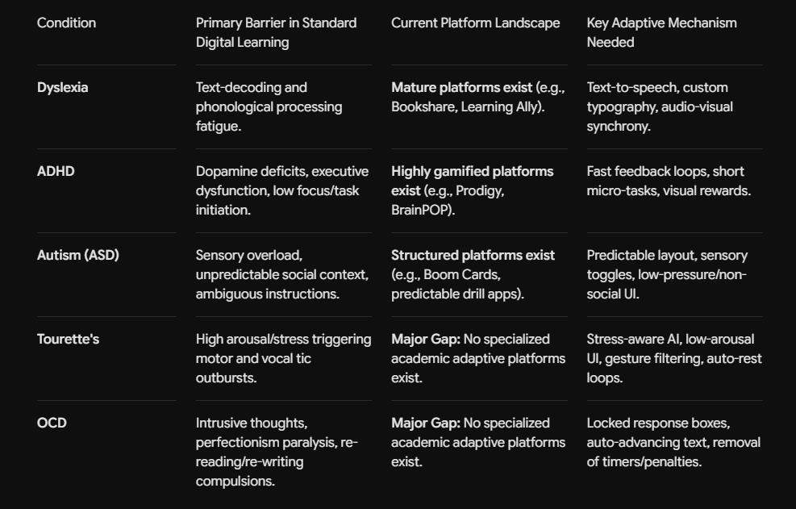

Tourette Syndrome
While emerging research highlights the potential of computer vision, bio-telemetry, and generative AI to detect physical stress and modify interfaces, there is currently no dedicated, commercially available AI-based adaptive learning platform explicitly designed for Tourette Syndrome and Tic Disorders. Existing digital interventions remain largely isolated within clinical applications—such as internet-delivered habit reversal therapy or diagnostic monitoring tools—rather than educational suites. Consequently, mainstream adaptive learning platforms continue to rely on traditional engagement loops that inadvertently trigger motor tics through strict timers, visual clutter, and rigid feedback penalties. This clear gap presents a significant opportunity to develop a stress-aware, low-arousal learning environment tailored to the unique motor and cognitive needs of students with Tourette Syndrome.

OCD
Similarly to how tele-therapy platforms, ERP-specific tools, and symptom-tracker apps have enhanced the medical field's capacity to serve patients with Obsessive-Compulsive Disorder (OCD), there is an absence of learning-specific software serving students with OCD. The existing tools address clinicians' and therapists' needs, not the general educational ones. Thus, when using generic academic software, students with OCD are confronted with edit boxes, error flags, and time locks as triggers which then induce their disorder's symptoms, such as 'not-just-right' experiences (NJREs) and perfectionism. As a result, the users get stuck in an OCD loop of rumination, checking, erasing, re-doing, and re-reading before proceeding to the next step or, eventually, 'moving on'.
The flaw in the existing academic software ecosystem calls for a need for an OCD-aware system which would disrupt the users' 'infinite do-over loop'. The solution would involve implementing exposure-response therapies through the employment of 'exposure-adjacent' UI suggestions. These include progress locks, time-based advance sliders for reading/writing components, and good-enough-doers' encouragers. The software would lower the cognitive barrier for students with OCD to complete in-game or academic tasks and, thus, prevent the 'task-perfection OCD loop'.

Core Structural Contrast
- Dyslexia, ADHD, and Autism have well-documented assistive digital frameworks. Platforms for these conditions either alter how information is presented (Dyslexia), how motivation is sustained through reward mechanics (ADHD), or how environment and structure are stabilized (Autism).
- Tourette Syndrome and OCD represent unaddressed gaps in educational software design. Gamification mechanics like strict timers, score drops, flashing reward graphics, and infinite edit inputs—which keep an ADHD student engaged—often actively trigger motor tics in Tourette Syndrome or induce perfectionist anxiety and compulsive checking in OCD.

Other Neurodivergent Disorders with Dedicated Learning Platforms
- Dyscalculia: A specific learning difference affecting how the brain processes numbers, math concepts, and spatial numerical reasoning.
- Dysgraphia: A condition impacting motor skills and cognitive processing needed for physical handwriting, spelling, and translating thoughts into written words.
- Dyspraxia (Developmental Coordination Disorder / DCD): Affects physical coordination, motor planning, spatial awareness, and balance.
- Sensory Processing Differences (SPD): Occurs when the brain struggles to take in, respond to, or filter sensory inputs like sound, light, texture, or temperature.
- Developmental Language Disorder (DLD): A condition affecting how the brain processes and understands spoken language and sentence structures.
- Synesthesia: A neurological trait where stimulation of one sense triggers an involuntary experience in another (e.g., 'tasting' words or 'seeing' numbers as specific colors).

Reference Paper Analysis: AI-Based Adaptive Learning and Tourette Syndrome
Reference paper: https://www.ijert.org/an-ai-based-adaptive-learning-framework-and-algorithm-with-gesture-interaction-and-behavior-mood-aware-adaptation-for-idd-children-ijertv15is010488

How It Correlates with Tourette Syndrome
The paper introduces the idea of an AI-based adaptive framework that goes beyond quantitative evaluations of a child's interaction with the material (e.g., whether the answer was right or wrong). Instead, it analyzes such factors as repetition, time spent, engagement, and other indicators associated with the states of engaged, neutral, frustrated, and fatigued. Based on this information, the paper suggests that the framework could modify the material, the complexity of the game, the speed of the instructions, and the amount of guidance provided. This idea would significantly benefit students with Tourette syndrome, who may exhibit attention problems, tics, and focus issues throughout a learning session, impacting their writing, reading, participation, and overall experience negatively. While the symptoms do not indicate any cognitive impairment on the Tourette syndrome scale, the manifestations of the disorder disrupt regular learning activities. Thus, an intelligent platform as described in the paper could alleviate some of the burdens experienced by TS students by analyzing whether they remain consistently engaged in the material or become frustrated (or tired) and adjust the instructions, game, or other elements of learning.

What the Paper Contributes to a Tourette-Focused Platform
The paper's strongest contribution towards developing a Tourette-focused platform lies in its description of an adaptive framework based on behaviors and moods rather than the traditional algorithm of quantitative assessments. Indeed, most often, platforms that attempt to offer an adaptive learning experience base their adjustments on test results, grade, or other elements that only represent one side of the learner's performance. The IJERT paper, however, theorizes grade and performance adaptation based on engagement and frustration levels. In the context of a Tourette syndrome learning platform, such an approach would alleviate the burden of combating the disorder and adjusting to it for the user, as a computer would intuitively understand when the student needs a break, an explanation, or a more straightforward task. Moreover, the paper highlights that such learning tools could be applied to children with special needs, including attention disorders and TS. This aspect is vital for the target audience because the conventional education system does not adequately accommodate such students, often punishing them for their symptoms or hardships. The IJERT paper could, therefore, serve as a prototype for an adaptive Tourette syndrome-friendly learning platform, while research into such a platform would determine the specific needs of TS students that the general adaptive framework would fail to address.

Reference Paper Analysis: Serious Board Game for Tourette Syndrome Adolescents
Reference paper: https://games.jmir.org/2025/1/e76208

How It Is Correlated with Tourette Syndrome
The paper by Lee et al. (2025) evaluates the effectiveness of a serious board game created for Tourette syndrome adolescents. The researchers conducted a RCT study among 79 Tourette adolescents divided into an interventional and control group. The participants of the former received an additional treatment, which consisted of a 60-min weekly session, during 4 weeks, while the latter got the treatment as usual (Lee et al., 2025). The intervention followed the psychoeducation and situated-learning principles, incorporated scenarios, problem-solving, discussion elements, and role-playing components to help patients manage their Tourette syndrome (TS) (Lee et al., 2025). The study measured such variables as Young’s Tic Severity Scale, positive mental health, social adjustment, and depression as persons with TS often experience social impairment (Lee et al., 2025).
The significant insight for my project is that gamification might be helpful in TS management, but it is essential to consider patients’ positive mental health and social aspects rather than only the reduction of tics. Specifically, the study found no statistically significant differences in tic severity between the two groups (Lee et al., 2025). However, the intervention had a beneficial impact on positive mental health, social adjustment, and depression in TS adolescents, with a follow-up observation (Lee et al., 2025). Thus, designing gamified learning material for TS management should not be limited to tic severity reduction, but rather include various components to affect all three variables. Finally, the authors mention that further studies might involve the creation of a computer-simulated version of the board game.

