Communications (Exstream) Cloud-Native 25.4 Installation Planning

Prepared by:
Kamal Ramalingam
Solutions Architect | Professional Services
Contents
1 Document Purpose 3
2 Audience 3
3 Summary 3
4 Installation Planning – Exstream CN on Kubernetes/OpenShift 4
4.1 System Sizing Considerations 7
4.1.1 Kubernetes/OpenShift cluster 8
4.1.2 Database Sizing 8
4.1.3 File System Sizing 8
4.2 K8s/OC/Helm CLI Setup (Bastion Host) 8
4.3 Download Helm Charts 9
4.3.1 OpenText charts 9
4.3.2 Third-party/public charts 10
4.4 Docker Container Images 10
4.5 Database 11
4.6 Storage – Persistent storage for k8s 14
4.7 Load balancer setup 14
4.8 DNS name setup 15
4.9 SSL Certs and Trust store setup 15
4.10 ingress-nginx setup 15
4.11 Sample app setup 16
5 Installation Steps – Exstream CN on Kubernetes/OpenShift 16
5.1 OTDS Installation 16
5.2 RabbitMQ Installation 17
5.3 Optional Deployments 17
5.4 Exstream Installation 18
6 License Deployment 18
6.1 Apply for License 19
6.2 Allocating users, groups or Partitions 19
7 Installation Planning – Exstream Desktop Application 20
8 Installation and Configuration Steps – Exstream Desktop Application 20
8.1.1 Install Design and Production 20
8.1.2 Configure ODBC DSN 21
8.1.3 Configure Design Database 22
8.1.4 Connecting Design Manger to Database 25
9 OpenText Documentation Links 26

Version History
Ver. No. | Ver. Date | Prepared / Revised By | Description | Filename
1.0 | 10/07//2024 | Kamal Ramalingam | Initial Version
1.1 | 11/18/2024 | Suresh Kannankkot | Updated information for Version 24.4.0
1.2 | 12/03/2024 | Kamalraj Ramalingam | Updated for OT provided RabbitMQ chart and image
1.3 | 1/28/2025 | Kamalraj Ramalingam | Updated for v25.1
1.4 | 4/28/2025 | Kamalraj Ramalingam | Updated for v25.2
1.5 | 07/07/2025 | Suresh Kannankkot | Updated as per latest release note 2025-04-29 | Page 4 support system table and storage compatibility Matrix
1.6 | 07/14/2025 | Suresh Kannankkot | Included missed Messaging broker in table
1.7 | 08/01/2025 | Suresh Kannankkot | Updated for 25.3 | Updated charts,image tags, documentation links, supported systems
1.8 | 10/8/2025 | Kamalraj Ramalingam
1.9 | 11/5/2025 | Kamalraj Ramalingam | Updated for 25.4
1.9 | 1/15/2025 | Kamalraj Ramalingam | Updated for patch release 25.4.3

Document Purpose
The purpose of this document is to cover installation planning, prerequisites, and installation of OpenText Communications (formerly Exstream) Cloud-Native.

Audience
The following are the primary teams involved in the installation process.
- System Admin, Engineers, Developers and System Analysts
- Infrastructure and Database Team

Summary
Exstream Product Architecture View:
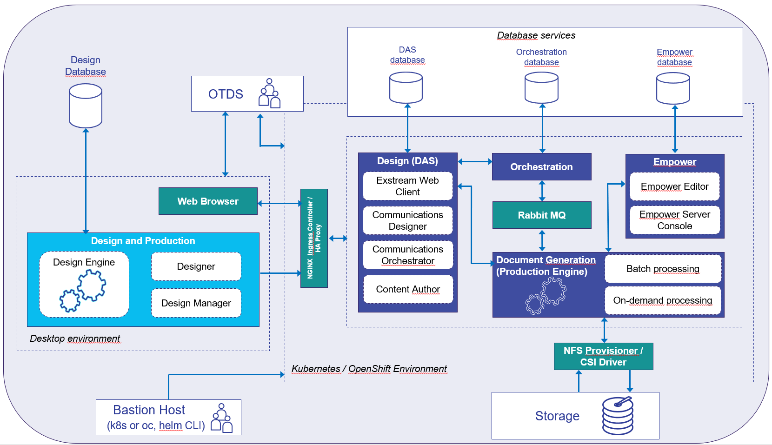

The sequence of actions is as listed below.
  - Exstream CN (runtime) install on Kubernetes / OpenShift.
    - Review Section 4 and its sub-sections and complete software download and all the pre-requisites listed.
    - Review Section 5 and its sub-sections and complete the installation.
  - Review Section 6 and complete the License deployment.
  - Exstream Desktop Application on Windows.
    - Review Section 7 and 8 and complete the installation.

Installation Planning – Exstream CN on Kubernetes/OpenShift
Consider these areas listed in the sub sections here and plan the installation accordingly. These cover the prerequisite steps for the Exstream Cloud-Native installation.
From Exstream Release Notes:
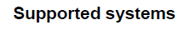
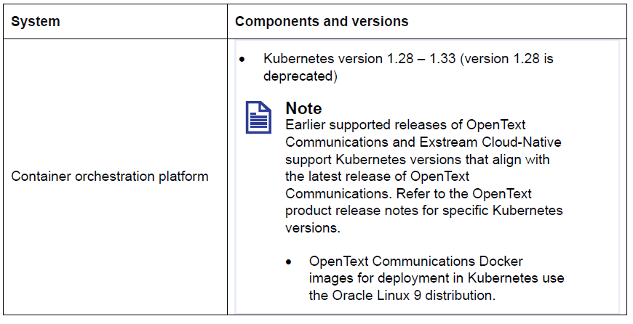
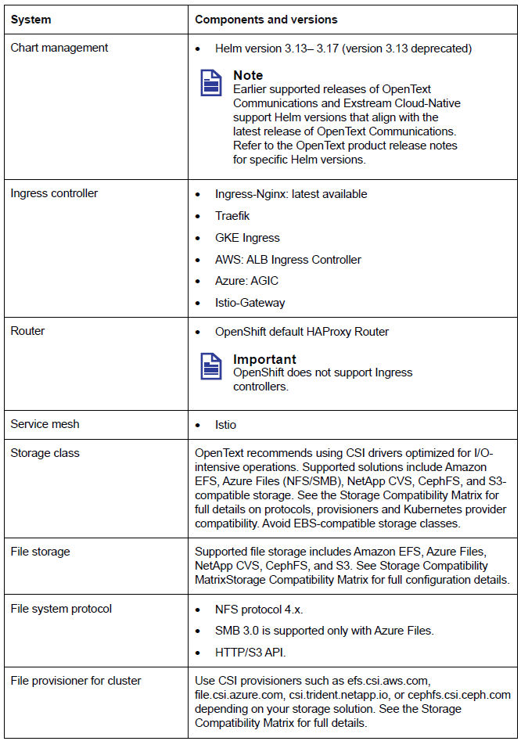
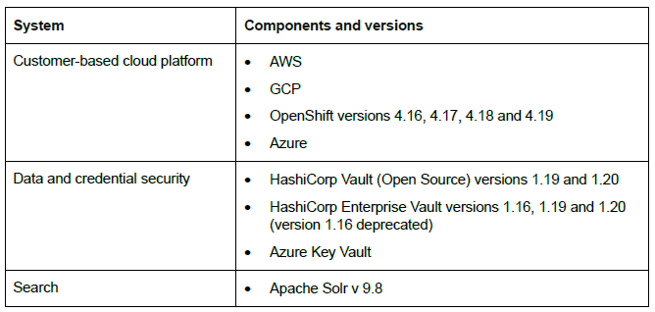

Storage Compatibility Matrix.
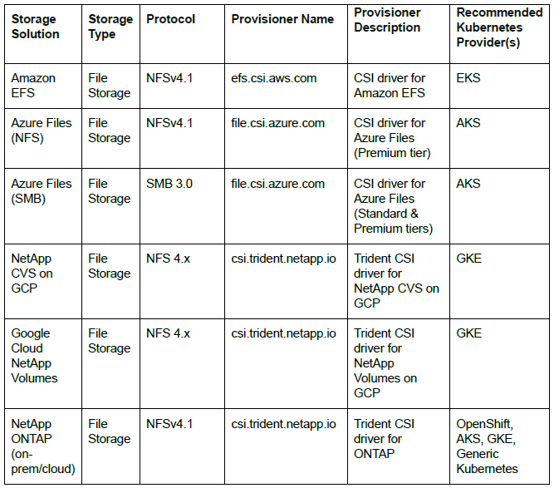
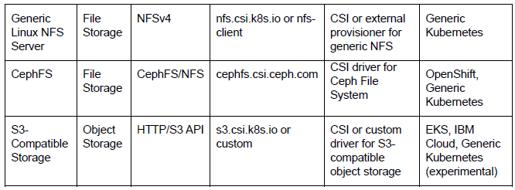

System Sizing Considerations
System sizing upfront is going to be approximate until performance test phase is completed. A ballpark estimate would be, start with minimum total compute, memory and storage used in today’s existing system and then scale up or down as per the performance test results.

Kubernetes/OpenShift cluster
Setup K8s (Kubernetes) or OpenShift cluster with master (control plane) and worker (data plane) nodes. You would need at least two master and two worker nodes for high availability. Size of master node depends on your infrastructure team choice with cluster size and sharing considerations.
NOTE: These are minimum requirements, your sizing would depend on the solution requirements.

 | Worker Node
Number of nodes | 2+
vCPU | 4+
Memory | 16GB+
Local storage | 20GB+

Database Sizing
The databases should all be set to grow based on application needs and be setup with monitoring to alert the DBA when certain thresholds are exceeded. Initial DB size recommendations are as follows:
- DAS – 50GB to 100GB
- Orchestration – 50GB to 100GB
- OTDS - 5GB
- Empower - 10GB (Optional – only for interactive edit use case)

File System Sizing
- Storage – Min 200G however, the file system calculation needs to take into consideration a multitude of factors.

- Volume of document transactions.

- Size of input files.

- Size of output files.

- Job retention considerations.

K8s/OC/Helm CLI Setup (Bastion Host)
Setup kubectl (for k8s) or OC (for OpenShift) and Helm CLI on your Bastion host where you will be running the installation commands to K8s cluster. Refer the supported versions in section 4.

Download Helm Charts

OpenText charts
Exstream Cloud-Native docker images can only be downloaded from registry.opentext.com using docker commands at the time of install or pull/push to private registry (same credentials as OT Support site). There is a section below listing the options and steps to download docker images.
Download the helm chart from OpenText support site links mentioned below, when it prompts for login enter your OT support credentials.
RabbitMQ – OT Provided:
https://registry.opentext.com/helm/opentext-experience-cloud-25.4.1.tgz

OTDS v25.4.0:
https://registry.opentext.com/helm/otds-25.4.3.tgz
NOTE: OTDS can be installed using the same chart “opentext-experience-cloud” used for RabbitMQ. Follow PS team recommendation.

Exstream v25.4:
https://registry.opentext.com/helm/exstream-25.4.3-68058.tgz

You can also pull the charts using the following commands using your OT support account login:
helm repo add opentext https://registry.opentext.com/helm --username <user@example.com>
helm repo update

# to list all available charts
helm search repo opentext/opentext-experience-cloud -l
helm search repo opentext/otds -l
helm search repo opentext/exstream -l

# to download/pull a specific chart version - the most recent version is listed below
helm pull opentext/opentext-experience-cloud --version=25.4.1
helm pull opentext/otds --version=25.4.3
helm pull opentext/exstream --version=25.4.3+68058

Custom installation scripts and config from PS team:
Some of the steps are automated by OT PS team using script, config, and sample override yaml files. These will be provided by OT PS team at the time of install. You will notice that these files are referenced in the sections below for planning/prerequisites/installation steps.
Unzip the file containing scripts and sample chart override yaml files from OT PS team.

Third-party/public charts
Exstream deployment requires these third-party/public charts.
Ingress-nginx: (Not applicable for OpenShift)
Exstream requires ingress-nginx as ingress controller for Kubernetes but not for OpenShift. You can download the chart as follows.
helm repo add ingress-nginx https://kubernetes.github.io/ingress-nginx
helm pull ingress-nginx/ingress-nginx
Apache Solr: (Optional)
Exstream provides optional feature of text-based search on content objects. If you want to enable that feature, then you would need to deploy Apache solr. You can download the chart as follows.
helm pull oci://registry-1.docker.io/bitnamicharts/solr --version 9.5.1
Prometheus: (Optional)
Exstream provides option for autoscaling batch engine pods based on the message queue size. If you want to make use of that then download the Prometheus charts as follows.
helm repo add prometheus https://prometheus-community.github.io/helm-charts
helm pull kube-prometheus-stack
helm pull prometheus-adapter

Docker Container Images
Docker container images can be pulled directly from OpenText registry and docker hub and uploaded to customer’s own private repository from which the k8s can pull those images at the time of install.
OpenText Image list from registry.opentext.com:
registry.opentext.com/experience-cloud-config:25.4.0
registry.opentext.com/experience-cloud-rabbitmq:4.1.6
registry.opentext.com/otds-server:25.4.3
registry.opentext.com/exstream-docgen:25.4.0.5779
registry.opentext.com/exstream-design:25.4.0.27561
registry.opentext.com/exstream-orchestration:25.4.0.7364
registry.opentext.com/exstream-empower:25.4.0.26938 (optional – needed only for interactive edit use case)
registry.opentext.com/exstream-rationalization:25.4.0.2592 (optional – installed only on DEV environment if needed).
Third-party/Public images:
- ingress-nginx (required for Kubernetes but not for OpenShift, syntax of name, ingress-nginx, should match exact as there are NGINX variations that are not supported for an ECN deployment.)
Refer image tags used in ingress-nginx charts.
- Apache solr (optional)
Image tags used in solr chart v9.5.1 are
“docker.io/bitnami/zookeeper:3.9.3-debian-12-r2”
“docker.io/bitnami/solr:9.7.0-debian-12-r4”
- Prometheus (optional)
Refer image tags used in Prometheus charts.

Database
Exstream Cloud-Native requires a database for runtime services (DAS, Orchestration and Empower) outside of K8s cluster.
Supported databases are listed in release notes.
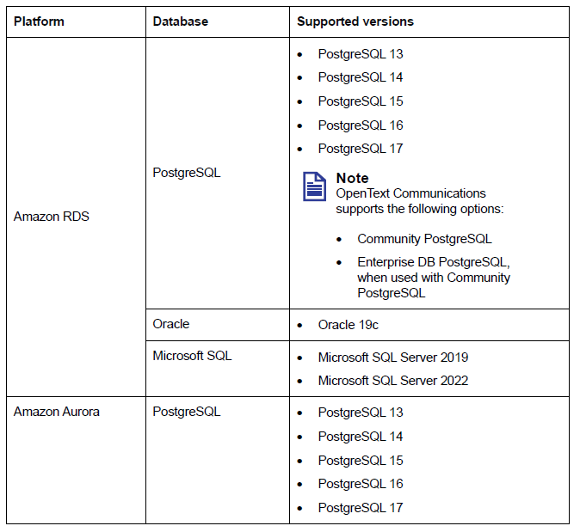
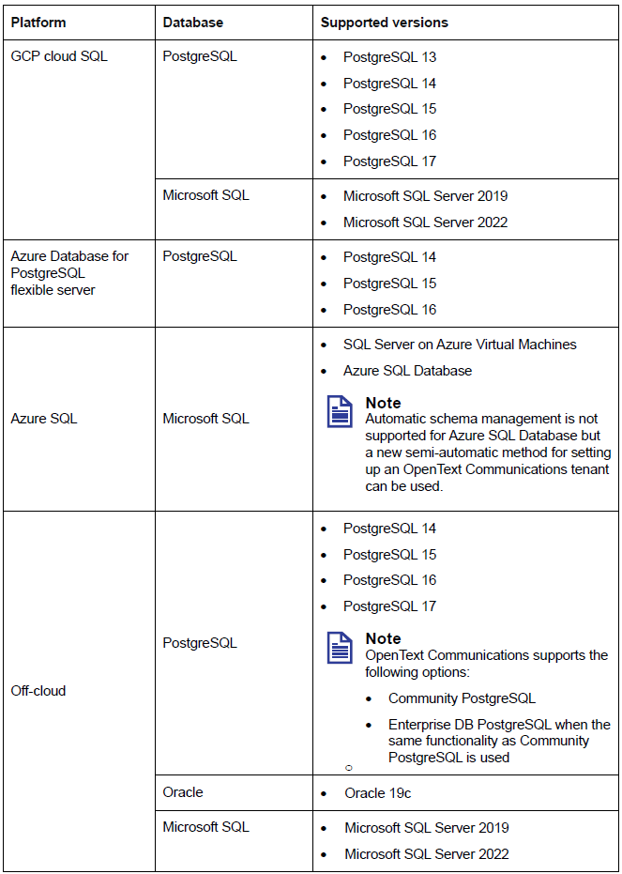

For OTDS, pre-create the database, user and schema. Initialize the database with scripts provided by OT PS team. The installer will create objects within the schema.
For Exstream, database credential with DB privilege to create users/schemas. Initialize the database with scripts provided by OT PS team. There are two options to manage Exstream database schemas as listed below.
  - Semi-automatic (Recommended) – The installation process will create the database objects and maintains it for future upgrades. Databases, users, schemas need to be created before installation.
  - Self-manage – Manually generate the database sql scripts using Liquibase tool and apply the sql scripts to the databases and for the future upgrades run the Liquibase tool again to generate sql scripts again to upgrade the schema objects. This adds overhead to the Application and DBA team during install time and future upgrades.

Storage – Persistent storage for k8s
Storage will be used for creating persistent volumes (PV) by all the containers for this installation. For the shared storage, you can use a network storage outside of K8s cluster. Deploy NFS provisioner or CSI driver with dynamic provisioning to K8s cluster which will facilitate the persistent volume creation for pods.
Only RabbitMQ and Exstream deployments need storage. You can either create one storage class for both or separate for each if you want to keep the root folders for the PVs to be separate. Create the storage classes with K8s spec with respect to the storage provisioner installed.
Exstream deployment uses a shared persistent volume claim (PVC) for the pods (Batch, OnDemand and Orchestration) that need persistent volume (PV). Make sure the accessMode can be set as ReadWriteMany (RWX) for this PVC.
RabbitMQ deployment will make separate PVC for each replica and the accessMode will be ReadWriteOnce (RWO).
NOTE: AWS EFS has limitations on number of reads/writes per second, if performance is critical then consider other performant storage options.

Load balancer setup
For OpenShift:
A Load balancer is needed in front of the openshift cluster nodes to route the external requests to the HA Proxy Router on the cluster which will route requests to backend services.

For Kubernetes:
A Load balancer is needed in front of the on k8s cluster nodes to route the external requests to the services/pods.
Automatic LB setup via ingress install:
When you install NGINX ingress on K8s with service type as “LoadBalancer” then it can automatically launch LB and configure it if your cluster infrastructure allows.
Manual LB setup:
If you are going to setup LB manually then you need to provision NGINX ingress on K8s with ServiceType as “NodePort” and then map your LB to point to NGINX ingress service.

DNS name setup
An external DNS name is needed for friendly hostname in the URLs and point to the load balancer. This DNS name will be used in SSL certificate generation. If you use external-dns or similar in k8s or OpenShift then DNS name(s) will be setup and mapped automatically when an ingress is created with host param value.

SSL Certs and Trust store setup
SSL termination at LoadBalancer:
- Configure the LoadBalancer with generated SSL certs (using the DNS from section 3.8) and terminate SSL at LoadBalancer.
- Any traffic beyond LoadBalancer to k8s cluster will go over non-SSL.
SSL termination at the backend ingress:
- If the SSL certs are public CA certs, then default java truststore within containers will recognize those certs.
- If the SSL certs are not public CA certs (self-signed or Enterprise certs) and Exstream pods can access OTDS and RabbmitMQ over non-SSL within namespace using internal service names (within cluster pods to service calls) then no need of custom truststore.
- If the SSL certs are not public CA certs (self-signed or Enterprise certs) and Exstream must access OTDS and RabbitMQ via external URL (going outside of cluster) over SSL then obtain all the SSL certs, private keys and import them into a PKCS12 (.pfx) key store. Note down the PKCS12 store password you set, it will be used in Exstream helm chart values yaml. NOTE: The default java truststore does not anything about self-signed or Enterprise certs, so this custom truststore is required.

ingress-nginx setup
For OpenShift:
In OpenShift all ingress specs will be registered as HA Proxy routes. In the values yaml “openshiftRoute” must be specified under ingress section.

For Kubernetes:
An Ingress (nginx) is required to reverse proxy the requests to the deployed services on k8s cluster. Use helm to install ingress-nginx on k8s cluster using chart and image from public repository. You can also pull/download the chart and image and host it on local repository.
Multiple ingress controllers setup:
If you have other controllers as front-end to map/manage your Load Balancer (like AWS ALB, Traefiq etc.) then you would need to setup ingress-nginx as NodePort serviceType so that it does not spawn/create a Load Balancer and then setup nginx as the only ingress to the front-end controller. The traffic will be routed by Load Balancer è front-end controller è ingress-nginx è backend services.

Sample app setup
Install/deploy a sample application and validate the infrastructure with above sections are working correctly before proceeding with Exstream install.
- Verify URL (DNS and SSL certs) works with LoadBalancer and NGINX Ingress.
- Verify the sample deployment can create persistent volume using the storage provisioner.
- Verify connection to Database server from K8s cluster works.

Installation Steps – Exstream CN on Kubernetes/OpenShift
In this installation of Exstream Cloud-Native, these are the options taken from the installation planning step.
NOTE: These steps will be updated as per the approach taken.
- External database.
- Persistent storage.
- Load balancer setup.
- SSL termination at LB.
- Unzip the file containing scripts and chart override yaml files from OT PS team.

OTDS Installation
OTDS must be installed first before installing Exstream Cloud-Native. If you plan to terminate TLS at ingress then create a k8s tls secret with SSL cert/key and add the secret to the override yaml file below.
Update the OTDS override values yaml as needed and run this command:
helm upgrade -i otds charts/otds-<chart-version>.tgz --values override-values-yaml/otds-override-values.yaml

Validation:
After OTDS is deployed successfully access this URL and login to OTDS to validate the installation.
System Tenant: Error! Hyperlink reference not valid.

RabbitMQ Installation
RabbitMQ must be installed using external helm chart and image. Use the OT PS provided override values yaml sample and update it with respect to your environment.
helm upgrade -i exstream-rabbitmq charts/ opentext-experience-cloud-<chart-version>.tgz -f override-values-yaml/ot-ecf-rabbitmq-override-values.yaml

Validation:
After RabbitMQ is deployed successfully access this URL and login to validate the installation.
RabbitMQ Mgmt Console: https://<your-dns-name>/rabbitmq/

Optional Deployments
The following optional items can be installed before Exstream installation if you plan to use those.
Apache Solr: (For text-based search)
helm upgrade -i exstream-solr charts/solr-<chart-version>.tgz -f override-values-yaml/solr-override-values.yaml

Validation:
Access Solr admin console URL to validate the installation.
Solr console URL: https://<your-dns-name>/solr
Prometheus: (For autoscaling batch engine)
helm upgrade -i kube-prometheus-stack charts/kube-prometheus-stack-<chart-version>.tgz -f override-values-yaml/kube-stack-prometheus-override-values.yaml

helm upgrade -i prometheus-adapter charts/prometheus-adapter-<chart-version>.tgz -f override-values-yaml/prometheus-adapter-override-values.yaml

Validation:
Access Prometheus URL to validate the installation.
Prometheus query URL: https://<your-dns-name>/prometheus/query

Exstream Installation
Exstream Cloud-Native deployment chart will install all the required containers and services. Update the exstream-override-values.yaml files as needed.
- Update to override default values of Exstream chart.
- Update with your DB connection information.
- Update as needed for users/passwords. The password for OTDS Admin user must match the values used in OTDS install.
- Install by running this command.
helm upgrade -i exstream charts/exstream-<chart-version>.tgz --wait --timeout 30m0s --values override-values-yaml/exstream-override-values.yaml

Validation:
After Exstream deployed successfully access these URLs and login to validate the installation.
Tenant OTDS Admin: https://<your-dns-name>/otdstenant/<tenant-name>/otds-admin/
Non-system Tenant Design Web Client:
https://<your-dns-name>/design/index.html?tenant=<tenant-name>
Non-system Tenant Empower Admin:
https://<your-dns-name>/empower/console/index.html?tenant=<tenant-name>

License Deployment
After the OTDS and Exstream is installed, it will need to be licensed. This will enable the functionality of individual features including Exstream Web application access for Orchestration, Design and Production, etc.
Please refer to the “OpenText Exstream (Cloud-Native) CE - Containerized Deployment Licensing Guide” link listed below.

Apply for License
To apply for a license you must first find the OTDS tenant fingerprint (under “System Status” in Tenant OTDS Admin Console - https://<your-dns-name>/otdstenant/<tenant-name>/otds-admin/).

Allocating users, groups or Partitions
To allocate a user, group, or partition to the product key:
1. Sign in to the OTDS web client as a tenant administrator user at the following URL:
https://<your-dns-name>/otdstenant/<tenant-name>/otds-admin/

2. In the Setup menu, click Users & Groups or Partitions, depending on the allocation
type.

3. Locate the user, group, or partition that you want to allocate to the product key.

4. In the Actions menu for each user, group, or partition, click Allocate to License.

5. In the License list, choose the product key.

6. If you want to change which feature the user, group, or partition has permission to use,
select the appropriate feature in the Counter list.

Counters
The counters that appear in the Counter list are determined by which features have been
licensed.
As a best practice, allocate counters individually to specific user groups.

Important: EXSTREAM is the primary (root) counter and, if selected, allocates the
license key to all of the EXSTREAM counters in the license key for that user, group of
users, or all of the users in a partition. OpenText recommends that you control
license key access by allocating specific feature counters to groups or individual
users instead of to the EXSTREAM root counter.
If needed, the allocation process can be repeated to provide access to more than one
counter.
Note: It is not required to allocate the EXSTREAM.MESSAGES and
EXSTREAM.TRANSACTIONS counters.

7. Click Allocate to License.
Containerized Deployment Licensing Guide
2 Exstream OTDS product key licensing
Refer Licensing Guide - https://webapp.opentext.com/piroot/ccdpcd/v250400/ccdpcd-uli/docovw.xml

8. If necessary, repeat step 6 through step 7 to allocate a Named User Seat for any
additional features.

9. Click Close

Installation Planning – Exstream Desktop Application
Exstream Design and Production is a Windows Desktop Application which contains Design Manager, Designer and other tools. This application will be used by Developers/Designers to design document templates and package them as an application. The Developers/Designers will perform unit testing on the Windows machine and then upload the package to Exstream CN runtime (on k8s/OpenShift) repository.
NOTE: A separate DesignManager DB (supported databases are in release notes) is required for this Desktop Application and the Windows machine hosting this desktop application must be close to the DB to avoid latency issues impacting performance and productivity for the Developers/Designers.
DesignManager DB (Sizing) - Start with 10G for new Exstream implementation and extend as needed, if not it’ll be dependent up on legacy Exstream Design DB size. NOTE: This DB is used by Windows Desktop Application not by Kubernetes / OpenShift.
Software Location: https://support.opentext.com/csm?id=kb_article_view&sysparm_article=KB0850335
Release Notes: https://support.opentext.com/csm/?id=kb_article_view&sysparm_article=KB0850411
Installation, Admin and Configure Guide: https://webapp.opentext.com/piroot/ccdpicu/v250400/ccdpicu-igd/en/html/_manual.htm

Installation and Configuration Steps – Exstream Desktop Application

Install Design and Production
Extract Designer zip
The Design and Production download comes as a zip file. This should be extracted on the local desktop to access the executable.
- designer_x64_25_4_0.zip
extracts as
- OpenTextExstream_setup_x64_25.4.0.exe

Run the Executable
The Executable will install Design and Production. This requires Microsoft VC++ redistributable. The appropriate.
Choose an install location. The default is within the Windows Program Files directory.
e.g. “C:\Program Files\OpenText\Exstream\Exstream 25.4.0”
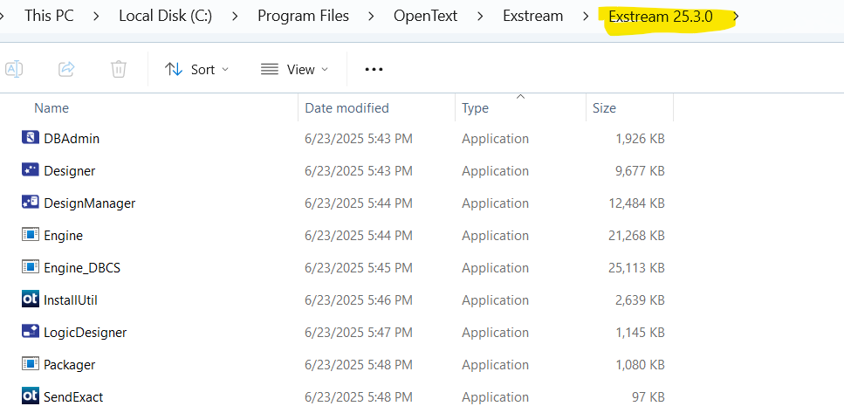

The Installation is complete. Though it will require additional steps to configure access.

Configure ODBC DSN
To facilitate connecting to the Design Database an ODBC DSN must be created.
Download the appropriate ODBC driver for the database.
For Example for PostgreSQL psqlodbc - PostgreSQL ODBC driver.
The latest as of this writing: pslodbc_16_00_0000.zip

Run the windows ODBC Data Sources applications.
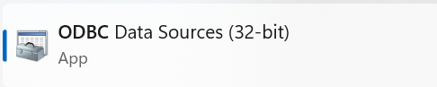

Create a System DSN to connect to the Design Database created in the Provisioning steps.
Ensure the DSN is tested with the Database Owner before completing.
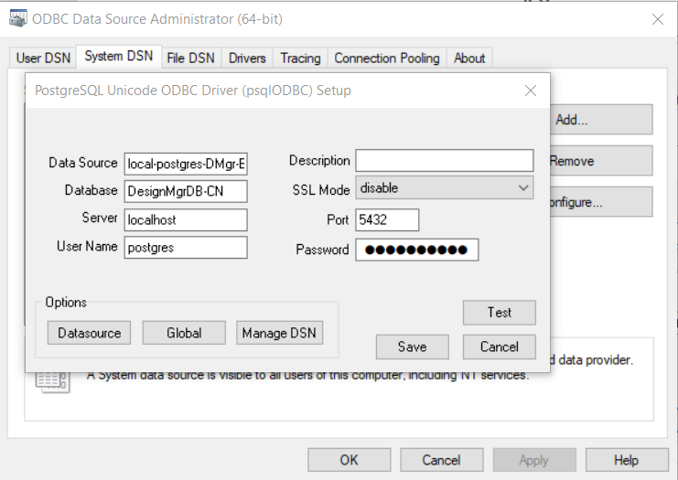

Configure Design Database
The Design and Production will require the Database to be configured. This will require the use of the DBAdmin tool. This should only be required once with subsequent client installs connecting to the existing database. Subsequent Design and Production installations will be able to connect to the configured repository.



This should be found in the installation directory e.g.
C:\Program Files\OpenText\Exstream\Exstream 25.4.0\DBadmin.exe

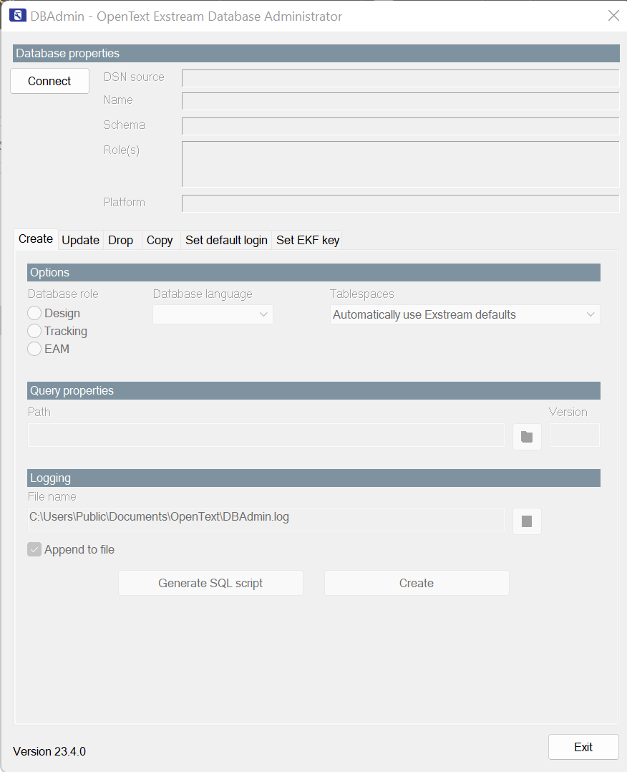

Connect to the Database using the ODBC DSN configured in the previous Step.
NOTE: the DSN source name should match the ODBC DSN created in the previous steps.
The schema should match the schema name of the database provisioned for the Design and Production.
The User to login should be the Database user with sufficient privileges.
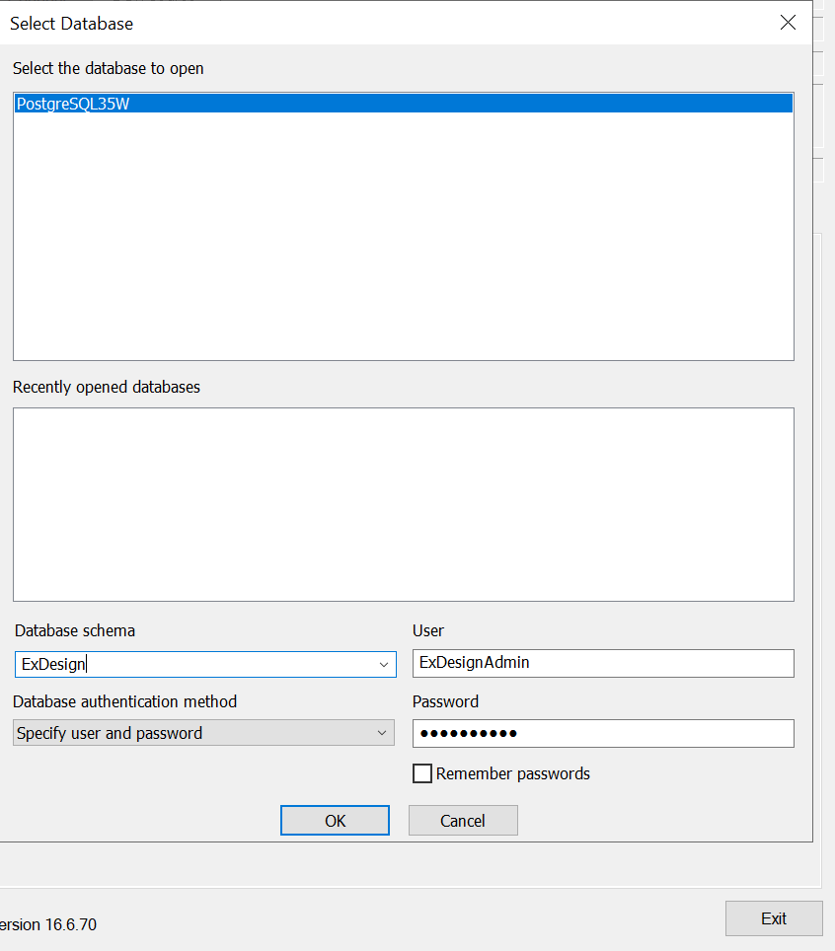

On the ‘Create’ tab select the ‘Design’ radio button. The default settings may be sufficient.
Select the ‘Create’ button (lower right side) to start the database configuration.
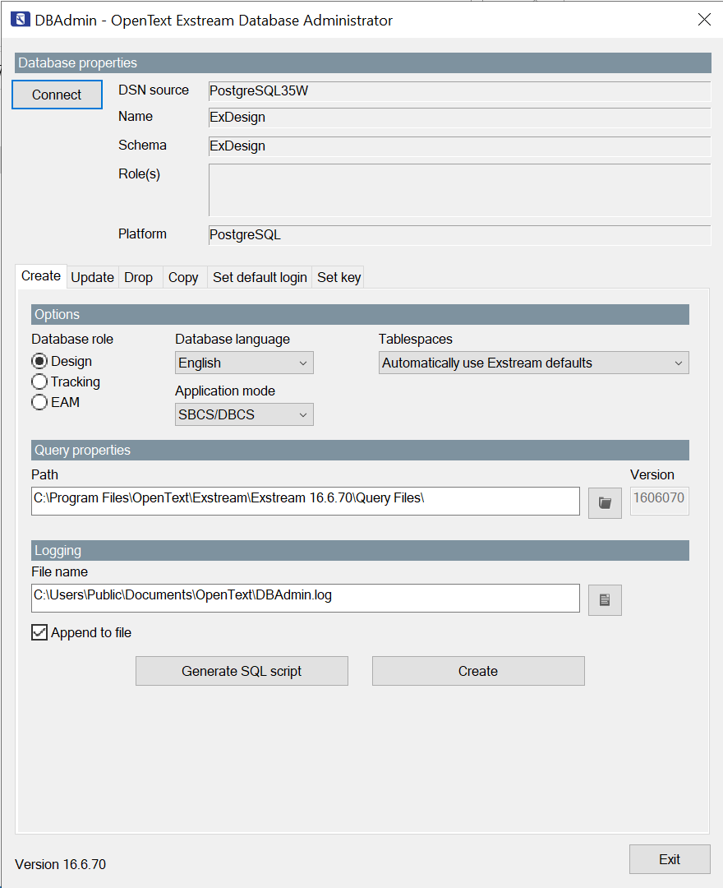

Once Complete exit from the DBAdmin tool.

Connecting Design Manger to Database
The connection to the Design Manager
Open Design Manager: Start -> All Apps -> OpenText Exstream 25.4.0 -> Design Manager
Connect to the ODCB data source. This should be the same as when using the DBAdmin tool.
Login with the appropriate profile. Must be within OTDS and a license allocated to either the Group or user.

OpenText Documentation Links
◗ OpenText Communications CE 25.4.0: Documentation
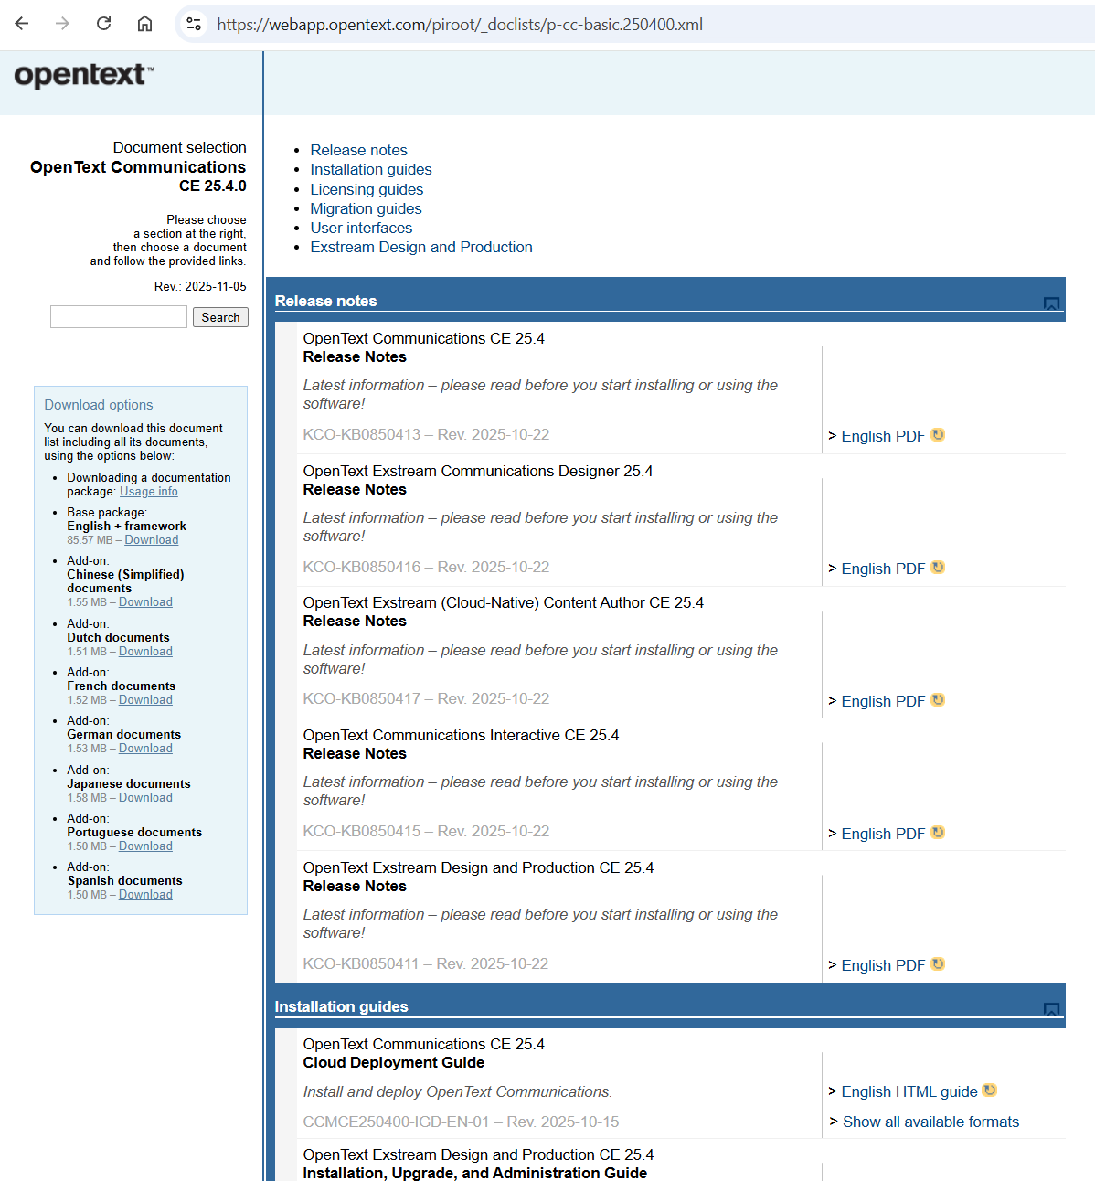

About OpenText
OpenText enables the digital world, creating a better way for organizations to work with information, on premises or in the cloud. For more information about OpenText (NASDAQ: OTEX, TSX: OTC) visit opentext.com.

Connect with us:
OpenText CEO Mark Barrenechea’s blog
Twitter | LinkedIn | Facebook

