SUPPLY CHAIN – BUSINESS ANALYSIS DOCUMENTATION
Delivery & Operational Performance Intelligence
Prepared by Jeevagan K | Tools: SQL (Google BigQuery) · Power BI | Dataset: DataCo Supply Chain (Jan 2015 – Jan 2018)

Section 1: Project Overview & Business Objectives

Project Introduction
This project analyses the order, shipping and sales history of a global supply chain business to understand how reliably orders are delivered and where profit is made or lost. The dataset holds 180,519 order-item records across 65,752 orders, 118 products, 50 product categories and 23 order regions, spanning 1 January 2015 to 31 January 2018. The data was loaded into Google BigQuery, analysed with 14 SQL queries, and summarised in a two-page Power BI dashboard.

180,519  Order items | 65,752  Unique orders | $36.78M  Total sales | 10.8%  Profit margin | 54.8%  Late deliveries
Currency is not stated in the dataset; $ is used for readability. “Order items” are individual product lines; one order can contain several items.

Business Problem
More than half of all order items arrive later than scheduled, yet leadership has no single view of which shipping modes, regions or products drive the problem. At the same time, it is unclear whether sales growth is translating into profit, whether discounts are helping or hurting margin, and how dependent the business is on a few products.

Objectives
- Measure delivery performance: late-delivery rate and actual vs scheduled shipping time.
- Identify which shipping modes and regions create the most delivery risk.
- Find the categories and products that generate the most sales and profit, and those that lose money.
- Evaluate the effect of discounts on profitability.
- Compare customer segments and turn the findings into practical business recommendations.

Tools and Technologies
Tool | Purpose
Google BigQuery (SQL) | Data loading, data quality checks and 14 analytical queries (aggregations, COUNTIF, SAFE_DIVIDE, date extraction)
Power BI | Interactive two-page dashboard: Delivery & Operational Performance, and Sales & Profitability Analysis
Microsoft Word | Business documentation of questions, answers, insights and recommendations

Section 2: Objective Questions & Answers

Q1. How many records are in the dataset?
ANSWER
The dataset contains 180,519 order-item records and 45 columns, covering 65,752 unique orders. The duplicate check on Order Item Id found 0 duplicate records, and no column has missing values, so no cleaning was needed before analysis.

Dataset snapshot | Value | SQL query used
Total records (order items) | 180,519 | Query 3
Unique orders (Order Id) | 65,752 | Query 2
Duplicate order items | 0 | Query 3
Products / Categories / Regions | 118 / 50 / 23 | Query 1
Date range | 01 Jan 2015 – 31 Jan 2018 | Query 10
Insight: An order contains 2.75 items on average, so counts must be labelled correctly: row counts represent order items, while unique orders require COUNT(DISTINCT Order Id).

Q2. What is the late delivery percentage?
ANSWER
98,977 of 180,519 order items (54.83%) were delivered late. Only 17.8% shipped on time, 23.0% shipped ahead of schedule and 4.3% were cancelled.

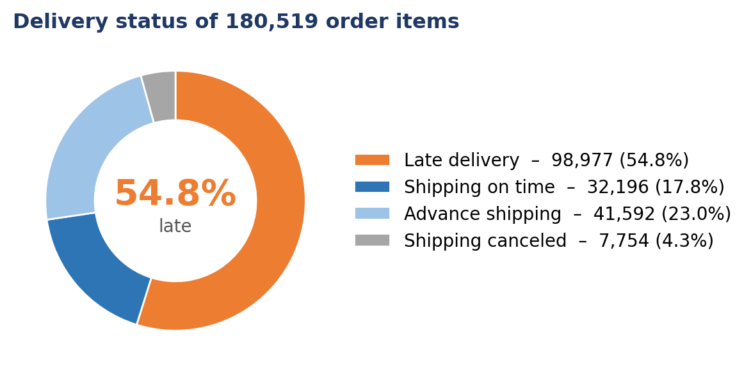
Figure 1: Delivery status split (SQL Query 4; Power BI KPI “Late deliveries”)
Insight: Late delivery is the norm rather than the exception: late items outnumber on-time and early items combined (40.8%).

Q3. What is the average actual vs scheduled delivery time?
ANSWER
Order items take 3.50 days on average against 2.93 days scheduled, a gap of 0.57 days (about 19% longer than promised). Averages are calculated at order-item level.

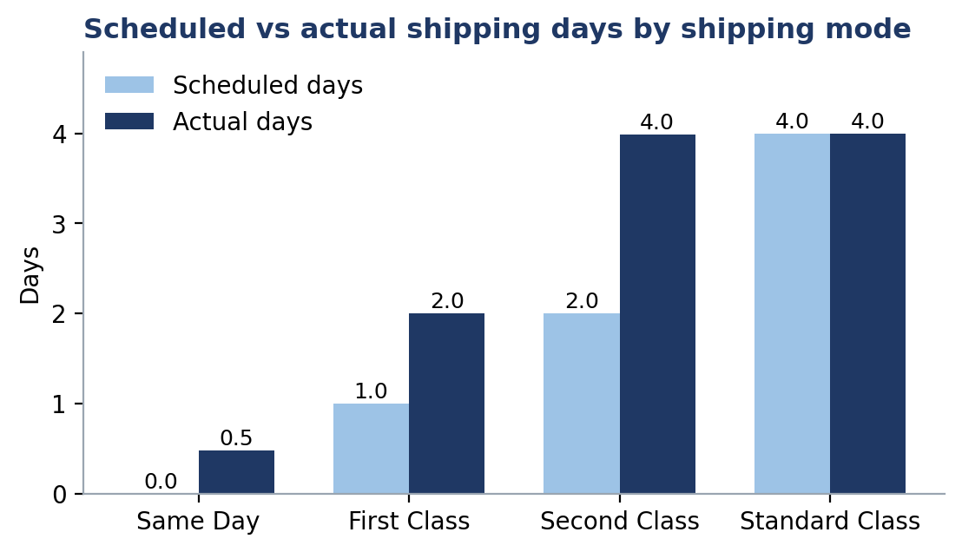
Figure 2: Scheduled vs actual shipping days by shipping mode (SQL Queries 4 and 5)
Insight: The gap is not spread evenly. Standard Class delivers exactly as scheduled (4.0 vs 4.0 days), but First Class takes 1 day longer than promised (2.0 vs 1.0) and Second Class takes 2 days longer (4.0 vs 2.0). The delivery promise itself is unrealistic for the premium modes.

Q4. Which shipping mode has delivery issues?
ANSWER
First Class (95.3% late) and Second Class (76.6% late) have the most serious delivery problems. Together they account for 53,500 late items (54% of all late deliveries) while making up only 35% of order items. Standard Class has the lowest late rate (38.1%) but, because it carries 60% of all order items, still produces the largest number of late items (41,023).

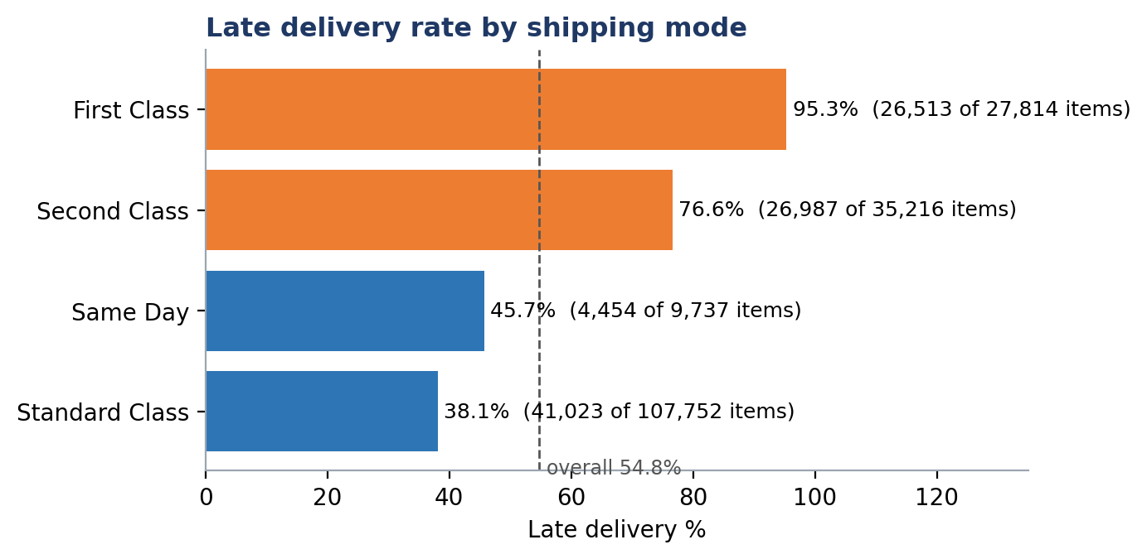
Figure 3: Late delivery rate by shipping mode (Power BI: Avg delivery days by Shipping Mode)
Insight: Customers paying for faster shipping receive the worst service relative to the promise. Fixing First and Second Class is the quickest route to reducing the overall late rate.

Q5. Which category generates the highest profit?
ANSWER
Fishing generates the highest profit at $756.2K, 19.1% of total profit ($3.97M). It is followed by Cleats ($494.6K) and Camping & Hiking ($427.5K).

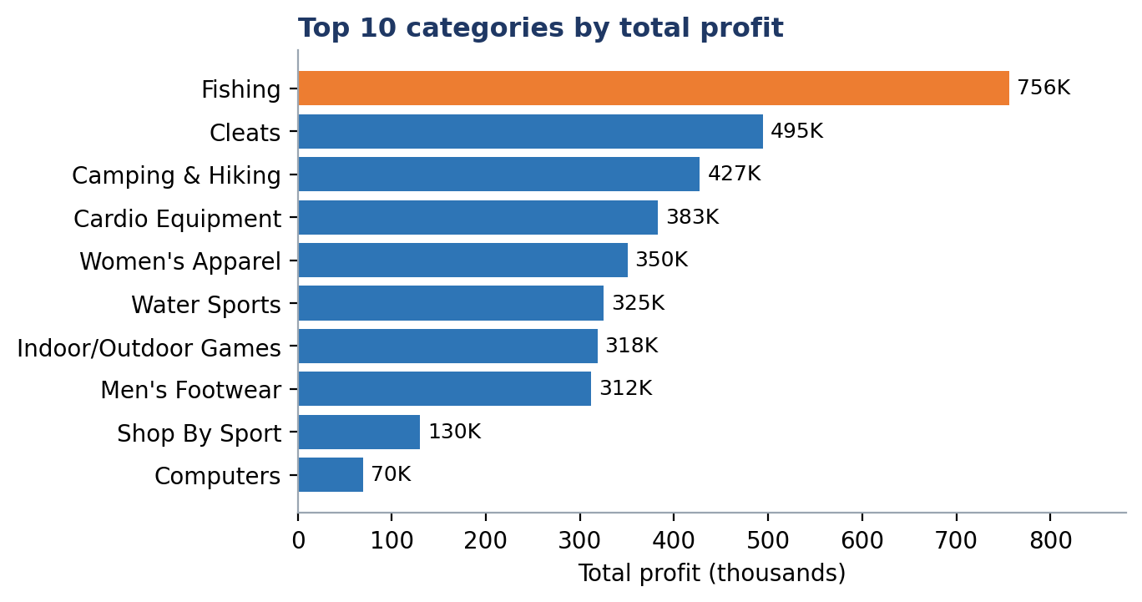
Figure 4: Top 10 categories by total profit (SQL Query 8; Power BI: Profit by Product Category)
Insight: The Fishing category contains a single product (the Field & Stream Sportsman 16 Gun Fire Safe) and earns $43.65 profit per item, about twice the portfolio average of $21.97. One product carrying a fifth of profit is a concentration risk.

Q6. Which products generate the highest sales?
ANSWER
Field & Stream Sportsman 16 Gun Fire Safe leads with $6.93M in sales (18.8% of total), followed by Perfect Fitness Perfect Rip Deck ($4.42M) and Diamondback Women’s Serene Classic Comfort Bicycle ($4.12M). The top 10 products generate 90% of all sales.

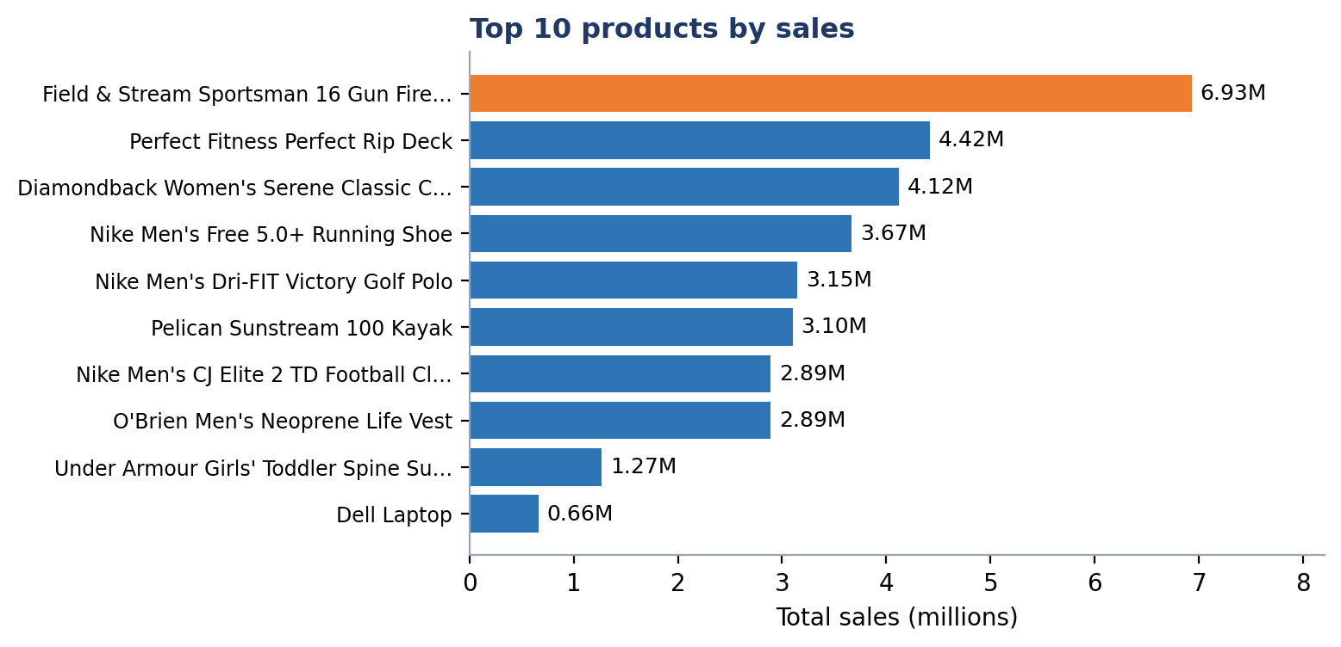
Figure 5: Top 10 products by sales (SQL Query 14; Power BI: Top 10 Products by Sales)
Insight: Sales are highly concentrated: 10 of 118 products deliver nine-tenths of revenue, so stock availability and delivery performance on these products matter most.

Section 3: Subjective Business Questions

Q1. How can late deliveries be reduced?
RECOMMENDED APPROACH
Delivery problems are concentrated in the premium shipping modes, so the plan should target shipping modes first, not regions (see Q2). The table sets out the action for each mode.

Shipping mode | Scheduled / actual days | Late rate | Late items | Recommended action
First Class | 1.0 / 2.0 | 95.3% | 26,513 | Re-baseline the promise to realistic lead time or renegotiate carrier SLAs; weekly carrier scorecard with penalties
Second Class | 2.0 / 4.0 | 76.6% | 26,987 | Same review as First Class; shift orders to carriers that meet the 2-day promise
Standard Class | 4.0 / 4.0 | 38.1% | 41,023 | Highest volume: add a 1-day buffer or priority handling at peak; early-warning alert for orders not shipped by day 2
Same Day | 0.0 / 0.5 | 45.7% | 4,454 | Set a daily order cut-off time and track same-day dispatch separately
Impact: Resetting First and Second Class promises to their actual 2- and 4-day performance would remove most of the 53,500 late items, but this only corrects the promise. Genuine improvement needs better carrier performance, so both actions should run together.

Q2. Which regions need operational improvement?
ANSWER
No region is a clear outlier. Late rates range only from 48.8% (Canada) to 58.0% (Central Africa) across 23 regions, while shipping modes range from 38% to 95%. The delivery problem is system-wide. Regions to prioritise are those with high volume and above-average late rates.

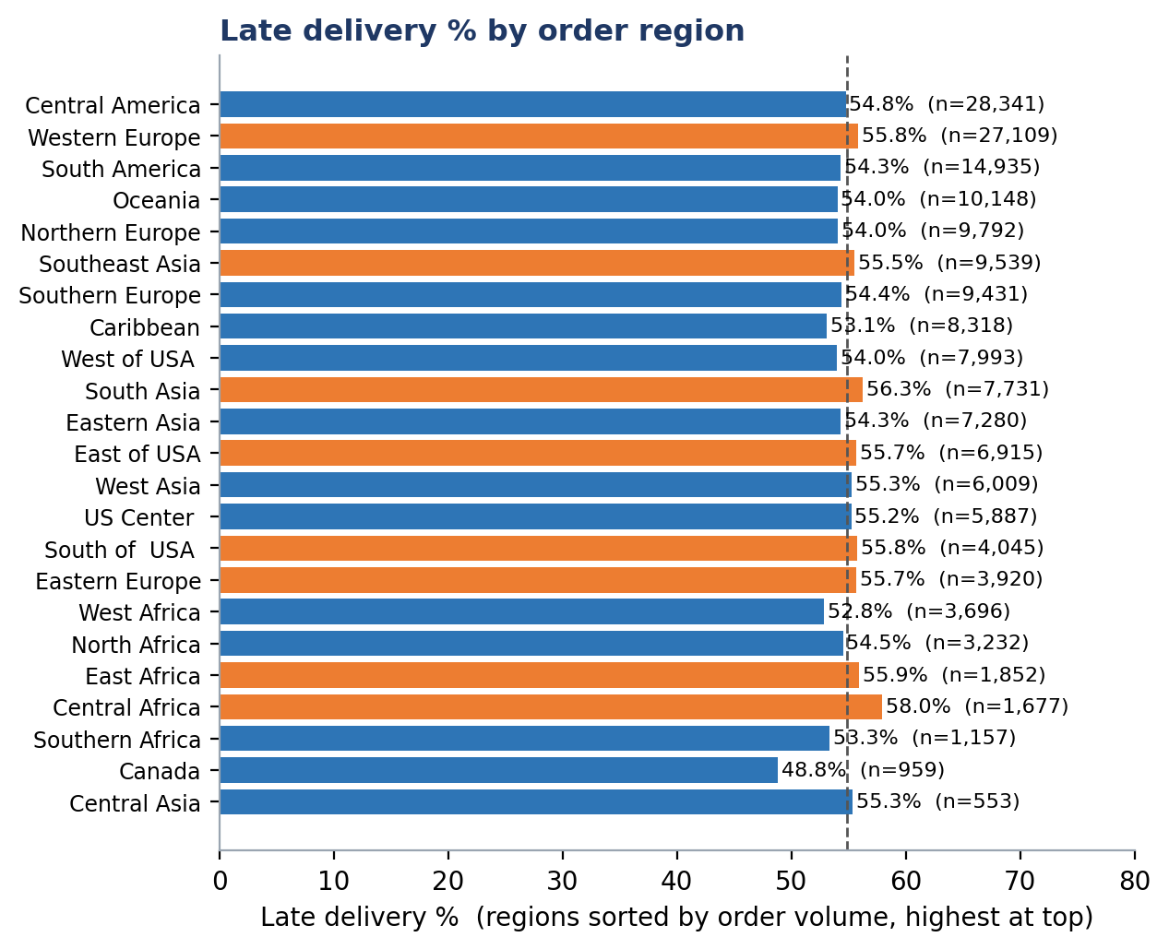
Figure 6: Late delivery % by order region; orange = above 55.5% (SQL Queries 6 and 7)
Priority regions: Western Europe (27,109 items, 55.8% late, about 15,100 late items) and Central America (28,341 items, 54.8%, about 15,500 late items) account for 31% of all late deliveries. South Asia (56.3%), Southeast Asia (55.5%) and East of USA (55.7%) are above average with meaningful volume. Central Africa has the highest rate (58.0%) but only 1,677 items.

Q3. How can product profitability be improved?
ANSWER
Overall margin is 10.8%. Profitability is held back by loss-making items: 33,784 items (18.7%) lost a combined $3.88M, offsetting about half of the $7.85M earned on profitable items. Margins are consistent at 10–11% across the high-sales categories, with weak spots in small categories such as Strength Training (0.6%), As Seen on TV (3.5%) and Men’s Clothing (4.6%).

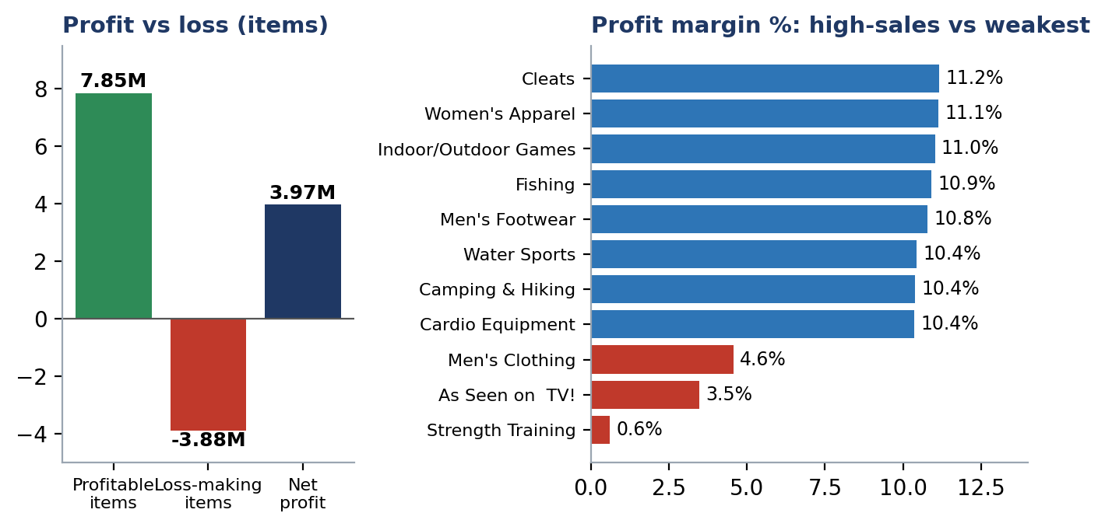
Figure 7: Profit vs loss and category margins (SQL Query 9)
- Investigate loss-making items by product and price point; apply price floors or cost reviews where items sell below cost.
- Fix or phase out low-margin categories (Strength Training, As Seen on TV, Men’s Clothing) through repricing or supplier renegotiation.
- Reduce dependence on one product. Build up the next-best earners (Cleats, Camping & Hiking, Cardio Equipment) so profit does not rely on the Fishing category.

Q4. What discount strategy should the business follow?
ANSWER
The average discount rate is 10.2%. Profit per item declines steadily as discounts deepen, from $23.9 (0–5% band) to $18.4 (20–25% band), a 23% drop. However, the share of loss-making items stays near 18–19% in every band, so discounting alone does not explain the losses.

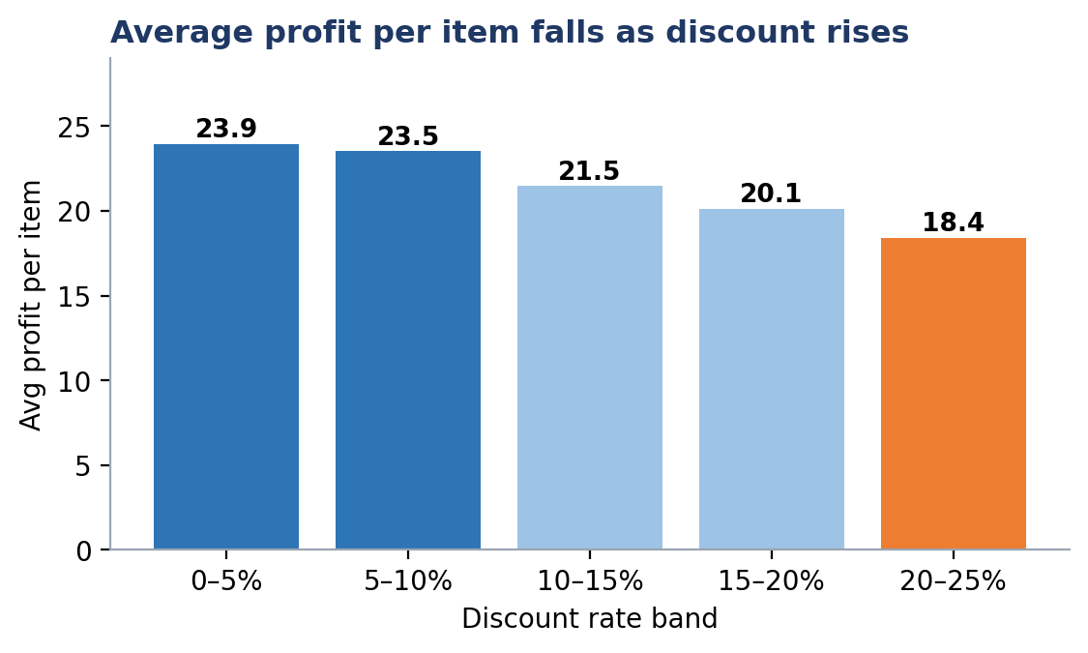
Figure 8: Average profit per item by discount band (Power BI: Discount vs Profitability by Product Category)
- Cap standard discounts at about 15%, where profit per item is still around $21.5.
- Reserve deep discounts (20%+) for slow-moving stock, bulk or contract orders, rather than offering them across the board.
- Exclude low-margin categories from promotions until their pricing is fixed.
- Test before scaling: run controlled promotions and compare volume lift against the profit lost per item.

Q5. Which customer segments generate more revenue?
ANSWER
Consumers generate the most revenue: $19.10M (51.9%), followed by Corporate ($11.17M, 30.4%) and Home Office ($6.52M, 17.7%).

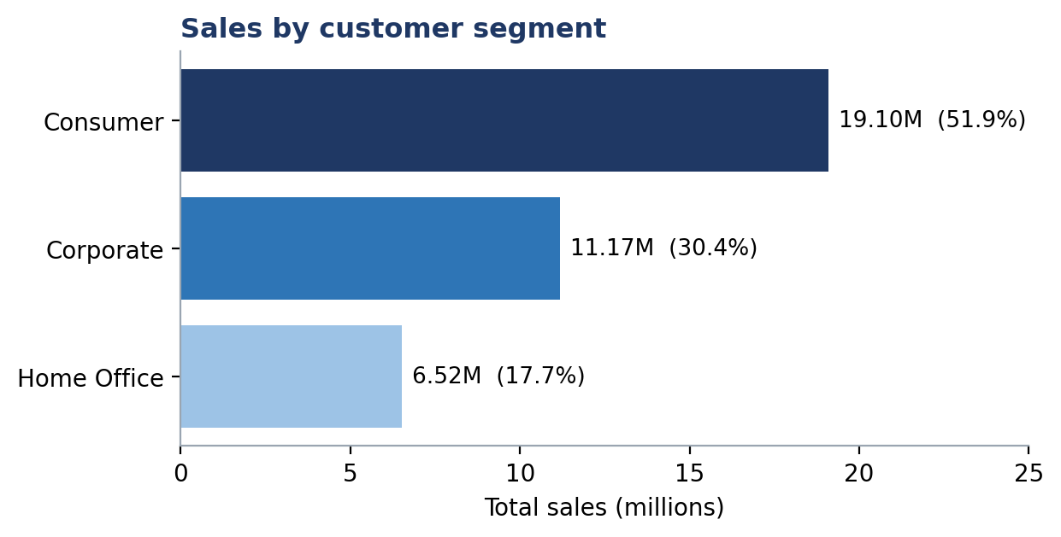
Figure 9: Sales by customer segment (SQL Query 12; Power BI: Sales by Customer Segment)
Insight: Average sales per item ($202–$204) and profit margin (10.6–10.9%) are almost identical across segments, so the revenue gap comes from customer volume, not basket size or profitability. Priorities: protect Consumer retention through loyalty offers, grow Corporate order value through bulk or contract pricing, and use targeted acquisition for Home Office rather than blanket discounts.

Section 4: Business Insights & Recommendations

Key Findings
- Delivery is the biggest weakness: 54.8% of order items are late, and the average order item takes 0.57 days longer than scheduled.
- Premium shipping under-delivers: First Class (95.3%) and Second Class (76.6%) are late far more often than Standard Class (38.1%).
- Late delivery is not a regional problem: all 23 regions fall within 48.8–58.0%, pointing to shipping mode and promise-setting as the root causes.
- Revenue and profit are concentrated: the top 10 products give 90% of sales, and one product (Fishing category) gives 19% of profit.
- Losses erode profit: 18.7% of items are sold at a loss, wiping out $3.88M of the $7.85M earned on profitable items.
- Discounts cost margin but do not explain losses: profit per item falls 23% from the lowest to the highest discount band.
- Order pipeline needs attention: only 33% of orders are Complete; 21.9% are in Pending Payment, and 2.3% are flagged as Suspected Fraud.

Business Recommendations
Priority | Recommendation | Expected impact
1 | Re-baseline First and Second Class lead times and enforce carrier SLAs | Largest reduction in late items (53,500 items sit in these two modes)
2 | Add buffers and early-warning alerts for Standard Class | Cuts late items in the highest-volume mode (41,023)
3 | Investigate loss-making items; apply price floors | Recovers part of the $3.88M lost on 18.7% of items
4 | Cap blanket discounts near 15%; target deeper discounts | Protects profit per item ($21.5 vs $18.4)
5 | Diversify beyond the Fishing category and top 10 products | Reduces concentration risk in sales and profit
6 | Review pending payment and suspected fraud orders | Speeds up order completion and limits revenue leakage

Dashboard Screenshots
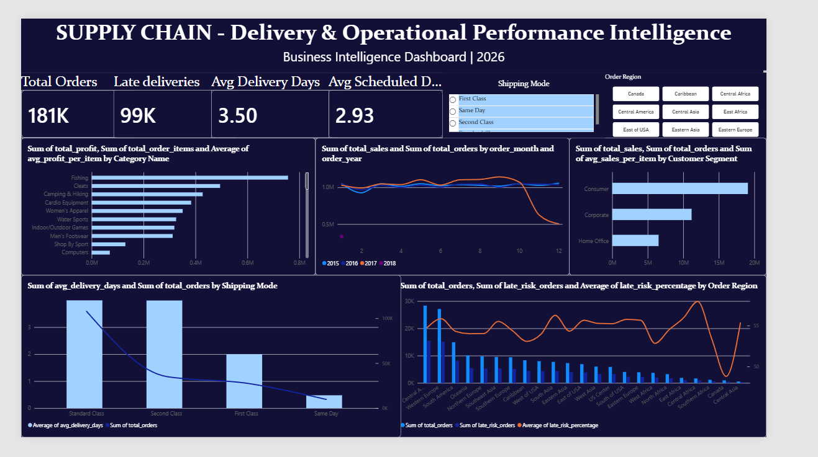
Dashboard page 1: Delivery & Operational Performance Intelligence. The “Total Order Items” card (181K) shows records, not unique orders; unique orders total 65,752.
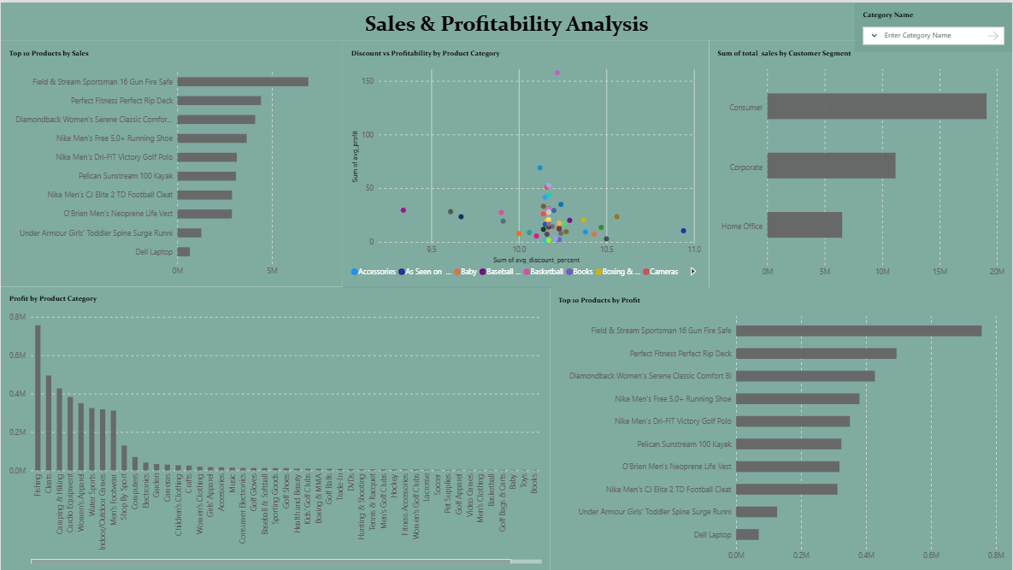
Dashboard page 2: Sales & Profitability Analysis

Data Notes
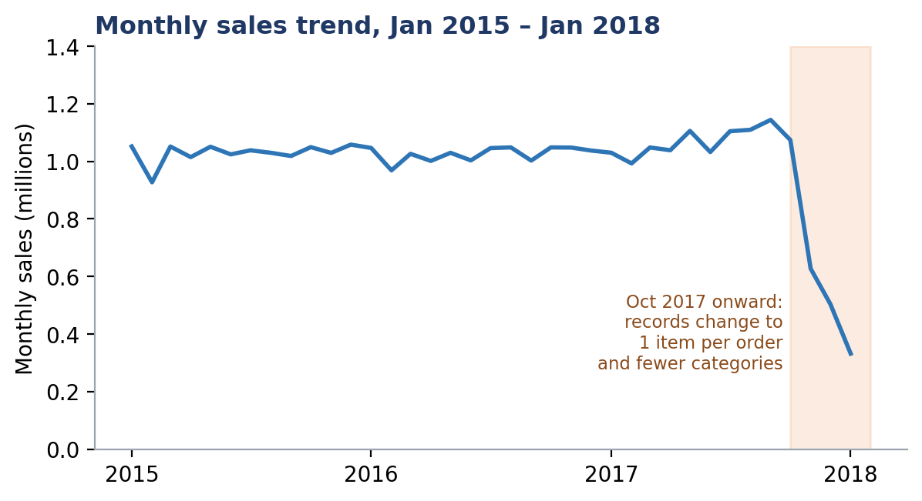
Figure 10: Monthly sales, January 2015 – January 2018 (SQL Query 10)
Monthly sales were stable at roughly $1.0–1.1M from January 2015 to September 2017. The sharp fall from October 2017 coincides with a change in the records: orders switch to one item each, the number of active categories drops from about 25 to 8–20, and the Fishing category disappears after October 2017. This looks like a change in data coverage rather than a confirmed business decline, so the late-2017 figures should be validated with the source system before drawing conclusions. Annual sales were $12.34M (2015), $12.30M (2016) and $11.81M (2017).

Final Conclusion
The business is not primarily losing money on volume. It is losing reliability and margin. More than half of deliveries miss their schedule, driven by unrealistic promises and weak performance in First and Second Class shipping, not by geography. Profit is healthy at 10.8% but depends heavily on a small number of products and is reduced by loss-making items and deep discounts. Fixing shipping-mode performance, tightening discount rules and diversifying the product base would improve both customer experience and profitability.

