RAI UNIVERSITY
Rai School of Engineering
030805506 - COMPUTER NETWORK
B.Tech Semester - 5
UNIT 2: THE REFERENCE MODEL
Study Notes - Written in Very Easy Language
Topics Covered:
• OSI Model & TCP/IP Model (with comparison)
• Network Topologies (Types, Design & Implementation)
• Switching Networks - Circuit, Packet & Message Switching
• MAC Address & Mobile Telephone System
• Line Configuration & Multiplexing
• Duplex Modes - Simplex, Half Duplex, Full Duplex
• Protocols - Stop & Wait, Sliding Window, ARQ (Go-Back-N & Selective Repeat)

Introduction to Unit 2
In Unit 1, we learned what a computer network is and why we use it. Now, in Unit 2, we will learn HOW computers actually talk to each other in a proper, organised way.
Think of it like this: when two people from different countries want to talk, they need a common process - maybe a translator, some rules of politeness, and an order in which they speak. Computer networks also need such rules. These rules and their organisation are called the 'Reference Model'.
Easy Tip: Whenever you feel confused, just remember - a 'model' is simply a step-by-step plan that tells data how to travel safely from one computer to another.

1. OSI Model (Open Systems Interconnection)

1.1 What is the OSI Model?
The OSI Model is like a rulebook made by an organisation called ISO (International Organization for Standardization) in 1984. It tells us how data should travel from one computer to another computer, step by step, through 7 different layers.
Imagine you are sending a birthday gift by courier to your friend in another city. You don't just hand over the gift directly - you pack it in a box, write the address, hand it to the courier company, the courier company puts it on a truck, the truck takes it to another city, and finally someone delivers it to your friend's door. Each step is a different 'layer' of work. OSI model works exactly like this for data.
Easy Tip: OSI has 7 layers. A famous trick to remember all 7 layers (from Layer 7 to Layer 1) is: 'All People Seem To Need Data Processing' -> Application, Presentation, Session, Transport, Network, Data Link, Physical.

1.2 The 7 Layers of OSI Model (One by One, in Very Easy Words)

Layer 1: Physical Layer
This is the lowest layer. Its only job is to send raw bits (0s and 1s) through a physical medium like a wire, cable, or radio wave.
- It deals with real hardware - cables, connectors, voltage, and signals.
- It decides things like: Is the cable copper or fiber? Is the signal electrical or light?
- Example: When you plug an Ethernet cable into your laptop, the Physical layer is the one actually pushing electrical signals through that cable.

Layer 2: Data Link Layer
This layer takes the raw bits from the Physical layer and organises them into small packets called 'frames'. It also checks if any error happened during sending.
- It uses something called a MAC Address to identify devices on the same local network.
- It also does error detection - if some bits got damaged on the way, this layer can often catch that mistake.
- Example: Your Wi-Fi router and your laptop talk to each other using this layer's rules.

Layer 3: Network Layer
This layer decides the best PATH for data to travel from the sender's computer to the receiver's computer, even if they are in different cities or countries.
- It uses IP Addresses (like 192.168.1.1) to identify computers across different networks.
- It performs 'routing' - choosing the best road for the data, just like Google Maps chooses the best road for you.
- Example: When you open a website hosted in another country, the Network layer helps find the route to reach that far-away server.

Layer 4: Transport Layer
This layer makes sure that ALL the data reaches the destination completely and in the correct order - nothing missing, nothing mixed up.
- It breaks big data into smaller pieces called 'segments' and numbers them so they can be arranged correctly at the other end.
- Two popular protocols work here: TCP (reliable, checks everything) and UDP (fast, but does not check everything).
- Example: While downloading a movie file, the Transport layer makes sure every small part of the file arrives, and if any part is missing, it asks the sender to resend it.

Layer 5: Session Layer
This layer starts, manages, and ends a 'conversation' (called a session) between two computers.
- It keeps track of whose turn it is to send data, just like a moderator in a discussion.
- Example: When you log in to your college's online portal, a session is created that stays active until you log out.

Layer 6: Presentation Layer
This layer is like a translator. It converts the data into a format that both computers can understand - because different computers may store data differently.
- It also handles encryption (making data secret/safe) and compression (making data smaller).
- Example: When you send a WhatsApp message with special emojis, this layer makes sure the emoji looks correct on the receiver's phone too.

Layer 7: Application Layer
This is the topmost layer - the one closest to YOU, the user. It provides the actual services you use, like browsing websites, checking email, or transferring files.
- Protocols like HTTP (websites), SMTP (email), and FTP (file transfer) work at this layer.
- Example: When you open Google Chrome and type a website name, you are directly using the Application layer.

1.3 Quick Summary Table of OSI Layers
Layer No. | Layer Name | Main Job | Example
7 | Application | Gives services to the user | Browser, Email, FTP
6 | Presentation | Formats, encrypts, compresses data | Emoji/Image display, SSL
5 | Session | Starts/ends conversation | Login sessions
4 | Transport | Reliable delivery, breaks data into segments | TCP, UDP
3 | Network | Finds best path (routing) | IP Address, Router
2 | Data Link | Frames data, error check, MAC address | Switch, Wi-Fi card
1 | Physical | Sends raw bits (0s & 1s) | Cables, connectors, hubs

Easy Tip: For exams, always remember the DIRECTION of data flow: at the sender side, data goes from Layer 7 down to Layer 1. At the receiver side, data goes from Layer 1 up to Layer 7.

1.4 How Data Actually Travels - Encapsulation (Very Easy Explanation)
When you send a WhatsApp message, your data does not travel as it is. It gets 'wrapped' with extra information at every layer, one by one, before finally leaving your device. This wrapping process is called Encapsulation.
Think of it like packing a gift: first you put the gift in a small box (Application layer adds its info), then you wrap that box with paper (Presentation/Session), then you put it in a bigger courier box with a label (Transport layer adds a header), then the courier company adds the destination address (Network layer adds IP header), then the courier attaches a tracking sticker with the vehicle number (Data Link layer adds MAC header), and finally it is loaded onto the truck (Physical layer sends it as electrical/light signals).
At the receiving end, the EXACT OPPOSITE happens - this is called Decapsulation. Each layer opens/removes its own wrapping, one by one, until only the original gift (your message) remains.

1.5 Important Short Questions on OSI Model (with Answers)

Q1. Why do we need a layered model instead of just sending data directly?
Answer: A layered model breaks a complex task into small, manageable parts. Each layer has its own clear job, so it becomes easy to design, test, and fix problems. If something goes wrong, we can check layer by layer instead of checking everything together. It also allows different companies to build hardware/software for just one layer without worrying about the rest.

Q2. Which layer is responsible for error detection?
Answer: Mainly the Data Link Layer (Layer 2) checks for errors in frames using techniques like checksums. The Transport Layer (Layer 4) also re-checks that complete, correct data has arrived using its own methods.

Q3. What is the difference between a Router and a Switch, based on OSI layers?
Answer: A Switch normally works at Layer 2 (Data Link Layer) and uses MAC addresses to send data to the correct device on the SAME network. A Router works at Layer 3 (Network Layer) and uses IP addresses to send data between DIFFERENT networks.

Q4. Why is the OSI model called a 'reference' model and not used directly on the internet?
Answer: OSI model was designed as a general teaching/reference guide, made AFTER many protocols already existed. The real internet was already being built using the simpler TCP/IP model, so the world continued using TCP/IP in practice, while OSI is still used to EXPLAIN and UNDERSTAND networking concepts clearly.

2. TCP/IP Model

2.1 What is the TCP/IP Model?
TCP/IP Model is another, simpler set of rules for how data travels over a network. It was made by the US Department of Defense, and it is the model that the REAL INTERNET actually uses today - not OSI!
While OSI has 7 layers (mostly theoretical/for teaching), TCP/IP has only 4 layers (practical, used in real life).

2.2 The 4 Layers of TCP/IP Model

1. Network Access Layer (also called Link Layer)
This combines the work of OSI's Physical + Data Link layers. It deals with the physical connection and how data frames move on the local network (like your Wi-Fi or Ethernet).

2. Internet Layer
This is the same job as OSI's Network layer - deciding the path and handling IP addressing so that data can travel between different networks. The main protocol here is IP (Internet Protocol).

3. Transport Layer
Just like in OSI, this layer makes sure the data reaches completely and correctly, using TCP or UDP.

4. Application Layer
This combines OSI's Session + Presentation + Application layers into one single layer. It handles everything related to the actual application, like websites (HTTP), email (SMTP), file transfer (FTP), etc.

2.3 Comparison: OSI Model vs TCP/IP Model
Point | OSI Model | TCP/IP Model
Number of Layers | 7 layers | 4 layers
Developed By | ISO | US Department of Defense (DoD)
Usage | Used as a teaching / reference guide | Used in real, practical networks (Internet)
Approach | Layer first, then protocol | Protocol first, then layer (built around existing protocols)
Reliability | Well defined but theoretical | Practical and reliable, used worldwide
Layers Combined | All layers are separate | Session+Presentation+Application combined; Physical+Data Link combined

Easy Tip: Exam favourite question: 'Differentiate OSI and TCP/IP'. Just remember - OSI = 7 layers = theory/reference book. TCP/IP = 4 layers = actually used on the internet.

2.4 Why Does TCP/IP Combine Some OSI Layers?
In real practical use, the jobs of Session and Presentation layers (like managing conversations and formatting/encryption) are often handled directly by the applications themselves (like a browser or an email app), so a separate layer for them was not felt necessary in TCP/IP. Similarly, Physical and Data Link layer jobs (raw signal + framing) are so closely related in real hardware that TCP/IP treats them as one single 'Network Access' layer.
This is why TCP/IP is considered more practical - it was built by looking at protocols that ALREADY worked well, and grouping them sensibly, rather than first designing layers and then fitting protocols into them (which is roughly how OSI was designed).

2.5 Important Short Questions on TCP/IP Model

Q1. Name one protocol each that works at the Internet layer and Transport layer of TCP/IP.
Answer: Internet layer -> IP (Internet Protocol). Transport layer -> TCP (Transmission Control Protocol) or UDP (User Datagram Protocol).

Q2. Is TCP/IP older or newer than OSI?
Answer: TCP/IP is actually OLDER in real-world use. Its basic protocols were developed in the 1970s for ARPANET (the earliest form of the internet), while the OSI model was published later, in 1984, mainly as a teaching/reference standard.

Q3. Can TCP/IP model work without the OSI model?
Answer: Yes. TCP/IP model runs the actual internet independently. OSI model is not required for the internet to function - OSI is used only to help us understand and describe networking concepts in a structured, layer-by-layer way.

3. Network Topology

3.1 What is Topology?
Topology simply means the ARRANGEMENT or SHAPE of how computers and cables are connected in a network. Just like how chairs can be arranged in a classroom in a circle, in rows, or randomly - computers can also be 'arranged' in different shapes in a network.
There are two types of topology: Physical Topology (how it actually looks/is wired) and Logical Topology (how data actually flows, which may be different from the physical layout).

3.2 Types of Topology (with Easy Explanation)

1. Bus Topology (also called Line Topology)
All computers are connected to a single long cable, called the 'backbone' or 'bus'. It's like all the houses on a single street being connected to one main water pipe.
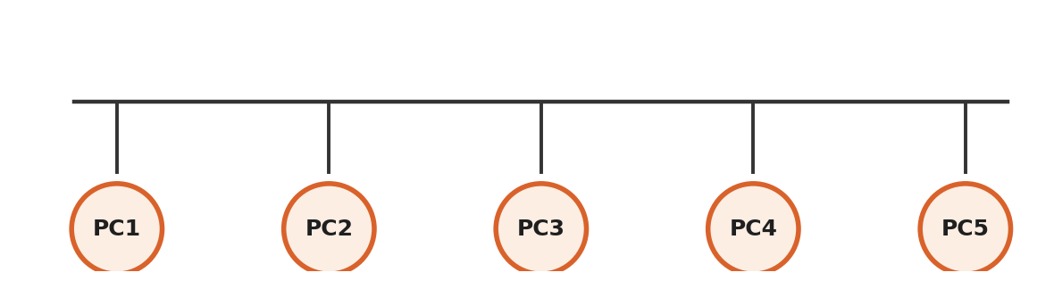
- Advantage: Easy and cheap to install, uses less cable.
- Disadvantage: If the main cable breaks, the WHOLE network stops working.

2. Ring Topology
Every computer is connected to exactly two other computers, forming a closed loop/circle - like students holding hands in a circle. Data travels around the ring in one direction (or sometimes both).
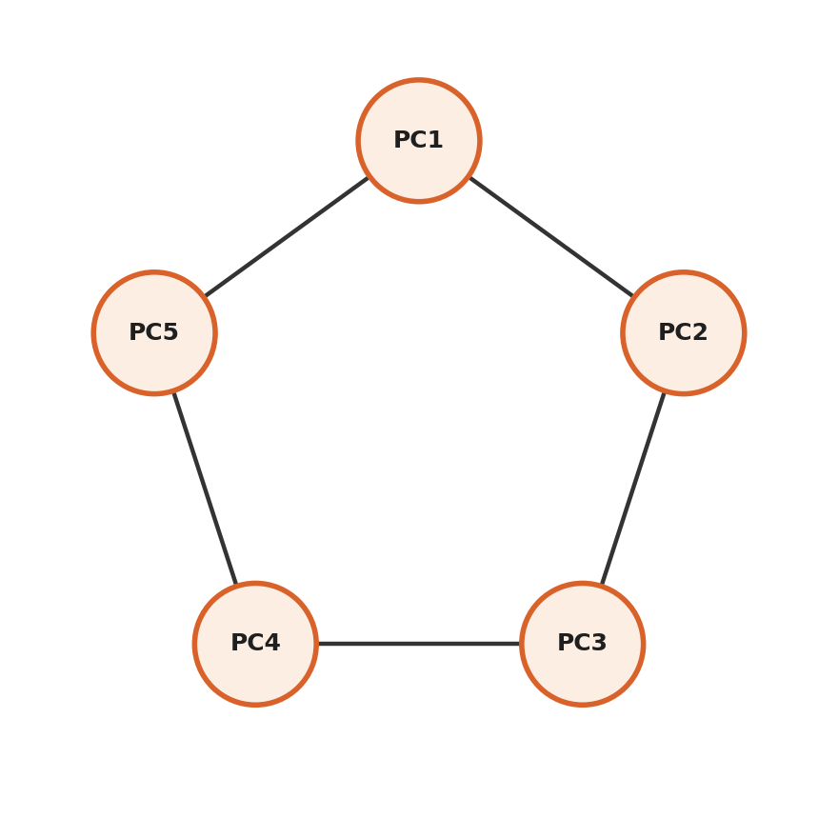
- Advantage: Data flows in an organised manner, no data collision.
- Disadvantage: If one connection/computer fails, it can break the entire ring (unless a special backup path exists).

3. Star Topology
All computers are connected to one central device (like a switch or hub) - just like spokes of a bicycle wheel connecting to the center hub. This is the MOST COMMONLY used topology today, including in your college labs!
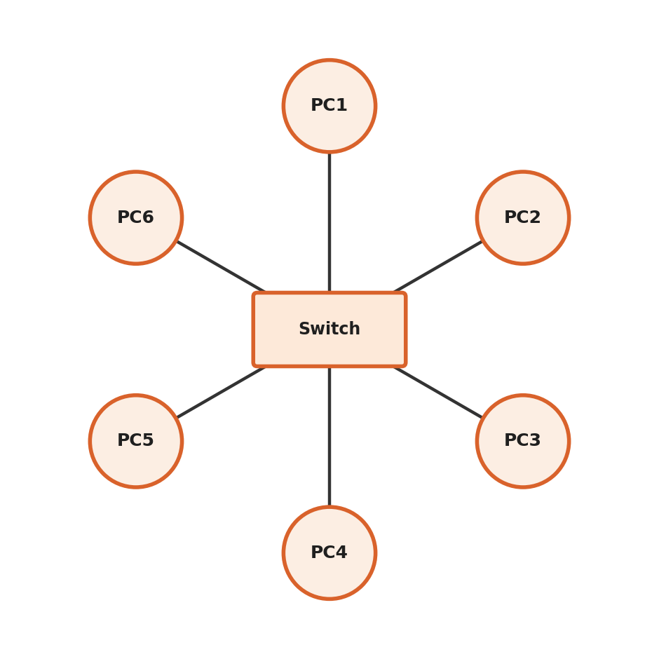
- Advantage: If one computer's cable fails, only that computer is affected - the rest of the network keeps working.
- Disadvantage: If the central device (hub/switch) fails, the ENTIRE network goes down.

4. Mesh Topology
Every single computer is directly connected to every other computer. It's like a WhatsApp group where every person can directly message every other person, instead of going through one central group admin.
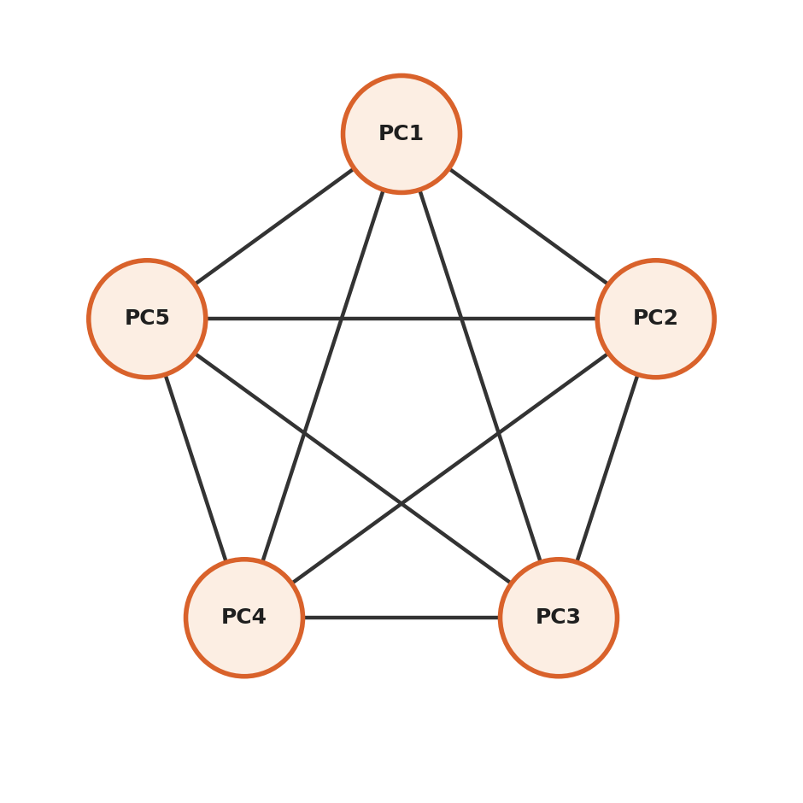
- Advantage: Very reliable - even if one connection fails, data can find another path.
- Disadvantage: Needs a LOT of cables, very expensive, hard to install for a big network.

5. Tree Topology
This is a combination of Star and Bus topology. Multiple star networks are connected together through a bus-like backbone, forming a structure that looks like a tree with branches. Think of it as a company's organisation chart - a manager, under them team leads, and under them team members.
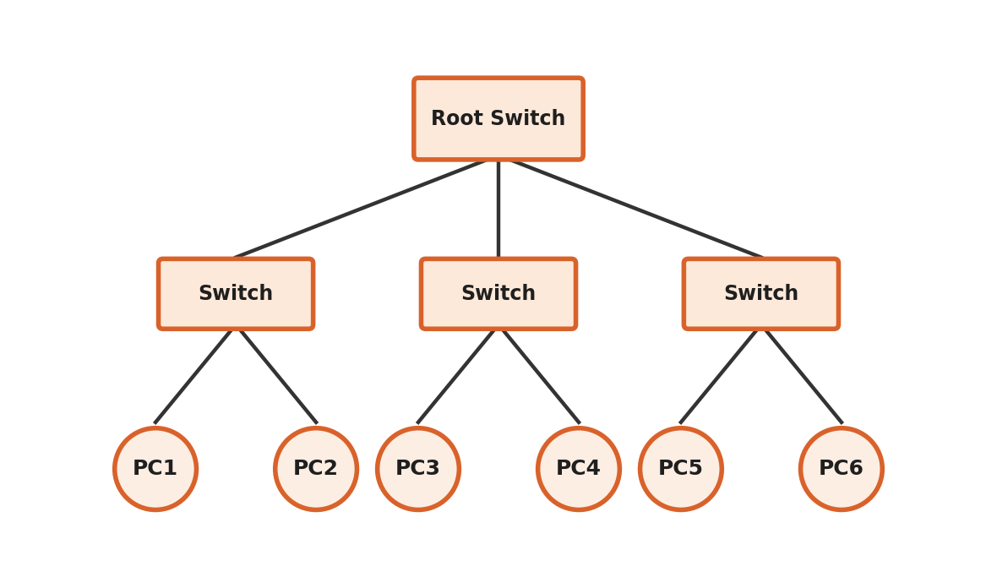
- Advantage: Good for expanding the network in the future (scalable).
- Disadvantage: If the main backbone cable fails, big sections of the network can go down.

6. Hybrid Topology
This is simply a MIX of two or more different topologies used together, based on what an organisation actually needs. For example, one department may use Star topology, and it connects to another department using Bus topology.
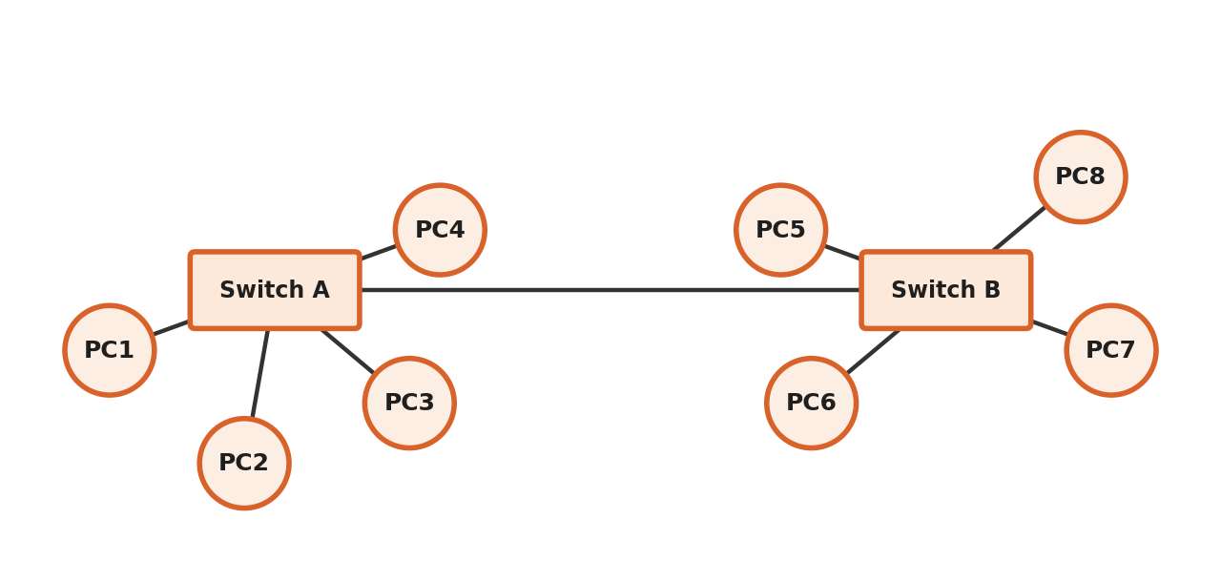
- Advantage: Flexible, can be designed based on real requirements.
- Disadvantage: Complex to design and can be costly.

3.3 Quick Comparison Table
Topology | Shape | Main Advantage | Main Disadvantage
Bus | Single straight cable | Cheap, simple | One cable failure = full network down
Ring | Closed circle/loop | Organised data flow | One failure can break the ring
Star | Central hub with spokes | Easy to find faults, popular | Central device failure = full network down
Mesh | Every node to every node | Very reliable, many backup paths | Very costly, too many cables
Tree | Star networks joined by a bus | Easy to expand | Backbone failure affects big sections
Hybrid | Mix of 2 or more topologies | Flexible, best of multiple types | Complex and costly to design

3.4 Design and Implementation - Simple Points to Remember
When actually designing/implementing a topology in real life (like in your practical exam using Cisco Packet Tracer), keep these easy steps in mind:
- Decide how many computers/devices need to be connected.
- Choose the topology based on budget, reliability need, and size of the network.
- Select the correct networking device (hub, switch, or router) as the central point, if needed.
- Connect the cables according to the chosen shape (Star = all to one switch; Bus = all to one line; Ring = each to exactly two neighbours; Mesh = each to every other).
- Assign IP addresses and test the connection using simple commands like 'ping'.
Easy Tip: In your practicals, Star Topology is used the most in real offices and colleges because it is easy to manage and one cable failure doesn't affect everyone.

3.5 Important Short Questions on Topology

Q1. Which topology is the most fault-tolerant (best at surviving failures) and why?
Answer: Mesh Topology is the most fault-tolerant because every device has a direct, separate connection to every other device. Even if one or more connections fail, data can still find an alternate path to reach its destination.

Q2. Why is Star Topology so popular in offices and colleges despite its central point of failure risk?
Answer: Because it is very easy to install, manage, and troubleshoot. If one computer's cable has a problem, only that one computer is affected, and it's very easy to find which cable is faulty. Also, modern switches are quite reliable, so the risk of the whole central device failing is low.

Q3. Give one real example of Hybrid Topology in daily life.
Answer: A college campus network is a great example - each classroom/lab may use Star topology internally (all computers connected to a local switch), and then all these local switches across different buildings are connected together using a Bus or Tree style backbone to form the complete campus network.

4. Types of Switching Networks
Switching is the METHOD used to move data from the sender to the receiver through a network that has many in-between paths (nodes). There are 3 main types.

4.1 Circuit Switching
In Circuit Switching, a DEDICATED path (like a private road) is set up between the sender and receiver BEFORE the data transfer starts, and this path stays reserved for the entire conversation, even if no data is being sent at some moment.
Real-life Example: A traditional landline telephone call. Once you dial and connect, that specific line is reserved just for your call until you hang up - even during pauses of silence.
- Advantage: Once connected, data transfer is fast and has no delay.
- Disadvantage: Wastes resources, because the path is reserved fully even during idle/silent time.

4.2 Packet Switching
In Packet Switching, data is broken into small pieces called 'packets'. Each packet can travel through a DIFFERENT path to reach the destination, and they are reassembled in the correct order at the receiver's end.
Real-life Example: Sending a big parcel by splitting it into multiple smaller boxes, and each box may travel via a different courier truck/route, but all boxes finally reach your friend's house and are combined.
- Advantage: Efficient use of network resources - no path is wasted/reserved unnecessarily.
- Disadvantage: Packets can arrive out of order or get delayed, so they need to be reassembled and checked.
This is the method used by the modern Internet.

4.3 Message Switching
In Message Switching, the ENTIRE message (not broken into packets) is sent as one complete unit from one node to another. Each in-between node receives the FULL message, stores it, and then forwards it to the next node when the path is free. This is why it is also called 'store-and-forward' switching.
Real-life Example: Old-style telegram system - the complete telegram message is received at one office, stored, and then forwarded to the next office, until it reaches the final destination.
- Advantage: No dedicated path needed, so the network is used efficiently.
- Disadvantage: Storing a full big message at every node needs a lot of storage space and can be slow.

4.4 Comparison Table
Point | Circuit Switching | Packet Switching | Message Switching
Path | Dedicated, fixed path | No fixed path, packets can differ | No fixed path, whole message travels
Data Unit | Continuous stream | Small packets | Complete message
Resource Use | Wasteful (reserved always) | Efficient | Efficient
Example | Telephone call | Internet browsing | Old telegram system
Delay | Very low once connected | Can vary (some delay) | Higher delay (store & forward)

4.5 Step-by-Step: How Packet Switching Actually Works
Let's understand packet switching with a simple, complete example - suppose you want to send a 10 MB photo to your friend over the internet:
- Your device breaks the 10 MB photo into many small packets, say 1000 packets of 10 KB each.
- Each packet is given a header containing the destination address and a sequence number (so it can be identified and reordered later).
- These 1000 packets travel through the network. Some packets might go through one route (say via Router A), while others might go through a different route (say via Router B), depending on which path is less busy at that moment.
- Each packet independently reaches your friend's device, possibly in a different order than they were sent.
- Your friend's device uses the sequence numbers to reassemble all 1000 packets back into the correct order, recreating the original 10 MB photo.
Easy Tip: This is exactly why sometimes a large file download shows 'reassembling' or takes a moment to finish even after the download bar reaches 100%.

4.6 Important Short Questions on Switching

Q1. Why is Circuit Switching considered wasteful of resources?
Answer: Because once a dedicated path is set up (like in a phone call), that path remains reserved for the entire duration of the call, even during silent pauses when no actual data/voice is being transferred. This reserved capacity cannot be used by any other user during that time, so it wastes network resources.

Q2. Why does the modern internet use Packet Switching instead of Circuit Switching?
Answer: Packet switching allows the network's resources to be shared efficiently among MANY users at the same time, since no path is permanently reserved. If one route becomes busy or fails, packets can automatically be sent through another available route, making the network more flexible, efficient, and reliable for the huge amount of varied traffic (websites, videos, calls) on today's internet.

Q3. What does 'store-and-forward' mean in Message Switching?
Answer: It means that each intermediate node (in-between device) in the network FIRST fully receives and stores the entire message, and only AFTER that does it forward the complete message onward to the next node, once the required path becomes free.

5. MAC Address & Mobile Telephone System

5.1 What is a MAC Address?
MAC stands for 'Media Access Control'. A MAC Address is like a permanent FINGERPRINT given to every network device (like your laptop's Wi-Fi card or Ethernet card) by its manufacturer.
- It is a 48-bit (6-byte) address, usually written as 6 pairs of hexadecimal digits, like: 00:1B:44:11:3A:B7
- It is unique for every device in the world - no two devices should have the same MAC address.
- It works at the Data Link Layer (Layer 2) of the OSI model, and it is used to identify devices WITHIN the same local network.
Simple way to remember: IP Address can change (like your home address can change if you shift houses), but MAC Address never changes (like your fingerprint never changes).

5.2 Mobile Telephone System
This explains how mobile phones (cell phones) connect and communicate wirelessly using a network of small areas called 'cells'.
- The coverage area is divided into small hexagonal-shaped regions called 'cells', and each cell has its own small tower/base station.
- When you move from one cell's area to another cell's area while talking on a call, your call is automatically transferred to the new tower - this is called 'Handoff' or 'Handover', and normally you don't even notice it happening.
- A central system called MSC (Mobile Switching Center) manages the connections between all these small cell towers and connects calls to the regular telephone network or internet.
Real-life Example: While travelling in a car and talking on the phone continuously, your phone keeps automatically switching between nearby towers - that is the mobile telephone system working in the background.

5.3 Why is the Coverage Area Divided into Hexagonal Cells?
The hexagon (six-sided) shape is chosen because it covers a large area efficiently with the fewest number of overlapping towers, compared to circles or squares. Hexagons fit together perfectly like tiles on a floor, without leaving any gaps and without too much unnecessary overlap - this saves cost and avoids interference between neighbouring towers.

5.4 Important Short Questions on MAC Address & Mobile System

Q1. Can two devices in the world have the same MAC address?
Answer: Ideally, NO. Every network device manufacturer is assigned a unique code range by an official body, and they use it to give every single device a globally unique MAC address, burned into the hardware at the time of manufacturing.

Q2. What is 'Handoff' or 'Handover' in mobile networks?
Answer: Handoff is the automatic process of transferring an ongoing call or data connection from one cell tower to another nearby cell tower, as the mobile device moves out of the range of the first tower and into the range of the second - all done smoothly, without the user noticing any interruption.

Q3. What is the difference between MAC Address and IP Address in one line each?
Answer: MAC Address is a permanent, hardware-level address used to identify a device on its LOCAL network (Layer 2). IP Address is a logical, often-changeable address used to identify a device across DIFFERENT networks, including the internet (Layer 3).

6. Line Configuration & Multiplexing

6.1 Line Configuration
Line Configuration means HOW MANY devices share a single communication link (cable/line). There are two types:

1. Point-to-Point Configuration
Only TWO devices share the link, connected directly to each other. Example: Your laptop connected directly to a printer using a single cable.

2. Multipoint Configuration (also called Multidrop)
MORE THAN TWO devices share the SAME single link at the same time. Example: Multiple computers in an old-style office connected to one shared central line.

6.2 Multiplexing
Multiplexing is a clever technique where MULTIPLE signals (from different sources) are combined and sent together over a SINGLE shared communication line, to save cost and use resources efficiently. At the receiving end, a 'demultiplexer' separates them back into individual signals.
Real-life Example: Imagine one big school bus (the single line) carrying many different students (the many signals) from different families to school at the same time, instead of using a separate car for every single student.

Types of Multiplexing (Just the basic idea):
- FDM (Frequency Division Multiplexing): Different signals are sent using different frequency bands at the SAME time - like different radio stations broadcasting at different frequencies simultaneously.
- TDM (Time Division Multiplexing): Different signals are sent using the SAME frequency but at different TIME slots, turn by turn - like students taking turns to speak one after another in a group discussion.
Easy Tip: Multiplexing = combining many small signals into one big shared line to save resources, just like carpooling saves fuel and road space!

6.3 A Simple Worked Example of TDM
Suppose 4 students (A, B, C and D) want to use ONE single shared phone line to send their voice one after another, using Time Division Multiplexing with each student getting a 1-second time slot in turn:
Time Slot | 0-1 sec | 1-2 sec | 2-3 sec | 3-4 sec | 4-5 sec
Student Speaking | A | B | C | D | A (repeats)

This cycle (A, B, C, D) keeps repeating very fast, so quickly that it feels like all 4 students are talking at almost the same time, even though technically only one student's voice is travelling on the shared line at any given instant.

6.4 Important Short Questions on Line Configuration & Multiplexing

Q1. Give a real example of Point-to-Point and Multipoint configuration.
Answer: Point-to-Point example - a direct cable connection between your laptop and a single external hard disk. Multipoint example - several computers in a computer lab connected to and sharing one single central server line.

Q2. What is the main benefit of using multiplexing?
Answer: The main benefit is COST SAVING and efficient use of an expensive communication line (like a long-distance cable), because it allows many different signals/users to share just one physical line, instead of needing a separate, costly line for every single signal/user.

7. Communication Modes: Simplex, Half Duplex, Full Duplex
This tells us in WHICH DIRECTION data can travel on a communication link.

1. Simplex Mode
Data travels in ONLY ONE DIRECTION, always. The sender can only send, and the receiver can only receive - never the other way around.
- Real-life Example: A TV broadcast - the TV station sends the signal to your television, but your TV can never send anything back to the station. Also, a keyboard sending data to a computer is simplex.

2. Half Duplex Mode
Data can travel in BOTH directions, but only ONE DIRECTION AT A TIME (not simultaneously). Both parties must take turns.
- Real-life Example: A Walkie-Talkie. You press the button and speak, then release it to listen - both of you cannot talk at the exact same time.

3. Full Duplex Mode
Data can travel in BOTH directions AT THE SAME TIME, simultaneously. This is the fastest and most efficient mode.
- Real-life Example: A normal telephone call - both people can speak and listen to each other at the exact same time.

Quick Comparison Table
Mode | Direction | Example
Simplex | One direction only, always | TV broadcasting, Keyboard to CPU
Half Duplex | Both directions, but one at a time | Walkie-talkie
Full Duplex | Both directions, at the same time | Telephone call

Important Short Questions

Q1. Is a walkie-talkie Half Duplex or Full Duplex, and why?
Answer: Half Duplex, because although both people CAN speak and listen, they cannot do BOTH at the exact same time - only one person can transmit at any given moment while the other must listen, and they must take turns using the push-to-talk button.

Q2. Why is Full Duplex considered the most efficient mode?
Answer: Because it allows simultaneous two-way communication without any waiting, making the best use of available time and bandwidth - similar to a normal, natural human conversation where both people can technically speak and be heard at the same time if needed.

8. Protocols: Stop & Wait, Sliding Window, and ARQ (Noiseless & Noisy Channels)
These are 'Flow Control' protocols. Flow Control means making sure that a FAST sender does not overwhelm/flood a SLOW receiver with too much data at once. It's like a teacher making sure not to speak too fast for slow-writing students.

8.1 Stop and Wait Protocol
This is the SIMPLEST flow control method. The sender sends ONE frame (data packet) and then STOPS and WAITS for an acknowledgement (a confirmation message, called 'ACK') from the receiver before sending the next frame.
- Sender sends Frame 1.
- Sender waits (does nothing else) until it receives an ACK from the receiver.
- Once ACK is received, sender sends Frame 2, and the cycle repeats.
- Advantage: Very simple to understand and implement.
- Disadvantage: Very slow, because the sender is idle (wasting time) while waiting for each ACK, especially over long distances.
Real-life Example: Imagine passing notes to a friend across the classroom, but you must wait for your friend to write back 'Got it!' before you can pass the next note. This is quite slow.

8.2 Sliding Window Protocol
This is a smarter, faster method. Instead of waiting for an ACK after every single frame, the sender can send SEVERAL frames continuously (within an agreed 'window' size) without waiting for individual acknowledgements for each one.
- The 'window' is like a limit - for example, if the window size is 4, the sender can send up to 4 frames before it must stop and wait for at least one acknowledgement.
- As acknowledgements arrive for old frames, the 'window slides forward', allowing the sender to send new frames - hence the name 'Sliding Window'.
- Advantage: Much faster than Stop and Wait, because the sender does not sit idle - it keeps sending more data while waiting for older ACKs.
- Disadvantage: More complex to design and implement than Stop and Wait.
Real-life Example: Instead of waiting for your friend's 'Got it!' after every single note, you can pass 4 notes one after another, and your friend can confirm them together - much faster than one at a time!

8.3 Protocols for Noiseless Channels (No Errors Assumed)
A 'noiseless channel' means an IDEAL, error-free communication line where we assume no data is ever lost or damaged during transmission - purely for the sake of understanding the basic logic before adding real-world error handling. There are two simple protocols designed for such an ideal channel.

A. The Simplest Protocol
This is the most basic possible protocol, with NO flow control and NO error control at all. The sender just keeps sending frames one after another as fast as it can, and the receiver is assumed to accept and process every frame instantly, without ever needing time to prepare or getting overloaded.
- It works only because we ASSUME the receiver is infinitely fast and the channel is perfectly error-free - which never truly happens in real life.
- Real-life Example: Imagine a teacher dictating notes non-stop, assuming every single student can write infinitely fast and never falls behind - unrealistic, but useful to understand as a starting point.

B. Stop-and-Wait Protocol (for a Noiseless Channel)
This version of Stop-and-Wait is used purely for FLOW CONTROL (not error control, since the channel is assumed error-free). The sender sends one frame and waits for the receiver to say 'I am ready, send the next one' before sending again - this prevents a fast sender from overwhelming a slower receiver, even though no data loss is expected.
This is exactly the same idea explained in Section 8.1 above, but here it is used purely to manage speed/flow, since we are assuming a perfect, error-free channel.

8.4 Protocols for Noisy Channels (ARQ - Automatic Repeat reQuest)
In the REAL world, channels are 'noisy' - meaning frames can get damaged, corrupted, or completely lost while travelling. So we need protocols that do BOTH flow control AND error control together. These are called ARQ (Automatic Repeat reQuest) protocols, because they automatically request the sender to repeat (resend) any frame that did not arrive correctly. There are three main ARQ protocols.

A. Stop-and-Wait ARQ
This works just like the basic Stop-and-Wait protocol, but now with added ERROR CONTROL. The sender sends one frame and waits for an ACK. But now, two new tools are added to handle a noisy channel:
- Timer: If no ACK arrives within a fixed waiting time, the sender assumes the frame (or its ACK) was lost, and automatically resends the SAME frame again.
- Sequence Numbers: Every frame is given a small sequence number (usually just 0 and 1, alternating) so that the receiver can detect duplicate frames - for example, if an ACK gets lost and the sender resends a frame the receiver already received, the receiver can recognise it as a duplicate (using its sequence number) and simply discard it, instead of accepting it twice.
Real-life Example: You send a WhatsApp voice note and wait for the blue double-tick (ACK). If you don't see it within a few seconds (timeout), you assume it did not send properly, and you send it again - but your friend can tell if it's a repeated message and ignore the duplicate.
- Advantage: Simple, and now reliable even on a noisy/error-prone channel.
- Disadvantage: Still slow, because only ONE frame is sent at a time - just like the basic Stop-and-Wait.

B. Go-Back-N ARQ
This is a Sliding-Window-based protocol built for noisy channels. The sender can send SEVERAL frames continuously (up to the window size) without waiting for individual ACKs - but if ANY one frame in that group is found to be damaged or lost, the sender must go back and resend that frame AND every frame sent AFTER it, even if those later frames were actually received correctly.
- Sender sends Frame 1, 2, 3, 4, 5 continuously (within its window).
- Suppose Frame 3 gets lost or damaged, but Frame 4 and 5 arrive safely at the receiver.
- The receiver DISCARDS Frame 4 and 5 anyway, because it is only willing to accept frames in the correct order, and Frame 3 is missing.
- The receiver sends a request/ACK indicating it needs Frame 3 again.
- The sender must then resend Frame 3, 4, AND 5 all over again - hence the name 'Go-Back-N' (going back N frames).
- Advantage: Faster than Stop-and-Wait ARQ since multiple frames can be in transit.
- Disadvantage: Wastes bandwidth, because even correctly-received frames (like Frame 4 and 5 above) must be resent unnecessarily, just because one earlier frame had a problem.

C. Selective Repeat ARQ
This is a smarter improvement over Go-Back-N. Instead of resending an entire batch of frames when just one is lost, the sender resends ONLY the SPECIFIC damaged or lost frame - not the correctly received ones after it. The receiver is now smart enough to store correctly-received out-of-order frames temporarily (in a buffer) and just wait for the missing one, instead of discarding everything.
- Sender sends Frame 1, 2, 3, 4, 5 continuously (within its window).
- Suppose Frame 3 gets lost, but Frame 4 and 5 arrive safely.
- The receiver KEEPS Frame 4 and 5 safely in a temporary buffer (instead of discarding them) and specifically requests only Frame 3 to be resent.
- The sender resends ONLY Frame 3.
- Once Frame 3 arrives, the receiver now has Frame 3, 4, and 5 and can arrange them in the correct order.
- Advantage: Most efficient of all three - the least amount of unnecessary resending, saving the most bandwidth and time.
- Disadvantage: Most complex to implement, since the receiver needs extra memory (buffer) to hold out-of-order frames, and both sender and receiver need more complex bookkeeping.

8.5 Quick Comparison: Stop-and-Wait ARQ vs Go-Back-N ARQ vs Selective Repeat ARQ
Point | Stop-and-Wait ARQ | Go-Back-N ARQ | Selective Repeat ARQ
Frames sent before ACK | Only 1 at a time | Multiple (window size) | Multiple (window size)
On error, what is resent? | Just that 1 frame | That frame + all frames after it | ONLY that specific damaged/lost frame
Receiver buffer needed? | Not needed | Not needed (discards out-of-order frames) | Needed (stores out-of-order frames)
Efficiency | Lowest (slowest) | Medium | Highest (fastest, least wasteful)
Complexity | Simplest | Moderate | Most complex

Easy Tip: Easy way to remember: as we go from Stop-and-Wait ARQ to Go-Back-N to Selective Repeat, each protocol becomes FASTER and more EFFICIENT, but also becomes MORE COMPLEX to design and implement.

8.6 Comparison Table: Stop and Wait vs Sliding Window (General Idea)
Point | Stop and Wait | Sliding Window
Frames sent before ACK | Only 1 frame at a time | Multiple frames (based on window size)
Speed | Slow | Fast, efficient use of link
Complexity | Very simple | More complex
Best Used When | Simple, low-traffic links | High-speed, real-world networks (like TCP)

Easy Tip: TCP (which you use every day on the internet) actually uses a version of the Sliding Window protocol to send data quickly and reliably.

8.7 A Simple Worked Example of Sliding Window (Window Size = 4)
Suppose the sender has 8 frames to send (Frame 1 to Frame 8), and the agreed window size is 4. Here is how it works, step by step:
- Sender sends Frame 1, Frame 2, Frame 3, and Frame 4 together, one after another, WITHOUT waiting for individual ACKs (because the window allows up to 4 frames).
- Receiver receives them and sends back an acknowledgement, say 'ACK for Frame 1 and 2 received'.
- As soon as this ACK arrives, the sender's window 'slides forward' by 2 - now the sender is allowed to send 2 NEW frames (Frame 5 and Frame 6), in addition to the still-unacknowledged Frame 3 and Frame 4.
- This process keeps repeating - as older frames get acknowledged, the window keeps sliding forward, allowing new frames to be sent - until all 8 frames are successfully sent and acknowledged.
Notice how, unlike Stop and Wait (where the sender would need to stop 8 separate times, once per frame), here the sender only pauses when the window is completely full - making the whole process much quicker.

8.8 Important Short Questions on Protocols

Q1. What problem does Flow Control actually solve?
Answer: Flow control prevents a fast sender from overwhelming a slow receiver with more data than the receiver can handle/process/store at once, which could otherwise cause the receiver to lose or drop incoming data.

Q2. In Stop and Wait, what happens if an ACK gets lost or delayed?
Answer: If the sender does not receive the expected ACK within a certain waiting time (called a 'timeout'), it assumes the frame or the ACK was lost, and it simply resends the SAME frame again, repeating this until a proper ACK is received.

Q3. Why is Sliding Window generally preferred over Stop and Wait in real, modern networks?
Answer: Because Sliding Window allows multiple frames to be 'in transit' (on the way) at the same time instead of sending just one frame and then sitting idle, which makes much better use of the available network bandwidth and drastically reduces the total time needed to send a large amount of data, especially over long-distance, high-speed links.

Q4. What is the key difference between Go-Back-N ARQ and Selective Repeat ARQ?
Answer: In Go-Back-N ARQ, when one frame is lost, the sender must resend that frame AND all the frames sent after it, even if those later frames were received correctly - this wastes bandwidth. In Selective Repeat ARQ, the sender resends ONLY the specific lost/damaged frame, because the receiver is smart enough to store correctly-received out-of-order frames in a buffer - this makes Selective Repeat more efficient, though more complex to implement.

9. Case Study - A Day in the Life of a Data Packet
To tie together everything you've learned about the OSI model, topology, and switching, let's follow one single message from start to finish, in a simple story. Suppose you type 'www.example.com' in your browser and press Enter, on a computer connected in a Star topology LAN in your college lab.

Step 1: Application Layer
Your browser (the application) creates a request asking for the website's page, using the HTTP protocol. This is the very first piece of 'real' data.

Step 2: Presentation Layer
If needed, this request is formatted properly and encrypted (for secure HTTPS websites), so it can travel safely and be understood correctly by the destination web server.

Step 3: Session Layer
A session is opened between your browser and the destination web server, so that this particular conversation can be tracked and later closed properly once the page has fully loaded.

Step 4: Transport Layer
Your request is broken into segments, and (since websites need reliability) the TCP protocol is used. Each segment gets a sequence number, and the Transport layer will make sure every segment eventually reaches the destination completely.

Step 5: Network Layer
Each segment is placed inside a packet, and an IP header is added, containing your computer's IP address (source) and the web server's IP address (destination). This layer also helps decide the route/path your packet should take across the internet - it may even pass through several routers of different countries.

Step 6: Data Link Layer
Within your college's LAN (which uses Star topology), each packet is placed inside a frame with MAC addresses added, so your local switch knows exactly which physical port to send the frame towards - first towards your lab's gateway/router.

Step 7: Physical Layer
Finally, all this data is converted into raw electrical signals (if using an Ethernet cable) or radio signals (if using Wi-Fi), and physically transmitted out through the network cable or wireless card.

On the Way and On Arrival
Because packet switching is used, your packets may pass through several different routers on completely different paths on their way to reach the web server, possibly in different countries. At the web server, the entire process happens in REVERSE (decapsulation) - Physical to Data Link to Network to Transport to Session to Presentation to Application - until the server finally understands your original request and sends back the website's page, again passing through all 7 layers, both ways, this time as the reply.
Easy Tip: This complete round trip - through 7 layers, twice (once going, once coming back) - usually happens in a few hundred milliseconds! This is why the internet feels so instant, even though so much organised work is happening in the background.

10. Commonly Confused Terms - Cleared Up
Students often mix up these similar-sounding terms. Here is a simple, side-by-side clarification for each pair.

Hub vs Switch vs Router
Device | OSI Layer | What it does (very simply)
Hub | Physical Layer (1) | Just repeats/broadcasts the signal to ALL connected devices, no intelligence
Switch | Data Link Layer (2) | Sends data only to the CORRECT device using MAC address - smarter than a hub
Router | Network Layer (3) | Connects two DIFFERENT networks together and finds the best path using IP address

LAN vs MAN vs WAN
Term | Full Form | Simple Meaning
LAN | Local Area Network | A small network within one building or campus, e.g. your college lab
MAN | Metropolitan Area Network | A network spread across one city, e.g. cable TV network in a city
WAN | Wide Area Network | A network spread across countries/continents, e.g. the internet itself

TCP vs UDP (at Transport Layer)
Point | TCP | UDP
Full Form | Transmission Control Protocol | User Datagram Protocol
Reliability | Reliable - checks and resends lost data | Not reliable - does not resend lost data
Speed | Slower (because of checking) | Faster (no checking overhead)
Best Used For | Web browsing, email, file transfer | Video calls, live streaming, online gaming

Internet vs Intranet vs Extranet (quick recap from Unit 1, still often confused)
- Internet: A public, global network open to everyone in the world.
- Intranet: A private network used ONLY within one organisation (like your college's internal portal).
- Extranet: A private network shared between an organisation and specific outside partners (like a college sharing results access with an affiliated exam board).

11. Practical / Viva Preparation Guide
Your syllabus lists 10 practicals for this subject. Here is very simple guidance and likely viva questions for each one, connecting them directly to the theory you just studied in this unit.

Practical 1: Write down basic Networking commands
Commonly used basic networking commands include: ping (checks if another device is reachable), ipconfig / ifconfig (shows your own device's IP and MAC address), tracert / traceroute (shows the path/route data takes to reach a destination), and nslookup (finds the IP address of a website name).
Likely viva question: 'What does the ping command actually check?' Answer: It sends a small test signal to another device and checks whether that device replies, telling us if the network connection to it is working and roughly how much delay (time) there is.

Practicals 2 to 7: Configuring Topologies in Cisco Packet Tracer (Bus, Ring, Star, Mesh, Tree, Hybrid)
For each of these practicals, the general steps are similar: (1) Open Cisco Packet Tracer, (2) drag and drop the required number of PCs and the correct networking device (switch/hub, as needed), (3) connect them using the correct cables in the shape matching that topology (refer to Section 3.5 of this unit for the exact shape of each), (4) assign IP addresses to each PC, and (5) test connectivity between PCs using the 'ping' command or the simple PDU (Packet Data Unit) tool in Packet Tracer.
Likely viva question: 'Why did the ping fail between two PCs in your topology?' Answer: Common reasons are - PCs are on different IP subnets/ranges, a cable is not properly connected in the topology diagram, or a required central device (like a switch) is missing or misconfigured.

Practical 8: Steps to Configure a Local Area Network (LAN)
Basic steps: (1) Connect all devices to a central switch (Star topology is most commonly used for a simple LAN), (2) assign each device a unique IP address from the same network range (e.g. 192.168.1.1, 192.168.1.2, and so on), (3) set the same Subnet Mask for all devices, and (4) test the connection between devices using the ping command.

Practical 9: Classification of Transmission Media (with diagram)
Transmission media are broadly classified as Guided (Wired) Media - like Twisted Pair cable, Coaxial cable, and Fiber Optic cable - and Unguided (Wireless) Media - like Radio waves, Microwaves, and Infrared. For this practical, you are simply expected to draw a small tree-diagram showing this classification and briefly describe each type.

Practical 10: IP Address Classification
IP addresses (IPv4) are classified into 5 classes: Class A, B, C, D, and E, based on the range of their first number (called an octet). Class A, B, and C are used for normal devices (with Class C being most common for small networks like homes and small offices), Class D is reserved for multicasting (sending data to a group), and Class E is reserved for experimental/research use.
Easy Tip: These last two practicals connect directly to Unit 3 (Transmission Media and IP Address) - you may want to also refer to your Unit 3 notes for full details.

12. Multiple Choice Questions (MCQs) for Quick Practice
Try to answer these yourself first, then check the answer key given at the end.

Q1. How many layers does the OSI model have?
(a) 4 (b) 5 (c) 7 (d) 9

Q2. Which layer of OSI is responsible for routing using IP addresses?
(a) Data Link Layer (b) Network Layer (c) Transport Layer (d) Session Layer

Q3. The TCP/IP model has how many layers?
(a) 3 (b) 4 (c) 5 (d) 7

Q4. Which topology connects every device directly to every other device?
(a) Star (b) Bus (c) Mesh (d) Ring

Q5. Which switching method is used by the modern internet?
(a) Circuit Switching (b) Packet Switching (c) Message Switching (d) None of these

Q6. A MAC address works mainly at which OSI layer?
(a) Physical Layer (b) Data Link Layer (c) Network Layer (d) Application Layer

Q7. Which multiplexing technique divides the channel based on TIME slots?
(a) FDM (b) TDM (c) Both (d) None

Q8. A normal telephone call is an example of which duplex mode?
(a) Simplex (b) Half Duplex (c) Full Duplex (d) None

Q9. In which protocol does the sender wait for one ACK before sending the next single frame?
(a) Sliding Window (b) Stop and Wait (c) Both (d) None

Q10. Which topology is a combination of Star and Bus?
(a) Mesh (b) Ring (c) Tree (d) Hybrid only

Answer Key
Q1 | Q2 | Q3 | Q4 | Q5 | Q6 | Q7 | Q8 | Q9 | Q10
(c) 7 | (b) Network | (b) 4 | (c) Mesh | (b) Packet | (b) Data Link | (b) TDM | (c) Full Duplex | (b) Stop & Wait | (c) Tree

13. Model Long-Answer Questions (Exam Writing Practice)
These are typical 7-10 mark exam-style questions with complete, ready-to-write model answers. Practice writing these out by hand for exam speed.

Q1. Explain the OSI Reference Model with the function of each layer. (7 Marks)
Answer: The OSI (Open Systems Interconnection) model is a 7-layer reference model developed by ISO in 1984 to standardise how computer networks communicate. Each layer performs a specific function and passes data to the next layer, either up or down the stack.
The Physical layer (Layer 1) transmits raw bits as electrical, light, or radio signals through the physical medium. The Data Link layer (Layer 2) organises bits into frames, adds MAC addresses, and performs error detection. The Network layer (Layer 3) is responsible for logical addressing (IP addresses) and routing, deciding the best path for data across networks. The Transport layer (Layer 4) ensures reliable, ordered delivery of data by breaking it into segments and using protocols like TCP or UDP. The Session layer (Layer 5) establishes, manages, and terminates sessions (conversations) between two communicating applications. The Presentation layer (Layer 6) handles data formatting, encryption, and compression, ensuring data is presented in a form both systems understand. Finally, the Application layer (Layer 7) provides network services directly to end-user applications, such as web browsing (HTTP), email (SMTP), and file transfer (FTP).
In summary, each OSI layer builds upon the one below it, together forming a complete, organised, step-by-step system for reliable network communication.

Q2. Differentiate between OSI and TCP/IP models. (5 Marks)
Answer: The OSI model consists of 7 distinct layers and was developed by ISO mainly as a theoretical, general-purpose reference standard for understanding networking concepts. The TCP/IP model, on the other hand, has only 4 layers and was developed by the US Department of Defense; it is the model actually implemented and used by the real, practical internet today.
In the TCP/IP model, the Application layer combines the responsibilities of OSI's Session, Presentation, and Application layers, while the Network Access layer combines OSI's Physical and Data Link layers. OSI was designed layer-first and then protocols were fitted in, whereas TCP/IP was built around protocols that already existed and worked well in practice. Because of this practical origin, TCP/IP remains the model that governs real-world internet communication, while OSI continues to serve as an excellent teaching and reference tool for understanding network functions in a structured, organised manner.

Q3. Explain different types of network topologies with their advantages and disadvantages. (10 Marks)
Answer: Network topology refers to the physical or logical arrangement of computers and devices in a network. There are six main types of topology.
In Bus topology, all devices are connected to a single central cable (the backbone). It is simple and cost-effective but if the backbone cable fails, the entire network stops functioning. In Ring topology, each device connects to exactly two neighbouring devices, forming a closed loop, and data travels around the ring in one direction; however, a failure at any single point can disrupt the whole ring unless a backup path exists. In Star topology, every device connects individually to one central hub or switch; this is currently the most widely used topology because a single cable failure affects only that one device, though a failure of the central device brings down the entire network. In Mesh topology, every device is directly connected to every other device, offering the highest reliability and fault tolerance since multiple alternate paths exist, but it requires a very large amount of cabling, making it expensive and difficult to scale. Tree topology combines multiple Star networks connected through a Bus-like backbone, offering good scalability for growing organisations, although a backbone failure can affect large sections of the network. Finally, Hybrid topology is a combination of two or more of the above topologies, chosen to meet the specific, flexible needs of an organisation, though it can be complex and costly to design and maintain.
In conclusion, the choice of topology depends on factors such as budget, required reliability, ease of maintenance, and the size of the network being designed.

Q4. Explain Stop and Wait protocol and Sliding Window protocol with a suitable example. (7 Marks)
Answer: Both Stop and Wait and Sliding Window are flow control protocols used to manage the rate at which data is sent from a sender to a receiver, preventing the receiver from being overwhelmed.
In the Stop and Wait protocol, the sender transmits a single frame and then stops, waiting for an acknowledgement (ACK) from the receiver before sending the next frame. While simple to implement, this method is inefficient, especially over long-distance or high-speed links, because the sender remains idle while waiting for each individual acknowledgement.
The Sliding Window protocol improves on this by allowing the sender to transmit multiple frames continuously, up to an agreed 'window size', without waiting for an acknowledgement after every single frame. For example, with a window size of 4, the sender can send Frames 1 to 4 together; as acknowledgements arrive for earlier frames, the window 'slides forward', allowing new frames to be sent. This approach makes far more efficient use of the available bandwidth and significantly reduces overall transmission time compared to Stop and Wait, which is why modern protocols like TCP use a form of the Sliding Window technique.

Q5. Explain the different types of switching techniques used in computer networks. (7 Marks)
Answer: Switching refers to the method used to move data through a network containing multiple intermediate nodes. There are three main switching techniques.
Circuit Switching establishes a dedicated communication path between the sender and receiver before data transfer begins, and this path remains reserved for the entire duration of the session, similar to a traditional telephone call; while this ensures fast, uninterrupted transfer once connected, it can waste resources during idle periods. Packet Switching breaks data into small units called packets, each of which may travel through a different path to reach the destination, where they are reassembled in the correct order; this is the technique used by the modern internet because it makes efficient, shared use of network resources. Message Switching sends an entire message as a single unit through the network using a store-and-forward method, where each intermediate node fully receives and stores the message before forwarding it onward, similar to the old telegram system; though efficient in resource sharing, it requires significant storage at each node and can introduce higher delays.
Each technique has its own trade-offs between speed, reliability, and efficient resource usage, and the choice of technique depends on the specific requirements of the network being designed.

Q6. What is Multiplexing? Explain its types with examples. (5 Marks)
Answer: Multiplexing is a technique that allows multiple signals from different sources to be combined and transmitted together over a single shared communication link, thereby making efficient use of expensive transmission media and reducing overall cost.
There are two main types of multiplexing. Frequency Division Multiplexing (FDM) divides the available bandwidth of the link into separate frequency bands, allowing each signal to be transmitted simultaneously on its own dedicated frequency, similar to how different radio stations broadcast at different frequencies at the same time. Time Division Multiplexing (TDM) instead divides the transmission time into small time slots, allocating each signal its own turn to use the full channel, one after another in a rapidly repeating cycle, similar to how several people might take turns speaking one at a time in a meeting. At the receiving end, a demultiplexer separates the combined signal back into its original individual signals.
Multiplexing is widely used in telephone networks, cable television systems, and modern digital communication systems to maximise the efficient use of costly transmission infrastructure.

Q7. Explain MAC Address and how the Mobile Telephone System works. (5 Marks)
Answer: A MAC (Media Access Control) Address is a unique, 48-bit hardware address permanently assigned to every network interface card by its manufacturer, and it is used at the Data Link layer to identify devices within the same local network. Unlike an IP address, which can change depending on the network a device connects to, a MAC address generally remains fixed for the lifetime of the device.
The Mobile Telephone System allows wireless communication by dividing a geographic coverage area into small, hexagon-shaped regions called cells, each served by its own base station or tower. As a mobile user moves from the coverage area of one cell into another while on a call, the system automatically performs a 'handoff', transferring the ongoing connection to the new tower without any noticeable interruption to the user. A central Mobile Switching Center (MSC) coordinates and manages the connections across all these cells, linking them to the wider telephone network and the internet.

14. Solved Numerical Problems (Step-by-Step)
Some exam papers include small numerical/calculation-based questions. Here are a few common types, solved in a simple, step-by-step way.

Problem 1: TDM Frame Time Calculation
Question: 4 signals are being combined using Time Division Multiplexing (TDM). Each signal is given a time slot of 2 milliseconds (ms). How long does it take to complete one full round (one 'frame') covering all 4 signals once?
Solution: In TDM, one full frame time = number of signals x time slot per signal.
Frame time = 4 signals x 2 ms = 8 ms.
Answer: It takes 8 milliseconds to complete one full round covering all 4 signals once. This entire 8 ms cycle then repeats continuously for as long as the signals need to be sent.

Problem 2: Stop and Wait - Total Time Calculation
Question: A sender needs to send 5 frames using the Stop and Wait protocol. Each frame takes 2 ms to transmit, and each acknowledgement (ACK) takes 1 ms to travel back after being received (assume no errors occur). What is the total approximate time to send all 5 frames?
Solution: In Stop and Wait, for EACH frame, the sender must complete: (transmit frame time) + (wait for ACK time), before moving to the next frame.
Time for 1 frame cycle = 2 ms (send frame) + 1 ms (wait for ACK) = 3 ms.
Total time for 5 frames = 5 x 3 ms = 15 ms.
Answer: It takes approximately 15 milliseconds in total to send all 5 frames using Stop and Wait.

Problem 3: Sliding Window - Comparing Efficiency
Question: Using the same figures as Problem 2 (2 ms per frame, 1 ms per ACK), if a Sliding Window protocol with window size 5 is used instead (so all 5 frames can be sent together before waiting for ACKs), roughly how long would it take, and how does this compare to Stop and Wait?
Solution: With window size 5, the sender can transmit all 5 frames back-to-back without individually pausing after each one.
Approximate time to send 5 frames continuously = 5 x 2 ms = 10 ms, and then it waits for the acknowledgements to arrive, which can overlap with transmission time, adding only a small amount of extra time (approximately 1 ms in this simplified example).
Approximate total time = 10 ms + 1 ms = 11 ms.
Answer: Sliding Window takes approximately 11 ms, compared to 15 ms for Stop and Wait - clearly showing that Sliding Window is faster and more efficient, especially as the number of frames increases.
Easy Tip: These numericals are simplified for easy understanding. In advanced numericals, propagation delay, transmission delay, and bandwidth are calculated separately using formulas - but the core logic (Sliding Window saves waiting time) remains the same.

Problem 4: Number of Cells vs Coverage (Mobile System)
Question: If one hexagonal cell in a mobile network covers an area of 5 square kilometres, approximately how many cells (towers) would be needed to cover a city area of 100 square kilometres?
Solution: Number of cells needed = Total area to cover / Area covered by one cell.
Number of cells = 100 sq km / 5 sq km per cell = 20 cells.
Answer: Approximately 20 hexagonal cells (and therefore 20 base station towers) would be needed to cover the entire 100 sq km city area, assuming no overlap between cells.

15. Fill in the Blanks & True/False Practice

A) Fill in the Blanks
- The OSI model has a total of ______ layers.
- ______ Address is a permanent hardware address, while ______ Address can change and is used across networks.
- In ______ topology, all devices are connected to one single central switch or hub.
- ______ switching reserves a dedicated path for the entire duration of communication, like a telephone call.
- The TCP/IP model's ______ layer combines the OSI's Session, Presentation, and Application layers.
- ______ multiplexing divides a channel based on time slots, while ______ multiplexing divides it based on frequency bands.
- In ______ duplex mode, data can travel in both directions at the same time.
- The ______ protocol sends only one frame and waits for its acknowledgement before sending the next.
- A ______ tower handoff happens automatically when a mobile user moves from one cell's coverage to another.
- ______ topology is a mix of two or more different topologies used together.

Answer Key (Fill in the Blanks)
1. Seven (7) 2. MAC, IP 3. Star 4. Circuit 5. Application 6. TDM, FDM 7. Full 8. Stop and Wait 9. Cell/mobile 10. Hybrid

B) True or False
- The TCP/IP model is used more practically on the real internet than the OSI model. (True/False)
- In Bus topology, if the main cable fails, only one computer is affected. (True/False)
- Packet switching sends all data through only one single fixed path. (True/False)
- A Switch works using MAC addresses at the Data Link layer. (True/False)
- Sliding Window protocol is generally faster than Stop and Wait. (True/False)
- A walkie-talkie is an example of Full Duplex communication. (True/False)
- Mesh topology needs the least amount of cabling among all topologies. (True/False)
- MAC address can be easily changed every day, just like an IP address. (True/False)

Answer Key (True or False)
1. True 2. False (whole network is affected) 3. False (different packets can use different paths) 4. True 5. True 6. False (it is Half Duplex) 7. False (Mesh needs the MOST cabling) 8. False (MAC is normally permanent/fixed by the manufacturer)

NUMERICALS
Question 1:
The window size = 4.
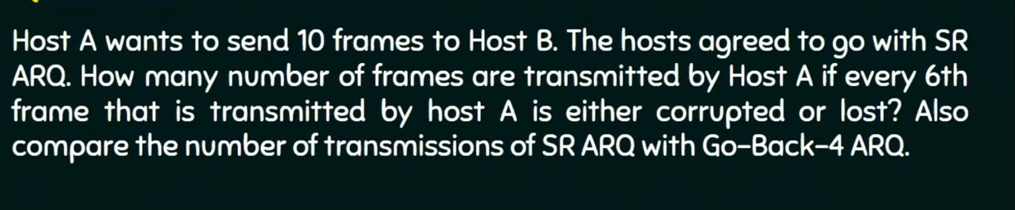

Question 2:
The window size = 3
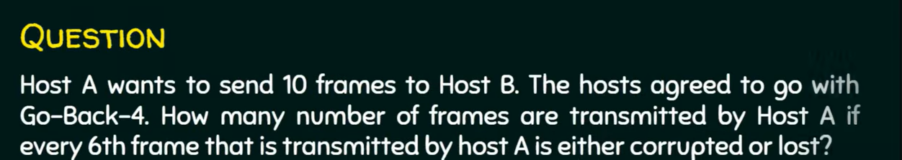
Question 3:
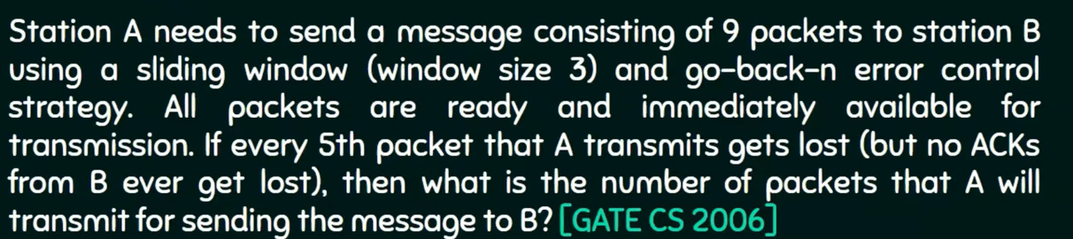

16. Glossary - Important Terms in Very Easy Words
Term | Very Easy Meaning
Protocol | A set of agreed rules that devices follow to communicate with each other
Frame | A small unit of data used at the Data Link layer, includes MAC addresses
Packet | A small unit of data used at the Network layer, includes IP addresses
Segment | A small unit of data used at the Transport layer
Bandwidth | The maximum amount of data that can travel through a link in a given time
Node | Any device connected to a network (computer, switch, router, printer, etc.)
ACK | A short confirmation message sent back saying 'data received successfully'
Backbone | The main central cable/line that connects different parts of a bigger network
Handoff | Automatic transfer of a mobile call from one tower to another while moving
Routing | The process of choosing the best path for data to travel to its destination

17. Full Unit Revision - One Page Summary
Use this page just before your exam for a quick last-minute revision.
- OSI Model = 7 layers (Physical, Data Link, Network, Transport, Session, Presentation, Application) - theoretical reference model.
- TCP/IP Model = 4 layers (Network Access, Internet, Transport, Application) - practical model used by the real internet.
- Topology = shape/arrangement of network: Bus, Ring, Star, Mesh, Tree, Hybrid. Star is most common today.
- Switching = Circuit (dedicated path, e.g. telephone), Packet (broken into pieces, e.g. internet), Message (store-and-forward, e.g. telegram).
- MAC Address = permanent, unique hardware fingerprint of a device (Layer 2); IP Address can change, MAC does not.
- Mobile Telephone System = cell-based coverage with towers and automatic handoff between cells.
- Line Configuration = Point-to-Point (2 devices) or Multipoint (many devices share one line).
- Multiplexing = combining many signals onto one shared line (FDM = different frequencies, TDM = different time slots).
- Duplex Modes = Simplex (one-way only), Half Duplex (both ways, one at a time), Full Duplex (both ways, together).
- Stop & Wait = send 1 frame, wait for ACK, repeat - simple but slow.
- Noiseless channel protocols = Simplest Protocol (no control at all) and Stop-and-Wait (flow control only, no errors assumed).
- Noisy channel ARQ protocols = Stop-and-Wait ARQ (1 frame + timer + sequence numbers), Go-Back-N ARQ (resends lost frame + all after it), Selective Repeat ARQ (resends ONLY the lost frame, most efficient).
- Sliding Window = send multiple frames within a 'window' before waiting - faster and more efficient.
All the best for your exam!

