**For the following question write the corresponding MongoDB queries:**

**1.Find all the information about each products**

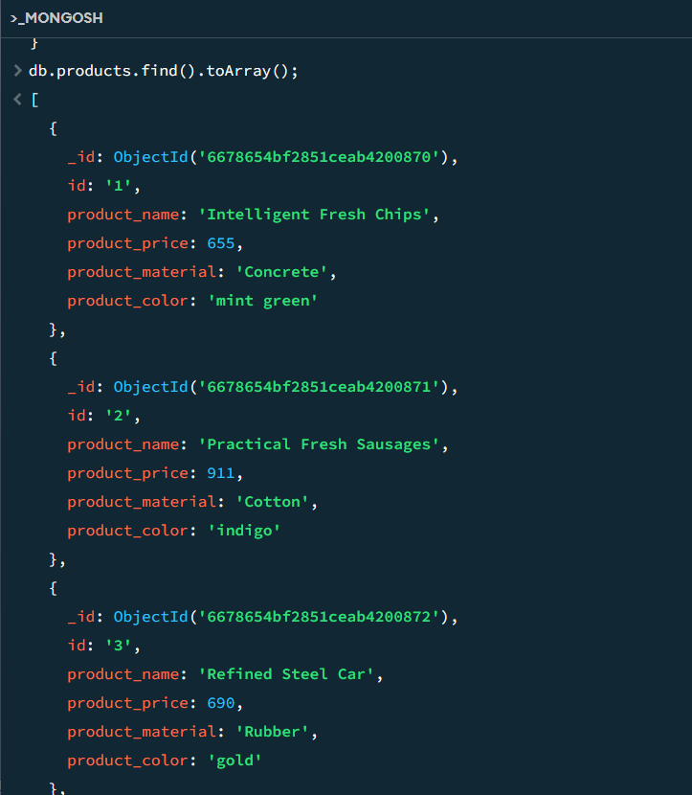

**2. Find the product price which are between 400 to 800.**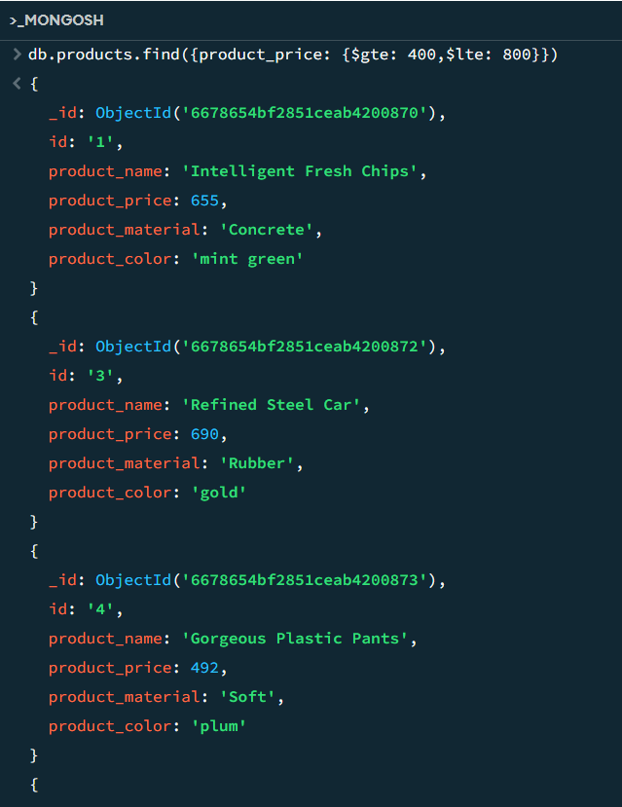

**3. Find the product price which are not between 400 to 600.**

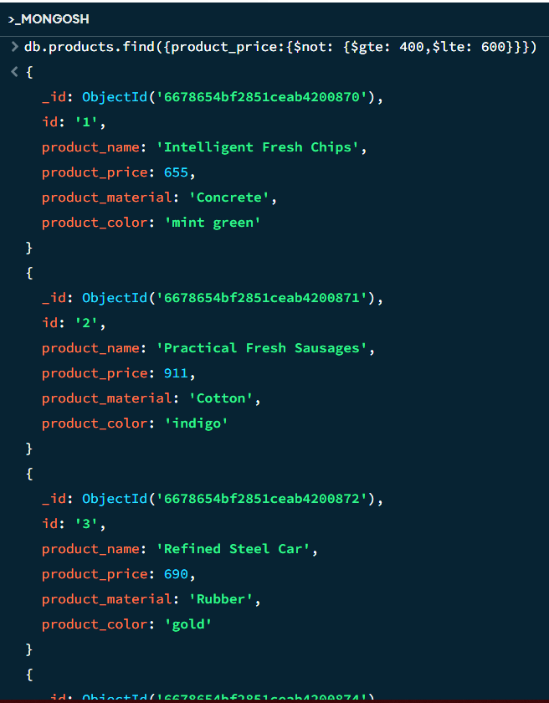

**4. List the four product which are greater than 500 in price.**

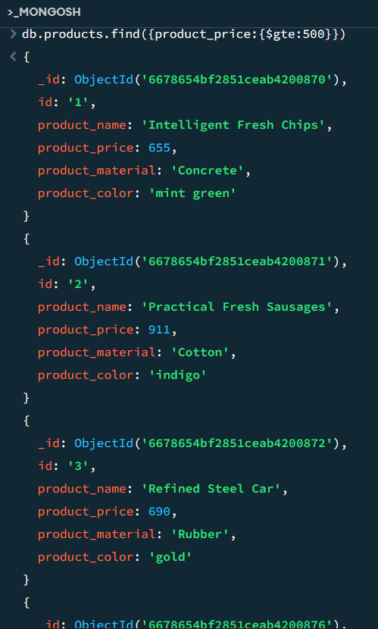

**5. Find the product name and product material of each products.**

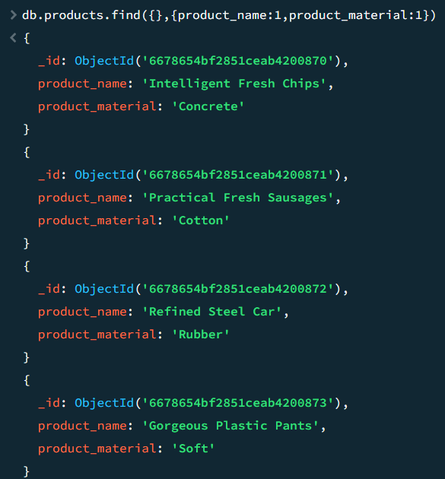

**6. Find the product with a row id of 10.**

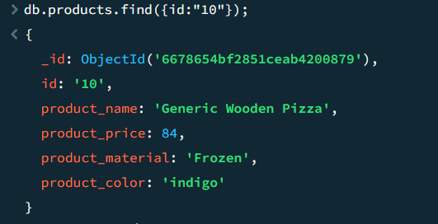

**7. Find only the product name and product material**

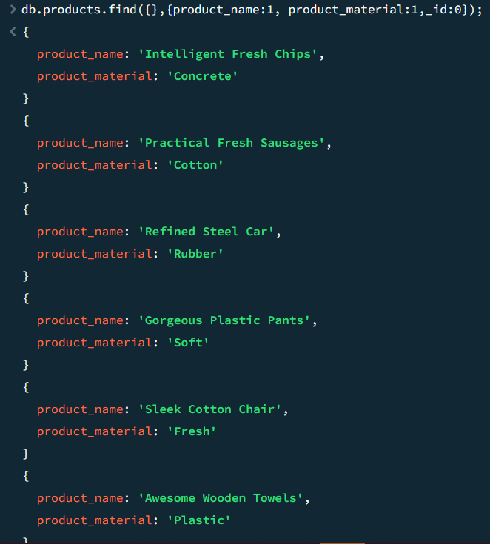

**8. Find all products which contain the value of soft in product material**

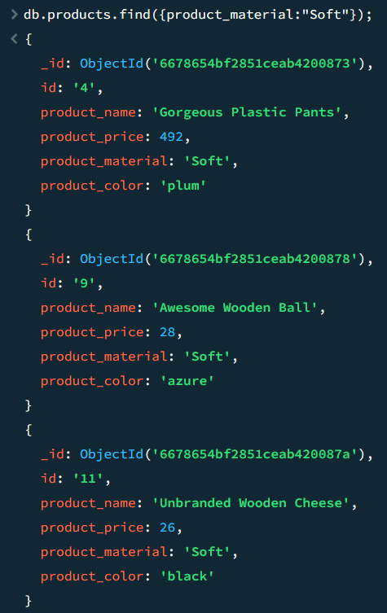

**9. Find products which contain product color indigo  and product price 492.00.**

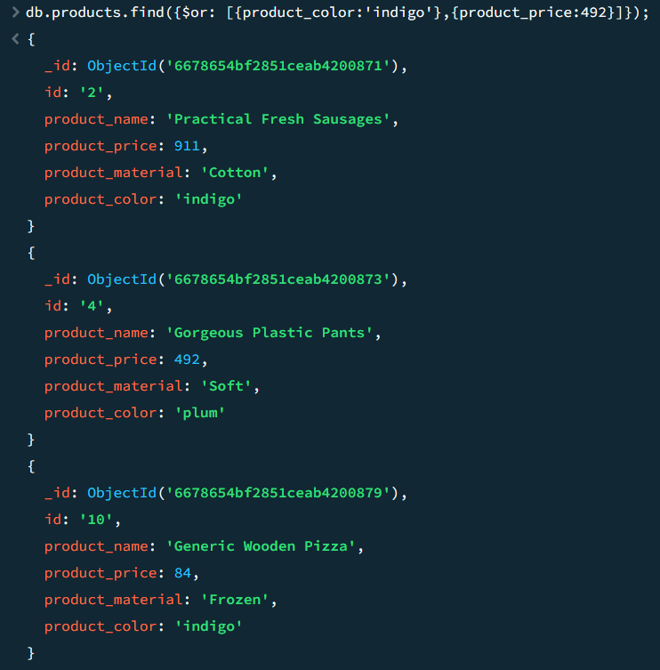

**10. Delete the products which product price value are 28.**



