The Internet

**Internet Protocol Versions**

IPv4 and IPv6

horizontal line

# Placeholder image

# Introduction

IPv4 and IPv6 are protocols used to identify devices on a network like the internet. IPv4 uses 32-bit numbers to assign unique addresses, limiting the number of available addresses to around 4.3 billion, which led to IPv6's development. IPv6 uses 128-bit numbers to assign addresses, providing a practically infinite supply of unique addresses. It also offers features such as built-in security and improved network performance. Despite IPv6's development and standardization for over 20 years, many networks still use IPv4. However, it is expected that IPv6 will eventually replace IPv4 as the dominant protocol for internet communication.

# IPv4

# 

IPv4 is a protocol that is used to assign unique addresses to devices on a network such as the internet. It uses a 32-bit number to identify each device, allowing for around 4.3 billion unique addresses. An IPv4 address is divided into four parts, separated by dots, each consisting of 8 bits or one byte. These four parts are called octets and can be represented by decimal numbers ranging from 0 to 255. The parts represent the network ID, the subnet ID, and the host ID. The network ID specifies the network to which the device belongs, while the host ID identifies the specific device on that network. The subnet ID is used to divide a network into smaller subnetworks.

## Allocation of IP’s

IPv4 addresses are assigned by the Internet Assigned Numbers Authority (IANA), which manages the global allocation of IP addresses. IANA assigns blocks of IP addresses to the five Regional Internet Registries (RIRs) based on geographical regions. These RIRs then distribute the IP addresses to Internet Service Providers (ISPs) and other organizations within their regions.

ISPs, in turn, assign IP addresses to their customers based on their needs. They may use various methods, such as dynamic or static IP address allocation, to assign IP addresses to their customers. Dynamic allocation assigns IP addresses temporarily to devices for a specific period, while static allocation assigns permanent IP addresses to devices.

### IPv4 Subnetting

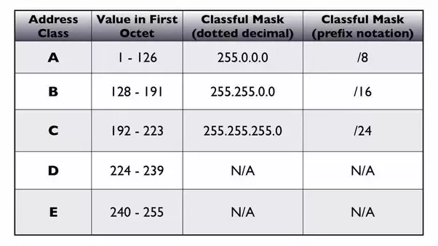

* IPv4 subnetting is the process of dividing a large network into smaller subnetworks, each with its own unique network ID and host ID. This is done by borrowing bits from the host ID portion of the address to create the subnet ID. The number of bits borrowed depends on the desired number of subnets and the number of hosts required for each subnet.
* For example, if we have a Class C IPv4 address, which has 24 bits for the network ID and 8 bits for the host ID, we can create multiple subnets by borrowing some bits from the host ID. If we borrow 3 bits from the host ID, we get 5 bits for the subnet ID, which can create up to 8 subnets (2 to the power of 3). Each of these subnets can have up to 2^5 - 2 = 30 hosts (2 to the power of 5 minus 2 for the network and broadcast address).
* Subnetting allows for efficient use of IP addresses and improved network management. It also provides better security by isolating subnets from each other, limiting the impact of potential security breaches.

# IPv6

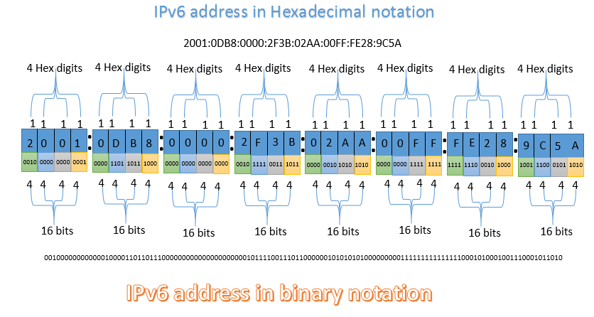

IPv6 (Internet Protocol version 6) is a newer version of the Internet Protocol, which is used to identify devices on a network such as the internet. It was developed as an alternative to IPv4 due to the limited number of available addresses in IPv4, which is 32-bit, allowing for around 4.3 billion unique addresses. In contrast, IPv6 uses 128-bit numbers to identify devices, allowing for a practically unlimited number of unique addresses. IPv6 also includes features such as improved security, better network performance, and support for new types of network devices. Despite its many benefits, IPv6 adoption has been relatively slow, and many networks still rely on IPv4. However, it is expected that IPv6 will eventually replace IPv4 as the dominant protocol for internet communication.

## Allocation of IP’s

IPv6 addresses are allocated by the Internet Assigned Numbers Authority (IANA) to the five Regional Internet Registries (RIRs) based on geographical regions. The RIRs then assign IPv6 address blocks to Internet Service Providers (ISPs) and other organizations within their regions. ISPs and organizations can then allocate IPv6 addresses to their devices, using various methods such as dynamic or static allocation.

### IPv6 Subnetting

* IPv6 subnetting is the process of dividing a large IPv6 network into smaller subnetworks, each with its own unique network ID and host ID. In IPv6, subnetting is typically done by using the Interface ID portion of the address, which consists of 64 bits.
* For example, an organization might receive an IPv6 address block with a prefix of 2001:db8:1234::/48, which contains 16 bits for the network ID and 64 bits for the Interface ID. By borrowing bits from the Interface ID, the organization can create smaller subnets with unique network IDs.
* IPv6 uses a hexadecimal number system, so each digit can represent 16 different values (0-9, A-F). Subnetting in IPv6 is typically done by dividing the Interface ID into 4-bit or 8-bit blocks, which can be represented by a single hexadecimal digit.
* IPv6 subnetting allows for efficient use of IP addresses and improved network management, similar to IPv4 subnetting. However, the much larger address space in IPv6 means that subnetting is generally less necessary than it is in IPv4.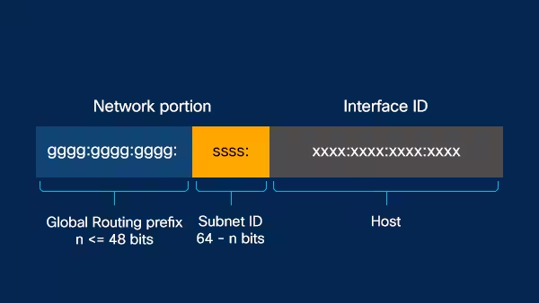
* The **first 64 bits of an IPv6 address** are typically reserved for the **network ID**, and the **remaining 64 bits** are used for the **Interface ID**, which identifies a specific device on the network.
* The first three blocks of an IPv6 address (**the first 48 bits**) are used to identify the **network**. The **first block represents the global routing prefix**, which is assigned by the Internet Assigned Numbers Authority (IANA) to the Regional Internet Registries (RIRs) for allocation to Internet Service Providers (ISPs) and other organizations.
* **The second block is used to identify the Internet Service Provider (ISP)** or organization, and the third block is used to identify the specific network within that ISP or organization.
* The remaining five blocks of the IPv6 address (**the last 80 bits**) are used for the **Interface ID**, which identifies a specific device on the network. The Interface ID can be assigned manually or automatically, and can be based on a variety of factors, such as the device's MAC address or a randomly generated number.

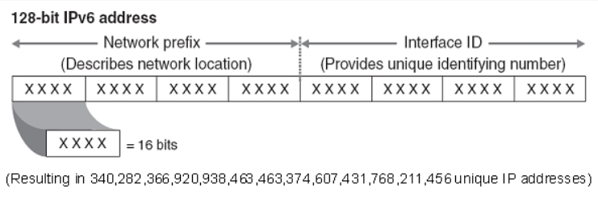

## 

## 

## 

## 

## 

## 

## 

## Types of IPv6

There are 3 main types of IPv6 Addresses:

* Unicast Addresses
* Multicast Address
* Anycast Addresses

**1. Unicast Addresses:**

* Global unicast address: This type of unicast address is used for communication over the Internet, and is globally unique. An example of a global unicast address is 2001:db8:85a3::8a2e:370:7334.
* Link-local address: This type of unicast address is used for communication within a single network segment, and is automatically assigned by the operating system. An example of a link-local address is fe80::c33a:3f51:93e2:2e20.
* Unique local address: This type of unicast address is used for private communication within an organization or network, and is not globally routable. An example of a unique local address is fd00::/8.

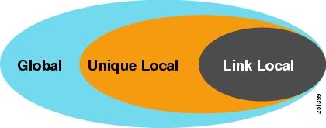

**2. Multicast Addresses:**

* All nodes multicast address: This is a multicast address that is used to send a packet to all nodes on a network segment. The address is ff02::1.
* Solicited-node multicast address: This is a multicast address that is used to send a packet to a specific node on a network segment. The address is formed by taking the prefix ff02::1:ff00/104 and appending the last 24 bits of the unicast address.
* Site-local multicast address: This is a multicast address that is used for communication within a specific site or organization. The address is ff05::/16.

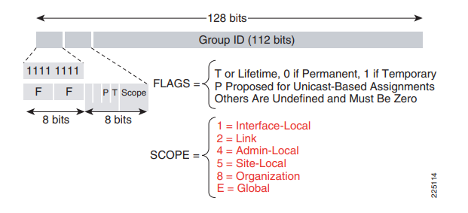

**3. Anycast Addresses:**

* Router anycast address: This is an anycast address that is assigned to multiple routers on a network, and is used for load balancing and network redundancy. An example of a router anycast address is 2001:db8::/64.
* Service anycast address: This is an anycast address that is assigned to multiple servers providing the same service, and is used for load balancing and network redundancy. An example of a service anycast address is 2001:db8::/64.

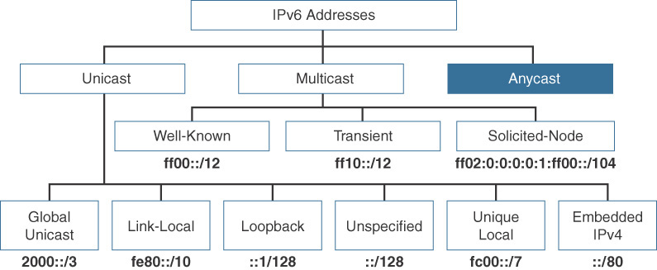

# References

Jeevan Gharate : [GITHUB](https://github.com/Jeevan-Gharate/dcc-sem4-mp)

Internet Protocol White Paper (October 1994) -

*URL*: [RFC 1710: Simple Internet Protocol Plus White Paper](https://www.rfc-editor.org/rfc/rfc1710)

IPv6 Addressing Architecture WP (February 2006) -

*URI:*  [iETF RFC4291](http://www.ietf.org/rfc/rfc4291.txt)

Google Docs “Supplementary Reading on Networking”

Bits and Bytes of Computer Networking [Coursera](2018).

*URI:*

[Learn Computer Networking by google](https://youtu.be/veyNxHVfFq8)

[The Bits and Bytes of Computer Networking | Coursera](https://www.coursera.org/learn/computer-networking/)

IP addressing | CIDR Charts  
*URI:* [Understanding IP Addressing and CIDR Charts — RIPE Network Coordination Centre](https://www.ripe.net/about-us/press-centre/understanding-ip-addressing)

Configuring IPv6  
*URI:* [Configuring IPv6 - N10-008 CompTIA Network+ : 1.4](https://youtu.be/S0dKMst-ED0)