Find all the information about each films

> db.films.find()

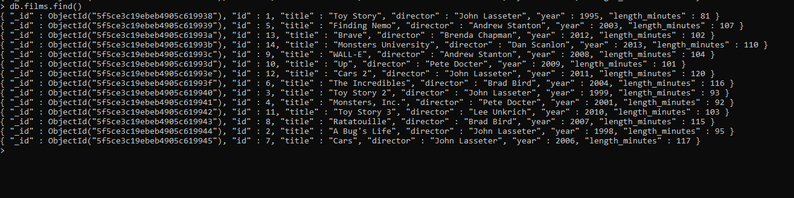

2.Find the title of each films

db.films.find({},{"title":1})

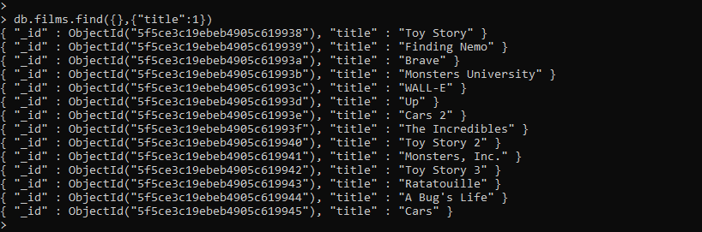

3.Find the directors in each films

> db.films.find({},{"director":1})

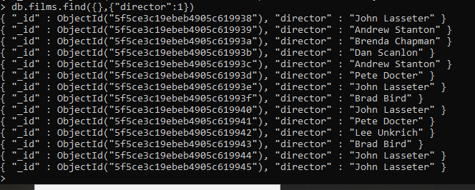

4.find the title and director of each film

> db.films.find({},{"title":1,"director":1})

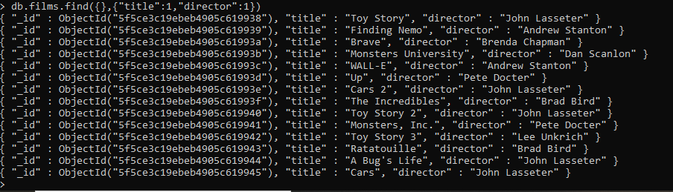

5. Find the title and year of each film

> db.films.find({},{"title":1,"year":1})

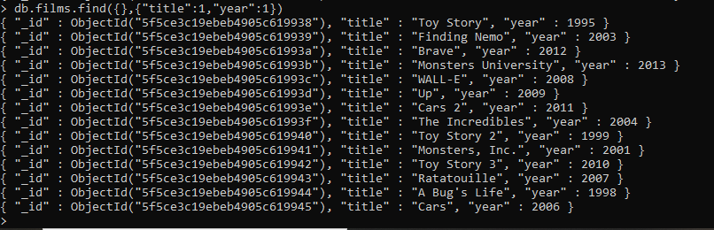

6. Find the movie with a row id of 6

> db.films.find({id:6})



7. Find the movies released in the years between 2000 and 2010

db.films.find({year:{$gte:2000,$lt:2010}})

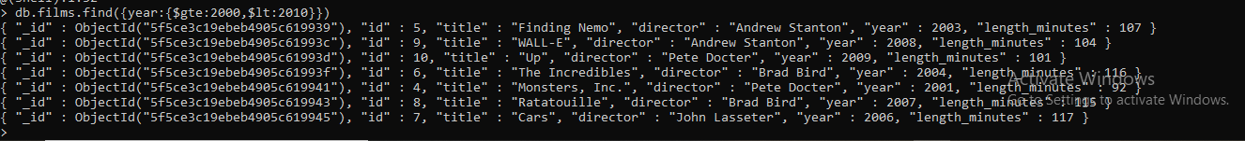

8. Find the movies not released in the years between 2000 and 2010

> db.films.find({year:{$not:{$gte:2000,$lte:2010}}})

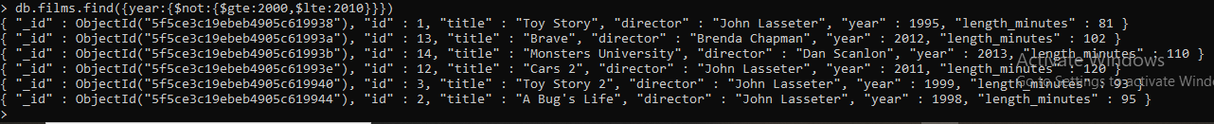

9. Find the first 5 Pixar movies and their release year

> db.films.aggregate([{$limit:5}])



10. Find all the Toy Story movies

> db.films.find({title:{$regex:".\*Toy Story\*."}})



11. Find all the movies directed by John Lasseter

> db.films.find({director:{$eq:"John Lasseter"}})



12. Find all the movies (and director) not directed by John Lasseter

> db.films.find({director:{$ne:"John Lasseter"}})

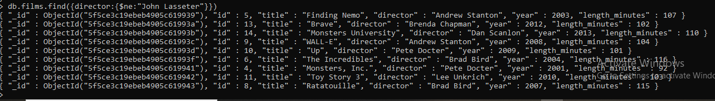

13. Find all the WALL-\* movies

> db.films.find({title:{$regex:".\*WALL-\*."}})



14. List the last four Pixar movies released (ordered from most recent to least)

> db.films.aggregate([{$sort:{year:1}},{$limit:4}])



15. List the first five Pixar movies sorted alphabetically

> db.films.aggregate([{$sort:{title:1}},{$limit:5}])



16. List the next five Pixar movies sorted alphabetically

> db.films.aggregate([{$sort:{title:1}},{$skip:5},{$limit:5}])

