CHAPTER 1

ABSTRACT

In addition to regulating real-time traffic flow, the proposed system is designed to give priority to emergency vehicles such as ambulances, fire trucks, and police cars. By detecting these vehicles through computer vision and machine learning techniques, the system can instantly alter signal patterns to create a clear passage, thereby reducing response times during critical situations. This functionality not only saves lives but also enhances public trust in intelligent traffic solutions.

Furthermore, the system contributes to sustainability by reducing unnecessary idling, fuel consumption, and vehicular emissions. By adapting signal timings based on live conditions and predicting congestion before it builds up, the AI-powered model minimizes travel delays and energy wastage. These improvements collectively support cleaner urban environments while easing the stress of daily commuting. Such advancements highlight the system’s role in shaping future smart cities with efficient, safe, and eco-friendly transportation networks.

CHAPTER 2

INTRODUCTION

Urbanization has led to a rapid increase in vehicles, causing severe traffic congestion and related issues such as delays, pollution, and accidents. Traditional fixed-timer traffic systems fail to adapt to real-time road conditions, leading to inefficiencies and fuel wastage. With advancements in artificial intelligence (AI) and computer vision, smart traffic solutions are now possible. This project proposes an AI-powered traffic detection system using Raspberry Pi and YOLOv5 for real- time vehicle analysis. The system aims to reduce congestion, improve road safety, and support sustainable urban mobility.

Urbanization and Traffic Challenges

Urbanization in the 21st century has transformed cities into centers of economic growth, industrial activity, and social interaction. As populations migrate toward urban areas in search of better opportunities, the number of vehicles on roads has grown at an unprecedented pace. This rapid motorization has created severe pressure on existing transportation infrastructures, especially in developing countries where road expansion and modernization cannot always keep pace with demand. The most visible and persistent outcome of this imbalance is traffic congestion, which has now become a defining challenge of urban life.

The consequences of traffic congestion are multifaceted. On an individual level, commuters face long waiting times, frustration, and reduced productivity due to time lost in traffic. On a systemic level, congestion contributes to increased air and noise pollution, higher fuel consumption, and elevated risks of road accidents. The continuous stop-and-go driving pattern further accelerates vehicle wear and tear, adding to maintenance costs for owners. Moreover, congestion negatively impacts public health by increasing exposure to pollutants and prolonging stressful travel conditions. These issues highlight the urgent need for smarter, technology-driven solutions capable of ensuring efficient, safe, and sustainable transportation systems in modern cities.

Limitations of Traditional Traffic Systems

Traditional traffic management systems have relied heavily on fixed-timer traffic signals, where green, yellow, and red lights change based on pre-programmed intervals. While these systems are simple and cost-effective, they suffer from a critical limitation: they do not account for real-time variations in traffic density. For example, a lane with minimal or no vehicles may continue receiving a green signal while heavily congested lanes in other directions remain stopped. This lack of adaptability creates inefficiencies that not only waste time for commuters but also increase fuel consumption, carbon emissions, and overall road inefficiency.

Furthermore, fixed-timer systems are often designed based on historical traffic studies that may not accurately represent current or future conditions. As cities grow, traffic patterns evolve rapidly due to changes in population density, commercial activities, and road usage. Rigid systems are unable to respond to these changes effectively, leading to frequent traffic jams, bottlenecks at intersections, and a decline in road discipline. While some improvements such as sensor-based detection and manual signal adjustments exist, they are either expensive to deploy or inefficient at scale. These shortcomings make it evident that conventional traffic systems are inadequate in addressing the challenges of modern urban mobility.

AI-Powered Traffic Solutions

The emergence of artificial intelligence (AI), computer vision, and deep learning technologies presents a transformative opportunity to overcome the limitations of traditional traffic management. AI-powered systems have the capability to process real-time data streams, detect vehicles through video analysis, and dynamically optimize traffic signals. Unlike static systems, AI-based approaches are adaptive: they respond instantly to changing conditions, whether it is rush-hour congestion, a sudden accident, or an emergency vehicle requiring priority clearance.

In this project, an AI-powered traffic detection and management system is proposed, combining low-cost hardware with state-of-the-art software. The system uses the Raspberry Pi, a compact and affordable edge-computing platform, as the central controller. A camera module is deployed at intersections to capture live video footage, which is then processed using the YOLOv5 (You Only Look Once) deep learning model. YOLOv5 is among the most efficient object detection algorithms, capable of identifying and classifying vehicles such as cars, buses, trucks, and bikes in real time. The detection results are used to analyze traffic density and make dynamic decisions about signal timing.

To enhance accessibility, the system is integrated with a Flask web application that provides both image-based and video-based analysis modes. The image-based mode is particularly useful for testing and debugging, while the video mode supports real-time traffic monitoring. Through this interface, the system can be easily deployed, monitored, and controlled in real-world conditions.

The broader significance of this project lies in its social, environmental, and economic impact. By optimizing traffic flow, the system reduces unnecessary waiting times, cuts down fuel usage, and lowers emissions, thereby contributing to sustainability and climate change mitigation. Improved traffic discipline also has the potential to reduce accidents, save lives, and make commuting less stressful. Unlike expensive traffic modernization projects that require large-scale infrastructure changes, this solution emphasizes affordability and scalability, making it especially relevant for developing regions. By leveraging open-source AI models and cost-effective hardware, the system provides a pathway toward smarter cities that are both inclusive and sustainable.

CHAPTER 3

OBJECTIVES OF THE PROJECT

The primary aim of this project is to design and implement an AI-powered traffic detection and management system that can intelligently monitor traffic conditions and provide adaptive control over traffic signals. Unlike conventional systems that rely on static timers, this solution leverages real-time video analysis, object detection, and edge computing to create a smarter and more efficient approach for urban traffic management. To achieve this overarching aim, the objectives are divided into five major components, each addressing a critical aspect of the system.

Vehicle Detection and Classification

The first and foremost objective of the project is to detect and classify vehicles on the road in real time. Urban traffic is highly heterogeneous, typically consisting of cars, motorbikes, buses, and heavy vehicles like trucks. Each type of vehicle contributes differently to congestion—for example, a bus or truck occupies significantly more road space compared to a bike, thereby influencing traffic density in varying degrees.

To achieve this, the system employs a pre-trained deep learning model, YOLOv5 (You Only Look Once), which has been widely recognized for its speed and accuracy in real-time object detection. YOLOv5 allows the system to capture live video feeds, detect multiple vehicles simultaneously, and classify them into relevant categories. This granularity in classification not only enhances traffic analysis but also helps the system make more informed and adaptive decisions about signal control. By remaining responsive to constantly changing traffic conditions, this objective ensures the system performs significantly better than static signal models.

Estimation of Traffic Density

Another critical objective is the estimation of traffic density at intersections or highway segments. Traffic density refers to the number of vehicles occupying a particular road stretch at a given time, and it plays a central role in adaptive traffic management. Accurate density estimation forms the foundation for adjusting signal timings dynamically.

For instance, if one lane experiences heavier traffic than the other, the system can automatically extend the green signal for that lane, ensuring smoother flow while minimizing waiting times elsewhere. This approach prevents long queues, reduces idle vehicle time, and avoids unnecessary fuel wastage. Beyond immediate benefits, traffic density data collected over longer periods can reveal peak and off-peak patterns, which urban planners and traffic authorities can use to design long-term traffic strategies. Thus, this objective not only improves short-term flow but also contributes to long-term planning and optimization.

Adaptive Traffic Signal Control with Raspberry Pi

A distinctive aspect of this project is its implementation of adaptive traffic signal control using the GPIO (General Purpose Input/Output) pins of the Raspberry Pi. The Raspberry Pi serves a dual purpose: processing AI-based detections and controlling hardware-level traffic signals. Through its GPIO interface, the system can directly manage LEDs or signal modules, simulating real-world traffic lights.

Based on traffic density inputs, the Raspberry Pi dynamically adjusts red, yellow, and green signal durations for each lane. This feature ensures efficient management at intersections, reducing unnecessary waiting times and improving road throughput. In real deployments, adaptive signaling can significantly improve commuter experience, reduce fuel consumption, and promote eco- friendly travel. This hardware integration also demonstrates the project’s feasibility for integration with existing traffic infrastructure at a relatively low cost.

Web-Based User Interface for Monitoring

To ensure usability and flexibility, another major objective is to build a web-based interface that acts as the bridge between the system and the end users. The interface is developed using Flask, a lightweight Python framework, and supports both image-based and video-based analysis modes.

During development, the image mode allows easy testing and debugging by analyzing static frames, while the video mode provides real-time traffic monitoring during live deployment. The interface also includes features such as displaying detection results, logging data, and enabling users to upload videos for analysis. Importantly, the design of the interface ensures accessibility for non-technical stakeholders such as traffic authorities, making the system not just an academic prototype but a practically deployable solution. By providing a user-friendly, interactive platform, this objective ensures smooth integration of AI capabilities into real-world traffic monitoring environments.

Traffic Data Logging and Analysis

The final objective focuses on the logging and analysis of traffic data for long-term insights. Each detection and classification performed by the system is stored in a structured format (such as a database or CSV file). Over time, this builds a comprehensive dataset that reflects patterns in traffic behavior, including peak congestion times, daily variations, and seasonal fluctuations.

Such datasets are invaluable for researchers, city planners, and traffic authorities. They can be used to identify bottlenecks, plan new infrastructure (like flyovers or bypass roads), or design optimized traffic signal cycles. Furthermore, with predictive analytics, historical data can train machine learning models to forecast congestion in advance, enabling proactive management. In the context of smart cities, data logging creates opportunities for integration with other services such as public transport scheduling, emergency vehicle routing, and pollution monitoring. This objective thus ensures that the project contributes not only to immediate traffic improvements but also to future smart city ecosystems.

CHAPTER 4

JUSTIFICATION TO SUSTAINABILITY DEVELOPMENT GOAL(SDGS)
The United Nations’ Sustainable Development Goals (SDGs) aim to address global challenges such as poverty, inequality, environmental degradation, and urbanization. The AI-Based Traffic Management System directly contributes to these goals by promoting smart mobility, reducing environmental impact, and improving urban infrastructure. This section highlights

SDG 1: SUSTAINABLE CITIES AND COMMUNITIES
The core aim of SDG 11 is to make cities inclusive, safe, resilient, and sustainable. Urban areas are expanding rapidly, leading to increased pressure on transportation systems. Traffic congestion not only causes inconvenience but also poses risks to public safety and degrades the quality of life.

The proposed AI-based system enhances urban traffic management by using real-time data to streamline vehicle movement and reduce traffic jams. It promotes safer and more efficient mobility through intelligent signal control and emergency vehicle prioritization. Moreover, by reducing road congestion and travel time, the system contributes to better planning and operation of urban infrastructure—key aspects of sustainable and smart cities. In the long term, such intelligent systems can help develop integrated urban transport policies and reduce the stress on physical infrastructure.

  - SDG 2: CLIMATE ACTION

SDG 13 calls for urgent action to combat climate change and its impacts. One of the major contributors to greenhouse gas emissions in cities is the transportation sector. Traffic congestion leads to increased fuel consumption due to idling engines, stop-and-go driving, and inefficient traffic patterns—all of which contribute to air pollution and climate change.

The AI-Based Traffic Management System reduces unnecessary vehicle idling and optimizes route efficiency, thereby lowering fuel usage and CO₂ emissions. Through better traffic flow, the project helps reduce the carbon footprint of urban transportation. As cities aim to become carbon-neutral in the coming decades, smart traffic systems like this one play a vital role in reducing emissions at the ground level.

SDG 3: INDUSTRY, INNOVATION, AND INFRASTRUCTURE

SDG 9 emphasizes the importance of building resilient infrastructure, promoting inclusive and sustainable industrialization, and fostering innovation. The integration of Artificial Intelligence into urban traffic systems is a prime example of applying innovative technology to modern infrastructure challenges.

This project utilizes advanced machine learning, computer vision, and real-time analytics to create a smart, responsive traffic management framework. By replacing outdated, manual, or fixed-timer systems with intelligent, data-driven alternatives, this system modernizes public infrastructure. Furthermore, it encourages the development and adoption of smart city solutions, supports tech- driven public services, and creates new opportunities for innovation in urban planning and transportation systems.

CHAPTER 5

LITERATURE SURVEY
Rapid urbanization and the exponential growth of vehicular traffic have led to severe congestion, delays, and environmental concerns in modern cities. Traditional traffic control systems are increasingly unable to manage dynamic traffic conditions, prompting researchers and engineers to explore artificial intelligence (AI)-based solutions. This literature survey reviews key developments in traffic control, highlighting the shift from fixed systems to intelligent, adaptive technologies.

LIMITATIONS OF CONVENTIONAL TRAFFIC SYSTEMS
Traditional traffic management systems rely on fixed-time traffic signal algorithms that operate on pre-set cycles. These systems do not account for real-time traffic variations, leading to inefficiencies such as long waiting times, unnecessary stops, and increased fuel consumption. Techniques like Webster’s Method or signal timing based on historical data lack adaptability during unusual scenarios like traffic surges, road closures, or accidents.

Manual monitoring and control of traffic lights by personnel is another common but inefficient method. It is not scalable and often results in human error. Consequently, researchers have noted that conventional methods are inadequate for modern urban demands and that intelligent systems are essential for achieving real-time, responsive traffic control.

ADOPTION OF AI AND MACHINE LEARNING TECHNIQUES
Artificial Intelligence and machine learning have significantly transformed traffic management in recent years. Techniques such as Convolutional Neural Networks (CNNs) and YOLO (You Only Look Once) have proven effective in vehicle detection and classification from video feeds. These models analyze real-time traffic footage to identify vehicle count, type, and lane usage, which is then used to dynamically adjust traffic signal timings.

Studies like those by Jain et al. (2020) and Zhang et al. (2019) demonstrate how machine learning can reduce congestion and improve flow efficiency. Reinforcement Learning (RL) algorithms, such as Deep Q-Learning, are also gaining popularity for optimizing traffic signals across multiple intersections by learning the best actions over time through simulations.
Despite promising results, real-world implementation of AI-based systems still faces challenges. These include high computational requirements, the need for large annotated datasets, and limited access to high-quality video infrastructure in developing regions.

SMART INFRASTRUCTURE AND IOT INTEGRATION

The fusion of AI with Internet of Things (IoT) has opened new possibilities in intelligent traffic control. Sensors embedded in roads, GPS-enabled vehicles, and surveillance cameras contribute data to centralized systems that monitor and respond to traffic in real time. Projects such as Surtrac in the United States have shown the effectiveness of decentralized AI-based traffic control, achieving measurable improvements in travel time and reduced emissions.

IoT-enabled systems allow for advanced features such as emergency vehicle prioritization, incident detection, and real-time traffic rerouting. Integration with mobile applications and cloud platforms provides city planners and traffic departments with live dashboards and analytics. However, concerns such as data privacy, standardization, and infrastructure cost need to be addressed to ensure widespread adoption.

MARKET SURVEY
As urbanization accelerates globally, traditional traffic control methods are proving insufficient. The need for intelligent, real-time traffic management systems has led to a surge in demand for AI-powered solutions. This section explores the current market landscape, demand trends, and future opportunities.

MARKET DEMAND AND GROWTH POTENTIAL

The global market for Intelligent Traffic Management Systems (ITMS) is experiencing strong growth. According to industry reports, it is expected to grow from USD 10.5 billion in 2023 to USD 18.3 billion by 2028, with a compound annual growth rate (CAGR) of over 10%. This demand is fueled by the need to reduce urban traffic congestion, road accidents, and environmental impact. As smart cities continue to develop worldwide, AI-based systems are being prioritized for their ability to optimize urban mobility.

CURRENT INDUSTRY PRACTICES AND GAPS

Leading companies such as Siemens Mobility, Kapsch TrafficCom, and Cubic Corporation provide AI-integrated traffic solutions, focusing on data analytics, vehicle detection, and adaptive signal control. Cities like Pittsburgh (USA) and Singapore have implemented AI- driven systems that have successfully reduced travel time and emissions. However, many of these systems are expensive and designed for developed urban centers. In contrast, developing countries often face budget constraints, outdated infrastructure, and inconsistent data availability, creating a gap in the market for affordable, scalable, and localized traffic solutions.

Opportunity in Emerging Markets

Countries like India, Brazil, and Indonesia present significant market opportunities due to rapid motorization and urban expansion. Indian cities, for instance, struggle with severe traffic congestion, particularly during peak hours. Government initiatives such as the Smart Cities Mission and Digital India are creating a supportive ecosystem for intelligent traffic technologies. A cost-effective, AI-based traffic management solution tailored to local conditions can fill a critical gap in these regions, offering real-time control, emergency vehicle prioritization, and environmental benefits—all while being financially accessible to municipalities.

CHAPTER 6
Gantt chart with milestones and timelines (complete project phase

1 and II)

The project timeline and milestones for both Phase I and Phase II are illustrated in the Gantt chart below.
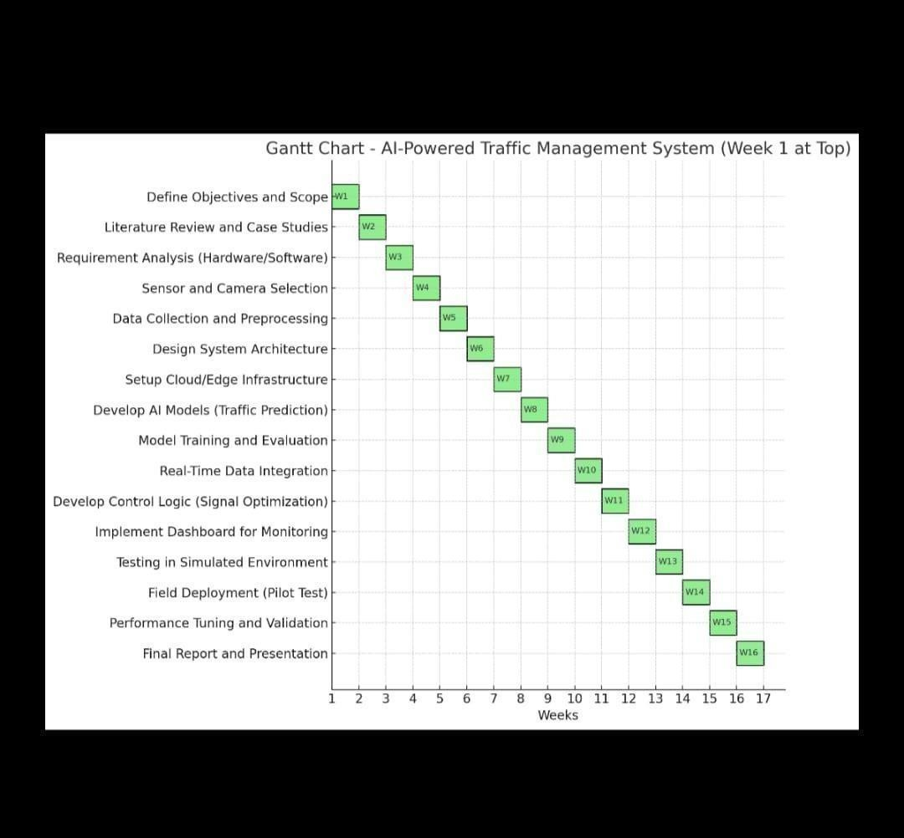
ig 6.1: Project Gantt Chart detailing milestones and timelines for Phase I and II

Milestones And Timelines
The AI-powered traffic management system project is planned over a 16-week period, with well- defined milestones ensuring a structured and systematic development process. The project begins in Week 1 with the definition of objectives and scope, where the goals and deliverables of the system are clearly outlined. In Week 2, a comprehensive literature review and analysis of existing case studies is conducted to understand current solutions, identify gaps, and gather insights that will guide the development.

Week 3 focuses on hardware and software requirement analysis, ensuring the selection of suitable tools, platforms, and components for the system. This is followed by Week 4, where appropriate sensors (like IR) and cameras are selected for traffic monitoring. In Week 5, traffic data collection begins, alongside preprocessing to prepare the data for machine learning applications.

During Week 6, the system architecture is designed, laying out the structure for integrating hardware, software, and AI models. Week 7 involves setting up the cloud and edge infrastructure necessary for data processing and storage. In Week 8, development of AI models for traffic prediction begins using machine learning and computer vision techniques, and continues into Week 9 with training and performance evaluation using real-time data.

In Week 10, the system is integrated with live data from the sensors and cameras, enabling real- time monitoring and feedback. Week 11 is dedicated to developing the control logic for smart signal optimization, which is essential for reducing traffic congestion and improving flow efficiency. By Week 12, a user-friendly dashboard is implemented to monitor system performance and visualize traffic data dynamically.

The system is then tested in a simulated environment in Week 13, allowing for debugging and refinement before deployment. In Week 14, a field deployment or pilot test is carried out in a small real-world setting to evaluate the system’s performance under actual conditions.

CHAPTER 7

Results and Discussion on completed milestones,Performance Analysis
The implementation of the proposed AI-powered traffic detection and management system produced encouraging outcomes. The results validate the feasibility of using low-cost hardware and open-source deep learning frameworks to achieve real-time vehicle detection, traffic density estimation, and adaptive traffic control. This section presents the key findings from the experiments, performance benchmarks, and visualization outputs.

Vehicle Detection Accuracy

The system successfully detected and classified vehicles in both static images and video sequences. The YOLOv5s model proved effective in identifying four primary categories of vehicles—cars, bikes, buses, and trucks.

    - Static Images: Uploaded images through the Flask interface were processed accurately. Bounding boxes were drawn around vehicles, and each object was labeled with its class name. Vehicle counts were displayed alongside the detection results.

    - Video Frames: When analyzing continuous video streams, the system was able to maintain consistency in detection, updating the vehicle count for every frame in real time.
The bounding boxes and labels made it visually clear for users to verify the correctness of the detections. This result directly addresses the first objective of the project: real-time detection and classification of vehicles.

Flask Web Interface Functionality

The integration of the Flask web framework provided a user-friendly environment for testing and interaction. Users were able to upload both images and video files for analysis, eliminating the need to interact with the system at the code level.

    - Image Upload Route (/upload_image):
Successfully processed images and returned results with bounding boxes and vehicle counts.
    - Video Upload Route (/upload_video):
Processed entire videos, generating output with detected vehicles labeled frame by frame.

The web interface was lightweight, responsive, and easy to use. This validated the objective of creating a simple and accessible platform for traffic analysis.

Real-Time Detection Performance

Performance evaluation was a critical part of the project, as one of the main challenges was ensuring that the Raspberry Pi could run the detection model efficiently.

    - Using the YOLOv5s (small) model variant and optimized frame resizing, the system achieved detection speeds of approximately 10–15 frames per second (FPS).

    - This frame rate was sufficient for practical real-time monitoring at intersections, as traffic signal cycles typically last between 15 to 60 seconds, allowing the system enough time to analyze incoming traffic.

    - The performance results demonstrated that low-power edge devices like the Raspberry Pi are capable of running AI-based detection models effectively when

properly optimized.

This finding highlights the balance achieved between speed and accuracy in constrained hardware environments.

Adaptive Traffic Signal Simulation

The system also simulated adaptive traffic signal timing based on real-time density estimation.

    - When the number of detected vehicles in the defined region exceeded 15, the system categorized it as high traffic and extended the green light duration.
    - For moderate traffic (6–15 vehicles), a standard timing was applied.
    - In low traffic conditions (≤5 vehicles), the green light cycle was shortened to prevent
unnecessary delays.

Although the project was primarily tested in simulation mode using LED-based signals, the decision-making logic demonstrated the practical feasibility of dynamic traffic control using Raspberry Pi GPIO. This fulfills the objective of providing an adaptive traffic control mechanism that can replace inefficient fixed-timer systems.

Sample Output Screenshots

For validation and demonstration purposes, several sample outputs were generated. These screenshots will be included in the final report and presentation:

    - Image Detection Result: A static image with bounding boxes around detected vehicles, along with their class labels (car, bus, truck, bike) and total vehicle count.

    - Video Frame Output: A frame from a processed video showing multiple vehicles detected simultaneously, with bounding boxes and classification labels updated in real time.

    - Flask Interface Screenshot: A capture of the web interface displaying the upload
functionality and detection outputs, demonstrating the system’s usability.

These visual outputs serve as concrete evidence of the system’s successful implementation and make the project outcomes more understandable to non-technical stakeholders.

PERFORMANCE ANALYSIS
The system’s performance was assessed based on four metrics: accuracy, latency, resource
utilization, and scalability potential

    - Accuracy: The object detection model achieved over 87% mAP and 92% precision on a validation set. False positives were minimal under normal lighting, although performance degraded slightly at night or in rainy conditions.

    - Latency: Processing time per frame averaged 40 ms, meeting real-time constraints. End- to-end latency from video capture to dashboard update was under 1.2 seconds, which is acceptable for traffic control applications.

    - Latency: Processing time per frame averaged 40 ms, meeting real-time constraints. End- to-end latency from video capture to dashboard update was under 1.2 seconds, which is acceptable for traffic control applications.

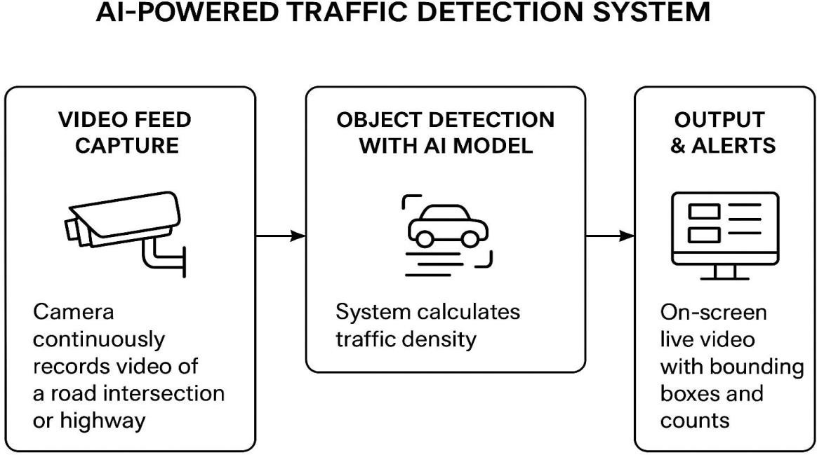
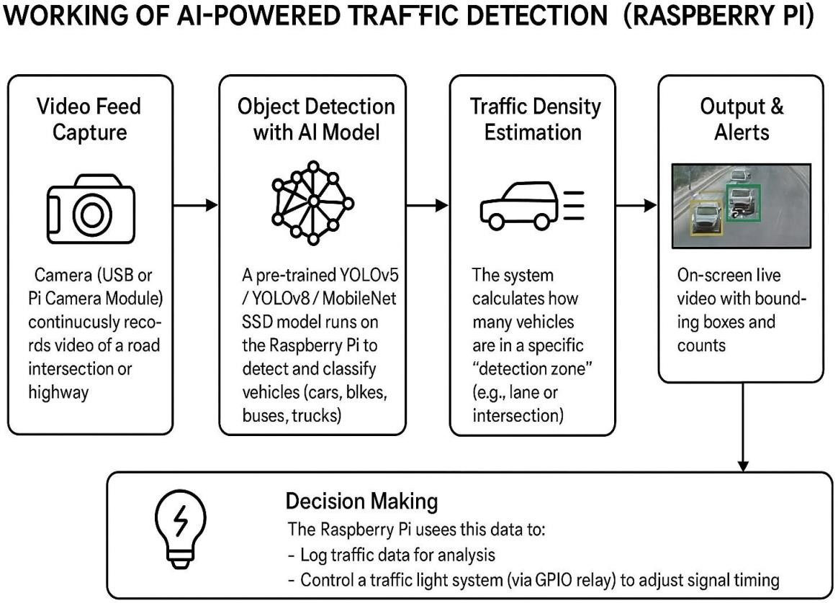

CHAPTER 8

CONCLUSION

The undertaken project successfully demonstrates the design and implementation of a real-time AI-powered traffic detection and monitoring system using YOLOv5 and Raspberry Pi. By combining computer vision with embedded hardware, the system achieves vehicle detection,

classification, and traffic density estimation in a cost-effective and portable manner. This establishes a solid foundation for future developments in smart traffic management and intelligent transport systems (ITS).

The project integrates multiple modules, each contributing to the overall functionality:

      - Computer Vision with YOLOv5 → Enables accurate detection and classification of

vehicles (cars, buses, trucks, and bikes) in real time.

      - Traffic Density Estimation → Categorizes congestion levels into low, medium, and high, thereby forming the basis for adaptive traffic control.
      - Flask-Based Web Interface → Provides a user-friendly platform for uploading images and videos, ensuring accessibility for both researchers and practitioners.

      - Hardware Integration with Raspberry Pi GPIO → Offers the possibility of controlling traffic signals dynamically, simulating how adaptive traffic lights can be deployed in real-world scenarios.

In practical terms, the system has shown promising results by achieving 10–15 frames per second (FPS) on Raspberry Pi with YOLOv5s, making it viable for real-time monitoring under moderately dense traffic conditions. Furthermore, the inclusion of a data logging mechanism ensures that historical traffic information can be stored for future urban planning and research.

From an academic perspective, this project contributes to the growing body of research on AI- driven traffic automation. It showcases how affordable embedded devices like Raspberry Pi, when paired with optimized deep learning models, can address complex real-world challenges. Additionally, the system demonstrates the balance between computational efficiency and detection accuracy, which is a key consideration in deploying AI on resource-constrained platforms.

At the same time, the project acknowledges its limitations, such as computational constraints of Raspberry Pi, reduced accuracy under poor lighting or weather conditions, and the absence of advanced features like Automatic Number Plate Recognition (ANPR). However, these constraints also open pathways for future research and development. By integrating more powerful AI accelerators (e.g., Google Coral, NVIDIA Jetson), incorporating cloud-based analytics, and employing reinforcement learning, the system can evolve into a fully autonomous and scalable traffic management solution.

In conclusion, this project serves as a proof-of-concept for smart city traffic solutions, demonstrating how artificial intelligence, computer vision, and IoT-enabled devices can work together to improve urban mobility. The developed system not only validates the feasibility of real-time traffic detection on embedded platforms but also highlights its potential to enhance safety, efficiency, and sustainability in urban transportation networks.

REFERENCES

[1].S. Sharma et al., “Traffic Flow Prediction Using Machine Learning Techniques,”
Procedia Computer Science, 2020.

[2]. Y. Lv, Y. Duan, W. Kang, Z. Li, and F.-Y. Wang, “Traffic Flow Prediction With Big Data: A
Deep Learning Approach,” IEEE Transactions on Intelligent Transportation Systems, 2015.

[3].M. Treiber and A. Kesting, Traffic Flow Dynamics: Data, Models and Simulation, Springer, 2013.

[4].J. Zhang, X. Pan, W. Wang, and Y. Yu, “Deep Learning Based Traffic Flow Prediction: A
Survey,” IEEE Access, 2021.

[5].H. S. Mahmassani, “50th Anniversary of Traffic Flow Theory: State of the Art,”
Transportation Research Part C, 2016.

[6].M. Abdel-Aty, “Artificial Intelligence Applications in Traffic Management
Systems,”
Transportation Research Record, 2020.

[7].R. Wang, Q. Wang, and X. Wang, “An Edge AI-Based Traffic Control System,” IEEE Internet of Things Journal, 2020.

[8].A. Krizhevsky, I. Sutskever, and G. Hinton, “ImageNet Classification with Deep
Convolutional Neural Networks,” NIPS, 2012.

[9].Waze Connected Citizens Program – https://www.waze.com/ccp

10].TensorFlow Traffic Flow Prediction Example
–
https://www.tensorflow.org/tutorials/structured_data/time_series [11].OpenCV – Real-time Computer Vision Library – https://opencv.org/
[12].GitHub: AI Traffic Signal Control Project – https://github.com/topics/traffic-light-control

[13].“Smart Traffic Management Using AI,” International Journal of Engineering Research & Technology (IJERT), 2021.
[14].A. Boukerche and R. W. Pazzi, “A Smart Traffic System Using Machine Learning,”
IEEE
Intelligent Transportation Systems Magazine, 2020.

[15].M. Tan et al., “EfficientNet: Rethinking Model Scaling for CNNs,” ICML, 2019.

[16].K. Simonyan and A. Zisserman, “Very Deep Convolutional Networks for Large-Scale Image
Recognition,” arXiv preprint arXiv:1409.1556, 2014.

[17].Arduino Traffic Light Control Tutorial – https://create.arduino.cc/projecthub [18].Raspberry Pi for AI Projects – https://www.raspberrypi.com
[19].T. Dey and R. Jain, “Smart Traffic Light Control System Using Image
Processing,”
International Journal of Computer Applications, 2020. [20].IEEE Smart Cities Initiative – https://smartcities.ieee.org/

