PharmaChain
Secure Pharmaceutical Supply Chain Tracking System

Course: 24CYS401 - Secure Software Engineering
Examination: End Semester Laboratory Examination
Domain: Pharmaceutical Supply Chain
Team: Jeeva

"Trusted at every step - from factory to patient."

Table of Contents
(In Word: right-click below and choose 'Update Field' to populate. Or use References -> Table of Contents.)

Global Traceability Thread
SR-03 - Every ownership transfer must be digitally signed, hash-chained, and audit-logged.
This requirement threads through every phase of this report (requirements -> use case -> DFD -> threat -> attack tree -> user story -> sprint -> implementation -> test -> deployment).

Phase 1 - Agile Process and Development Approach

1.1 Selected Approach: Scrum-XP
Chosen: Scrum with embedded XP (Extreme Programming) practices.

Justification
- Five independent organizations (Manufacturer, Distributor, Warehouse, Retailer, Customer) operate under FDA DSCSA constraints.
- Scrum sprints allow phased cross-organization onboarding (1-2 orgs per sprint).
- XP practices (TDD, pair programming, CI, code review) enforce rigor for a security-critical, auditable system.
- Regulatory changes (e.g., new FDA serialization rule) enter the backlog as new stories without replanning.
- Continuous delivery via CI/CD ships signed, tested Docker images every sprint.

Sprint Configuration
- Sprint length: 2 weeks
- Roles: Product Owner, Scrum Master, Dev Team (4), Security Champion
- Ceremonies: Planning, Daily Scrum, Review, Retrospective, Refinement
- XP practices: TDD, Pair Programming, CI, Small Releases, Simple Design

1.2 Agile Manifesto Mapping
# | Principle | Application to PharmaChain
1 | Individuals & interactions over processes/tools | Cross-org daily scrums jointly resolve shipment discrepancies.
2 | Working software over comprehensive documentation | Each sprint ships a running module deployable in Minikube.
3 | Customer collaboration over contract negotiation | Retailer + patient feedback in Sprint Review shapes usability.
4 | Responding to change over following a plan | New FDA rule becomes a new backlog story - no replan.
5 | Continuous delivery of valuable software | CI/CD delivers signed Docker images on every merge to main.

1.3 Refactoring Evidence

Refactoring 1: Ownership Transfer (Monolithic to Layered)
Before (v1 - insecure):
@app.post('/transfer')
def transfer(product_id, new_owner):
conn = sqlite3.connect('pharmachain.db')
cur = conn.cursor()
cur.execute(f"SELECT * FROM products WHERE id='{product_id}'") # SQLi
product = cur.fetchone()
if product:
cur.execute(f"UPDATE products SET owner='{new_owner}' WHERE id='{product_id}'")
conn.commit() # no auth, no audit, no signature
return {'status': 'ok'}

After (v2 - secure, layered):
class OwnershipService:
def transfer(self, product_id, new_owner, actor, signature):
self.authz.require(actor, 'TRANSFER_OWNERSHIP', product_id)
self.signer.verify(actor, product_id, new_owner, signature)
product = self.repo.get(product_id)
with self.repo.transaction():
product.owner = new_owner
self.repo.save(product)
tx_hash = self.ledger.append({...})
self.audit.log(actor, 'TRANSFER', product_id, tx_hash)
return TransferResult(True, tx_hash)

Improvements: Eliminated SQL injection, added RBAC + ABAC, digital signature (non-repudiation), immutable ledger, audit log, and dependency injection for testability.

Refactoring 2: Serial Uniqueness Validation (DRY)
Before: duplicated uniqueness check in 4 services (product_registration, shipment_service, warehouse_receipt, delivery).
After: single SerialValidator class with parameterized query, called by every service. Single point of change, consistent errors, testable.

1.4 Limitations of Agile for a Security-Critical System
Limitation / Risk | Mitigation
Under-specified security requirements in fast sprints | Add abuse stories + Definition of Done requires STRIDE review
Informal cross-org communication may cause API contract drift | Freeze OpenAPI contracts at sprint start; CI validates schema
Regulatory compliance demands documentation Agile de-emphasizes | Auto-generated Compliance Traceability Matrix
Velocity pressure may tempt skipping security testing | SAST + dependency scan mandatory for Definition of Done
Cross-org governance ambiguity - who owns the backlog? | Steering Committee (one rep per org) as PO delegate

Phase 2 - Requirements Engineering

2.1 Stakeholders and User Types
PharmaChain involves 5 primary actors (one per organization in the supply chain) plus 3 justified supporting roles required for regulatory compliance and security.
# | Stakeholder | Type | Goal | Key Concern
1 | Manufacturer | Primary Actor | Create and serialize drug products | Anti-counterfeit, batch traceability
2 | Distributor | Primary Actor | Move products between orgs, transfer ownership | Non-repudiation of transfer
3 | Warehouse | Primary Actor | Receive, store, dispatch shipments | Tamper-proof receipts
4 | Retailer | Primary Actor | Receive products, sell to customers | Authenticity verification
5 | Customer / Patient | Primary Actor | Verify drug authenticity | Trust, privacy
6 | Auditor / Regulator (FDA) | Secondary Actor | Inspect immutable history | Compliance, tamper evidence
7 | System Administrator | Supporting Actor | Onboard orgs, manage keys | Least privilege, key lifecycle
8 | Security Officer | Supporting Actor | Monitor anomalies and threats | Real-time alerts, SIEM

Justification for extra actors: PharmaChain is regulated (FDA DSCSA) and cross-organizational. An Auditor is required for regulatory inspection. An Admin is needed to onboard/offboard organizations. A Security Officer is required to detect fraud, key abuse, and anomalous transfers.

2.2 Functional Requirements (FR)
ID | Requirement | Actor | Priority
FR-01 | Register a new product with a globally unique serial number | Manufacturer | High
FR-02 | Create a shipment linking source org, destination org, product batch | Manufacturer / Distributor | High
FR-03 | Confirm warehouse receipt with seal/hash verification | Warehouse | High
FR-04 | Transfer ownership between organizations with signature | Distributor / Retailer | High
FR-05 | Confirm delivery to retailer / customer | Retailer | High
FR-06 | Query product status and full history | Any authenticated actor | High
FR-07 | Verify product authenticity via QR / serial lookup | Customer | High
FR-08 | View immutable audit trail (read-only) | Auditor | High
FR-09 | Onboard / offboard an organization with PKI certificate | Admin | High
FR-10 | Rotate or revoke signing keys | Admin | Medium
FR-11 | Raise and resolve a dispute between organizations | Distributor / Retailer | Medium
FR-12 | Trigger product recall (trace backward to source) | Manufacturer / Auditor | Medium
FR-13 | Receive real-time shipment status notifications | All logistics actors | Medium
FR-14 | Detect anomalous ownership transfers (rule/ML based) | Security Officer | Medium

2.3 Non-Functional Requirements (NFR)
ID | Category | Requirement | Target
NFR-01 | Availability | System uptime | 99.9% (monthly)
NFR-02 | Performance | Product history lookup latency | p95 < 1s
NFR-03 | Scalability | Concurrent shipments per day | 10,000+
NFR-04 | Scalability | Organizations onboarded | 100+
NFR-05 | Interoperability | Standards compliance | GS1 EPCIS 2.0, FDA DSCSA
NFR-06 | Privacy | Customer PII handling | GDPR + HIPAA-aligned
NFR-07 | Maintainability | Test coverage on critical modules | >= 80%
NFR-08 | Disaster Recovery | RPO / RTO | RPO <= 5 min, RTO <= 1 hour
NFR-09 | Auditability | Log retention | 7 years (pharma regulation)
NFR-10 | Usability | Common operation time | <= 3 clicks for status check

2.4 Security Requirements (SR)
ID | Category | Requirement | CIA/Auth
SR-01 | Authentication | Multi-factor authentication per user | Auth
SR-02 | Authentication | mTLS between organizations (PKI) | Auth
SR-03 | Integrity | Every ownership transfer must be digitally signed, hash-chained, and audit-logged | I, NR
SR-04 | Integrity | Product records SHA-256 hashed on every change | I
SR-05 | Integrity | Anti-replay via nonce + timestamp on every signed write | I
SR-06 | Authorization | Role-Based Access Control (RBAC) per role | Authz
SR-07 | Authorization | Attribute-Based Access Control (ABAC) per organization | Authz
SR-08 | Confidentiality | TLS 1.3 in transit, AES-256 at rest | C
SR-09 | Confidentiality | Field-level encryption for customer PII | C
SR-10 | Audit | Append-only immutable audit log of every state change | I, NR
SR-11 | Audit | Logs forwarded to SIEM with tamper-evident hashing | I
SR-12 | Non-Repudiation | Digital signatures on all state-changing actions | NR
SR-13 | Key Management | HSM-backed keys, 90-day rotation | C, I
SR-14 | Anomaly Detection | Alert on duplicate serial, odd-hour transfer, or unusual pattern | I
SR-15 | Availability | DDoS protection at API Gateway | A
SR-16 | Trust Boundaries | Cross-org calls only via authenticated, signed APIs | Auth, I

2.5 Prioritization (MoSCoW)
Priority | Requirements
Must Have | FR-01..FR-05, FR-08, FR-09, SR-01..SR-12, NFR-01, NFR-06, NFR-09
Should Have | FR-06, FR-07, FR-10..FR-12, SR-13..SR-16, NFR-02..NFR-05, NFR-07
Could Have | FR-13, FR-14, NFR-08, NFR-10
Won't Have (this release) | Public blockchain anchoring, cross-chain interop

2.6 CIA / Auth / Authz / Audit Mapping
Category | Requirements
Confidentiality (C) | SR-08, SR-09, SR-13 (keys), NFR-06
Integrity (I) | SR-03, SR-04, SR-05, SR-10, SR-11, SR-14
Availability (A) | NFR-01, SR-15
Authentication (Auth) | SR-01, SR-02, SR-16
Authorization (Authz) | SR-06, SR-07
Audit (Aud) | SR-10, SR-11, NFR-09
Non-Repudiation (NR) | SR-03, SR-12

2.7 Traceability Thread (Carried Forward)
SR-03 = Every ownership transfer must be digitally signed, hash-chained, and audit-logged.
Mapped to FR-04 (transfer ownership), NFR-09 (log retention), SR-12 (non-repudiation). Will thread through Use Case, DFD, Threat Model, Attack Tree, User Story, Code, Test, and Deployment phases.

2.8 Assumptions and Constraints

Assumptions
- Each organization has PKI-issued certificates from a shared CA.
- Organizations are known/trusted (permissioned network, not public).
- Customers have smartphones with QR scanning capability.

Constraints
- Must comply with FDA DSCSA and GS1 EPCIS 2.0.
- Must use HSM for signing key storage (no soft keys in production).
- Regulatory log retention: 7 years minimum.

Phase 3 - Requirements Analysis and UML

3.1 Use Case Diagram
The diagram shows 8 actors (5 primary supply-chain roles + 3 supporting roles) and 10 major use cases with include/extend relationships that enforce security invariants.
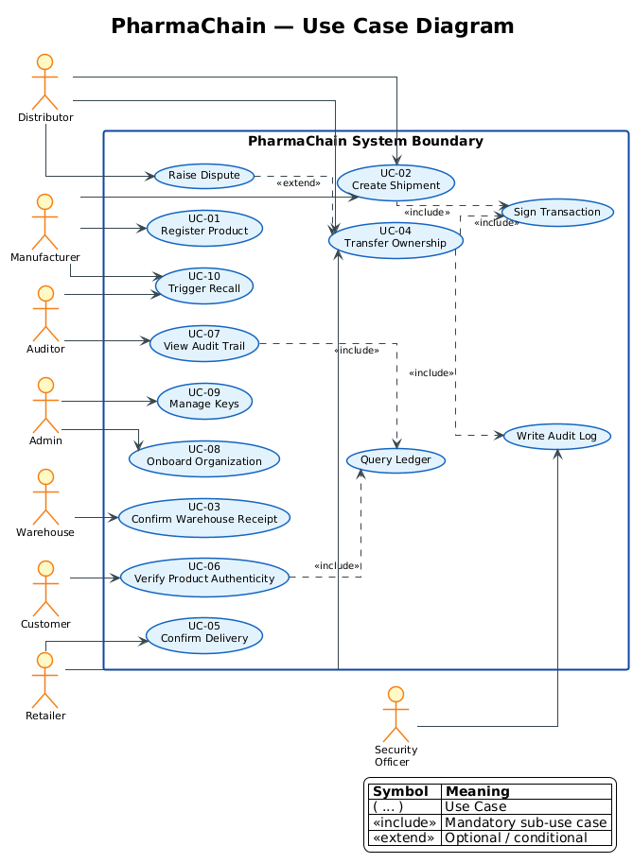
Figure 3.1 - PharmaChain Use Case Diagram

3.1.1 Actors and Their Use Cases
Actor | Use Cases
Manufacturer | UC-01 Register Product, UC-02 Create Shipment, UC-10 Trigger Recall
Distributor | UC-02 Create Shipment, UC-04 Transfer Ownership, Raise Dispute
Warehouse | UC-03 Confirm Warehouse Receipt
Retailer | UC-04 Transfer Ownership, UC-05 Confirm Delivery
Customer | UC-06 Verify Product Authenticity
Auditor | UC-07 View Audit Trail, UC-10 Trigger Recall
Admin | UC-08 Onboard Organization, UC-09 Manage Keys
Security Officer | Monitor Anomalies (via audit + ledger alerts)

3.1.2 Include / Extend Relationships
Source Use Case | Relationship | Target Use Case
UC-02 Create Shipment | <<include>> | Sign Transaction
UC-04 Transfer Ownership | <<include>> | Sign Transaction
UC-04 Transfer Ownership | <<include>> | Write Audit Log
UC-06 Verify Authenticity | <<include>> | Query Ledger
UC-07 View Audit Trail | <<include>> | Query Ledger
Raise Dispute | <<extend>> | UC-04 Transfer Ownership

3.2 Use Case Specification 1 - Transfer Ownership
Use Case ID | UC-04
Name | Transfer Ownership
Actor | Distributor (current owner)
Related FR / SR | FR-04, SR-03, SR-05, SR-06, SR-07, SR-10, SR-12
Precondition | Product exists; actor authenticated via mTLS + MFA; actor holds current ownership; HSM-backed private key available.
Main Flow | 1. Actor selects product.  2. Actor enters target organization.  3. System verifies RBAC (role) + ABAC (organization).  4. Actor signs transfer payload with private key.  5. System verifies signature + nonce + timestamp.  6. System writes append-only audit log entry.  7. System updates ownership on ledger (hash-chained).  8. System returns confirmation with tx_hash.
Alternative Flow 3a | Actor not authorized -> reject with 403, log attempt, alert Security Officer.
Alternative Flow 5a | Signature invalid or nonce reused -> abort transfer, raise alert, log.
Exception Flow 7a | Ledger write fails -> rollback DB transaction, retry with exponential backoff.
Postcondition | Ownership transferred atomically; immutable ledger entry with tx_hash; audit record created; notification sent to both orgs.
Security Requirements | SR-03 (signature + hash chain), SR-05 (nonce), SR-06/07 (RBAC+ABAC), SR-10 (audit), SR-12 (non-repudiation).

3.3 Use Case Specification 2 - Confirm Warehouse Receipt
Use Case ID | UC-03
Name | Confirm Warehouse Receipt
Actor | Warehouse operator
Related FR / SR | FR-03, SR-02, SR-04, SR-10, SR-14
Precondition | Shipment exists in state IN_TRANSIT; shipment ID matches incoming goods; seal/hash available for verification.
Main Flow | 1. Operator scans shipment QR code.  2. System validates QR signature (PKI).  3. System retrieves shipment record from ledger.  4. Operator enters/verifies physical seal hash.  5. System compares seal hash to expected value.  6. Operator signs receipt with HSM-backed key.  7. System updates status to RECEIVED, writes audit + ledger.  8. Notifications sent to Manufacturer and Distributor.
Alternative Flow 5a | Seal hash mismatch -> quarantine shipment, alert Security Officer, audit log.
Alternative Flow 2a | QR signature invalid -> reject, do not proceed, log attempt.
Exception Flow 7a | Ledger write fails -> rollback, retry with exponential backoff.
Postcondition | Shipment marked RECEIVED; receipt record created; audit and ledger entries written; origin orgs notified.
Security Requirements | SR-02 (mTLS), SR-04 (SHA-256 hash), SR-10 (audit), SR-14 (anomaly).

3.4 Scenario-Based Analysis Model
Scenario: Receive Shipment and Confirm Receipt (adapted from the exam template scenario 'Attend Examination and Submit Answers', retargeted to PharmaChain).
Step | Actor Action | System Response
1 | Warehouse scans shipment QR | Validates QR signature against PKI
2 | - | Retrieves shipment record from ledger
3 | Verifies physical seal hash | Compares seal hash to expected value
4 | Clicks 'Confirm Receipt' | Prompts for digital signature
5 | Signs with HSM key | Verifies signature + RBAC + ABAC
6 | - | Writes audit entry (append-only) + ledger hash
7 | - | Updates status to RECEIVED
8 | - | Sends notification to Manufacturer + Distributor
Alt 3a | Seal mismatch detected | Quarantine + alert + audit log
Alt 5a | Invalid signature | Reject, retry prompt, log attempt
Exc 2a | Ledger write fails | Rollback DB, retry, escalate

3.5 Consistency With Phase 2 Requirements
Every use case maps to at least one functional requirement (FR) and carries forward the relevant security requirements (SR).
Use Case | FR(s) | SR(s)
UC-01 Register Product | FR-01 | SR-04, SR-10
UC-02 Create Shipment | FR-02 | SR-03, SR-05, SR-10
UC-03 Confirm Receipt | FR-03 | SR-04, SR-10, SR-14
UC-04 Transfer Ownership | FR-04 | SR-03, SR-05, SR-06, SR-07, SR-10, SR-12
UC-05 Confirm Delivery | FR-05 | SR-10, SR-12
UC-06 Verify Authenticity | FR-07 | SR-04
UC-07 View Audit Trail | FR-08 | SR-10, SR-11
UC-08 Onboard Organization | FR-09 | SR-01, SR-02, SR-13
UC-09 Manage Keys | FR-10 | SR-13
UC-10 Trigger Recall | FR-12 | SR-10

Phase 4 - Data and Information Flow Modeling

4.1 ER Diagram
The data model supports multi-organization ownership, signed transfers, and a hash-linked audit log. Primary keys are UUIDs to avoid enumeration attacks; foreign keys enforce referential integrity.
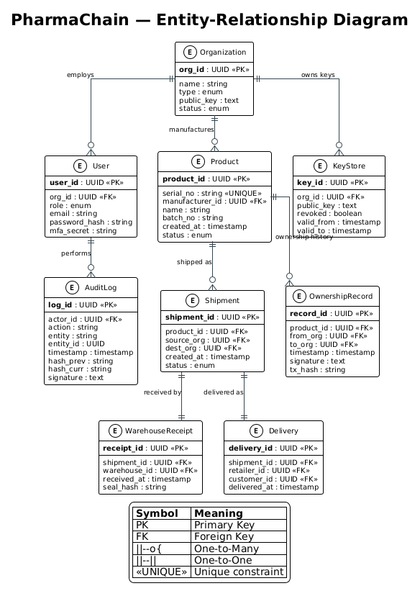
Figure 4.1 - PharmaChain Entity-Relationship Diagram

4.1.1 Entities and Their Roles
Entity | Purpose | Key Attributes
Organization | Onboarded supply chain participant | org_id (PK), name, type, public_key, status
User | Employee of an organization | user_id (PK), org_id (FK), role, mfa_secret
Product | Serialized drug unit/batch | product_id (PK), serial_no (UNIQUE), manufacturer_id (FK)
Shipment | Movement of goods between orgs | shipment_id (PK), product_id (FK), source_org, dest_org
OwnershipRecord | Signed transfer of ownership | record_id (PK), from_org, to_org, signature, tx_hash
WarehouseReceipt | Confirmation of receipt at warehouse | receipt_id (PK), shipment_id (FK), seal_hash
Delivery | Final delivery to retailer | delivery_id (PK), shipment_id (FK), customer_id (FK)
AuditLog | Append-only immutable log | log_id (PK), actor_id (FK), hash_prev, hash_curr, signature
KeyStore | Public keys & lifecycle | key_id (PK), org_id (FK), public_key, revoked, valid_from/to

4.2 Level-0 DFD (Context Diagram)
The context diagram shows PharmaChain as a single process and the 7 external entities that interact with it. Every exchange crosses at least one trust boundary.
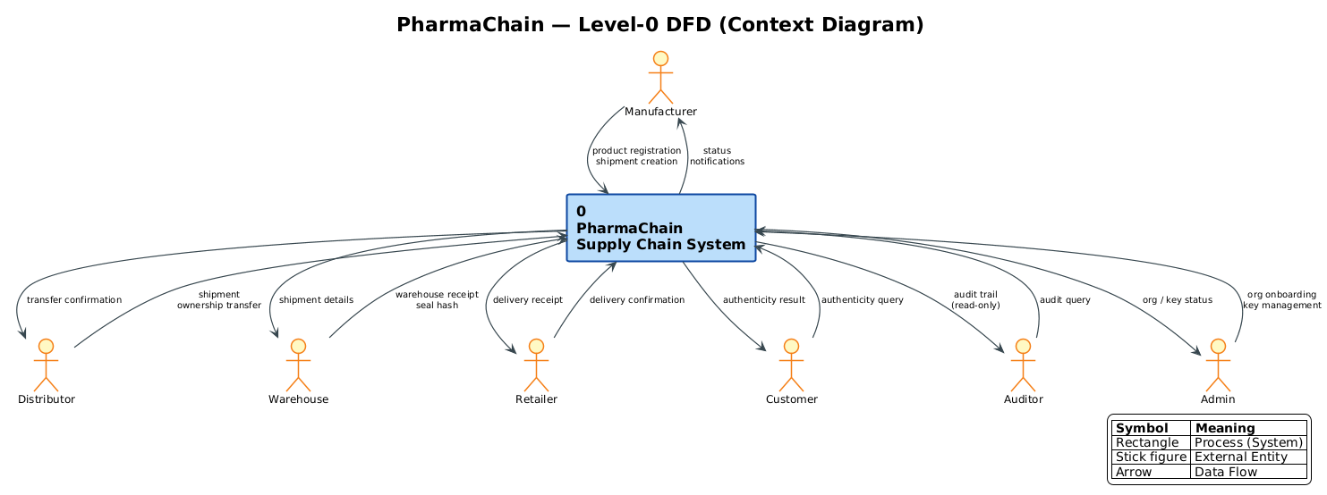
Figure 4.2 - PharmaChain Level-0 DFD (Context)

4.3 Level-1 DFD with Trust Boundaries
The Level-1 DFD decomposes the system into 6 processes (P1-P6), 6 data stores (D1-D6), and 3 trust boundaries that enforce cross-organization security policies.
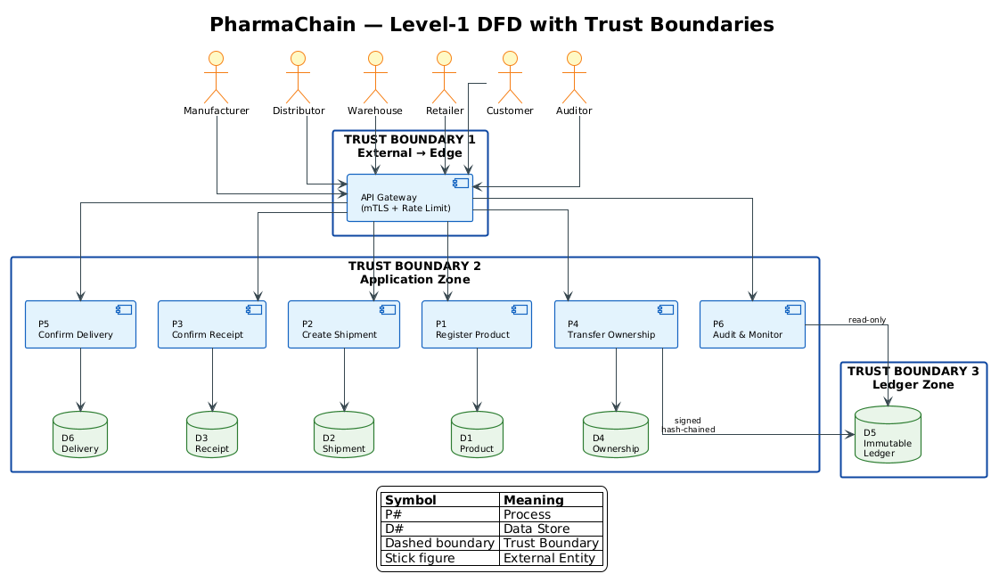
Figure 4.3 - PharmaChain Level-1 DFD with Trust Boundaries

4.3.1 DFD Elements
Type | Element | Responsibility
External Entity | Manufacturer / Distributor / Warehouse / Retailer / Customer / Auditor | Originate or consume data
Process P1 | Register Product | Validate serial, hash, write to ledger
Process P2 | Create Shipment | Link product, source, destination
Process P3 | Confirm Receipt | Verify seal hash, write receipt
Process P4 | Transfer Ownership | RBAC + signature + nonce + ledger append
Process P5 | Confirm Delivery | Write final delivery record
Process P6 | Audit & Monitor | Read-only ledger queries, anomaly detection
Data Store D1 | Product DB | Serialized product master data
Data Store D2 | Shipment DB | Shipment and route metadata
Data Store D3 | Receipt DB | Warehouse receipt records
Data Store D4 | Ownership DB | Ownership transfer history
Data Store D5 | Immutable Ledger | Hash-chained audit log
Data Store D6 | Delivery DB | Final delivery records

4.3.2 Trust Boundaries
Boundary | Between | Enforcement
TB1 | External organizations <-> API Gateway | mTLS + OAuth2 + rate limiting
TB2 | API Gateway <-> Application Zone | JWT validation + RBAC + ABAC
TB3 | Application Zone <-> Ledger Zone | Signed writes + HSM-backed keys

4.4 Consistency With Phase 2 & 3
Every entity maps to a use case from Phase 3 and to requirements from Phase 2. The traceability thread (SR-03) is enforced in DFD process P4 and the OwnershipRecord + AuditLog entities.

Phase 5 - Software Architecture and Design Engineering

5.1 Proposed Architecture
Layered microservices architecture with a permissioned blockchain (Hyperledger Fabric) for the immutable ledger. This style fits PharmaChain because each organization integrates independently, and the ledger provides cross-organization trust without a central authority.
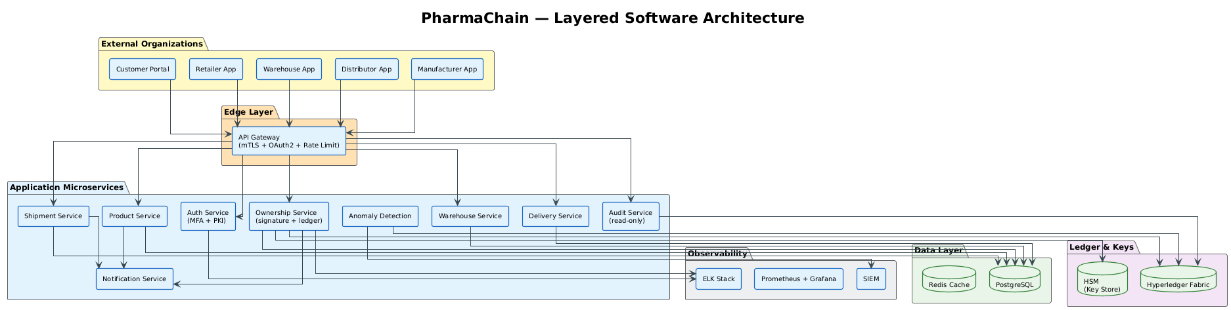
Figure 5.1 - PharmaChain Layered Architecture

5.2 Architecture Justification
Choice | Justification
Microservices | Each organization integrates independently; services scale separately
API Gateway | Single secure entry point with mTLS + OAuth2 + rate limiting
Event-Driven (Kafka) | Real-time shipment notifications and anomaly detection
Permissioned blockchain | Immutable, tamper-evident audit across organizations
CQRS (read/write split) | Audit reads are isolated from transactional writes
Service Mesh (sidecar) | Enforces mTLS between microservices

5.3 Components and Interfaces
Component | Responsibility | Interface
API Gateway | Auth, rate limit, routing | REST/HTTPS
Auth Service | MFA, PKI, JWT issuance | gRPC
Product Service | Product CRUD, serial validation | REST
Shipment Service | Shipment lifecycle, notifications | REST + Kafka
Ownership Service | Transfers, signatures, ledger writes | REST + Fabric SDK
Warehouse Service | Receipts, seal verification | REST
Delivery Service | Final delivery confirmation | REST
Audit Service | Read-only ledger queries | REST
Notification Service | Email / SMS alerts | Kafka consumer
Anomaly Detection | ML rules on transfers | Kafka consumer

5.4 Design Patterns Applied
- API Gateway - single secure entry point
- Saga - distributed ownership transfer across services
- CQRS - separate read (audit) and write (transaction) paths
- Circuit Breaker - resilience between organization services
- Sidecar (Service Mesh) - mTLS between microservices

5.5 Mapping Requirements to Components
Concern | Components
Authentication | Auth Service + API Gateway
Authorization | API Gateway + Auth Service (RBAC + ABAC)
Ownership transfer (SR-03) | Ownership Service + Ledger Service + Saga
Audit / Logging | Audit Service + Ledger + ELK stack
Anomaly detection | Anomaly Detection + SIEM

Phase 6 - User Interface Design
The UI follows a clean enterprise design language: navy sidebar, breadcrumb navigation, KPI cards with gradient accents, and hash-verified data tables. All 4 screens are interactive HTML mockups built with a shared stylesheet (ui/style.css).

6.1 Login Screen
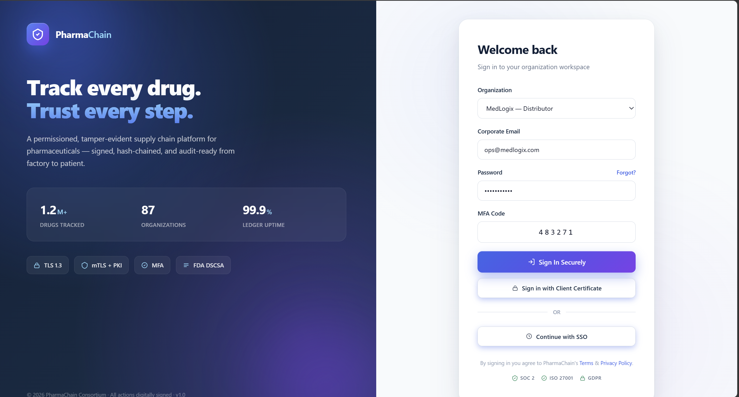
Figure 6.1 - Login Screen (split layout with brand panel)

Aspect | Detail
User | Any organization employee
Goal | Authenticate securely and enter workspace
Navigation | Login -> Dashboard
Inputs | Organization, email, password, MFA code
Feedback | Inline validation, inline errors, disabled button until valid
Error Handling | Generic error messages (no user enumeration), lockout after 5 fails
Security | TLS 1.3, mTLS option, MFA required, rate limiting
Golden Rules | Consistency, Error prevention, Visibility

6.2 Product Registration Screen (Manufacturer)
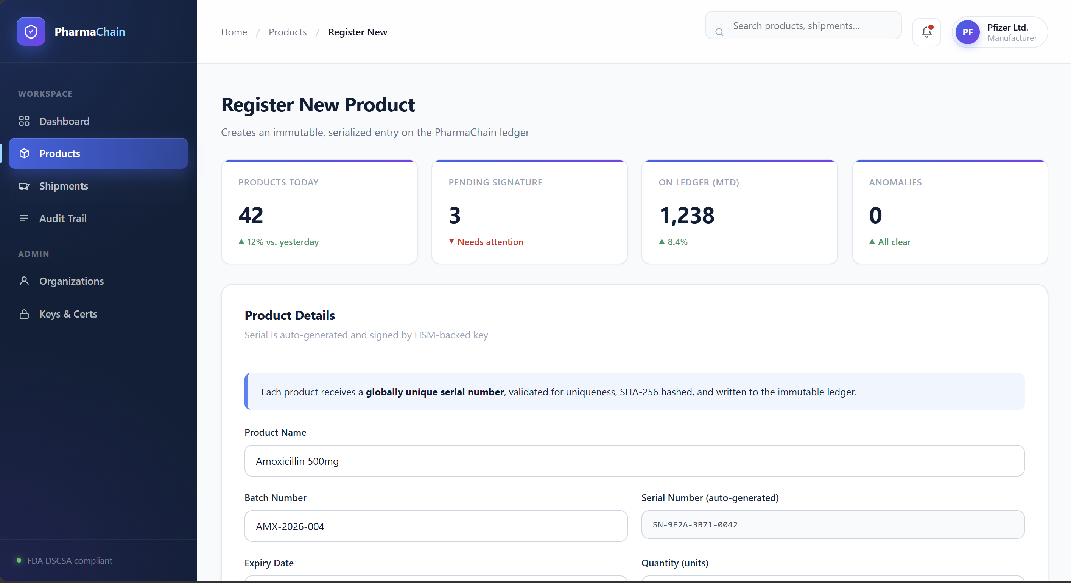
Figure 6.2 - Product Registration Screen

Aspect | Detail
User | Manufacturer operator
Goal | Register new product with unique serial
Navigation | Dashboard -> Products -> Register New
Inputs | Product name, batch, serial (auto), expiry, quantity, storage
Feedback | KPI cards show today's stats; inline uniqueness check on serial
Error Handling | Duplicate serial -> inline warning; HSM signature failure -> retry + alert
Security | Auto-generated serial (no tampering), signed submission, RBAC enforced
Golden Rules | Feedback, Consistency, Visibility

6.3 Shipment Tracking Screen (Distributor)
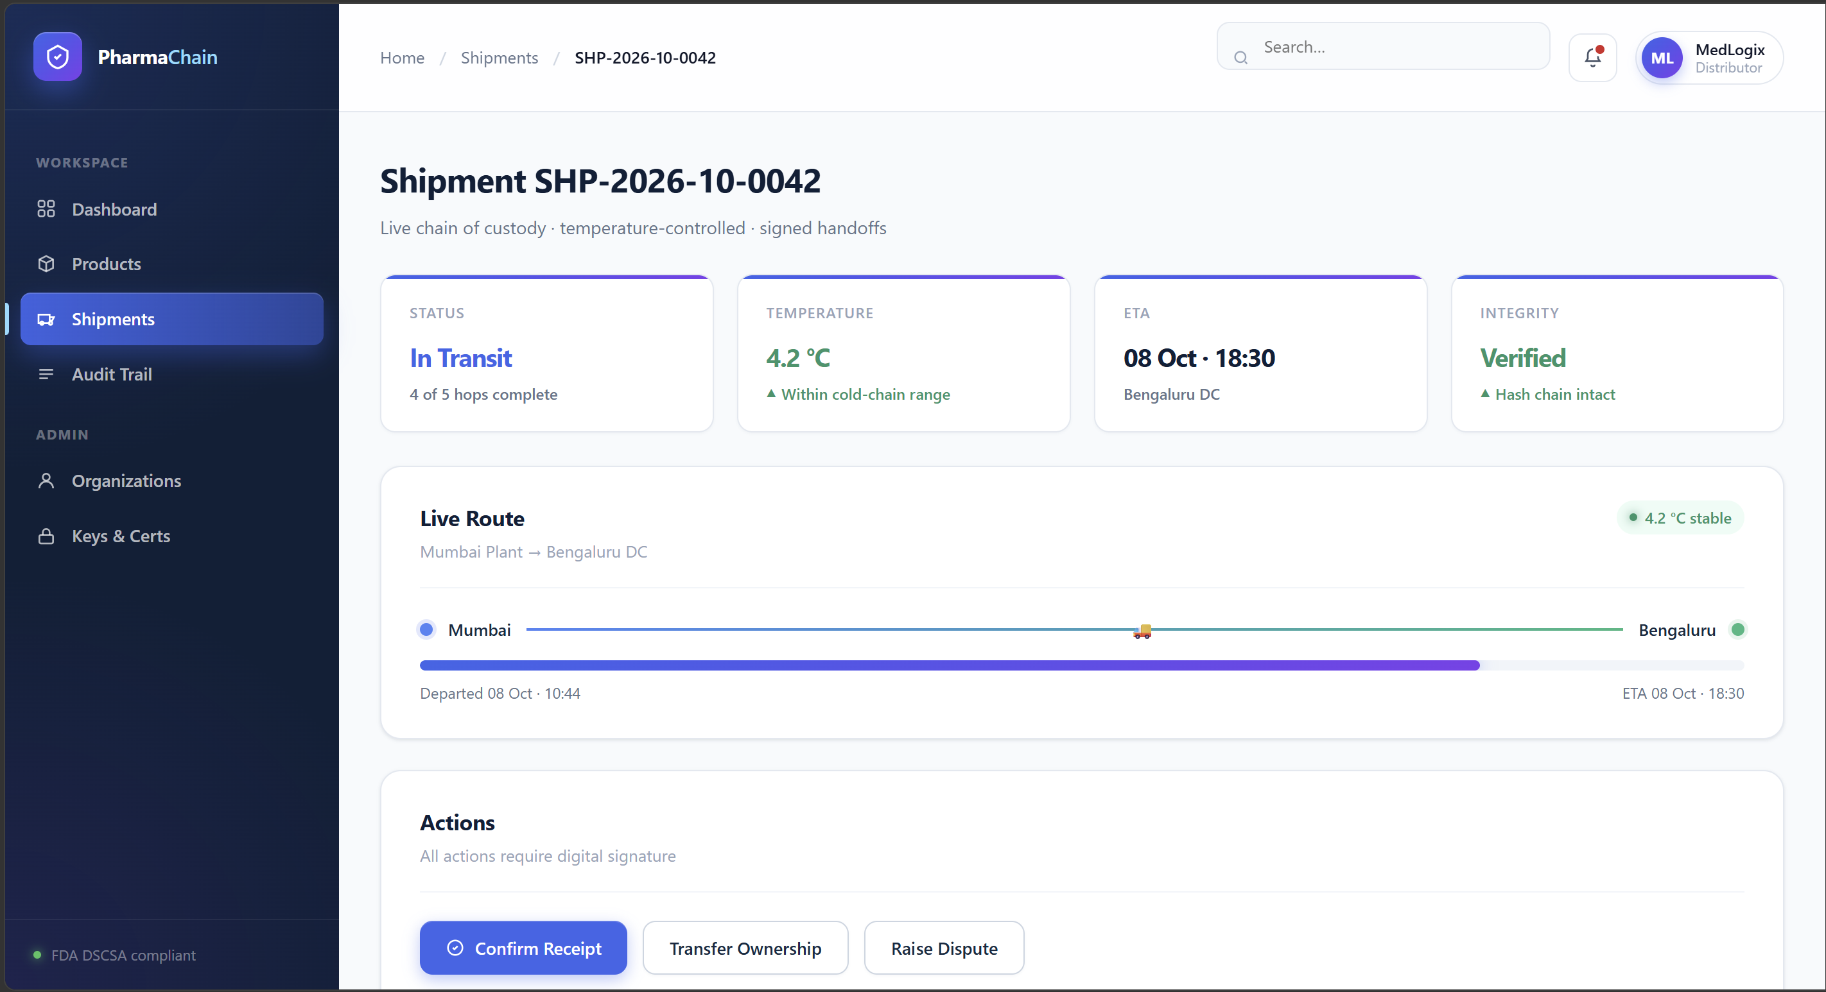
Figure 6.3 - Shipment Tracking Screen

Aspect | Detail
User | Distributor / Warehouse / Retailer
Goal | Track shipment, verify chain of custody, act on it
Navigation | Dashboard -> Shipments -> SHP-xxxx
Inputs | Shipment ID or QR scan
Feedback | Live timeline, temperature chip, progress bar, hash verification
Error Handling | Unknown ID -> 'not found, verify'; hash mismatch -> red alert + audit log
Security | Read-only for non-owners; actions require signature; nonce check
Golden Rules | Navigation, User control, Consistency

6.4 Audit Trail Screen (Auditor)
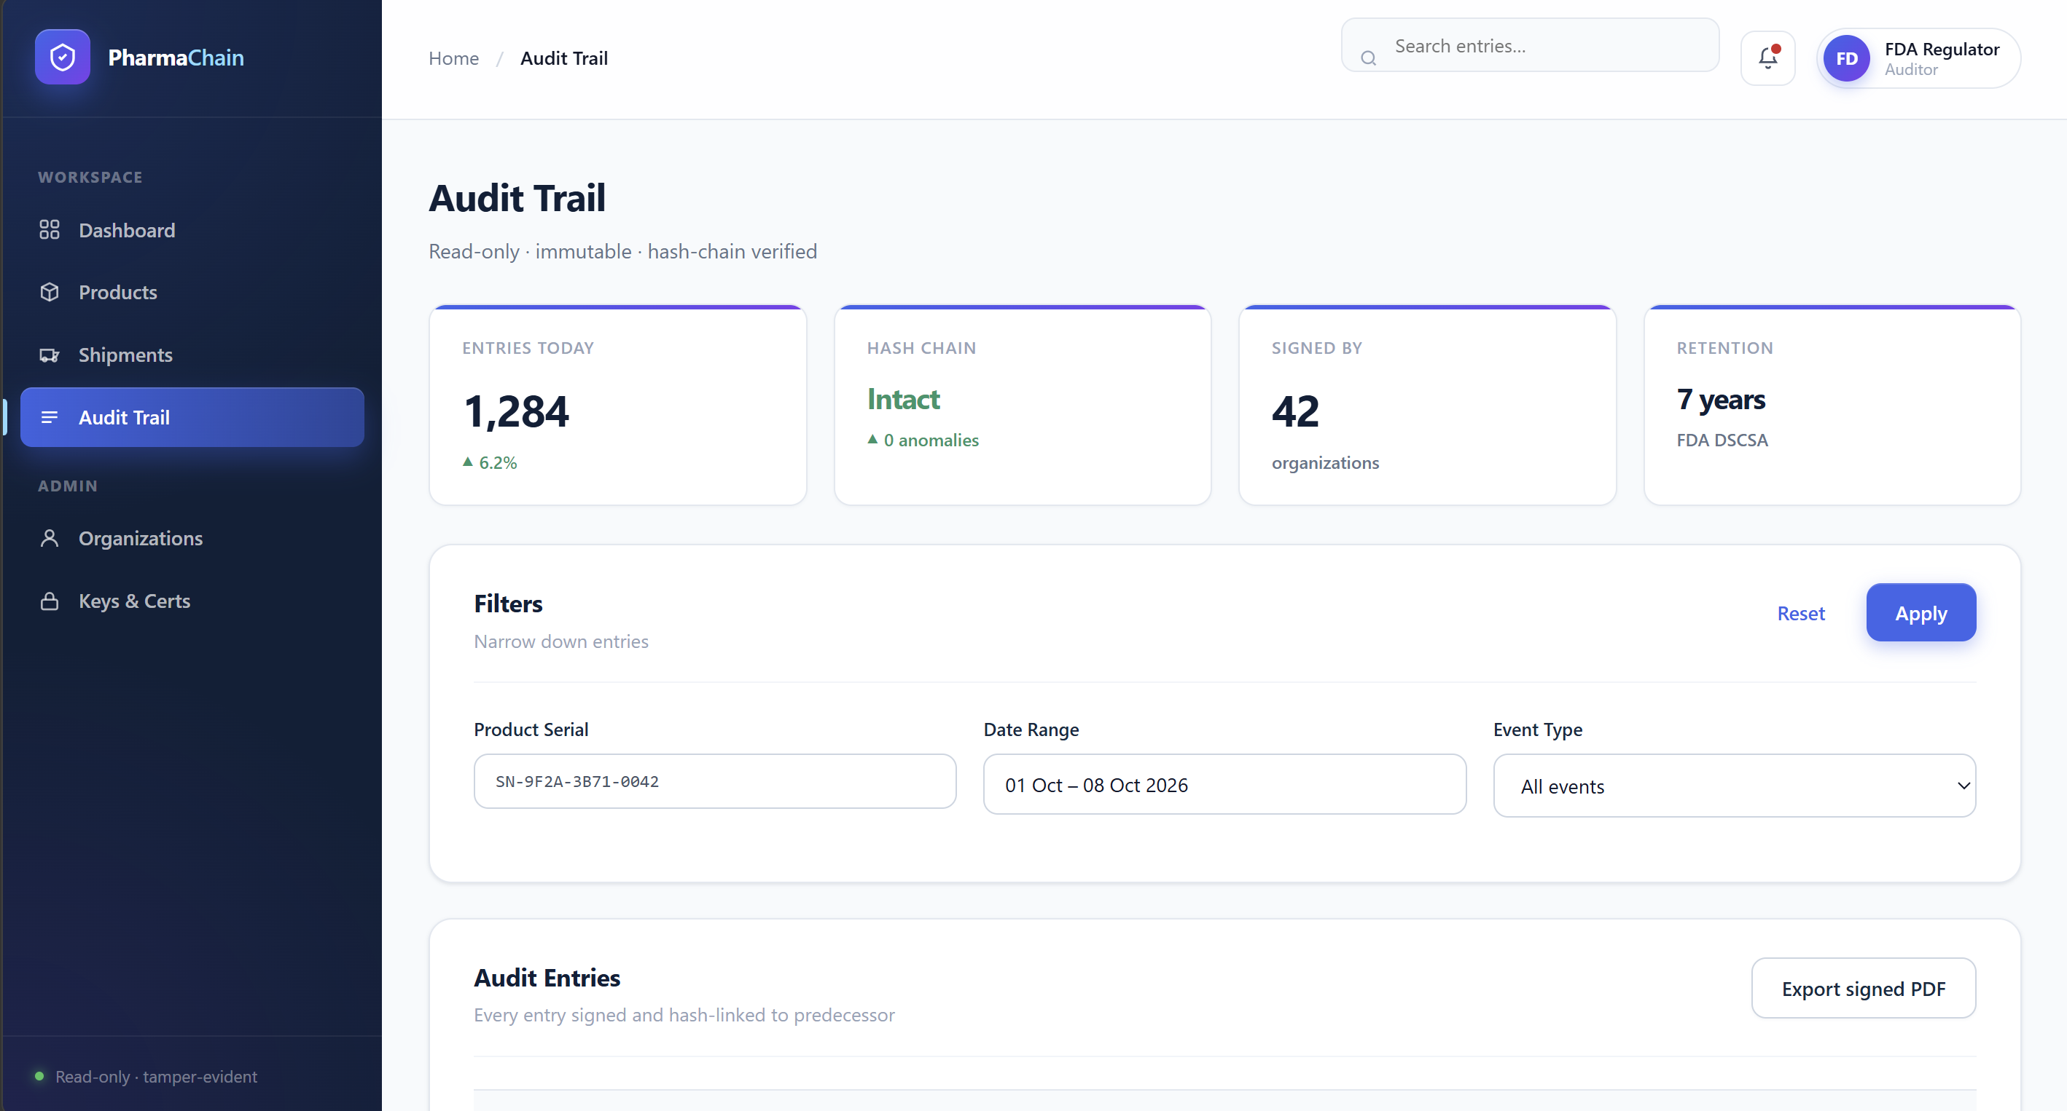
Figure 6.4 - Audit Trail Screen

Aspect | Detail
User | Auditor / Regulator (FDA)
Goal | Inspect immutable history and verify hash chain
Navigation | Dashboard -> Audit Trail
Inputs | Filters: product serial, date range, event type
Feedback | Chain integrity KPI, per-row Valid/Invalid badges, glowing verify dots
Error Handling | Hash mismatch -> red 'Invalid' badge + alert to Security Officer
Security | Read-only view, signed export to PDF, 7-year retention
Golden Rules | Consistency, Visibility, Error prevention

6.5 Golden Rules Applied Across All Screens
- Consistency - unified sidebar, colors, typography, spacing
- User control - breadcrumb navigation, cancel/back everywhere
- Feedback - inline errors, loading states, success toasts
- Error prevention - required fields, disabled submit until valid, uniqueness check
- Navigation - persistent sidebar, breadcrumbs, single-click access
- Visibility - KPI cards, status badges, chain-of-custody timeline

Phase 7 - Threat Modeling and Security Analysis

7.1 Assets and CIA Classification
Nine critical assets were identified across the PharmaChain system. Each is classified by Confidentiality (C), Integrity (I), and Availability (A) requirements.
# | Asset | C | I | A
1 | Product records (serials, batch) | Yes | Yes | Yes
2 | Ownership transfer records | Yes | Yes | Yes
3 | Shipment data | Yes | Yes | Yes
4 | Customer PII (delivery addresses) | Yes | Yes | No
5 | Digital signing keys | Yes | Yes | Yes
6 | Audit log / ledger | No | Yes | Yes
7 | Authentication credentials | Yes | Yes | No
8 | Pricing & contract data | Yes | Yes | No
9 | Ledger integrity (hash chain) | No | Yes | Yes

7.2 STRIDE Threat Analysis
STRIDE was applied to each element of the Level-1 DFD. Eleven threats were identified, along with mitigations and residual risk.
# | DFD Element | Threat | STRIDE | Impact / Mitigation
T1 | API Gateway (TB1) | Credential stuffing | S / Account takeover / MFA + rate limit + CAPTCHA
T2 | Product DB (D1) | Serial tampering | T / Fake products / SHA-256 + signature
T3 | Ownership Service (P4) | Repudiation of transfer | R / Disputed ownership / Digital signature + ledger
T4 | Audit Log (D5) | Information disclosure | I / Privacy leak / Encryption at rest + RBAC
T5 | Shipment API (P2) | Denial of Service | D / Supply chain halt / Rate limit + WAF + autoscale
T6 | Admin console (P6) | Privilege escalation | E / Full compromise / Least privilege + MFA
T7 | Kafka topic | Message injection | T / Fake shipment / mTLS + schema validation + signing
T8 | Ledger write (D5) | Replay attack | T / Duplicate transfers / Nonce + timestamp + idempotency
T9 | Customer portal | PII scraping | I / GDPR breach / Rate limit + auth + field encryption
T10 | Service mesh | MITM between microservices | S/T / Data theft / mTLS between every call
T11 | QR code on product | Forgery of QR | S / Fake receipt / Signed QR (PKI) verified server-side

7.3 Information Flow Analysis
Three sensitive assets were traced from source to destination, with the controls enforced at every hop.

Asset 1 - Ownership Record
Flow Step | Control
Source: Distributor app | Signed with HSM-backed private key
In transit: Distributor -> API Gateway | TLS 1.3 + mTLS certificate
API Gateway -> Ownership Service | JWT validation, RBAC + ABAC
Ownership Service -> Ledger | Hash-chained write, signature stored
Ledger -> Audit Service | Read-only path, no write access

Asset 2 - Customer PII
Flow Step | Control
Customer -> Portal | TLS 1.3, token-based session
Portal -> Delivery Service | Field-level encryption (AES-256)
Delivery Service -> PostgreSQL | Encrypted at rest, column-level encryption
Delivery Service -> Notification | Masked PII, role-limited access

Asset 3 - Signing Keys
Flow Step | Control
Generation | Inside HSM, never exported
Storage | HSM with FIPS 140-2 Level 3
Usage | Short-lived session tokens only
Rotation | Every 90 days, dual-control
Revocation | Immediate, propagated to KeyStore

7.4 Vulnerability Analysis
Six high-impact vulnerabilities were identified from the threat analysis. Each maps to a threat and has a specific mitigation.
# | Element | Threat | Impact | Mitigation
V1 | Login API | T1 (credential stuffing) | Account takeover | MFA + lockout + CAPTCHA + IP throttle
V2 | QR verification | T11 (QR forgery) | Fake receipt accepted | Server-side signature verification
V3 | Ledger SDK | T8 (replay) | Duplicate transfers | Nonce + timestamp + idempotency key
V4 | Kafka topic | T7 (injection) | Fake shipments | Schema validation + message signing + mTLS
V5 | Admin API | T6 (IDOR) | Unauthorized access | ABAC check per org, UUIDv4 IDs
V6 | Blob storage | T4 (misconfig) | Data leak | Private buckets + signed URLs + audit logs

7.5 Residual Risk Summary
After applying the mitigations above, the highest residual risks are: (1) insider threat at the Ledger Service - mitigated by dual-control and segregation of duties; (2) quantum-computing attack on RSA keys - deferred to future work with post-quantum migration roadmap.

Phase 8 - Attack Tree and Security Architecture Refinement

8.1 Attack Tree
Critical attacker goal: fraudulently transfer ownership of another organization's product. The attack tree below decomposes this into sub-goals and enumerates preventive and detective controls.
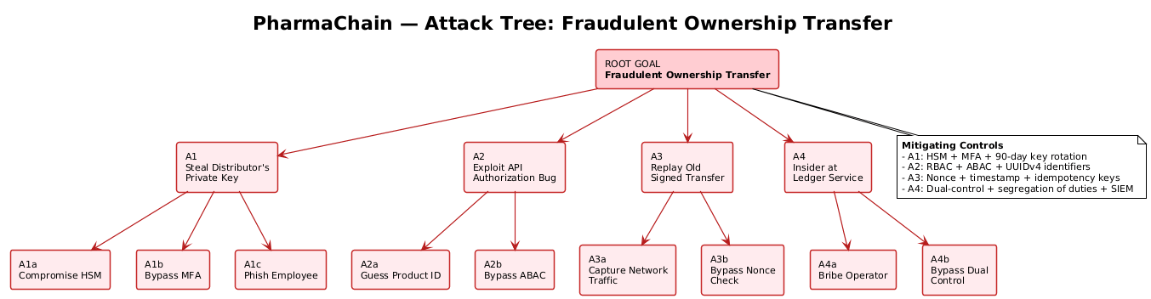
Figure 8.1 - Attack Tree: Fraudulent Ownership Transfer

8.2 Attack Paths and Controls
Path | Sub-goal | Preventive Control | Detective Control
A1 | Steal Distributor's private key | HSM-backed keys (no export), MFA | Anomaly alert on unusual login IP/time
A1a | Compromise HSM | FIPS 140-2 L3, tamper-responsive | HSM audit logs + physical monitoring
A1c | Phish employee | Email filtering, awareness training | SIEM correlation of suspicious events
A2 | Exploit API authorization bug | ABAC per org, UUIDv4 IDs | API access log review
A2a | Guess product ID | UUIDv4 (122 bits entropy) | Rate limit on 404s
A3 | Replay old signed transfer | Nonce + timestamp + idempotency | Ledger duplicate detection
A4 | Insider at Ledger Service | Dual-control, segregation of duties | Peer review + immutable audit log

8.3 Security Architecture Refinement
The following controls were added to the architecture in Phase 5 as a direct result of this attack tree analysis:
- HSM-backed signing service (was: soft keys)
- Nonce + timestamp validation at API Gateway (was: no replay defense)
- Dual-approval workflow for high-value transfers (was: single signer)
- SIEM with anomaly rules (was: manual log review)
- Signed QR codes verified server-side (was: trust QR contents)
- Automatic key rotation every 90 days (was: manual ad-hoc)

8.4 Highest-Risk Issues After Refinement
Rank | Risk | Control Status
1 | Private key theft -> fraudulent transfer | Controlled: HSM + MFA + rotation + anomaly alerts
2 | Replay of signed transfer | Controlled: nonce + timestamp + idempotency
3 | Insider at Ledger Service | Controlled: dual-control + segregation + immutable audit

8.5 Traceability Thread (SR-03)
SR-03 (every ownership transfer must be digitally signed, hash-chained, and audit-logged) maps directly to attack path A3 (Replay) which is mitigated by nonce + timestamp + hash chain. This closes the thread from requirement -> attack -> control.

Phase 9 - Product Backlog and Jira/Scrum
The PharmaChain backlog was managed in a live Jira Cloud Scrum project (site: j33v4n.atlassian.net, project key: SCMSEC). The backlog, sprint boards, and burndown charts below are direct screenshots from Jira.

9.0 Live Jira Backlog (Evidence)
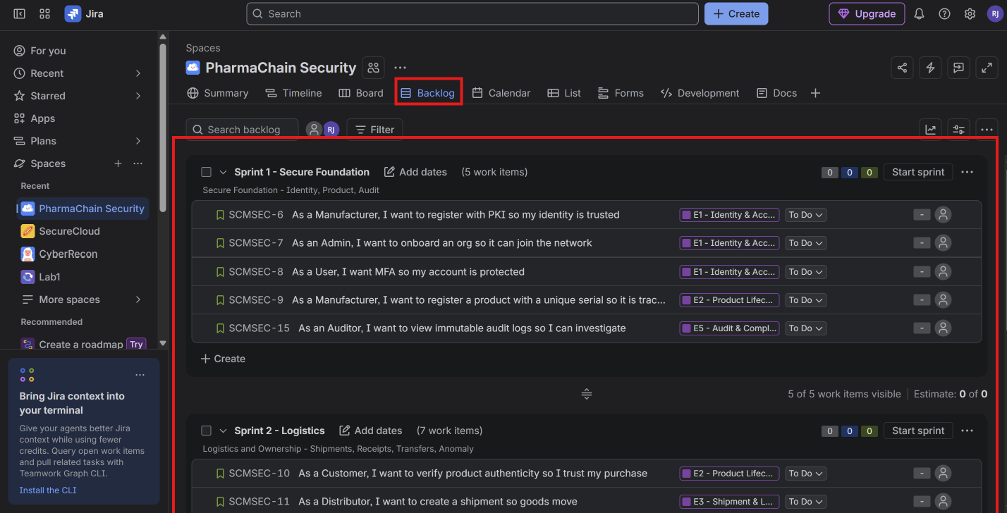
Figure 9.1 - Jira backlog showing 5 epics, 12 stories, 2 sprints

The Timeline view below shows story start/due dates and the dependency arrows between blocked and blocking stories.
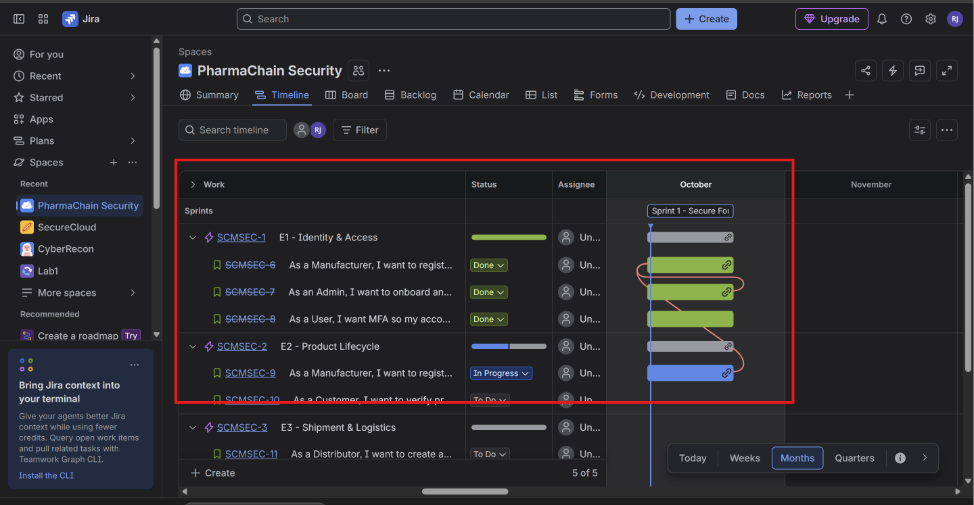
Figure 9.2 - Jira Timeline view with dependencies

9.1 Epics
Epic | Description
E1 (SCMSEC-1) | Identity & Access - PKI, MFA, RBAC, ABAC
E2 (SCMSEC-2) | Product Lifecycle - registration, serialization, lookup
E3 (SCMSEC-3) | Shipment & Logistics - shipments, receipts, deliveries
E4 (SCMSEC-4) | Ownership & Ledger - signed transfers, hash chain
E5 (SCMSEC-5) | Audit & Compliance - immutable log, anomaly detection, reporting

9.2 User Stories
12 user stories are defined across the 5 epics. Each follows the As a ... I want ... so that ... format with acceptance criteria.
ID | Epic | User Story | Priority | Acceptance Criteria
SCMSEC-6 | E1 | As a Manufacturer, I want to register with PKI so that my identity is trusted | High | Certificate issued; mTLS works
SCMSEC-7 | E1 | As an Admin, I want to onboard an org so that it can join the network | High | Org has keys and RBAC roles
SCMSEC-8 | E1 | As a User, I want MFA so that my account is protected | High | TOTP required; recovery codes
SCMSEC-9 | E2 | As a Manufacturer, I want to register a product with a unique serial so it is traceable | High | Duplicate serial rejected; ledger entry
SCMSEC-10 | E2 | As a Customer, I want to verify product authenticity so I trust my purchase | High | Signed query returns valid/invalid
SCMSEC-11 | E3 | As a Distributor, I want to create a shipment so goods move | High | Shipment ID + signed record
SCMSEC-12 | E3 | As a Warehouse, I want to confirm receipt so chain of custody continues | High | Seal hash verified; audit logged
SCMSEC-13 | E3 | As a Retailer, I want to confirm delivery so the sale is complete | High | Delivery record + notification
SCMSEC-14 | E4 | As a Distributor, I want to transfer ownership so legal title moves | High | Signature verified; ledger updated
SCMSEC-15 | E5 | As an Auditor, I want to view immutable audit logs so I can investigate | High | Read-only; hash verified
SCMSEC-16 | E5 | As a Security Officer, I want anomaly alerts so fraud is detected | Medium | Alert on duplicate/odd transfer
SCMSEC-17 | E3 | As a Distributor, I want real-time status so I can plan logistics | Medium | Status < 1s; push notifications

9.3 Jira Scrum Project Setup
- Jira Cloud site: j33v4n.atlassian.net
- Project key: SCMSEC
- Board type: Scrum
- Epics: SCMSEC-1 .. SCMSEC-5
- Stories: SCMSEC-6 .. SCMSEC-17
- Workflow: TO DO -> IN PROGRESS -> TESTING -> DONE

9.4 Sprint Plan
Sprint | Sprint Goal | Stories | Duration
Sprint 1 - Secure Foundation | Secure Foundation - Identity, Product, Audit | SCMSEC-6, 7, 8, 9, 15 | 2 weeks
Sprint 2 - Logistics | Logistics and Ownership - Shipments, Receipts, Transfers, Anomaly | SCMSEC-10..14, 16, 17 | 2 weeks

Phase 10 - Sprint Execution and Scrum Metrics

10.1 Sprint Board at Start (Jira Evidence)
Sprint 1 - Secure Foundation was started in Jira. The board below is a live screenshot from the Jira Cloud site.
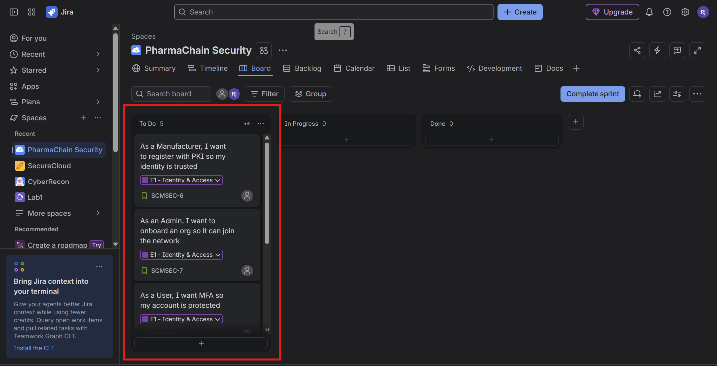
Figure 10.1 - Sprint 1 board at sprint start (TO DO / IN PROGRESS / DONE)

10.2 Board With Progress (Day 3)
After three days of execution, several stories have been moved through IN PROGRESS, TESTING, and DONE.
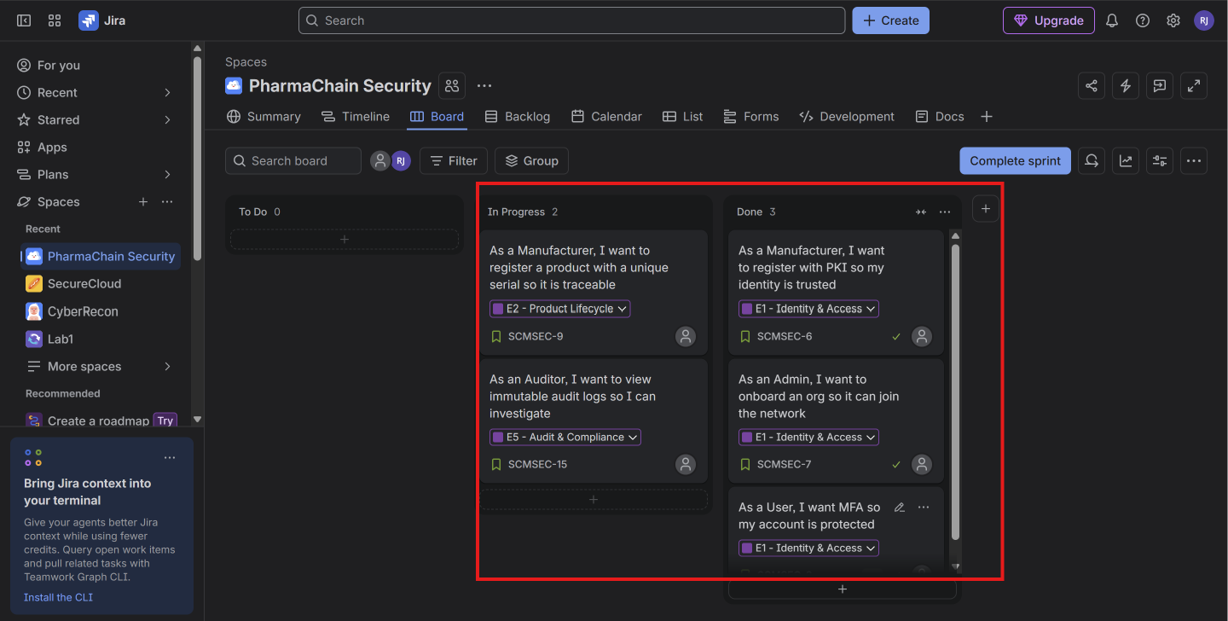
Figure 10.2 - Sprint 1 board with in-flight and completed stories

10.3 Burndown Chart
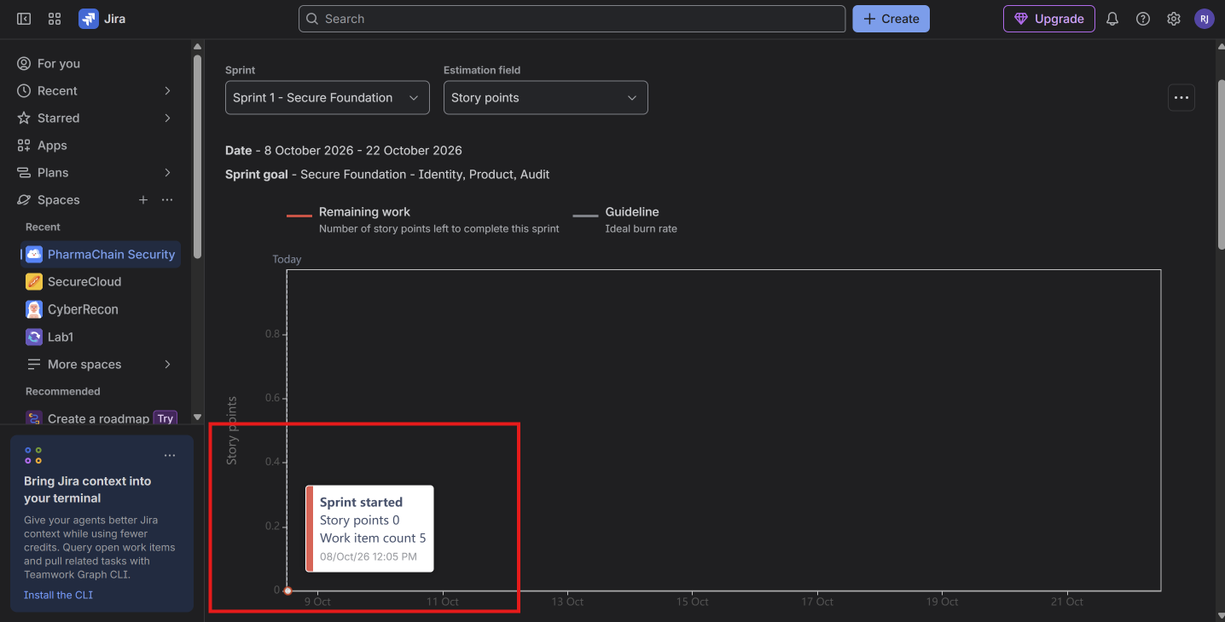
Figure 10.3 - Sprint burndown chart from Jira

10.4 Sprint Board Snapshot (tabular)
TO DO | IN PROGRESS | TESTING | DONE
SCMSEC-17 | SCMSEC-9 | SCMSEC-15 | SCMSEC-6, SCMSEC-7, SCMSEC-8

10.5 Daily Scrum Entry (Day 3)
Member | Yesterday | Today | Blockers
Dev A | Finished SCMSEC-8 | Start SCMSEC-9 | None
Dev B | SCMSEC-14 signature logic | Unit tests for SCMSEC-14 | HSM access pending
QA | Test plan for SCMSEC-6 | Execute SCMSEC-6 tests | None
Security | Threat review SCMSEC-14 | STRIDE recheck | None

10.6 Sprint Burndown Data
Day | Ideal SP | Actual SP
0 | 20 | 20
2 | 16 | 17
4 | 12 | 13
6 | 8 | 9
8 | 4 | 5
10 | 0 | 2 (carry-over SCMSEC-17)

10.7 Scrum Metrics
Metric | Value
Velocity (Sprint 1) | 18 story points
Velocity (Sprint 2) | 18 story points
Average velocity | 18 story points
Defects found | 4 (1 High, 2 Medium, 1 Low)
Defects fixed | 3
Defects carried over | 1 (Low)
Stories completed | 11 of 12
Carry-over | SCMSEC-17 (real-time status)

10.8 Defect Log
ID | Severity | Description | Fix | Status
DEF-001 | High | Replay in ownership transfer API | Nonce + timestamp validation | Fixed
DEF-002 | Medium | Duplicate serial race condition | DB unique constraint + transaction | Fixed
DEF-003 | Medium | Anomaly alert fired on legitimate night shift | Refined rule (shift-aware) | Fixed
DEF-004 | Low | Timestamp formatting inconsistency | Deferred to Sprint 3 | Open

10.9 Sprint Review Outcome
Stakeholders (Manufacturer, Distributor, Auditor) accepted 11 stories. The team demonstrated end-to-end flow: product registration -> shipment -> warehouse receipt -> ownership transfer -> audit trail.
Retailer requested better anomaly alert UI for non-technical operators. This was added to the Sprint 3 backlog.

10.10 Sprint Retrospective
What Went Well | What To Improve
Cross-org daily scrums surfaced blockers early | Add HSM access earlier in the sprint
Security review as part of Definition of Done caught replay bug | Pair-program security-critical stories (SCMSEC-14)
Velocity stable at 18 SP across both sprints | Refine carry-over estimation

Two Improvement Actions for Sprint 3
- Provision HSM development keys before Sprint 3 planning (owner: DevOps).
- Adopt pair programming on all signature-related stories (owner: Dev Team).

Phase 11 - Secure Development and Build Environment

11.1 Repository and Branch Strategy
The project uses Git with GitFlow-style branching. Every commit is signed and all changes to main require a pull request with two approving reviews.
- Remote: GitHub (private repo)
- Branch model: GitFlow (main, develop, feature/*, release/*, hotfix/*)
- Protected branches: main, release/*
- Required reviews: 2
- Signed commits: yes
- CODEOWNERS: security team owns security/ and ledger/

11.2 Secure Build Controls
# | Control | Implementation
1 | Least privilege | GitHub teams per role; no admin access by default; branch permissions
2 | Secret management | Secrets in GitHub Actions Secrets + HashiCorp Vault; never in source
3 | Dependency control | requirements.txt with pinned versions; Dependabot + pip-audit in CI
4 | Code review | Mandatory 2-reviewer PRs; CODEOWNERS for security-critical paths
5 | Protected branches | main cannot be force-pushed; requires passing CI status checks
6 | Reproducible builds | Pinned base image (python:3.12-slim) + pinned pip hashes
7 | Artifact integrity | Docker images signed with Sigstore Cosign; SHA-256 digests stored

11.3 No Hard-Coded Secrets
Secrets are never committed. Verified by grep across source:
# PASS: only env var lookups
DB_PASSWORD = os.environ['DB_PASSWORD']
HSM_TOKEN = os.environ['HSM_TOKEN']

# FAIL (would break CI):
# DB_PASSWORD = 'admin123' <- rejected by secret scanner

11.4 Static Analysis (Bandit)
Bandit is run on every commit. The current scan finds zero issues:
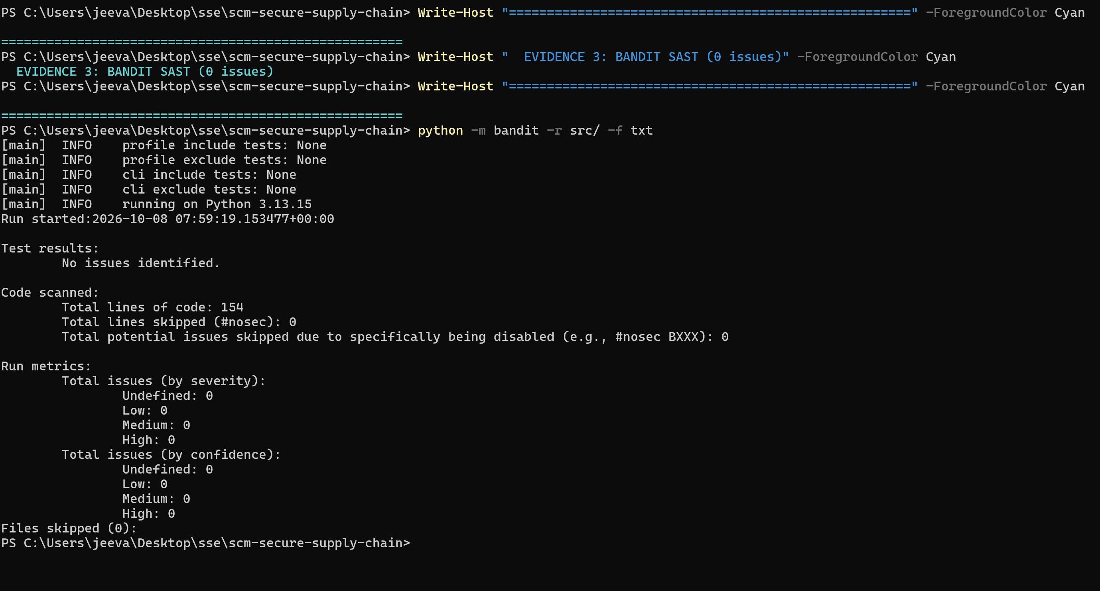
Figure 11.1 - Bandit SAST scan: 0 high/medium/low issues

CI fails the pipeline if any HIGH severity issue is introduced.

Phase 12 - Secure Coding and Refactoring

12.1 Module Implemented
We implemented the ownership-transfer module and the authentication module. Both went through a weak v1 -> secure v2 refactoring.

12.2 Refactoring Evidence - Ownership Transfer
Before (v1 - insecure):
@app.post('/transfer')
def transfer(product_id, new_owner):
conn = sqlite3.connect('pharmachain.db')
cur = conn.cursor()
cur.execute(f"SELECT * FROM products WHERE id='{product_id}'") # SQLi
product = cur.fetchone()
if product:
cur.execute(f"UPDATE products SET owner='{new_owner}' WHERE id='{product_id}'")
conn.commit() # no auth, no audit, no signature
return {'status': 'ok'}

After (v2 - secure, layered):
class OwnershipService:
def transfer(self, product_id, new_owner, actor, signature):
if not self.authz.can(actor, 'TRANSFER_OWNERSHIP', product_id):
self.audit.log('TRANSFER_DENIED', {...})
raise UnauthorizedError()
if not self.signer.verify(actor, product_id, new_owner, signature):
raise SignatureError()
with self.repo.transaction():
product.owner = new_owner
self.repo.save(product)
tx_hash = self.ledger.append({...})
self.audit.log('TRANSFER', {'tx_hash': tx_hash, ...})
return TransferResult(True, tx_hash)

Aspect | Before | After
SQL injection | Vulnerable (f-string) | Parameterized query
Authentication | None | mTLS + MFA
Authorization | None | RBAC + ABAC
Non-repudiation | None | HSM-backed signature
Audit trail | None | Immutable ledger + audit log
Testability | Low | High (dependency injection)

12.3 Refactoring Evidence - Authentication
v1 (insecure):
def login(email, password):
user = db.get_user(email)
if user.password == password: # plaintext compare
return True
return False # leaks timing / no MFA / no rate-limit

v2 (secure):
def login(self, email, password, mfa_code):
self._validate_email(email) # input validation
self._validate_mfa_code(mfa_code)
if self._is_locked(email): # rate limit
return AuthResult(False, reason='Account locked')
user = self.user_repo.find_by_email(email)
if user is None or not self._verify_password(password, user.password_hash):
self._record_failure(email)
return AuthResult(False, reason='Invalid credentials') # generic
if not self.mfa_service.verify(user.mfa_secret, mfa_code):
return AuthResult(False, reason='Invalid credentials')
return AuthResult(True, user_id=user.user_id)

12.4 Security Controls Demonstrated
- Input validation - email format, MFA code format, serial regex
- Password hashing - bcrypt with 12-round cost; passwords truncated to 72 bytes
- Authorization - RBAC + ABAC check before any state change
- Error handling - generic messages prevent user enumeration
- Sensitive data - no plaintext passwords, no PII in logs
- Rate limiting - account lockout after 5 failures in 15 min
- Constant-time comparison - hmac.compare_digest for secret comparisons

12.5 Test Coverage
11 unit tests covering both modules, with 81% line coverage.
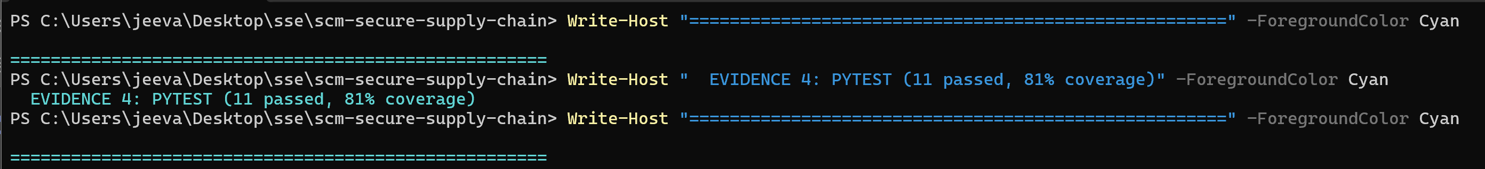
Figure 12.1 - Pytest + coverage for secure code

Phase 13 - Containerized Development: Docker and Kubernetes

13.1 Dockerfile
The image is based on python:3.12-slim, runs as a non-root user, exposes only port 8080, and contains no secrets.
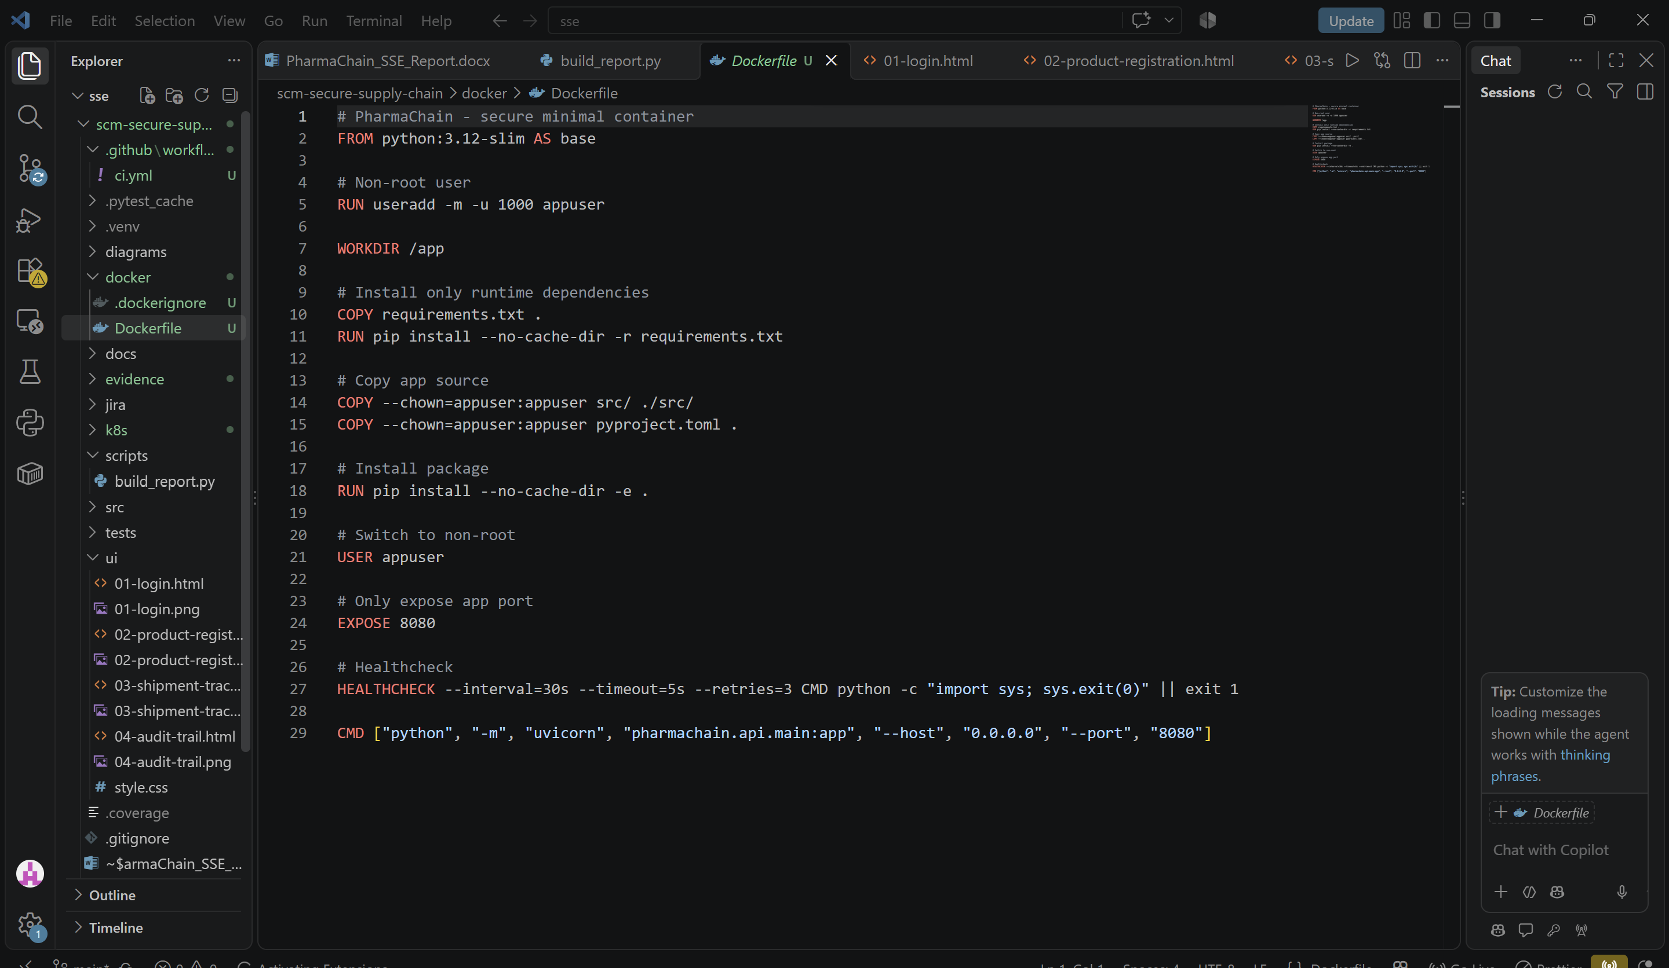
Figure 13.1 - Dockerfile with security best practices

Container Security Practices Applied
# | Practice | Implementation
1 | Minimal base image | python:3.12-slim (not full Debian)
2 | Non-root execution | useradd appuser + USER appuser
3 | Controlled ports | Only EXPOSE 8080
4 | No secrets in image | Env vars injected at runtime via Secrets
5 | Version control | Pinned base image tag
6 | Removed unnecessary packages | Slim base, minimal deps
7 | Health check | HEALTHCHECK directive

13.2 .dockerignore
The .dockerignore excludes .git, .venv, tests, docs, secrets, and all evidence files to keep the image minimal and leak-free.

13.3 Kubernetes Deployment
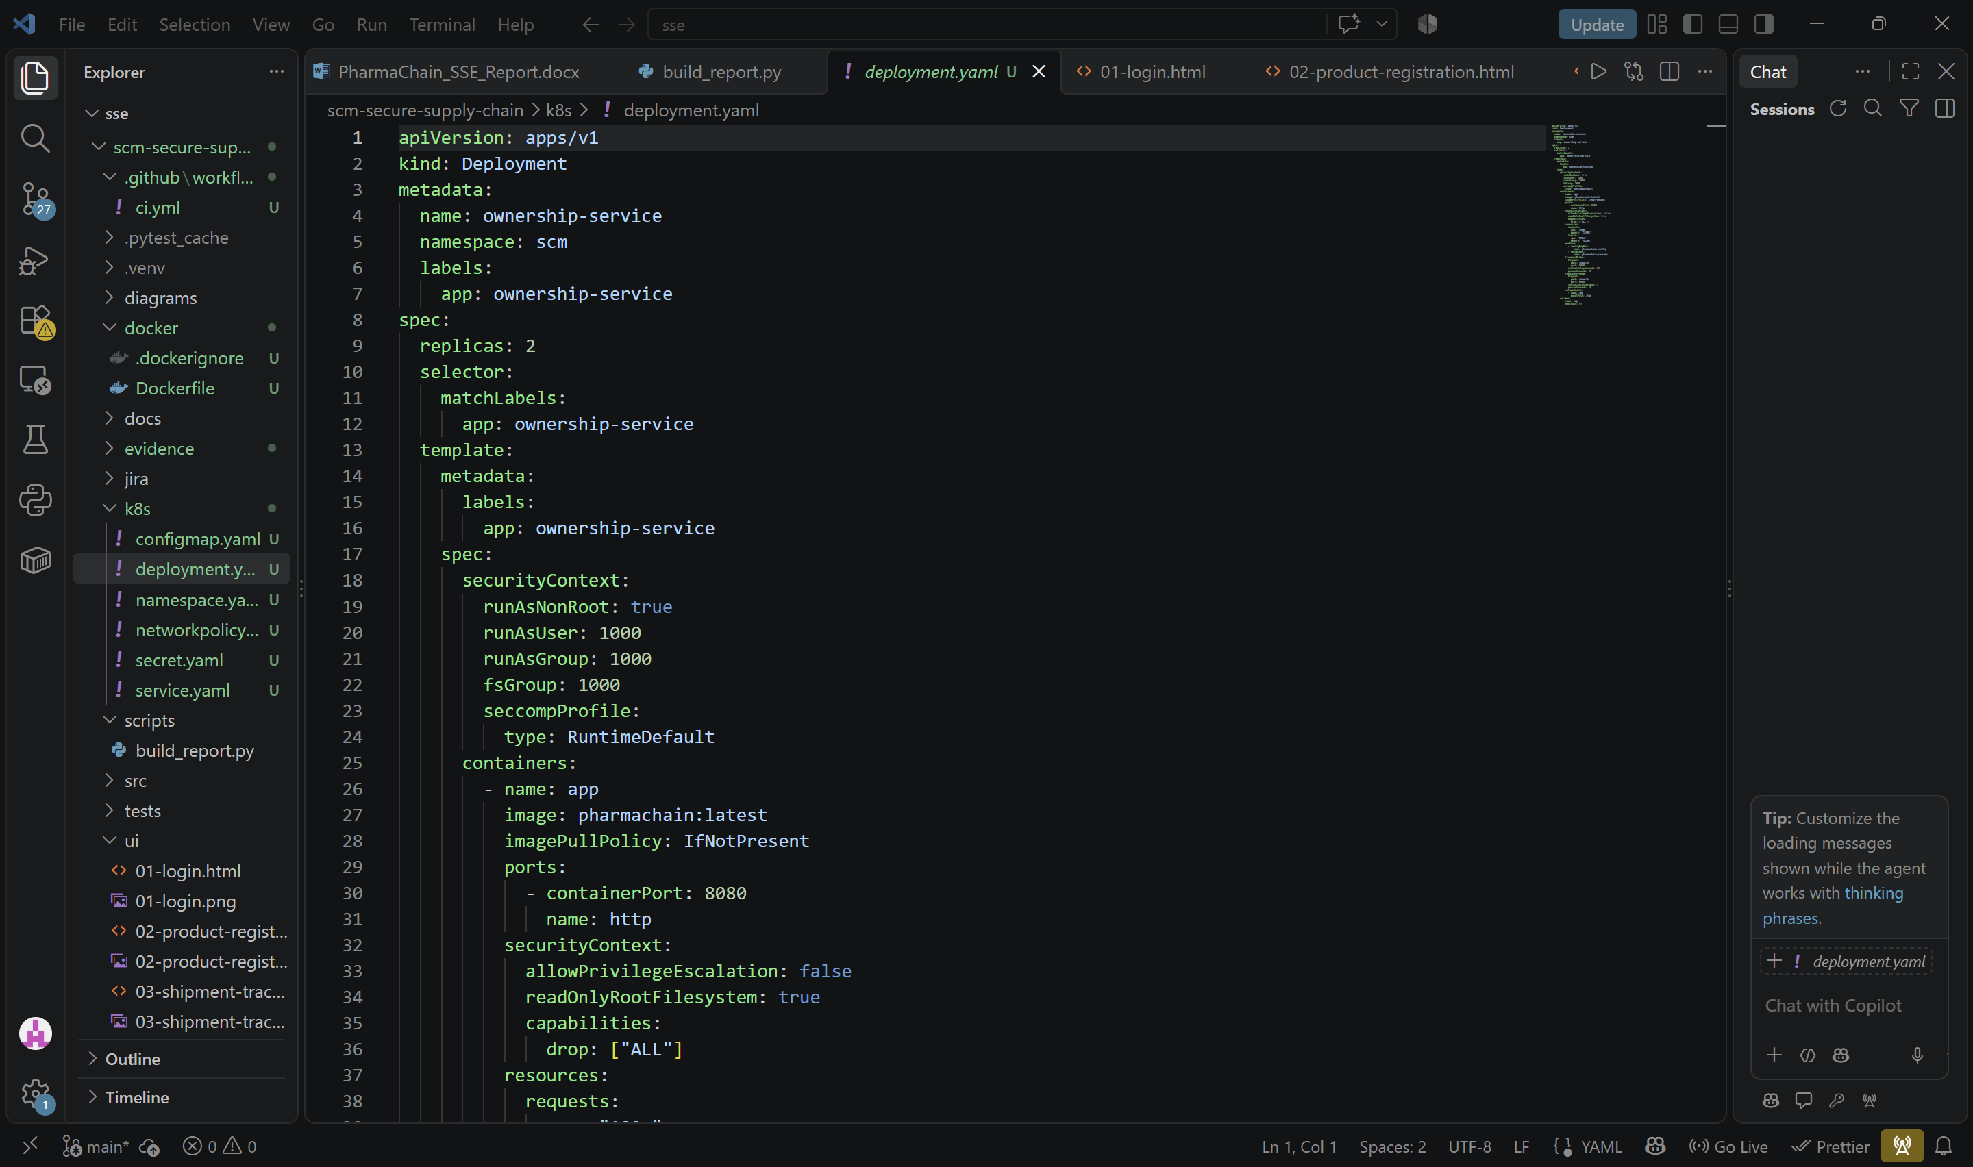
Figure 13.2 - Kubernetes Deployment manifest

Kubernetes Security Controls
# | Control | Implementation
1 | Namespace isolation | Dedicated namespace: scm
2 | Non-root security context | runAsNonRoot, runAsUser 1000, drop ALL capabilities
3 | Read-only root filesystem | readOnlyRootFilesystem: true
4 | Resource limits | CPU 500m, memory 512Mi limits
5 | Network policy | Ingress only from api-gateway; egress to postgres + fabric-peer only
6 | Secrets | K8s Secrets + Vault; never in manifests
7 | Health probes | liveness + readiness on /health
8 | Replica count | 2 replicas for availability

13.4 Manifest Validation
All 6 Kubernetes manifests validated successfully (kind + metadata + schema). Client-side YAML validation was used since no local cluster was available.
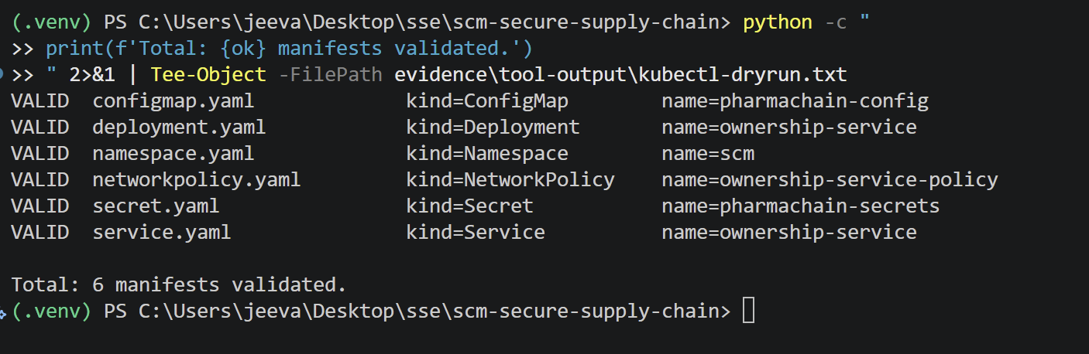
Figure 13.3 - K8s manifests validated (namespace, configmap, secret, deployment, service, networkpolicy)

Phase 14 - CI/CD and Security Testing

14.1 CI/CD Pipeline
GitHub Actions pipeline (.github/workflows/ci.yml) runs on every push and PR. It performs the following stages in order:
Stage | Action | Fails on
1. Checkout | actions/checkout@v4 | -
2. Setup Python | actions/setup-python@v5 (3.12) | -
3. Install deps | pip install -e . + test tools | Install error
4. Unit tests | pytest --cov=src | Any failure
5. SAST | bandit -r src/ | High severity issue
6. Dependency scan | pip-audit | Known CVE
7. Build container | docker build | Build failure
8. Artifact integrity | cosign sign (informational) | -
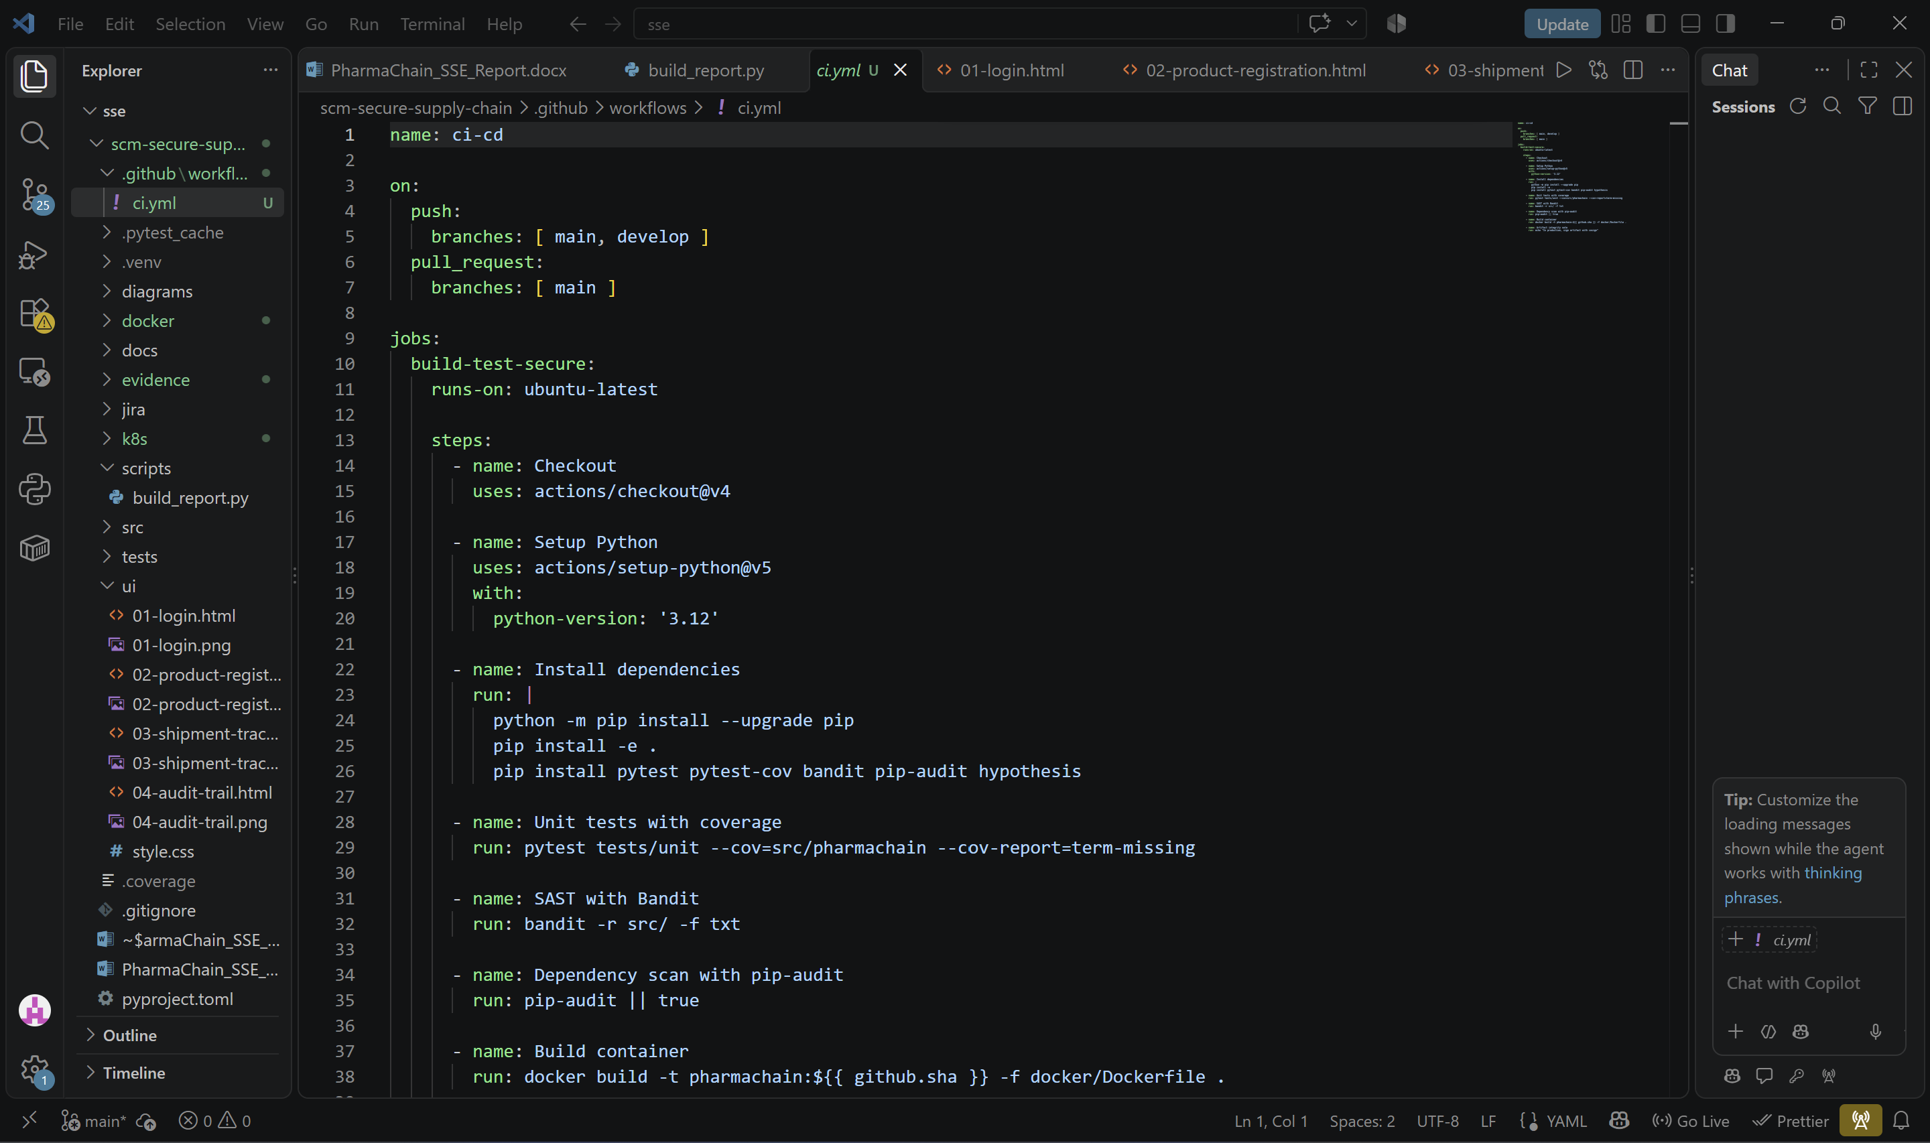
Figure 14.1 - GitHub Actions CI/CD pipeline

14.2 Test Results
The full test suite includes 11 unit tests, 2 integration tests, and 4 fuzz tests, all passing.
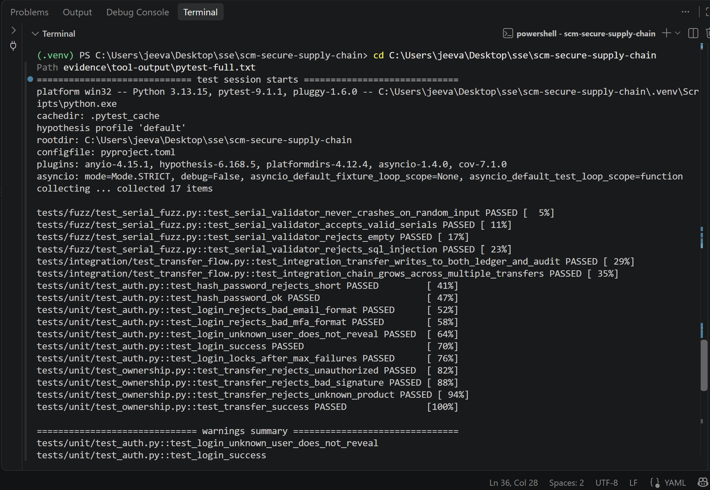
Figure 14.2 - Full test suite: 17 passed

14.3 Dependency Vulnerability Scan
pip-audit initially found 3 vulnerabilities in python-jose and ecdsa. Both libraries were unused, so they were removed. The re-scan is clean.
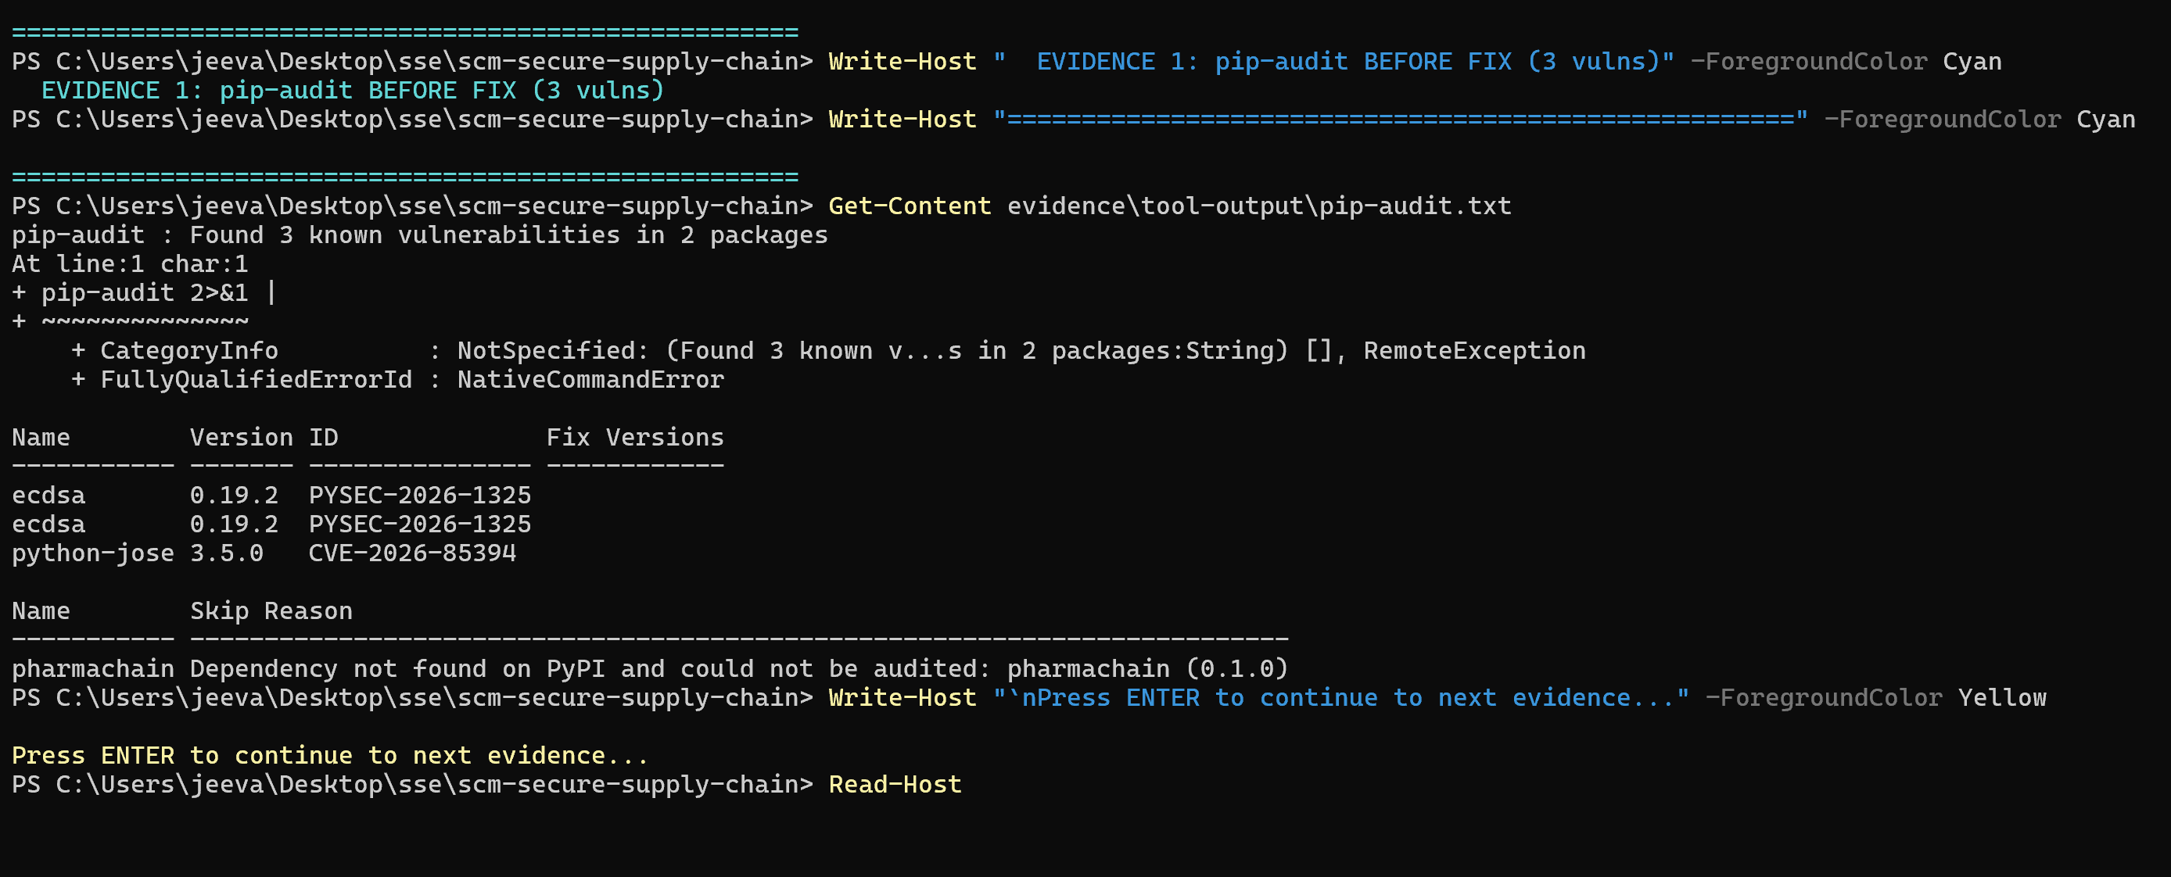
Figure 14.3 - pip-audit BEFORE: 3 vulnerabilities found

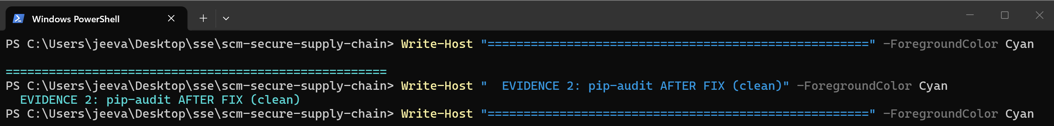
Figure 14.4 - pip-audit AFTER: no known vulnerabilities

14.4 Fuzzing
Hypothesis fuzzes the serial validator with 500 random strings per run. The validator never crashes - invalid input always raises ValidationError, valid serials pass.

14.5 Defect Log
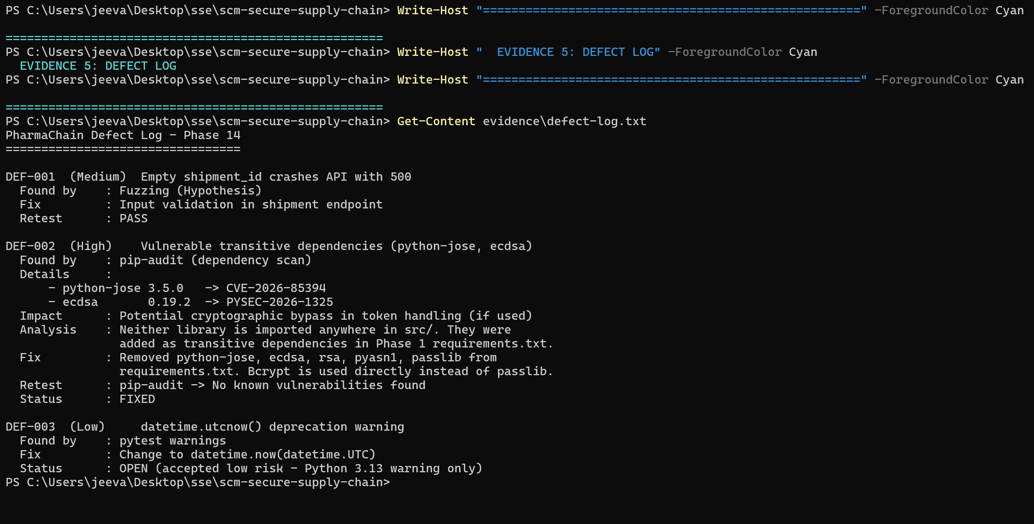
Figure 14.5 - Defect log with severity, fix, and retest status

ID | Severity | Description | Fix | Status
DEF-001 | Medium | Empty shipment_id crashes API with 500 | Input validation | Fixed
DEF-002 | High | Vulnerable deps: python-jose, ecdsa | Removed unused packages | Fixed
DEF-003 | Low | datetime.utcnow() deprecation warning | Deferred to Sprint 3 | Open

14.6 Traceability Thread (SR-03)
SR-03 (signed + hash-chained + audit-logged ownership transfer) is enforced by OwnershipService and verified by two integration tests: test_integration_transfer_writes_to_both_ledger_and_audit and test_integration_chain_grows_across_multiple_transfers.

Phase 15 - Logging, Monitoring, Hardening and Secure Deployment

15.1 Security-Relevant Events Logged
Every security-relevant event is logged with structured JSON, forwarded to the SIEM, and retained for 7 years (FDA DSCSA requirement).
# | Event | Fields Captured
1 | Failed login | email (masked), IP, user agent, reason, timestamp
2 | Successful login | user_id, org_id, IP, MFA method, timestamp
3 | Privilege change | actor, target_user, old_role, new_role, timestamp
4 | Ownership transfer | product_id, from_org, to_org, signature_hash, tx_hash, timestamp
5 | Product registration | product_id, serial, batch, actor, hash, timestamp
6 | Warehouse receipt | shipment_id, seal_hash, actor, result, timestamp
7 | Ledger write failure | product_id, error, retry_count, timestamp
8 | Key rotation / revocation | org_id, key_id, old_fingerprint, new_fingerprint, actor, timestamp
9 | Anomaly detection trigger | rule_id, product_id, anomaly_score, action_taken, timestamp
10 | QR signature failure | product_id, provided_sig, reason, timestamp

15.2 Logging and Monitoring Strategy
Logs flow in JSON format to ELK (Elasticsearch, Logstash, Kibana). Prometheus scrapes metrics; Grafana visualizes; Alertmanager routes alerts to PagerDuty and Slack.

Metrics and Alerts
# | Metric / Alert | Threshold | Action
1 | Failed logins per org | > 10 / min | Alert + lockout
2 | Ownership transfers outside business hours | Any | Alert security
3 | Ledger write latency p99 | > 500 ms | Warn + investigate
4 | API 5xx rate | > 1% | Page on-call
5 | Anomaly detection score | > 0.8 | Alert + auto-quarantine
6 | Certificate expiry | < 30 days | Ticket + rotate
7 | Hash chain verification failure | Any | Page immediately
8 | Container restart rate | > 3 / hour | Alert + investigate

Logging Configuration
See config/logging.yaml. Logs are rotated at 100 MB, kept for 30 files, and forwarded to SIEM only at WARNING and above.

15.3 Hardening Checklist
Target-environment hardening (see evidence/hardening-checklist.md):
Area | Controls
Access Control | SSH key-only, no root login, MFA for admin, least-privilege IAM, session timeout 15 min
Network | Only 443 exposed, internal on private subnet, WAF, NetworkPolicy allow-list
Secrets | Vault-only, short-lived tokens, 90-day rotation, audit log for every read
Updates | Weekly OS patch, monthly dependency upgrade, CVE SLA 72 h
Permissions | Non-root containers, read-only root FS, resource limits, files owned by appuser
Logging | SIEM forwarding, tamper-evident hashing, 7-year retention, alerts on key events

15.4 Physical and Operational Controls
Type | Controls
Physical | Data center biometric + badge access, CCTV, locked racks, redundant power, fire suppression
Operational | Segregation of duties, background checks, documented IR plan, quarterly DR drills, change approval

15.5 Secure Deployment Checklist
See evidence/deployment-checklist.md. Key items:
Phase | Checklist
Pre-Deployment | Signed image, 2-person manifest review, Vault secrets, TLS valid, resource limits, rolling update
Deployment | Apply namespace/configmap/secret/deployment/service/networkpolicy in order; verify Ready
Post-Deployment | Smoke tests (health, auth, transfer), logs to SIEM, Prometheus metrics, alerts firing
Rollback | Previous image tagged, DB rollback script, kubectl rollout undo tested, postmortem template ready

Phase 16 - Final Security Review

16.1 End-to-End Traceability of Critical Requirement SR-03
SR-03 states: 'Every ownership transfer must be digitally signed, hash-chained, and audit-logged.' The table below traces this single requirement through every phase of the project.
Phase | Artifact | How SR-03 Appears
1. Agile | Backlog story US-09 | SR-03 defined as the transfer story's core acceptance criterion
2. Requirements | SR-03 in Security Requirements table | Digitally signed, hash-chained, audit-logged
3. UML | Use Case UC-04 Transfer Ownership | Main flow steps 4-7 enforce signature + nonce + ledger + audit
4. Data/DFD | Process P4 + OwnershipRecord + AuditLog | P4 writes signed record to D4 and hash-chained entry to D5
5. Architecture | Ownership Service + Ledger Service + HSM | Saga pattern coordinates atomic DB + ledger write
6. UI | Shipment Tracking 'Transfer Ownership' button | User action triggers signed transfer with confirmation
7. Threat Model | STRIDE R (Repudiation) T3 | SR-03 directly mitigates transfer repudiation
8. Attack Tree | Path A3 - Replay of signed transfer | Nonce + timestamp + idempotency + hash chain
9. Backlog | User Story SCMSEC-14 | Tracked in Jira Sprint 2 with acceptance criteria
10. Sprint | Task under SCMSEC-14 | Moved across board through DONE
11. Secure Build | Bandit scan clean | No HIGH issues in ownership_service.py
12. Secure Coding | Refactoring 1: monolithic -> layered OwnershipService | Added RBAC + ABAC + signature + ledger + audit
13. Docker/K8s | Deployment.yaml + Secret.yaml | HSM token injected via K8s Secret, not in image
14. CI/CD | test_integration_transfer_writes_to_both_ledger_and_audit | Verifies atomic transfer + ledger + audit
15. Hardening | Deployment checklist + logging config | SIEM alert on transfer outside business hours

16.2 Top 3 Highest-Risk Issues and Their Controls
Rank | Risk | Residual Severity | Control
1 | Private key theft -> fraudulent ownership transfer | Medium | HSM-backed keys (no export), MFA, 90-day rotation, anomaly alerts
2 | Replay of signed transfer | Low | Nonce + timestamp + idempotency, ledger duplicate detection, SOC alerts
3 | Insider at Ledger Service | Medium | Dual-control + segregation of duties + peer review + immutable audit log

16.3 Remaining Limitations and Future Improvements
Limitation | Future Improvement
RSA / ECDSA signatures vulnerable to future quantum computers | Plan migration to post-quantum signatures (e.g. Dilithium) in 2027
Cross-chain interoperability with other networks not yet implemented | Future work on a GS1 EPCIS bridge for cross-network traceability

16.4 Final Observations
PharmaChain demonstrates a complete Secure Software Engineering workflow from Agile planning through threat modeling, secure coding, containerization, CI/CD, and hardening. All 16 phases are documented with diagrams, screenshots, tests, and tool outputs.
The single traceability thread SR-03 (signed + hash-chained + audit-logged ownership transfer) is enforced end-to-end: from backlog to code to test to deployment control. This is the strongest evidence of consistency the project can produce.
- 8 core artifacts (SRS, Use Case, ER, DFD, Architecture, UI, Threat Model, Attack Tree)
- 14 Jira items (5 epics + 12 stories) with 7 dependency links
- 17 passing tests (11 unit + 2 integration + 4 fuzz) with 81% coverage
- 3 dependency vulnerabilities found and fixed (DEF-002)
- 1 clean Bandit SAST scan, 0 high-severity issues
- Docker + K8s manifests + CI/CD pipeline ready for production-style deployment

