SAFESIGHT
YOLO11-Based Construction Site PPE
and Safety Event Monitoring
Project report
Computer vision • worker tracking • zone rules • evidence-based alerts
17 October 2026
Prepared from the supplied training log, notebook, literature survey and figures

Abstract
Construction sites contain moving workers, machinery and changing hazards. This project presents SafeSight, a local web-based prototype that applies a custom-trained YOLO11s object detector to construction safety imagery and connects detections to a camera monitoring workflow. The detector recognizes ten classes: Hardhat, Machinery, Mask, NO-Hardhat, NO-Mask, NO-Safety Vest, Person, Safety Cone, Safety Vest and Vehicle. The broader prototype combines live or uploaded camera input, ByteTrack camera-local track IDs, configurable polygon zones, a 1.5-second dwell rule, PPE status association, evidence snapshots, event records, a live dashboard and a configurable after-hours rule. Training used 50 epochs at 640-pixel image size with pretrained YOLO11s weights. On the final recorded validation epoch, precision was 0.8912, recall 0.7281, mAP@0.5 0.7986 and mAP@0.5:0.95 0.5609. Machinery had the strongest class AP@0.5 in the supplied precision-recall figure (0.926), while Safety Cone (0.596) and NO-Mask (0.691) were weaker. These are detector validation metrics; they do not establish tracking or event-level reliability. The notebook includes a separate test-split evaluation cell, but its output metrics were not supplied. The project’s central contribution is an integrated safety-monitoring prototype and a clearly defined need to evaluate its event logic—especially zone occupancy, PPE-to-person assignment, false alarms and after-hours detection—on annotated video sequences.

1. Introduction
Personal protective equipment (PPE) such as hardhats, masks and high-visibility vests reduces exposure to common construction hazards. Manual supervision is important but can be inconsistent across a large site or long shift. Computer vision offers a way to flag conditions for timely human review. Early work demonstrated that visual PPE detection could be connected to compliance categories, alarms and reports [1]. Later studies evaluated detector speed and accuracy under real construction imagery, reporting challenges from blur, occlusion and camera distance [2,4].
A detector produces objects for an individual frame. A site monitor needs more: it must associate detections with a person over time, determine whether a person is inside a configured work zone, apply a dwell or operating-hours rule, preserve evidence, and show the result to a supervisor. Research has connected worker identity, PPE classification and incident logging [3], and has used temporal reasoning to reduce transient false alarms [6]. SafeSight is designed as a local prototype that combines these elements with an operational dashboard.

1.1 Aim and objectives
- Train and use a YOLO11s detector for ten construction safety object classes.
- Connect live or uploaded imagery to camera-local person tracking and zone-based safety rules.
- Record event time, zone, track ID, observed PPE status and evidence image for review.
- Display current detections, safety events and after-hours conditions through a Flask dashboard.
- Report detector validation results while identifying the separate event-level evaluation still required.

1.2 Scope and contribution
The contribution is a working integration prototype, not a new YOLO architecture, a worker-identification system, or a validated safety product. ByteTrack IDs are temporary identifiers within a camera stream and may change after occlusion or tracking loss. PPE status is inferred from detected boxes and spatial association; it can be uncertain when an item is small, hidden or poorly localized. The literature already contains person-linked PPE monitoring and incident logging [3], temporal false-alarm handling [6], and alarm/report workflows [1]. The defensible gap is therefore the implementation and measurement of this specific combination of user-configured zones, dwell time, PPE evidence, closing-time rules and a live dashboard.

2. Related work
Prior work falls into three connected themes. First, construction PPE detection has progressed from a small set of protective items to multi-class detectors and efficiency-focused architectures. Delhi et al. demonstrated a YOLOv3 compliance workflow with alarms and timestamped reports [1]. Wang et al. compared YOLO variants on real construction images and documented the accuracy-speed trade-off and sensitivity to blur [2]. Karlsson et al. examined multiple PPE categories and showed that performance changed with camera distance [4]. More recent work improves small-object features or model efficiency, including SD-YOLOv5 [8] and MFD-YOLO [7]. Al-Khiami and ElHadad provide a particularly relevant Ultralytics construction PPE training precedent [5].
Second, papers address temporal and operational decisions beyond frame-level detection. Cheng et al. combine worker re-identification, PPE classification and incident logging, making their work the closest system-level base paper for this report [3]. Zaidi et al. use temporal analysis to reduce alarms caused by transient detections [6]. These works show that alerts and records alone are not a sufficient novelty claim. SafeSight’s implementation should be evaluated for event accuracy, latency and operator usefulness rather than relying only on detector mAP.
Study | Focus | Relevance to SafeSight
Delhi et al. (2020) [1] | YOLOv3 PPE compliance categories, alarms and reports | Operational precedent for alerts and timestamped records.
Wang et al. (2021) [2] | Eight YOLO detectors on real-site imagery | Accuracy-speed trade-offs and blur sensitivity.
Cheng et al. (2022) [3] | Worker re-identification, PPE classification and incident logging | Selected base paper; closest system-level relationship.
Karlsson et al. (2023) [4] | Five PPE classes and entry control | Distance and small-object limitations.
Al-Khiami & ElHadad (2024) [5] | Custom Ultralytics YOLOv8 PPE model | Detector training comparison.
Zaidi et al. (2024) [6] | Temporal analysis for reducing false alarms | Supports persistent-event confirmation.
Tong et al. (2025) [7] | MFD-YOLO multi-scale PPE detection and pruning | Accuracy/efficiency design context.
Li et al. (2025) [8] | SD-YOLOv5 construction PPE and small objects | Small/occluded PPE challenge.

2.1 Base paper and research gap
Cheng et al. (2022) is selected as the base paper because it combines worker-level PPE assessment with incident logging [3]. SafeSight adapts the system-level idea of linking a tracked person’s observed PPE state to an event record. It does not reproduce Cheng et al.’s cross-camera re-identification: the prototype uses ByteTrack IDs local to a single camera stream. Zaidi et al. [6] is a supporting reference for temporal confirmation, while Al-Khiami and ElHadad [5] is a supporting reference for custom Ultralytics detector training.
The gap addressed here is narrow and empirical: a single-camera prototype that combines user-drawn polygon zones, dwell-time logic, per-track PPE assessment, evidence snapshots, a live dashboard and configurable closing-time rules requires event-level evaluation as an integrated workflow. The supplied work establishes that the detector has useful validation performance, but does not yet establish zone-entry recall, PPE attribution accuracy, track continuity, false alerts per camera-hour, after-hours detection recall or alert latency. Claims of broad novelty or superiority would require a more complete systematic literature review and comparative experiment.

3. Method and system design
SafeSight uses a staged pipeline. A frame is read from a webcam, video or uploaded image. YOLO11s returns bounding boxes, class labels and confidence scores. A tracker associates detections across adjacent frames and assigns stream-local track IDs. The application checks tracked person locations against saved polygon zones and accumulates dwell time. PPE-related detections are associated spatially with a person box and converted to observed states (present, missing or uncertain). A rule engine evaluates zone dwell, missing required PPE, machinery presence and configured closing time. Events are stored with timestamps and evidence snapshots and surfaced on the dashboard.
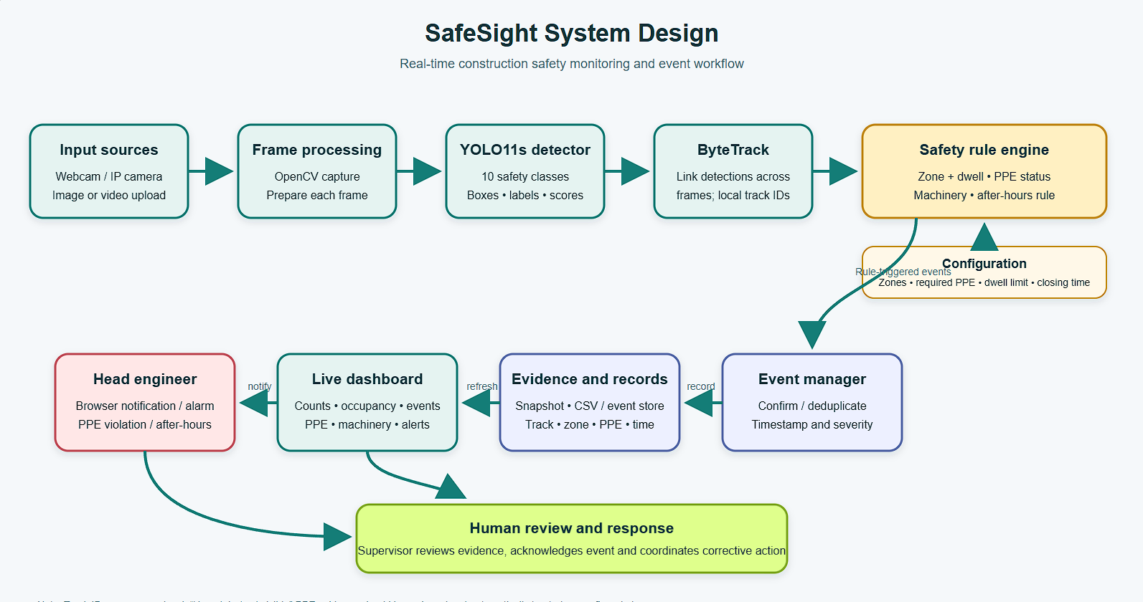

3.1 Algorithm
- Input: video stream V, detector weights W, configured zones Z, required PPE set R, dwell threshold τ, closing time Tclose.
- Load YOLO11s weights W and initialize the camera-local tracker and event store.
- For each frame f with timestamp t: run object detection; retain person, PPE, machinery and vehicle/cone detections above configured confidence thresholds.
- Update the tracker; for each person track p, compute a representative point (for example, bottom-center of the person box) and test membership in each polygon zone z ∈ Z.
- If p is in z, update its continuous dwell duration; otherwise reset or close the zone occupancy interval according to the implementation’s exit/missing-track policy.
- Associate PPE detections to p using spatial containment/overlap heuristics; assign each required item a state: detected, explicit no-item class detected, or uncertain/not visible.
- When dwell duration exceeds τ, or a confirmed PPE violation occurs, create/update an event with track, zone, time, PPE state and evidence image. Avoid duplicate alerts for the same active condition using an event cooldown/state.
- If local time is at or after Tclose and a person is detected, create an after-hours event and notify the dashboard/administrator.
- Publish current counts, tracked occupancy, event history and machinery detections to the live dashboard; continue until the stream ends.
The above is the intended system logic at an architectural level. The exact point-in-polygon convention, missing-track grace period, PPE matching thresholds, event cooldown and notification transport should be documented from the implementation configuration before this report is treated as an implementation specification.

3.2 Pseudocode
initialize detector YOLO11s(W), tracker, event_store
for frame, timestamp in stream:
detections = detector(frame)
tracks = tracker.update(detections)
for person in tracks.persons:
zone = polygon_containing(person.bottom_center, configured_zones)
if zone:
dwell[person.id, zone] += elapsed_time
ppe = associate_ppe(person, detections) # detected / missing / uncertain
if dwell[person.id, zone] >= dwell_limit or ppe.has_confirmed_violation:
save_event_once(person.id, zone, timestamp, ppe, evidence(frame))
else:
update_exit_or_lost_track_state(person.id)
if local_time(timestamp) >= closing_time:
save_after_hours_event_once(person.id, timestamp, ppe, evidence(frame))
update_dashboard(tracks, detections, event_store)

3.3 Design considerations
- Use camera-local track IDs only as short-lived references; do not treat them as employee identities.
- Represent uncertain PPE evidence separately from a confirmed missing item. A detector’s failure to see PPE is not proof that PPE is absent.
- Use evidence images and event timestamps to support human review.
- Calibrate polygon zones to the camera view and use a consistent person anchor point; a center point can misclassify large boxes near boundaries.
- Prevent repeated notifications for a single continuous violation with event state and cooldown logic.

4. Experimentation

4.1 Dataset
The training notebook downloads version 1 of the Roboflow project `safety-object-detection-app/construction-site-safety-ccp7o` in YOLO detection-label format. The associated survey records 1,819 training images, 518 validation images and 260 test images, for 2,597 images total. The ten labels are Hardhat, Machinery, Mask, NO-Hardhat, NO-Mask, NO-Safety Vest, Person, Safety Cone, Safety Vest and Vehicle. These split counts and class names are reported from the supplied project materials; the dataset manifest itself was not independently re-counted for this report.
The supplied class-distribution figure indicates imbalance: Person and NO-Safety Vest are frequent, while Mask and Vehicle have fewer instances. The notebook contains a separate `best.pt` evaluation using `split="test"`; however, no output from that evaluation was provided. Therefore, numerical results below are validation results from `results.csv` and validation plots, not test-set scores.
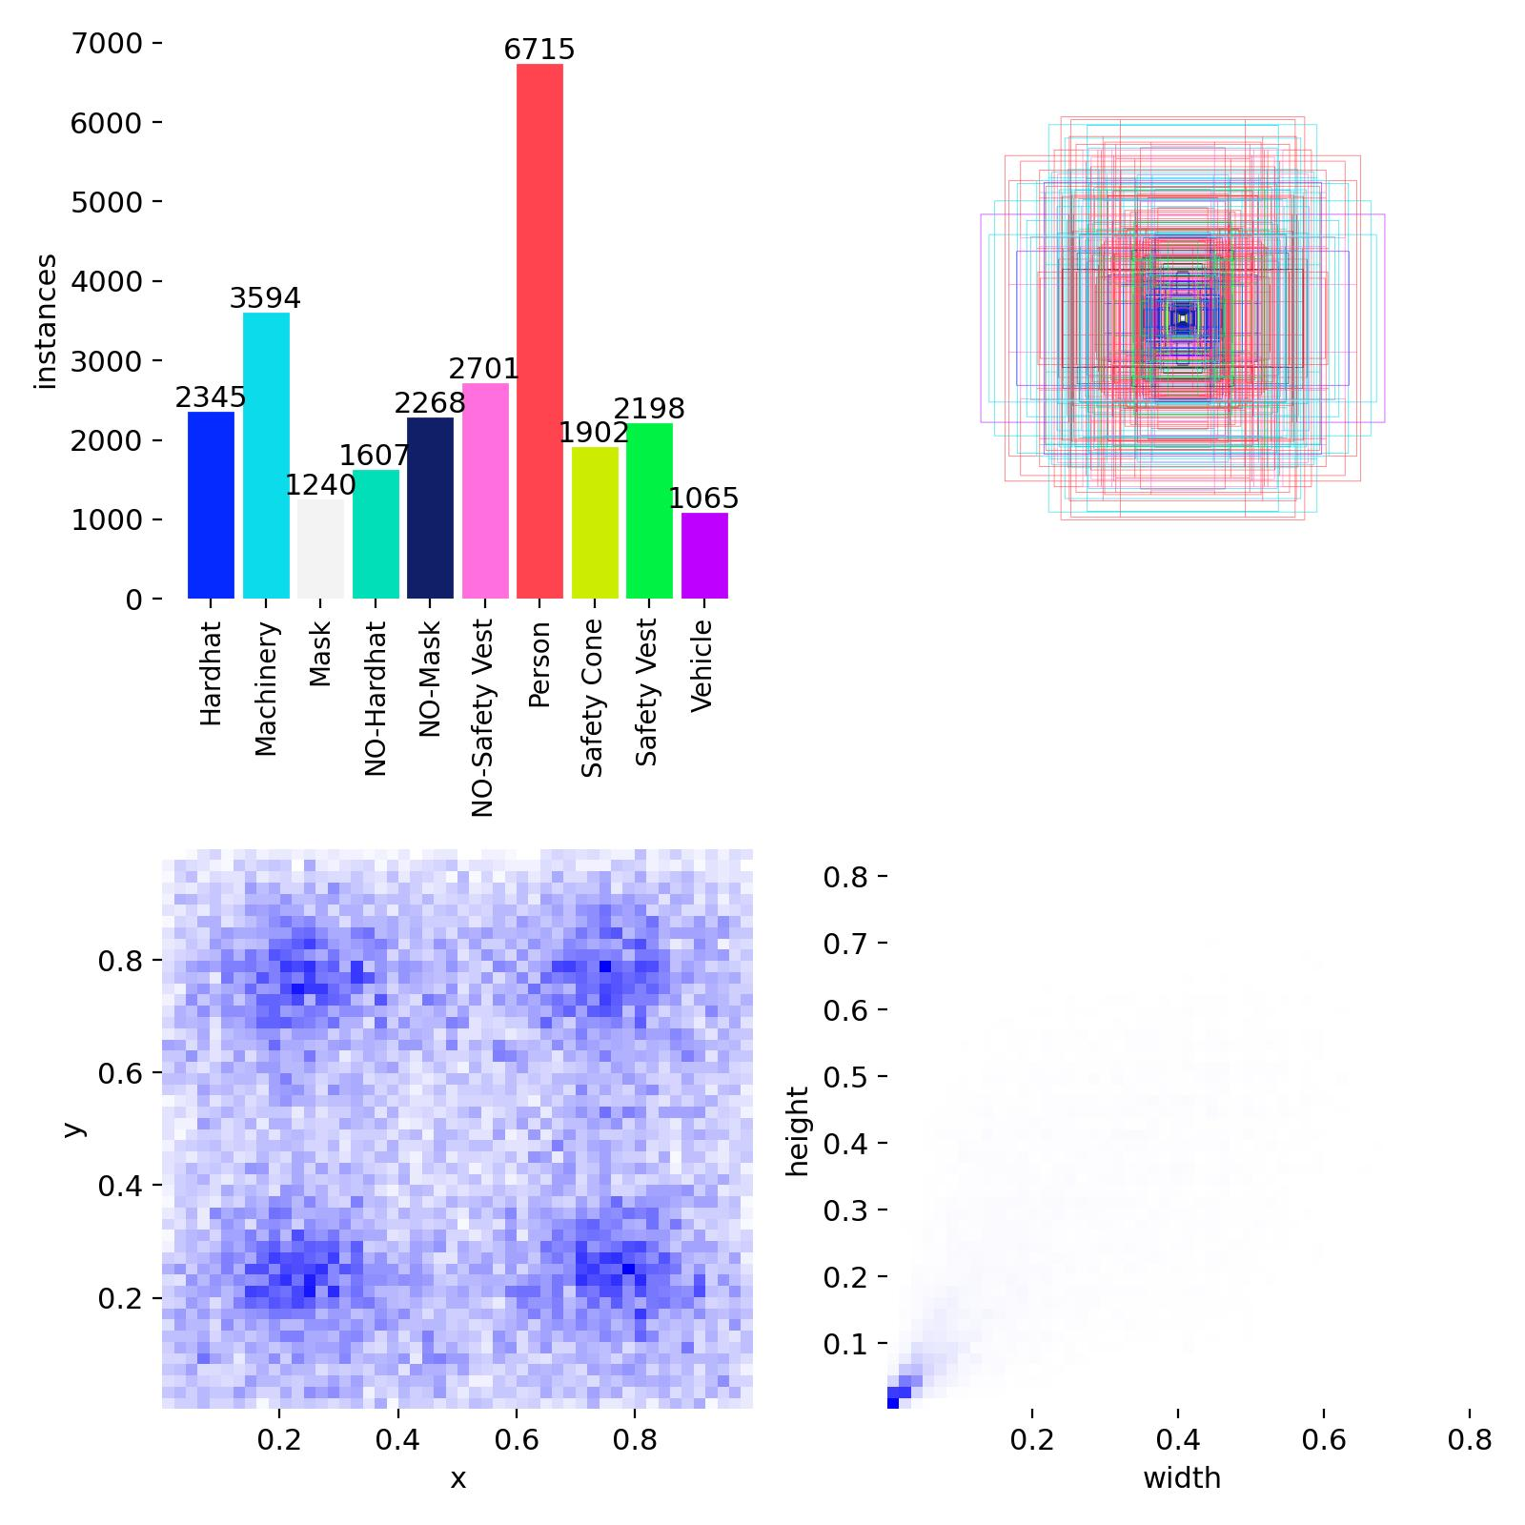
Figure 2. Training label distribution and bounding-box spatial statistics from the supplied dataset visualization.

4.2 Training configuration
Parameter | Setting
Model | YOLO11s initialized from pretrained `yolo11s.pt`
Epochs / image size / batch | 50 / 640 px / 16
Optimizer | SGD; lr0=0.01; lrf=0.01; momentum=0.937; weight decay=0.001
Reproducibility / compute | seed=0; workers=8; notebook requested device 0 (GPU)
Dataset interface | Roboflow version 1, YOLO-format labels
Checkpoint under evaluation | best.pt is referenced by the notebook test-evaluation cell; training CSV is from the named `construction_yolo11s_v1` run
The code computes a `device` variable based on CUDA availability for the later test evaluation, while the training call explicitly passes `device=0`. The completed results.csv demonstrates that a training run finished, but the available material does not reliably identify the exact hardware used for that run. Hardware and inference FPS should be recorded from the actual Colab runtime before making speed claims.

4.3 Evaluation protocol
The training log reports detector precision, recall and mAP at IoU thresholds summarized by Ultralytics. Precision-recall, confidence curves and confusion matrices provide class-level diagnostic views. These image-level measures do not evaluate track association, event timing, zone membership, PPE-to-person matching or notification delivery. A complete experiment should also annotate video-level event ground truth and report event precision/recall/F1, missed-event rate, false alerts per camera-hour, ID switches/fragmentation, PPE-association accuracy and alert latency. Threshold tuning must use validation data, leaving test data untouched for final reporting.

5. Results and analysis

5.1 Detector metrics
At epoch 50, the training log records precision 0.89124, recall 0.72814, mAP@0.5 0.79857 and mAP@0.5:0.95 0.56089. The figures below are rounded to three decimals. Precision is relatively high while recall is lower, indicating that the operating point favors fewer false detections at the cost of missed objects. The F1-confidence curve shows a maximum around 0.80 at confidence 0.361; this is a validation-curve operating point and should be rechecked on the held-out test set before deployment.
Metric (validation, epoch 50) | Value
Precision | 0.891
Recall | 0.728
mAP@0.5 | 0.799
mAP@0.5:0.95 | 0.561
Peak aggregate F1 / confidence (curve) | 0.80 / 0.361
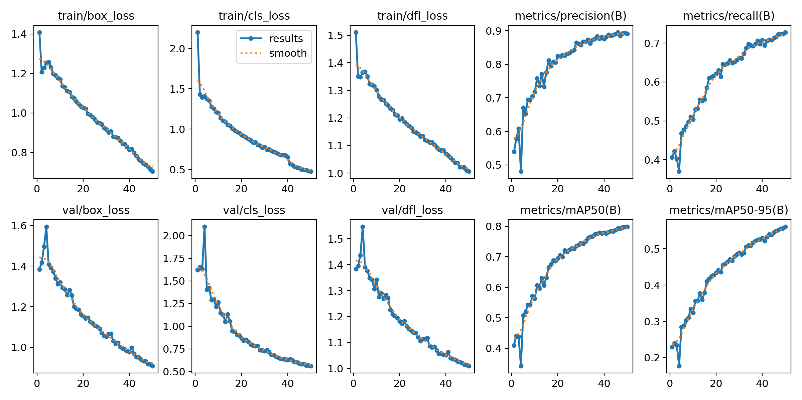
Figure 3. YOLO11s training and validation losses and detection metrics over 50 epochs.
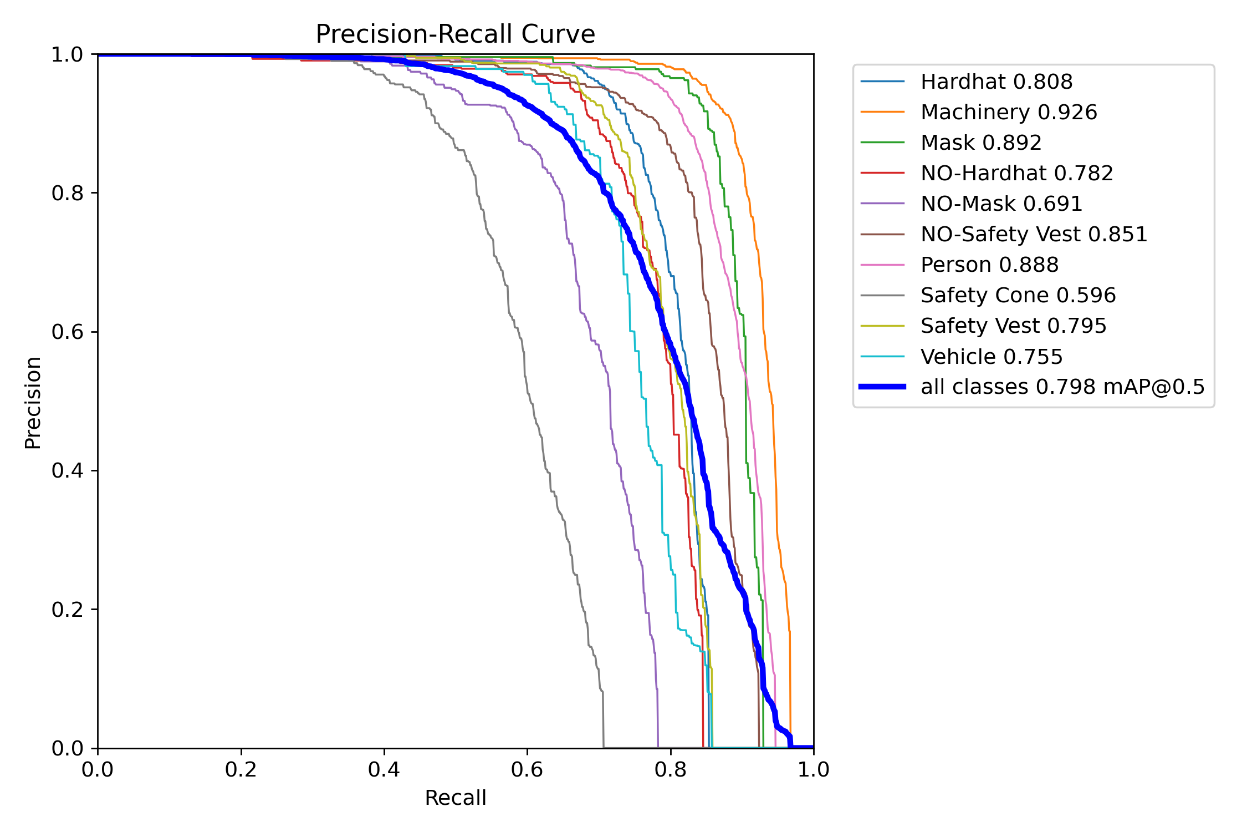
Figure 4. Validation precision-recall curves. Reported class AP@0.5: Machinery 0.926; Mask 0.892; Person 0.888; NO-Safety Vest 0.851; Hardhat 0.808; Safety Vest 0.795; NO-Hardhat 0.782; Vehicle 0.755; NO-Mask 0.691; Safety Cone 0.596.
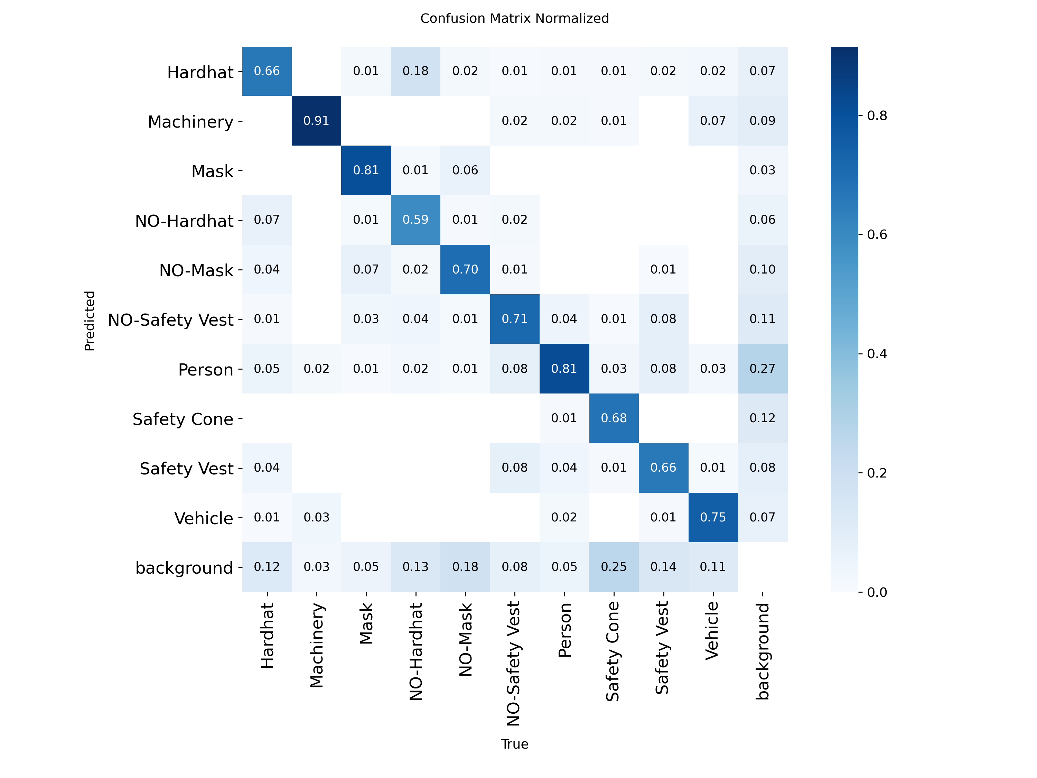
Figure 5. Normalized confusion matrix. The background row/column indicates missed and spurious detections; class confusions also remain.

5.2 Interpretation
Machinery is the strongest class in the supplied precision-recall plot (AP@0.5 0.926). Person and Mask detection are also relatively strong in that plot. Safety Cone (0.596) and NO-Mask (0.691) are the weakest classes, so a safety decision that depends on these labels deserves more cautious thresholds and human review. The confusion matrix shows substantial background-related errors and confusions among similar PPE categories. Because PPE classes can be small or partially occluded, this pattern is consistent with the limitations discussed in real-scene detector studies [2,4,8].
The aggregate mAP@0.5 of 0.799 is useful evidence that the model learned the supplied class set, but it does not imply 79.9% event accuracy or guarantee that a missing PPE item is assigned to the correct person. Zone and after-hours alarms depend on person recall and temporal continuity, while PPE alarms depend on both detection and association. These should be tested separately. The example prediction mosaic also contains crowded labels and overlapping boxes; this indicates that visualization readability and possibly crowded-scene suppression should be reviewed alongside raw metrics.
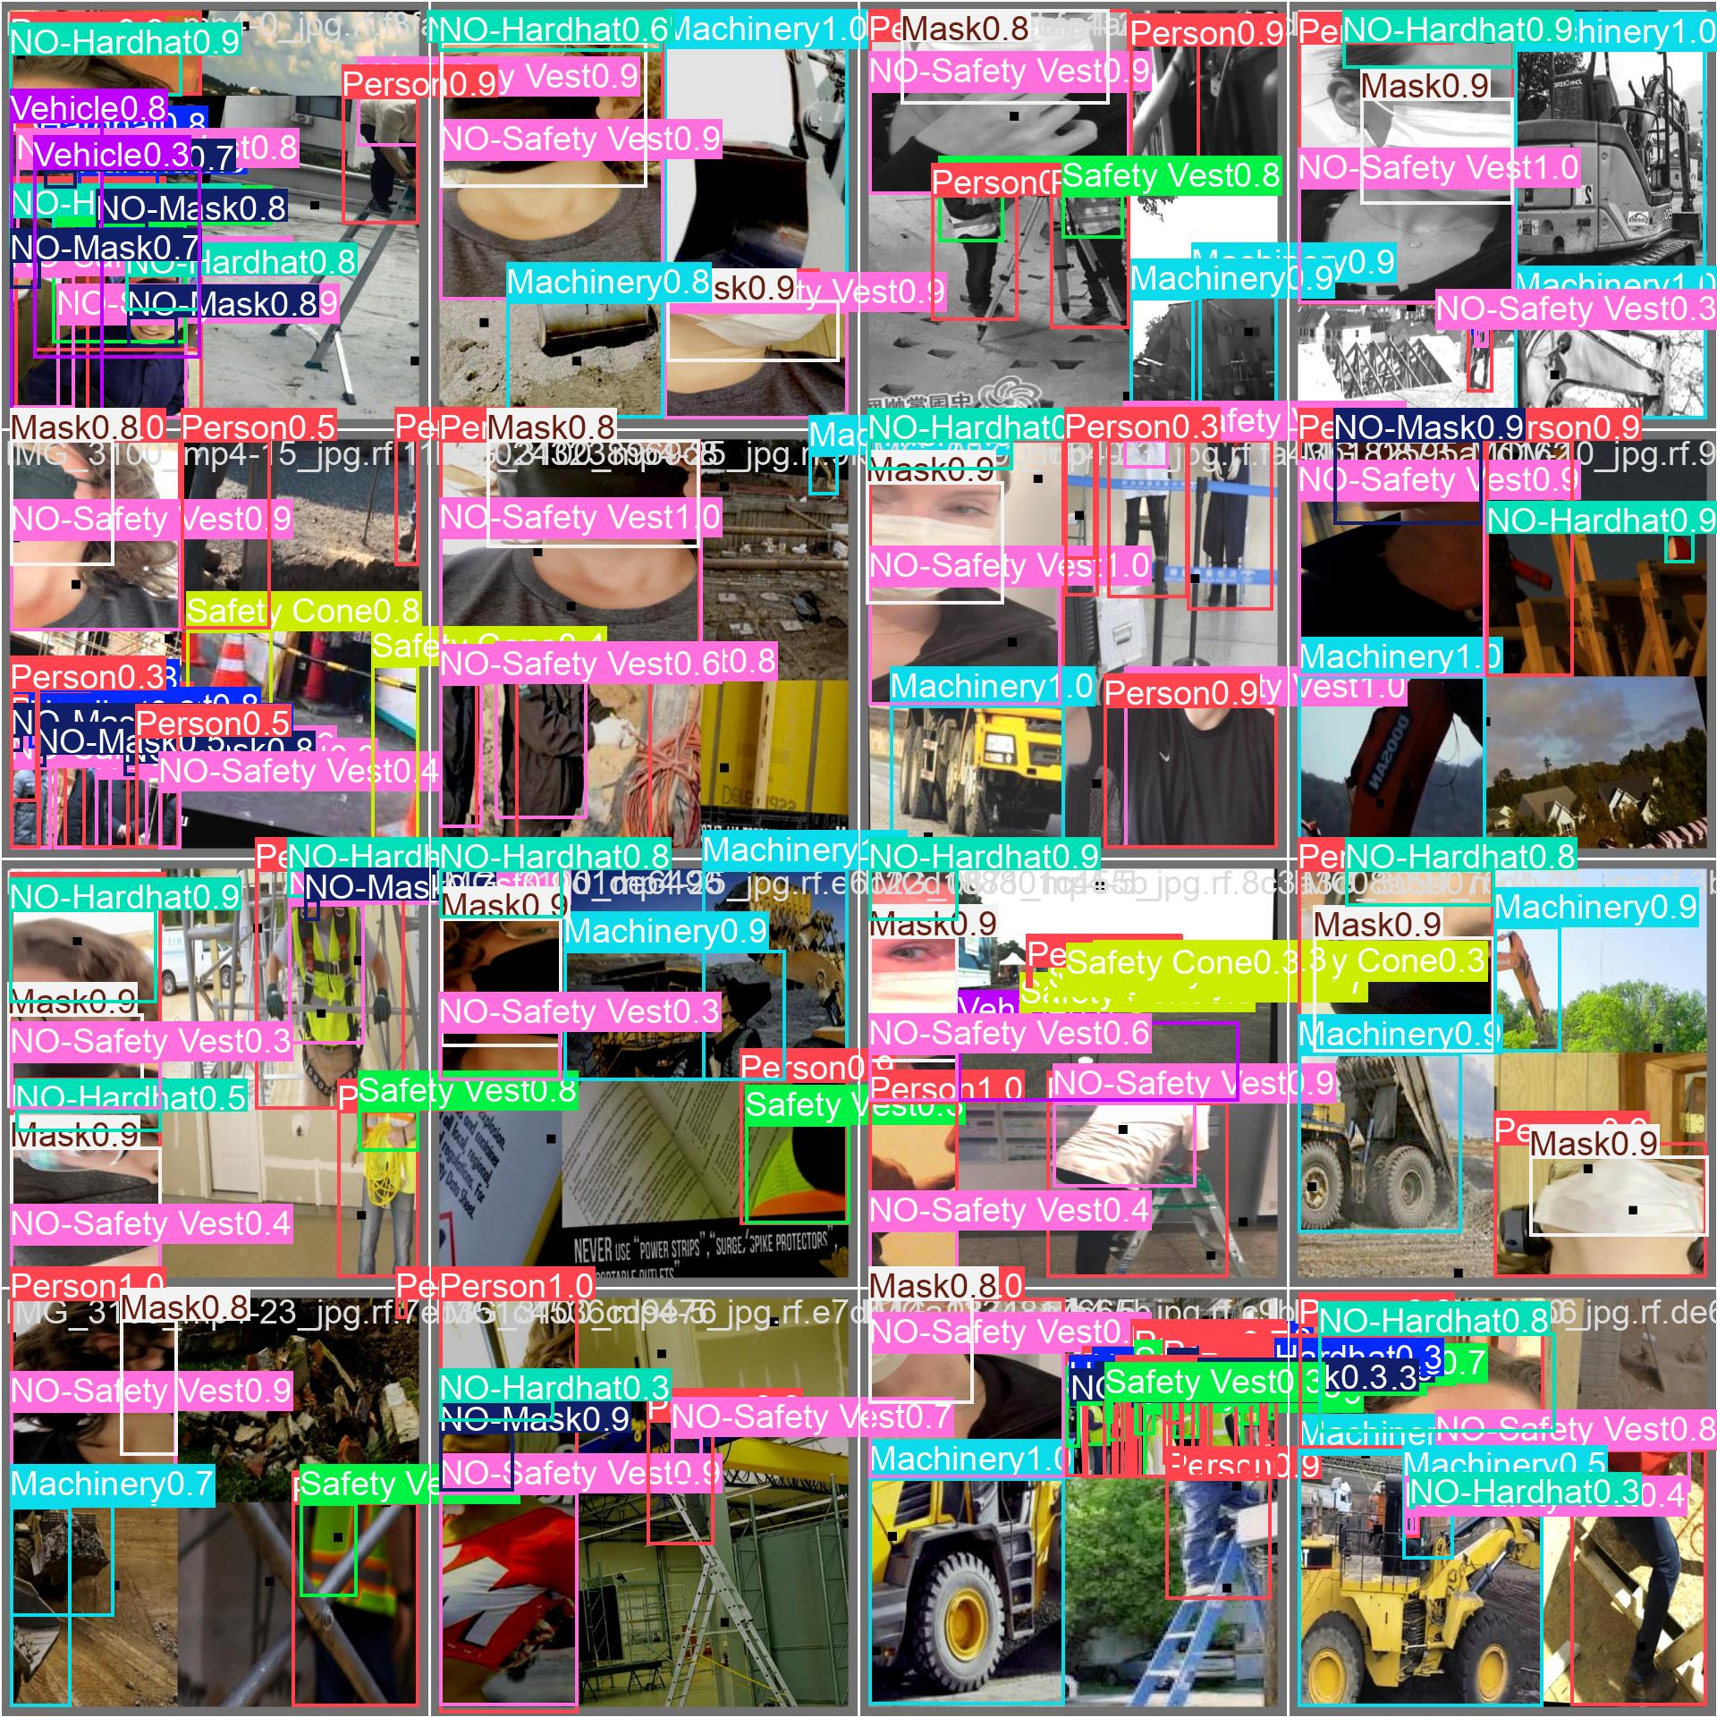
Figure 6. Sample detector predictions from the supplied validation/prediction montage; overlapping boxes in dense scenes motivate event-level and visual quality checks.

5.3 Results that remain unreported
No test-set metric output, FPS benchmark, event-level labeled video result, false-alarm rate, track continuity score, PPE attribution accuracy, or alert-delivery latency was supplied. These values are intentionally not inferred from the validation curves. Before describing SafeSight as reliable for site operations, run the notebook’s test evaluation and conduct a separate video event study with annotated zones, entries/exits, PPE states and after-hours presence.

6. Conclusion
This report documents SafeSight as an integrated YOLO11s construction safety monitoring prototype. The final training-log validation scores are precision 0.891, recall 0.728, mAP@0.5 0.799 and mAP@0.5:0.95 0.561. The detector performs unevenly across classes, with machinery strong and safety cones and no-mask detections weaker. The application adds camera-local tracking, configured zones, dwell rules, PPE assessment, evidence records, dashboard monitoring and after-hours alerts. Its chief research need is not another broad claim of novelty; it is rigorous evaluation of whether those components generate correct and timely events under realistic camera conditions. Future work should publish test-split metrics, annotate representative video, quantify track continuity and PPE association, tune uncertainty handling, and report FPS and alert latency on specified hardware. Cheng et al. [3] is the base system reference, while the project’s narrower contribution lies in implementing and evaluating its particular zone-and-policy workflow.

References
[1] V. S. K. Delhi, R. Sankarlal, and A. Thomas, “Detection of Personal Protective Equipment (PPE) Compliance on Construction Site Using Computer Vision Based Deep Learning Techniques,” Frontiers in Built Environment, vol. 6, 136, 2020. https://doi.org/10.3389/fbuil.2020.00136
[2] Z. Wang et al., “Fast Personal Protective Equipment Detection for Real Construction Sites Using Deep Learning Approaches,” Sensors, vol. 21, no. 10, 3478, 2021. https://doi.org/10.3390/s21103478
[3] J. C. P. Cheng, P. K.-Y. Wong, H. Luo, M. Wang, and P. H. Leung, “Vision-Based Monitoring of Site Safety Compliance Based on Worker Re-Identification and Personal Protective Equipment Classification,” Automation in Construction, vol. 139, 104312, 2022. https://doi.org/10.1016/j.autcon.2022.104312
[4] J. Karlsson et al., “Visual Detection of Personal Protective Equipment and Safety Gear on Industry Workers,” in Proc. 12th International Conference on Pattern Recognition Applications and Methods (ICPRAM), pp. 395–402, 2023. https://doi.org/10.5220/0011693500003411
[5] M. I. Al-Khiami and M. M. ElHadad, “Enhancing Construction Site Safety Using AI: The Development of a Custom YOLOv8 Model for PPE Compliance Detection,” Proc. European Conference on Computing in Construction, 2024. https://doi.org/10.35490/EC3.2024.307
[6] S. F. A. Zaidi et al., “Vision-Based Construction Safety Monitoring Utilizing Temporal Analysis to Reduce False Alarms,” Buildings, vol. 14, no. 6, 1878, 2024. https://doi.org/10.3390/buildings14061878
[7] B. Tong, G. Li, X. Bu, Y. Wang, and X. Yu, “A Deep Learning-Based Algorithm for the Detection of Personal Protective Equipment,” PLOS ONE, vol. 20, no. 5, e0322115, 2025. https://doi.org/10.1371/journal.pone.0322115
[8] C. Li et al., “SD-YOLOv5: A Rapid Detection Method for Personal Protective Equipment on Construction Sites,” Frontiers in Built Environment, vol. 11, 1563483, 2025. https://doi.org/10.3389/fbuil.2025.1563483

Source and reproducibility note
This report was prepared from the supplied SafeSight literature survey, the Colab notebook `DL_17_10.ipynb`, `construction_yolo11s_v1/results.csv`, and user-provided training and prediction figures. Metrics are transcribed from the CSV/figures and are labeled validation where applicable. The paper references are cited in the body. Dataset split counts are taken from project materials; test metrics and event-level results were not available in the supplied outputs.

