OS Assignment 2

1.WACP to create 5 child processes.

#include<stdio.h>
#include <stdlib.h>
int main()
{ pid_t pid;
for (int i = 0; i < 5; i++)
{ pid = fork();
if(pid == 0)
{ printf("\nChild process %d with PID: %d", i+1, getpid());
exit(0);
}
else
wait(NULL);
}
return 0;
}

OUTPUT:

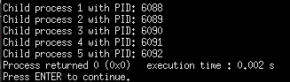

2.WACP to print number from 1 to 10 using fork

#include<stdio.h>
#include <stdlib.h>

int main() {
int i;

for (i = 1; i <= 10; i++)
{
if (fork() == 0)
{
printf("%d\n", i);
break;
}
else
wait(NULL);
}

return 0;
}

OUTPUT :

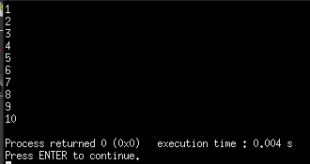

3. WACP to create a process and get its id and its parents id

#include<stdio.h>
#include <stdlib.h>

int main()
{
pid_t pid;
pid = fork();

if (pid == 0)
printf("I am child, my ID is %d and my parent's ID is %d\n", getpid(), getppid());
else
printf("I am parent, my ID is %d and my child's ID is %d\n", getpid(), pid);

return 0;
}

OUTPUT :

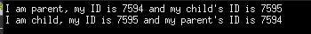

4. FCFS ( Non Premption , No arrival time)
#include<iostream>
using namespace std;
struct RQueue
{ char name[10];
int burst, waiting, turnaround;
};

int main()
{ int n,totalwaiting=0,totalturnaround=0;
float avgwaiting, avgturnaround;
cout<<"Enter total number of process : ";
cin>>n;
RQueue rq[n];

cout<<"\nEnter process name and Burst time for "<<n<< " Processes : \n";
for(int i=0;i<n;i++)
{ cin>>rq[i].name;
cin>>rq[i].burst;
}

for(int i=0;i<n;i++)
{ if(i==0)
rq[i].waiting = 0;
else
rq[i].waiting = rq[i-1].waiting + rq[i-1].burst;
rq[i].turnaround = rq[i].waiting + rq[i].burst;

totalwaiting += rq[i].waiting;
totalturnaround += rq[i].turnaround;
}
avgwaiting = totalwaiting/n;
avgturnaround = totalturnaround/n;

cout<<"\nProcess Details :";
for(int i=0;i<n;i++)
cout<<"\nName : "<<rq[i].name<<"\tBurst Time : "<<rq[i].burst<<"\tWaiting Time : "<<rq[i].waiting<<"\tTurn around Time : "<<rq[i].turnaround;

cout<<"\n\nTotal Waiting Time : "<<totalwaiting<<"\t\tAvg Waiting Time : "<<avgwaiting;
cout<<"\nTotal Turn around Time : "<<totalturnaround<<"\tAvg Turn around Time : "<<avgturnaround;

return 0;

}

OUTPUT :

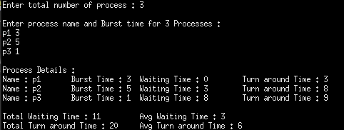

5. SJF ( Non Premption , No arrival time)
#include<iostream>
using namespace std;
struct RQueue
{ char name[10];
int burst, waiting, turnaround;
};

void bubbleSort(struct RQueue *rq, int n)
{ struct RQueue temp;
for(int i=0;i<n;i++)
{ for(int j=0;j<n-i-1;j++)
{ if(rq[j].burst > rq[j+1].burst)
{ temp = rq[j];
rq[j] = rq[j+1];
rq[j+1] = temp;
}
}
}
}

int main()
{ int n,totalwaiting=0,totalturnaround=0;
float avgwaiting, avgturnaround;
cout<<"Enter total number of process : ";
cin>>n;
RQueue rq[n];

cout<<"\nEnter process name and Burst time for "<<n<< " Processes : \n";
for(int i=0;i<n;i++)
{ cin>>rq[i].name;
cin>>rq[i].burst;
}

bubbleSort(rq,n);

for(int i=0;i<n;i++)
{ if(i==0)
rq[i].waiting = 0;
else
rq[i].waiting = rq[i-1].waiting + rq[i-1].burst;
rq[i].turnaround = rq[i].waiting + rq[i].burst;

totalwaiting += rq[i].waiting;
totalturnaround += rq[i].turnaround;
}
avgwaiting = totalwaiting/n;
avgturnaround = totalturnaround/n;

cout<<"\nProcess Details :";
for(int i=0;i<n;i++)
cout<<"\nName : "<<rq[i].name<<"\tBurst Time : "<<rq[i].burst<<"\tWaiting Time : "<<rq[i].waiting<<"\tTurn around Time : "<<rq[i].turnaround;

cout<<"\n\nTotal Waiting Time : "<<totalwaiting<<"\t\tAvg Waiting Time : "<<avgwaiting;
cout<<"\nTotal Turn around Time : "<<totalturnaround<<"\tAvg Turn around Time : "<<avgturnaround<<endl;

return 0;

}

OUTPUT :
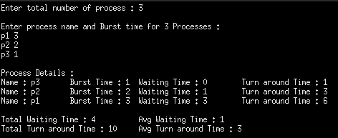

6. Priority ( Non Premption , No arrival time)
#include<iostream>

using namespace std;
struct RQueue
{ char name[10];
int priority,burst, waiting, turnaround;
};

void bubbleSort(struct RQueue *rq, int n)
{ struct RQueue temp;
for(int i=0;i<n;i++)
{ for(int j=0;j<n-i-1;j++)
{ if(rq[j].priority > rq[j+1].priority)
{ temp = rq[j];
rq[j] = rq[j+1];
rq[j+1] = temp;
}
}
}
}

int main()
{ int n,totalwaiting=0,totalturnaround=0;
float avgwaiting, avgturnaround;
cout<<"Enter total number of process : ";
cin>>n;
RQueue rq[n];

cout<<"\nEnter process name, Priority and Burst time for "<<n<< " Processes : \n";
for(int i=0;i<n;i++)
cin>>rq[i].name>>rq[i].priority>>rq[i].burst;

bubbleSort(rq,n);

for(int i=0;i<n;i++)
{ if(i==0)
rq[i].waiting = 0;
else
rq[i].waiting = rq[i-1].waiting + rq[i-1].burst;
rq[i].turnaround = rq[i].waiting + rq[i].burst;

totalwaiting += rq[i].waiting;
totalturnaround += rq[i].turnaround;
}
avgwaiting = totalwaiting/n;
avgturnaround = totalturnaround/n;

cout<<"\nProcess Details :\nName \tPriority \tBurst Time \tWaiting Time \tTurn
around Time"<<endl;

for(int i=0;i<n;i++)
cout<<rq[i].name<<"\t\t"<<rq[i].priority<<"\t\t"<<rq[i].burst<<"\t\t" <<rq[i].waiting<<"\t\t"<<rq[i].turnaround<<endl;

cout<<"\n\nTotal Waiting Time : "<<totalwaiting<<"\t\tAvg Waiting Time :
"<<avgwaiting;
cout<<"\nTotal Turn around Time : "<<totalturnaround<<"\tAvg Turn around
Time : "<<avgturnaround<<endl;

return 0;

}

OUTPUT :

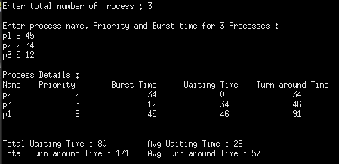

4. Round Robbin
#include<iostream>

OUTPUT :

