Project Charter

Date 5/17/2021

Project Title:
Location tracking shoe for kids

Team Name: Trace Catchers

Team Logo:

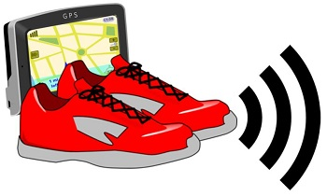

Team Members:
- Jeevan Bodigam
- Ajay Kumar Reddy Arram
- Amulya Mallepelli
- Madhu Babu Konda
- Nagarushyanth Tummala

Client: Margaret Couch

Project Start Date: 5/11/21 Projected Finish Date: June 2021

Budget Information:
The project would cost around 3.5 million dollars to complete which includes the cost for resources, inventory, and project expenses.

Project Manager:
Name: Jeevan Bodigam
Phone: +16605281386
e-mail: S542039@nwmissouri.edu
Project Objectives:

This project aims to track the real time location of the children who are vulnerable of missing, kidnapping or being a victim of child trafficking. This project would intend to act like a voice to these children, helping their parents to track their location, preventing them to be a part of any danger or harm.

Success Criteria:
The success criteria of the project lie when there would be a reduction of child related crime like human trafficking, kidnapping, missing etc. to at least 20% in the first 2 years of the project launch. It also depends how the parents of up to 7 years old children feel the shoe proves to be convenient for them as the project addresses the concern for their children’s safety, especially when they are away from them. Thus, over a period of 5 years, the above-mentioned crime could lead to a further decrease up to 60 % in such crime if the projects get assistance from the government initiatives. These 5 years could lead to the evolution of this project in other kids’ wearable business-like cap, school bag, etc.

Approach:

Our team would be implementing Agile approach to complete this project. This project will be monitored by conducting scrum meetings. We also get in touch with the client fortnightly and submit a project status report and the client feedback will be noted.

Roles and Responsibilities
Name and Signature | Role | Position | Contact Information
Jeevan Bodigam | Project Manager/ Application Developer | Manager | S542039@nwmissouri.edu
Ajay Kumar Reddy Arram | Test Engineer/Jr. Developer | Team Member | S541989@nwmissouri.edu
Amulya Mallepelli | Software Developer | Team Member | S542411@nwmissouri.edu
Madhu Babu Konda | UI/UX Developer | Team Member | S542311@nwmissouri.edu
Nagarushyanth Tummala | Sr. Developer | Project Lead | S543652@nwmissouri.edu
Comments: (Handwritten or typed comments from above stakeholders, if applicable)

N/A

Team Meetings:
As all the team members are highly active participants, the team expects everyone to deliver in full on their assigned tasks. Given, any team member deviates on the path, or faces any challenges, the team together decided to address these issues over daily Microsoft Teams meetings and help them get back with the tasks. The team also has a group on WhatsApp, to keep everyone updated with each individual work.

Our team will be communicating using MS Teams and university’s email.

We have also decided to meet in class or library to discuss the issues and challenges faced by a non-participating team member and assign work based on his/her interests.

Stakeholder Register for Project Name

Prepared by: Amulya Mallepalli Date:05/17/2021

Name | Position | Internal/External | Project Role | Contact Information
Jeevan Bodigam | Project Manager | Internal | Project Manager | S542039@nwmissouri.edu
Nagarushyanth Tummala | Team Lead | Internal | Project Lead | S543652@nwmissouri.edu
Amulya Mallepalli | Team Member | Internal | Software Developer | S542411@nwmissouri.edu
Ajay kumar reddy Arram | Team Member | Internal | Test Engineer/ Jr. Developer | S541989@nwmissouri.edu
Madhu babu konda | Team Member | Internal | UI/UX Developer | S542311@nwmissouri.edu
Margaret Couch | Client | External | End User | margaretcouch@nwmissouri.edu

Signatures:

- Jeevan Bodigam
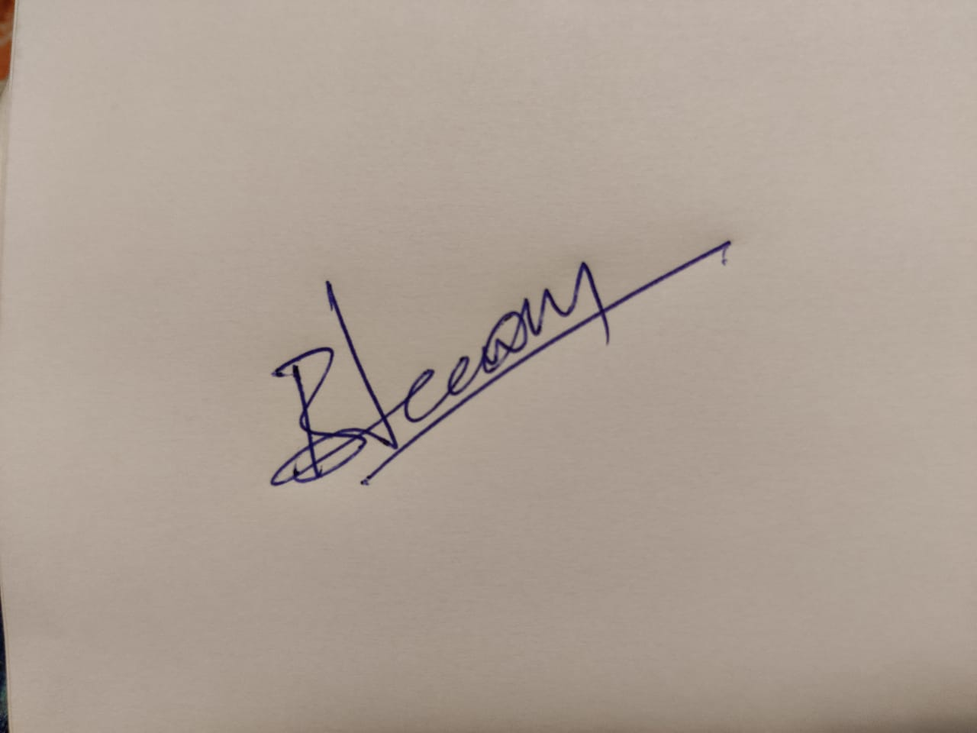
- Nagarushyanth Tummala
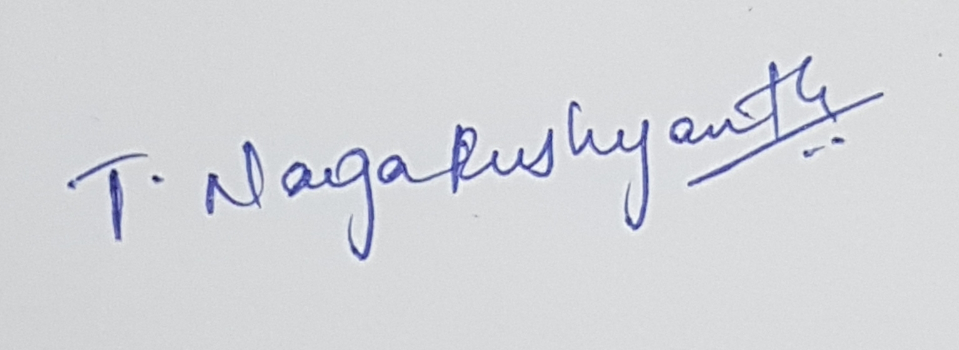

- Amulya Mallepelli
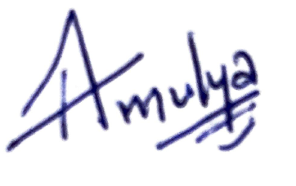
- Madhu Babu Konda
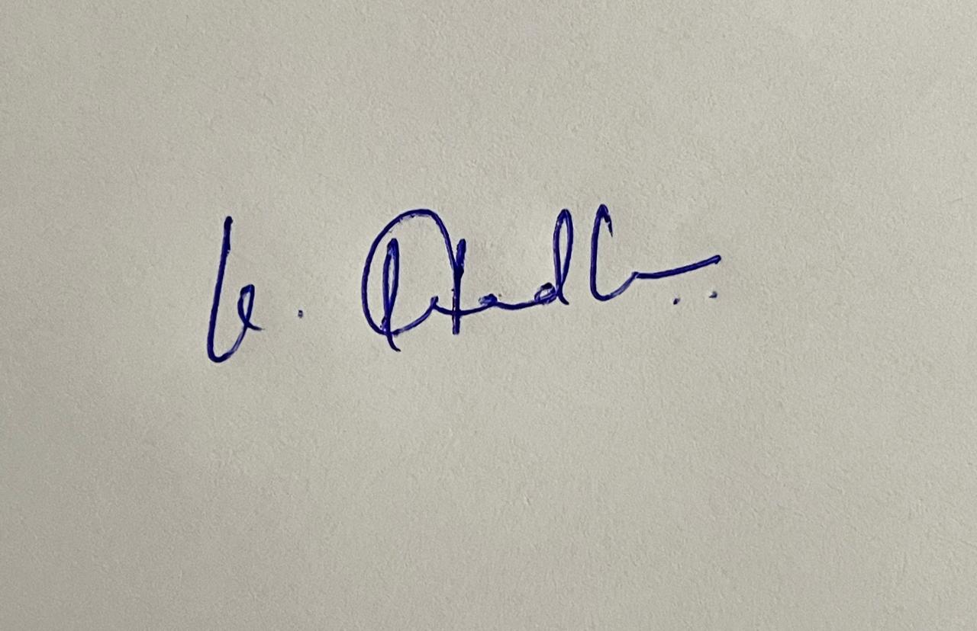

- Ajay Kumar Reddy Arram

