Project Management Plan Version 1.0
Date - 5/21/2021

Project Name: Location tracking shoe for kids

Team Members:
- Jeevan Bodigam
- Ajay Kumar Reddy Arram
- Amulya Mallepelli
- Madhu Babu Konda
- Nagarushyanth Tummala

Introduction/Overview of Project

This project is aimed to track real time location for children who are vulnerable of missing, kidnapping or being a victim of child trafficking. This project would intend to act like a voice to these children, helping their parents to track their location, preventing them to be a part of any danger or harm. The statistics say that every year at least 300,000 children go missing around the world from their family. They are either trafficked, abducted or abused, or the children get lost due to their vulnerability. Thus, this project would be addressing the social issue of child related crime and hopefully, it will reduce the huge numbers of such cases.

The location would be tracked through an application in the parent’s phone, connected with the shoe’s GPS sensor. The parent can access the child’s location at any part of the world.

Project Organization

Organization Structure

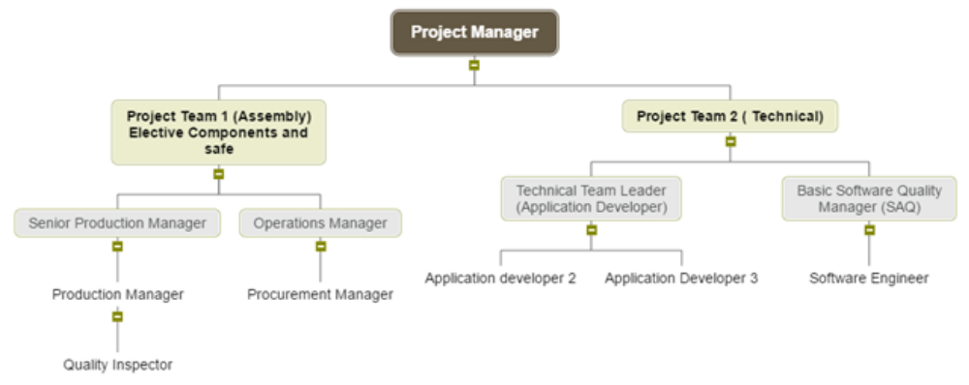

Management and Technical Processes
Management Processes:

The project manager ensures that the end product satisfies the customers as well as the sponsors. The monthly progress of the project is inspected by the management authority. Top priorities must be met. All the requirements are to be satisfied with the stated time and budget.

- Staffing Plan:
The project involves skilled and trained program manager, project manager, a database administrator, production team, a project lead, developers, quality analysis team and other staff.

- Risk Plan:
Identifying and realizing the risks associated with project is important to cope up with the threat or any mismanagement in the future or present. The entire team should always be prepared with the resources for any difficulties that might occur so that all the various concerned department should know how to cope with them. Monitoring and Controlling mechanisms guarantee that the project deliverables could be monitored periodically. If any irrelevant performance occurs, control it, and solve the issues throughout the project.

Technical Processes:

- Tools used:
This project’s website will be built by using HTML, CSS, JavaScript, React JS and MySQL is used to maintain a database. The mobile application will be built for both Android and iOS platforms. Other miscellaneous tools would be Microsoft Visio, MS Project, NetBeans, and Visual Studio.

- Software Documentation
This includes all the necessary documents produced by each team member in the project and is recorded according to all the rules. These documents must be reviewed and approved by the project manager.

- Project Support
The project manager prepares the final plan according to the customer's needs, time, scope and project budget. A Scrum meeting is held every day and all project stakeholders participate to update them on the status of the project and make any necessary changes suggested by the customer. Throughout the project life cycle, application performance will be monitored and controlled.

Work to Be Performed

This includes all the sub-tasks involved in the project, such as project charter, planning, demand analysis, software and hardware installation, resource collection and allocation, etc.

Schedule Information

With an efficient, skilled and trained team, this project has started on 5/11/2021 and will be completed by 06/04/2021.

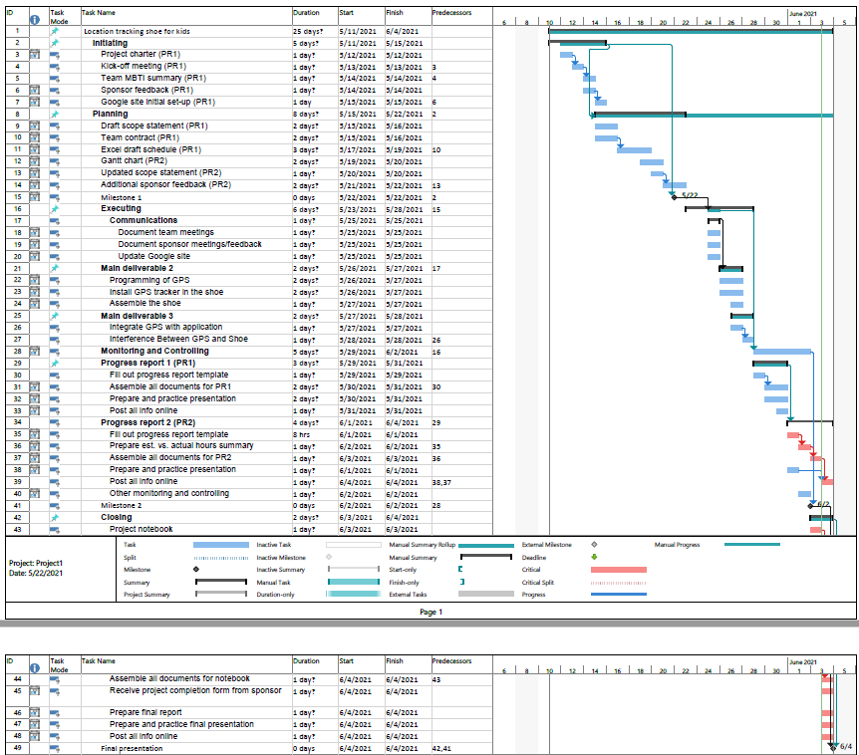
- Gantt Chart

Budget Information

The project would cost around 3.5 million dollars to complete which includes the cost for resources, inventory, and project expenses.

References to Other Project Planning Documents

As of now, there are no references to other project planning documents.

