Updated Project Charter
Milestone - 2
Date – 5/21/2021

Project Title: Location tracking shoe for kids

Team Members:
- Jeevan Bodigam
- Ajay Kumar Reddy Arram
- Amulya Mallepelli
- Madhu Babu Konda
- Nagarushyanth Tummala

Project Start Date: 5/11/2021 Projected Finish Date: 6/4/2021
Budget Information:
The project would cost around 3.5 million dollars to complete which includes the cost for resources, inventory, and project expenses.

Project Manager:
Name: Jeevan Bodigam
Phone: +16605281386
e-mail: S542039@nwmissouri.edu
Project Objectives:
This project aims to track the real time location of the children who are vulnerable of missing, kidnapping or being a victim of child trafficking. This project would intend to act like a voice to these children, helping their parents to track their location, preventing them to be a part of any danger or harm.

Success Criteria:
The success criteria of the project lie when there would be a reduction of child related crime like human trafficking, kidnapping, missing etc. to at least 20% in the first 2 years of the project launch. It also depends how the parents of up to 7 years old children feel the shoe proves to be convenient for them as the project addresses the concern for their children’s safety, especially when they are away from them. Thus, over a period of 5 years, the above-mentioned crime could lead to a further decrease up to 60 % in such crime if the projects get assistance from the government initiatives. These 5 years could lead to the evolution of this project in other kids’ wearable business-like cap, school bag, etc.

Approach:
Our team would be implementing Agile approach to complete this project. This project will be monitored by conducting scrum meetings. We also get in touch with the client fortnightly and submit a project status report and the client feedback will be noted.

The outcomes of every meeting held would be documented and required action is taken accordingly. In order to keep the team’s spirit high, regular team outings are conducted.
A reward program would also be conducted to encourage the team members and recognize their best performance.

The project would be tested thoroughly before its delivery.

Roles and Responsibilities
Name and Signature | Role | Position | Contact Information
Jeevan Bodigam  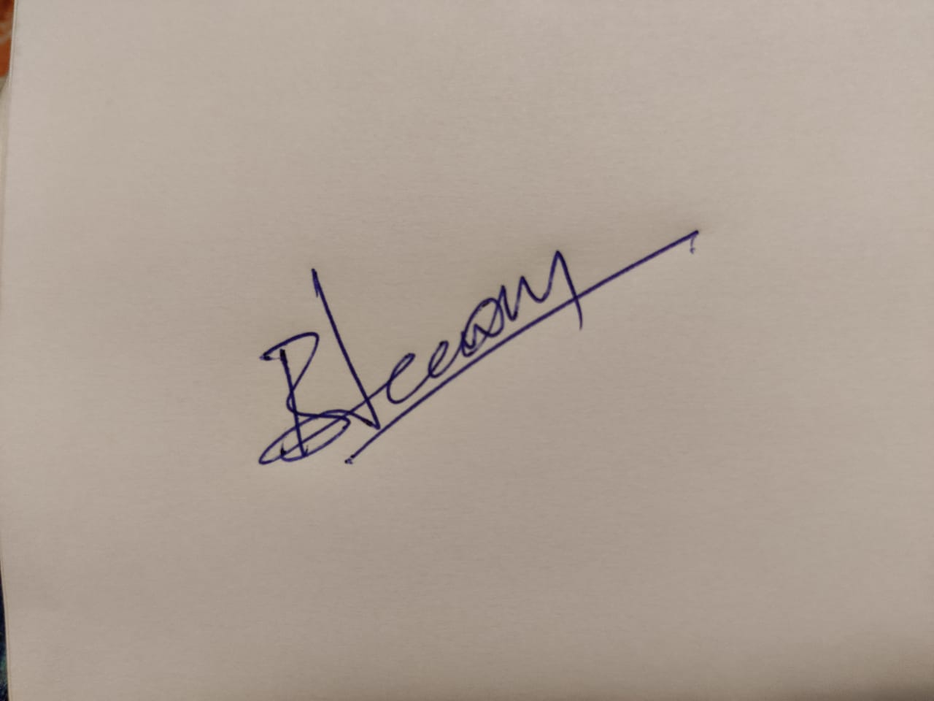 | Project Manager/ Application Developer | Manager | S542039@nwmissouri.edu
Ajay Kumar Reddy Arram  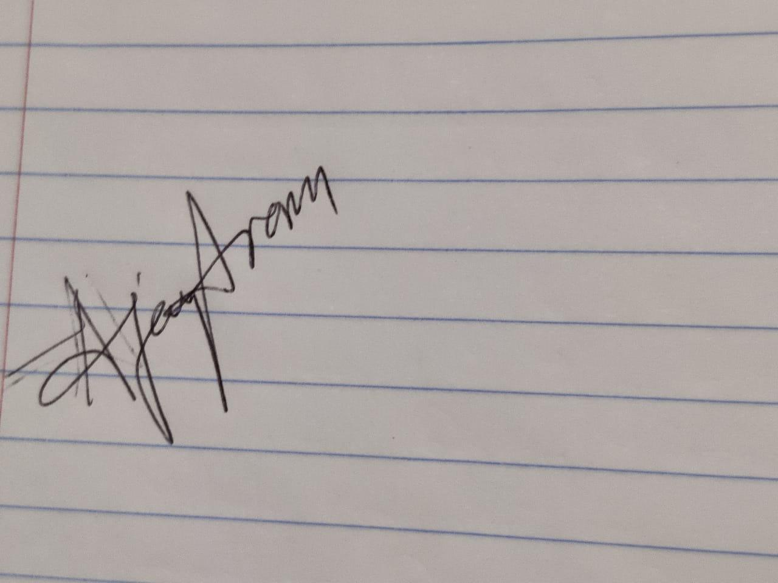 | Test Engineer/Jr. Developer | Team Member | S541989@nwmissouri.edu
Amulya Mallepelli  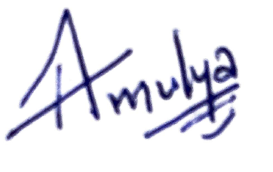 | Software Developer | Team Member | S542411@nwmissouri.edu
Madhu Babu Konda  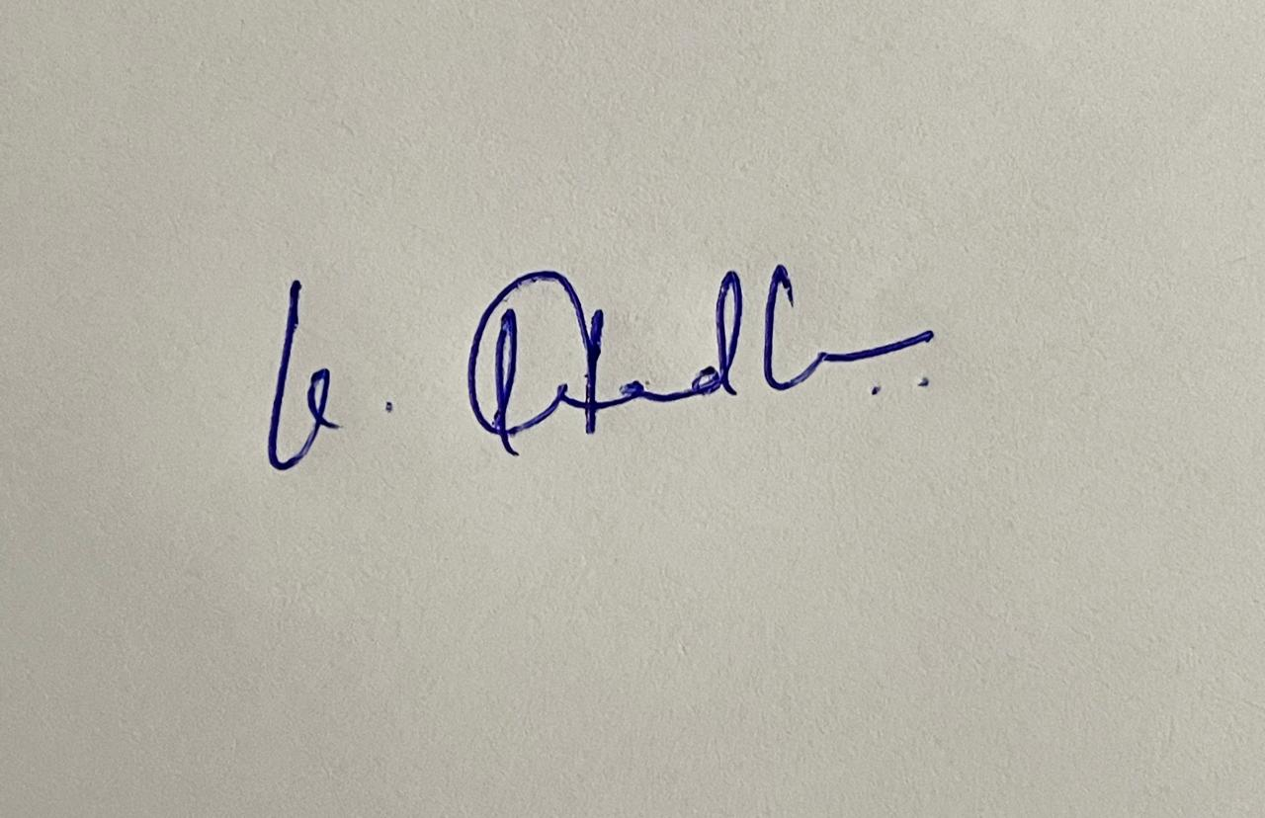 | UI/UX Developer | Team Member | S542311@nwmissouri.edu
Nagarushyanth Tummala  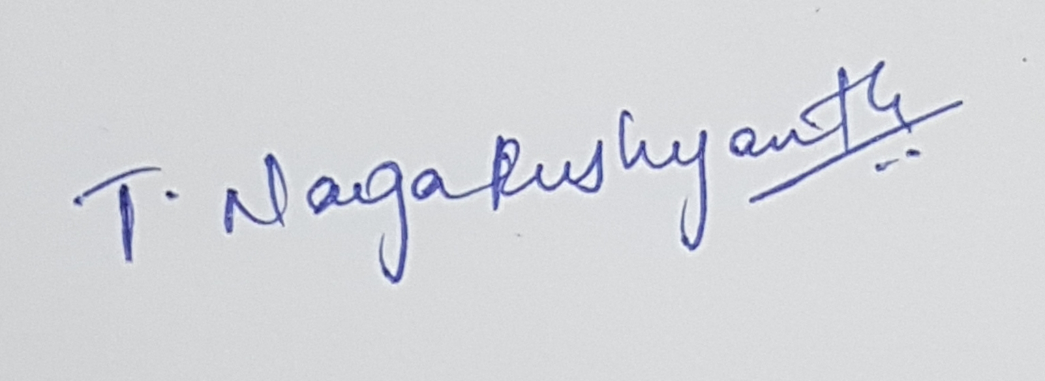 | Sr. Developer | Project Lead | S543652@nwmissouri.edu
Responsibilities:

- Jeevan Bodigam
- Create project schedules and assign tasks to team members
- Arranging team meetings, stand-up meetings
- Analyzing the scope
- Keeping track of all the requirements
- Manage risks Communicating with stakeholders Encouraging and providing guidance to team members
- Nagarushyanth Tummala
- Communicate with team members
- Integrate and coordinate with the tasks
- Motivating the team
- Analyze any challenges faced by team members
- Amulya Mallepelli
- Application backend developer
- Fix security issues
- Create support interface
- Push software updates
- Build coding for application
- Implement navigation system
- Create notification system and alert system
- Madhu Babu Konda
- User interface developer
- Create website for customers
- Integrating GPS system using fluid interfaces ·
- Ajay Kumar Reddy Arram
- Test if GPS trackers functioning properly
- Check if the GPS and Application linked Properly
- Check if Parents and Teachers getting notification properly
- Test performance
- Test quality and comfort of Shoe Perform Quality Assurance

Comments: (Handwritten or typed comments from above stakeholders, if applicable)

