ERD :-

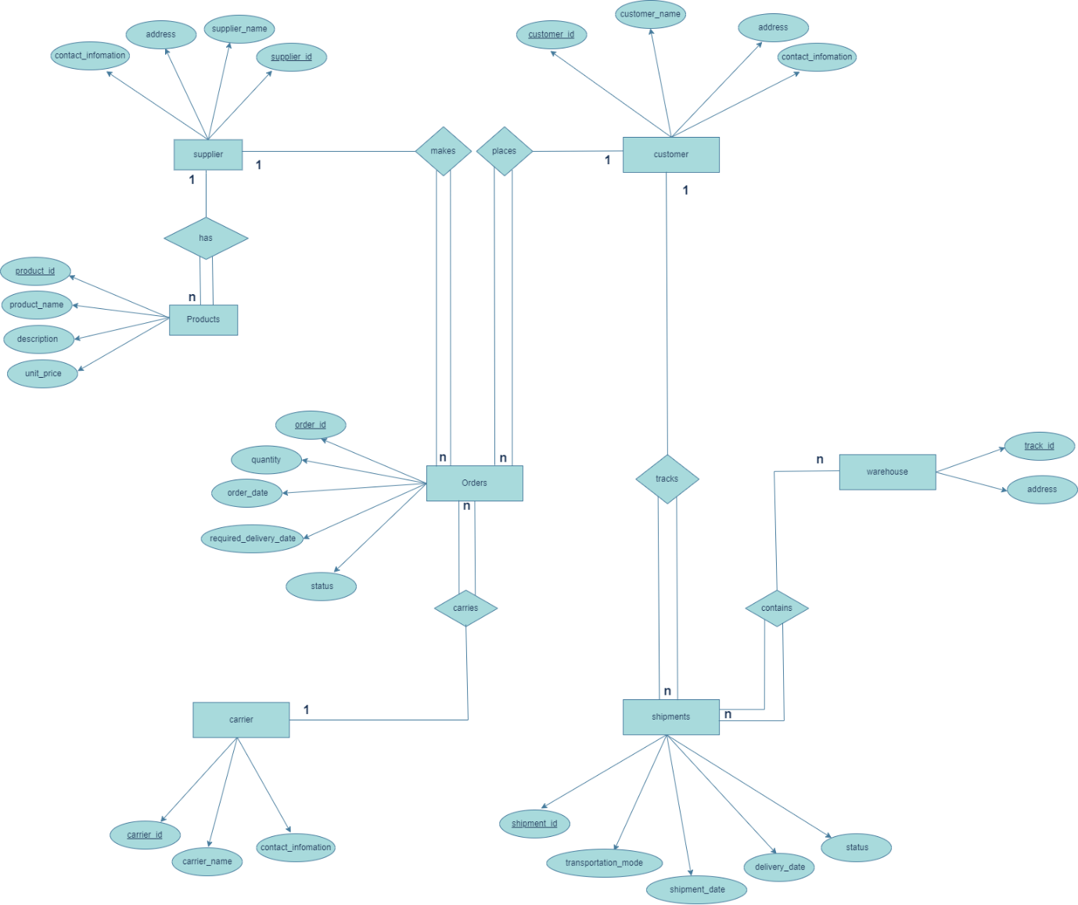

Table :-

CREATE TABLE supply_chain.suppliers (

id integer PRIMARY KEY,

name VARCHAR(255) NOT NULL,

address VARCHAR(255) NOT NULL,

contact_information VARCHAR(255) NOT NULL

);

CREATE TABLE supply_chain.products (

id integer PRIMARY KEY,

name VARCHAR(255) NOT NULL,

description VARCHAR(255) NOT NULL,

unit_price DECIMAL(10, 2) NOT NULL,

supplier_id INT NOT NULL,

FOREIGN KEY (supplier_id) REFERENCES supply_chain.suppliers(id)

);

CREATE TABLE supply_chain.customer (

id integer PRIMARY KEY,

name VARCHAR(255) NOT NULL,

address VARCHAR(255) NOT NULL,

contact_information VARCHAR(255) NOT NULL

);

CREATE TABLE supply_chain.carriers (

id integer PRIMARY KEY,

name VARCHAR(255) NOT NULL,

address VARCHAR(255) NOT NULL,

contact_information VARCHAR(255) NOT NULL

);

CREATE TABLE supply_chain.orders (

id integer PRIMARY KEY,

customer_id INT NOT NULL,

supplier_id INT NOT NULL,

carrier_id INT NOT NULL,

quantity INT NOT NULL,

order_date DATE NOT NULL,

required_delivery_date DATE NOT NULL,

status VARCHAR(255) NOT NULL,

FOREIGN KEY (customer_id) REFERENCES supply_chain.customer(id),

FOREIGN KEY (supplier_id) REFERENCES supply_chain.suppliers(id),

FOREIGN KEY (carrier_id) REFERENCES supply_chain.carriers(id)

);

CREATE TABLE supply_chain.shipments (

id integer PRIMARY KEY,

customer_id INT NOT NULL,

transportation_mode VARCHAR(255) NOT NULL,

shipment_date DATE NOT NULL,

delivery_date DATE NOT NULL,

status VARCHAR(255) NOT NULL,

FOREIGN KEY (customer_id) REFERENCES supply_chain.customer(id)

);

CREATE TABLE supply_chain.warehouse (

id integer PRIMARY KEY,

address VARCHAR(255) NOT NULL

);

CREATE TABLE supply_chain.bridge (

shipment_id INT NOT NULL,

track_id INT NOT NULL,

FOREIGN KEY (shipment_id) REFERENCES supply_chain.shipments(id),

FOREIGN KEY (track_id) REFERENCES supply_chain.warehouse(id)

);

Data :-

1 Supplier :-

insert into supply_chain.suppliers(id,name,address,contact_information)

values

(1,'Divansh','Jaipur',7094721500),

(2,'Gunjan','Ahmedabad',8838521582),

(3,'Aayush','Surat',9934571542),

(4,'Siddharth','Udaipur',6034621574),

(5,'Jinansh','Ahmedabad',9074721599),

(6,'Jeevan','Ahmedabad',8034521872),

(7,'Vivek','Rajkot',9334021577),

(8,'Rituraj','Jaipur',6084521572),

(9,'Ahmad','Surat',8934561572),

(10,'Ishaan','Rajkot',7634921572);

2 Products :-

INSERT INTO supply_chain.products (id, name, description, unit_price, supplier_id)

VALUES

(1, 'headphones', 'Premium headphones ', 1000, 1),

(2, 'Smartwatches', 'Boat smart watches', 5000, 2),

(3, 'TV', 'HD Quality Television in the world', 30000, 3),

(4, 'Keyboard', 'Mechanical gaming keyboard', 150, 4),

(5, 'Mouse', 'Wireless ergonomic mouse', 80, 5),

(6, 'Laptop', 'Ultra-thin powerful laptop', 2000, 6),

(7, 'Chair', 'Office chair', 300, 7),

(8, 'Desk', 'Adjustable desk', 500, 8),

(9, 'Monitor', '27-inch HD Monitor', 600, 9),

(10, 'Printer', 'All-in-one scanner', 400, 10),

(11, 'Speakers', 'Surround sound speakers', 800, 1),

(12, 'Microwave', 'Compact microwave oven', 1500, 1),

(13, 'Refrigerator', 'Double-door fridge', 3000, 2),

(14, 'Vacuum Cleaner', 'Robotic vacuum cleaner', 700, 3),

(15, 'Blender', 'High-speed blender', 120, 4);

3 Customer

insert into supply_chain.customer (id,name,address,contact_information)

values

(1,'Aarya','Mumbai',9878567443),

(2,'Kanak','Mount Abu',9878567444),

(3,'Urja','Telangana',9878567445),

(4,'Shruti','Noida',9878567446),

(5,'Ananya','Sikkim',9878567447),

(6,'Dev','Chennai',9878567448),

(7,'Alankrita','Uttrakhand',9878567449),

(8,'Rishabh','Jaipur',9878567453),

(9,'Samarth','Ahmedabad',9878557443),

(10,'Falguni','Hyderabad',9872567443);

4 Carrier

INSERT INTO supply_chain.carriers (id, name, address, contact_information) VALUES

(1, 'Rajat', 'Jaipur', '9876543210'),

(2, 'Anjali', 'Ahmedabad', '8765432109'),

(3, 'Vikram', 'Surat', '7654321098'),

(4, 'Meera', 'Udaipur', '6543210987'),

(5, 'Sohan', 'Ahmedabad', '5432109876'),

(6, 'Priya', 'Jaipur', '4321098765'),

(7, 'Kiran', 'Surat', '3210987654'),

(8, 'Arjun', 'Udaipur', '2109876543'),

(9, 'Neha', 'Ahmedabad', '1098765432'),

(10, 'Amit', 'Jaipur', '0123456789');

5 Order :-

INSERT INTO supply_chain.orders (id, customer_id, supplier_id, carrier_id, quantity, order_date, required_delivery_date, status)

VALUES

(1, 1, 1, 1, 100, '2023-01-15', '2023-01-25', 'Pending'),

(2, 1, 1, 2, 150, '2023-02-05', '2023-02-15', 'In Progress'),

(3, 2, 2, 1, 75, '2023-03-10', '2023-03-20', 'Shipped'),

(4, 2, 2, 3, 200, '2023-04-01', '2023-04-10', 'Delivered'),

(5, 3, 3, 1, 50, '2023-05-12', '2023-05-22', 'Pending'),

(6, 3, 3, 3, 120, '2023-06-02', '2023-06-12', 'In Progress'),

(7, 3, 3, 4, 80, '2023-07-15', '2023-07-25', 'Shipped'),

(8, 4, 4, 5, 180, '2023-08-05', '2023-08-15', 'Delivered'),

(9, 5, 5, 6, 90, '2023-09-10', '2023-09-20', 'Pending'),

(10,5, 6, 7, 250, '2023-10-01', '2023-10-10', 'In Progress');

6 Shipments :-

INSERT INTO supply_chain.shipments (id, customer_id, transportation_mode, shipment_date, delivery_date, status)

VALUES

(1, 1, 'Air', '2023-01-20', '2023-01-25', 'In Transit'),

(2, 1, 'Surface', '2023-02-10', '2023-02-18', 'Delivered'),

(3, 1, 'Air', '2023-03-15', '2023-03-22', 'In Transit'),

(4, 2, 'Surface', '2023-04-05', '2023-04-12', 'Delivered'),

(5, 2, 'Air', '2023-05-18', '2023-05-25', 'In Transit'),

(6, 3, 'Surface', '2023-06-08', '2023-06-15', 'Delivered'),

(7, 3, 'Air', '2023-07-22', '2023-07-29', 'In Transit'),

(8, 3, 'Surface', '2023-08-12', '2023-08-19', 'Delivered'),

(9, 4, 'Air', '2023-09-25', '2023-10-02', 'In Transit'),

(10, 4, 'Surface', '2023-10-15', '2023-10-22', 'Delivered');

7 Warehouse

INSERT INTO supply_chain.warehouse (id, address) VALUES

(1, 'Ahmedabad'),

(2, 'Surat'),

(3, 'Rajkot');

8 bridge

INSERT INTO supply_chain.bridge (shipment_id,track_id)

VALUES

(1,1),

(2,2),

(3,3);

* Simple Queries :-

[Q-1] Query to Retrieve the Number of Orders for a Specific Customer :-

[Ans] SELECT c.id, COUNT(*) AS order_count

FROM supply_chain.orders o, supply_chain.customer c

WHERE o.customer_id = c.id

AND c.id = 1

GROUP BY c.id;

[Q-2] Query to Retrieve all products that have the highest unit price :-

[Ans] SELECT * from supply_chain.products where unit_price in (select MAX(unit_price) from supply_chain.products);

[Q-3] Query to Sum the Quantities of Orders for a Specific Supplier :-

[Ans] SELECT supplier_id, SUM(quantity) AS total_quantity

FROM supply_chain.orders

WHERE supplier_id = 6

GROUP BY supplier_id;

[Q-4] Query to Retrieve Shipped Shipments Sorted by Shipment Date :-

[Ans] SELECT *

FROM supply_chain.shipments

WHERE status = 'Delivered'

ORDER BY shipment_date ASC;

[Q-5] Query to Calculate the Total Quantity of Products in Transit:

[Ans]SELECT SUM(o.quantity) AS Total_quantity_in_transit

FROM supply_chain.orders o,

supply_chain.shipments s where o.id = s.id

and s.status = 'In Transit';

* Complex Queries :-

[Q-1] Query to Find Customers with Multiple Orders :-

[Ans]

SELECT c.id AS customer_id, c.name AS customer_name, COUNT(o.id) AS order_count

FROM supply_chain.customer c

JOIN supply_chain.orders o ON c.id = o.customer_id

GROUP BY c.id, c.name

HAVING COUNT(o.id) > 1;

[Q-2] Query to Retrieve Products Ordered by a Specific Customer with Shipment Details :-

[Ans]

SELECT c.name AS customer_name, s.id AS shipment_id,s.status,s.delivery_date, w.address AS warehouse_address

FROM supply_chain.customer c

JOIN supply_chain.shipments s ON c.id = s.customer_id

JOIN supply_chain.bridge b ON s.id = b.shipment_id

JOIN supply_chain.warehouse w ON b.track_id = w.id

WHERE c.id = 1;

[Q-3] Query to Retrieve Products with the Lowest Total Order Quantity:

[Ans]

SELECT p.id AS product_id, p.name AS product_name, SUM(o.quantity) AS total_order_quantity

FROM supply_chain.products p

LEFT JOIN supply_chain.orders o ON p.supplier_id = o.supplier_id

GROUP BY p.id, p.name

ORDER BY total_order_quantity

LIMIT 1;

[Q-4] Query to Find the Customers Who Have Not Placed Orders:

[Ans] SELECT c.id AS customer_id, c.name AS customer_name

FROM supply_chain.customer c

LEFT JOIN supply_chain.orders o ON c.id = o.customer_id

WHERE o.id IS NULL;

[Q-5] Query to Retrieve Warehouse Information with the Total Quantity of Products Stored :-

[Ans]

SELECT w.id AS warehouse_id, w.address AS warehouse_address, SUM(o.quantity) AS total_products_stored

FROM supply_chain.warehouse w, supply_chain.bridge b, supply_chain.shipments s, supply_chain.orders o

WHERE w.id = b.track_id

AND b.shipment_id = s.id

AND s.id = o.id

GROUP BY w.id;

* Relational Algebra
* Simple Queries :-

[Q-1] Relational Algebra for Retrieving the Number of Orders for a Specific Customer :-

[Ans] π customer_id, count(orders) (σ_customer_id=1 (orders ⨝ customer) )

[Q-2] Relational Algebra for Retrieving all products that have the highest unit price :-

[Ans] π (σ_unit_price=π_max(unit_price) (products))

[Q-3] Query to Sum the Quantities of Orders for a Specific Supplier :-

[Ans] π supplier_id, sum(quantity) (σ_supplier_id=6 (orders))

[Q-4] Query to Retrieve Shipped Shipments Sorted by Shipment Date :-

[Ans] π shipment_id, transportation_mode, shipment_date, delivery_date, status

(σ status=’Delivered’ (σ shipment_date ASC (shipments)))

[Q-5] Query to Calculate the Total Quantity of Products in Transit:

[Ans] π_sum(quantity) (σ_status='In Transit' (orders ⨝ shipments ))

* Complex Queries :-

[Q-1] Query to Find Customers with Multiple Orders :-

[Ans]

[Q-2] Query to Retrieve Products Ordered by a Specific Customer with Shipment Details :-

[Ans]

[Q-3] Query to Retrieve Products with the Lowest Total Order Quantity:

[Ans]

[Q-4] Query to Find the Customers Who Have Not Placed Orders:

[Ans]

[Q-5] Query to Retrieve Warehouse Information with the Total Quantity of Products Stored :-

[Ans]