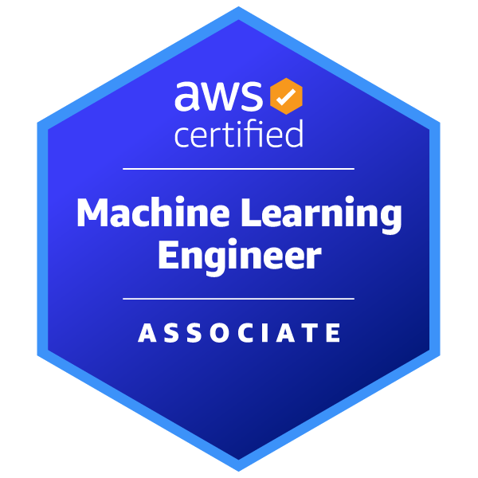
Bala Reddy Arlagadda
+1 (352) 871-8270 | arlagadda.jeevan@gmail.com | LinkedIn | GitHub | Dallas, Tx

PROFESSIONAL SUMMARY
Python Developer with 1+ years of experience building scalable microservices, serverless architectures, and ML-powered applications. Proficient in AWS, FastAPI, Kafka, and NLP frameworks including LangChain and RAG. Strong foundation in backend development, REST API design, event-driven systems, and Agile methodologies. MS in Computer Science from University of Florida.

TECHNICAL SKILLS
Programming Languages: Python, C, C++, JavaScript, SQL
Cloud & DevOps: AWS (Lambda, API Gateway, SES, EC2, CloudWatch, IAM), Docker, Podman, Git, GitHub, CI/CD Pipelines, Linux
Databases: MongoDB, MySQL, PostgreSQL, DynamoDB, Oracle, NoSQL
Web & API Development: FastAPI, Flask, Django, RESTful APIs, REST API, Microservices Architecture
Backend & Messaging: Kafka, Event Bus, Event-Driven Architecture, Message Queues
Testing & Quality: Pytest, Unit Testing, Integration Testing, TDD, Code Reviews, Bruno, Postman
Machine Learning & AI: Scikit-learn, TensorFlow, Keras, PyTorch, XGBoost, LLMs, GenAI, GPT
NLP: NLTK, SpaCy, BERT, Hugging Face Transformers, LangChain, RAG, NER, Text Classification
Data & Visualization: Pandas, NumPy, Matplotlib, Seaborn, Power BI, Tableau
Methodologies & Tools: Agile, Scrum, Sprint Planning, OOP, Data Structures, Algorithms, Distributed Systems, BeautifulSoup, Scrapy, Boto3
WORK EXPERIENCE
Python Developer, Apple Inc (Employer: Slesha) | Sunnyvale, California Aug 2025 – Present
- Designed and developed scalable API endpoints with FastAPI to handle paginated user conversations, message retrieval with attachment metadata, linked ticket details, soft deletes, and ticket updates.
- Integrated MongoDB for efficient data modeling and optimized query performance across multiple microservices.
- Tested and validated APIs using Bruno to ensure reliability, schema compliance, and data integrity.
- Worked with Kafka-based services, utilizing Kafka event bus and topics for communication among event-driven microservices.
- Implemented comprehensive unit and integration tests using Pytest, achieving 90%+ code coverage and regression-free deployments.
- Containerized applications using Podman for local development and testing, aligning with DevOps CI/CD standards.
- Gained exposure to Kubernetes-based container orchestration during internal deployments and testing workflows across microservices.
- Collaborated with cross-functional teams in Agile sprints, participating in daily standups, sprint planning, and retrospectives.
- Conducted thorough code reviews for team members, ensuring code quality, adherence to best practices, and knowledge sharing.
- Defined and documented system events and metrics to enhance observability and performance tracking.
Python Developer, Slesha Inc | Irving, Texas Feb 2025 – Jul 2025
Serverless Payroll System for Contract Workers:
- Developed a serverless payroll system using Lambda functions to execute backend logic for API calls and scheduled events.
- Implemented Amazon API Gateway to expose RESTful endpoints, enabling secure and scalable access to backend services.
- Utilized Amazon DynamoDB, a fully managed NoSQL database, to store and retrieve contract worker attendance and payroll data.
- Processed structured/unstructured worker input data and automated email summaries using SES.
- Applied AWS Identity and Access Management (IAM) to implement fine-grained role-based security for resource access.
- Used Postman to test REST APIs and implemented logging and monitoring with Amazon CloudWatch Logs for observability.
- Collaborated with stakeholders and team members in Agile environment, delivering features in 2-week sprint cycles.
- Participated in peer code reviews using GitHub pull requests, improving code quality and reducing bugs in production.
Artificial Intelligence Intern, Planet E-Com Solutions in collaboration with MICROSOFT | Noida, India
Overseas Education Consultant Software: May 2022 - July 2022
- Built recommendation engine pipelines using collaborative filtering with structured + unstructured data ingestion.
- Designed preprocessing workflows and automated ingestion using BeautifulSoup + Scrapy.
- Improved model quality by 25% via feature engineering and evaluation.
- Delivered dashboards and architectural diagrams supporting analytics-driven product decisions.

PROJECTS
Facially Expressive GenAI Mental Health Avatar | Master’s Research Project, University of Florida Jan 2024 – May 2024
- Developed a GenAI-powered mental health avatar integrating GPT-3.5, LangChain, and emotional analysis for empathetic, context-aware conversations.
- Trained Variational Autoencoders (VAE) using PyTorch/TensorFlow on 3D facial data (CoMA dataset) to generate facial expressions for user emotions.
- Built a retrieval-augmented generation (RAG) pipeline leveraging emotional and historical cues for contextual LLM responses.
- Designed LLM experimentation framework testing prompts, embeddings, and retrieval mechanisms.
- Synchronized lip movement (Rhubarb Lip Sync) with Eleven Labs TTS for lifelike speech and engagement.
- Conducted a user study (n = 20) to assess engagement and perceived empathy via two-way ANOVA.
Virtual Cricket Coach Chatbot | Python, NLTK, AWS
- Built an AI-powered virtual cricket coach chatbot using the NLTK framework to generate personalized training plans based on user goals and performance.
- Implemented NLP-based intent recognition for answering user queries and deployed the application on AWS EC2, ensuring scalability and availability.
MediMate | Python, NLP
- Led the development of a healthcare chatbot using advanced Named Entity Recognition (NER) techniques to extract and categorize medical entities from conversations.
- Improved work efficiency by 10% over the BERT baseline model using optimized sequence labelling and contextual entity recognition.
Gator Taxi | C++
- Developed a taxi dispatch system using Red-Black Trees and Heaps for efficient ride assignment and fair taxi allocation.
- Optimized data structures to achieve O(log n) efficiency, reducing dispatch time by 20%.

EDUCATION
University of Florida, Gainesville, Florida, USA Aug 2023 - Dec 2024
Master of Science in Computer Science and Engineering
Achievements: Received the scholarship of $4500 to support my master's program in Computer Science and Engineering at the University of Florida.
Amity University, Noida, India Jul 2019 - May 2023
Bachelor of Technology in Artificial Intelligence

CERTIFICATIONS
- AWS Machine Learning - Associate (MLA -C01) Amazon Web Services, 2025

