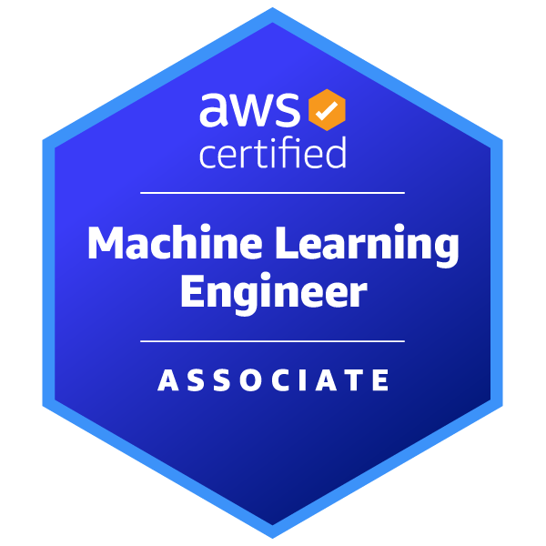
Bala Reddy Arlagadda
+1 (352) 871-8270 | arlagadda.jeevan@gmail.com | LinkedIn | GitHub | Dallas, TX

PROFESSIONAL SUMMARY
Data Engineer with strong foundations in analytics, SQL, and Python, experienced in building and maintaining data pipelines, analytics-ready datasets, and scalable data processes to support product insights and business decision-making. Proven ability to partner with engineers, product managers, and analysts to ensure data quality, reliability, and impact at scale.

TECHNICAL SKILLS
Programming Languages: Python, C/C++, SQL, R, JavaScript
Data Engineering & Analytics: ETL / ELT Pipelines, Data Modeling (Fact & Dimension Tables), Data Warehousing Concepts, Analytics Tables, Batch Processing, Data Validation, Data Quality Checks, Product Metrics, Exploratory Data Analysis (EDA)
Statistical & Experimental Methods: A/B Testing, Hypothesis Testing, Statistical Significance, Confidence Intervals, Linear & Logistic Regression, Time Series Forecasting, ANOVA
Machine Learning: Scikit-learn, XGBoost, TensorFlow, PyTorch, Random Forests, Classification & Regression Models, GenAI, GPT, Claude
NLP & Unstructured Data: SpaCy, NLTK, BERT, Hugging Face Transformers, Named Entity Recognition (NER), Text Classification
Visualization & Storytelling: Matplotlib, Seaborn, Tableau, Power BI
Databases & Data Systems: PostgreSQL, MongoDB, DynamoDB, MySQL, NoSQL
Cloud & DevOps: AWS (Lambda, API Gateway, SES, EC2, CloudWatch, IAM), Docker, Podman, Git, GitHub, CI/CD Pipelines, Linux, Azure (AKS fundamentals, container orchestration concepts)
Web & API Development: FastAPI, Flask, Django, REST API, Microservices Architecture
Backend & Messaging: Kafka, Event-Driven Architecture, Message Queues
Testing & Quality: Pytest, Unit Testing, Integration Testing, Code Reviews, Bruno, Postman
WORK EXPERIENCE
Python Developer, Apple Inc (Employer: Slesha) | Sunnyvale, California Aug 2025 – Present
- Designed and developed scalable API endpoints with FastAPI to handle paginated user conversations, message retrieval with attachment metadata, linked ticket details, soft deletes, and ticket updates.
- Built and maintained backend data services processing large volumes of semi-structured user conversation and message metadata.
- Designed analytics-ready datasets by aggregating service logs, events, and metadata to support downstream analysis and reporting.
- Performed exploratory data analysis to identify usage patterns, service bottlenecks, and reliability trends across distributed systems.
- Partnered with engineers and platform teams to define product metrics, ensure data quality, and improve observability for production data pipelines.
- Supported critical data processes in production by implementing data validation, monitoring, and automated testing (90%+ coverage).
- Worked closely with cross-functional stakeholders in Agile sprints to align data outputs with product and business needs.
Python Developer, Slesha Inc | Irving, Texas Feb 2025 – Jul 2025
Serverless Payroll System for Contract Workers:
- Developed serverless data pipelines using AWS Lambda, API Gateway, and DynamoDB to process structured and unstructured payroll data.
- Designed batch transformations to convert operational data into analytics-friendly formats for reporting and insights.
- Implemented data validation, aggregation, and quality checks to ensure accuracy of payroll summaries.
- Built monitoring dashboards using CloudWatch to track pipeline health and detect anomalies in production.
Artificial Intelligence Intern, Planet E-Com Solutions in collaboration with MICROSOFT | Noida, India
Overseas Education Consultant Software: May 2022 - July 2022
- Built recommendation pipelines using collaborative filtering on structured and unstructured datasets.
- Designed data ingestion and preprocessing workflows using web scraping and automated pipelines.
- Improved model performance by 25% through feature engineering, evaluation, and hyperparameter tuning.
- Delivered analytical dashboards and insights to support data-driven product decisions.

PROJECTS
Facially Expressive GenAI Mental Health Avatar | Master’s Research Project, University of Florida
- Developed a GenAI-powered mental health avatar integrating GPT-3.5, LangChain, and emotional analysis for empathetic, context-aware conversations.
- Trained Variational Autoencoders (VAE) using PyTorch/TensorFlow on 3D facial data (CoMA dataset) to generate facial expressions for user emotions.
- Built a retrieval-augmented generation (RAG) pipeline leveraging emotional and historical cues for contextual LLM responses.
- Designed LLM experimentation framework testing prompts, embeddings, and retrieval mechanisms.
- Synchronized lip movement (Rhubarb Lip Sync) with Eleven Labs TTS for lifelike speech and engagement.
- Designed experimentation frameworks to compare prompts, embeddings, and retrieval strategies.
- Conducted a user study (n = 20) to assess engagement and perceived empathy via two-way ANOVA.
Payments API | Python, FastAPI, PostgreSQL, Docker
- Built a backend system generating analytics-ready transaction data for deposits, withdrawals, refunds, and peer-to-peer transfers.
- Performed controlled A/B-style comparisons of alternative API flows to evaluate impact on transaction success rates and user drop-offs using statistical analysis.
- Implemented structured logging and monitoring to enable traceability and downstream analytics.
Research-HUB — Multi-Agent AI Research Assistant | Python, LangChain, LangGraph, FastAPI, LLMs
- Built backend services that orchestrate multi-step data extraction, analysis, and structured output generation.
- Designed APIs and data flows to transform unstructured inputs into analytics-ready structured results.
- Implemented real-time streaming and state management to support interactive data workflows.

EDUCATION
University of Florida, Gainesville, Florida, USA Aug 2023 - Dec 2024
Master of Science in Computer Science and Engineering
Achievements: Received the scholarship of $4500 to support my master's program in Computer Science and Engineering at the University of Florida.
Amity University, Noida, India Jul 2019 - May 2023
Bachelor of Technology in Artificial Intelligence

CERTIFICATIONS
- AWS Machine Learning - Associate (MLA -C01) Amazon Web Services, 2025
- REST API (Intermediate) certification - HackerRank,2025
- R certification- HackerRank, 2025
- Python certification - HackerRank, 2025

