**1.Objective** 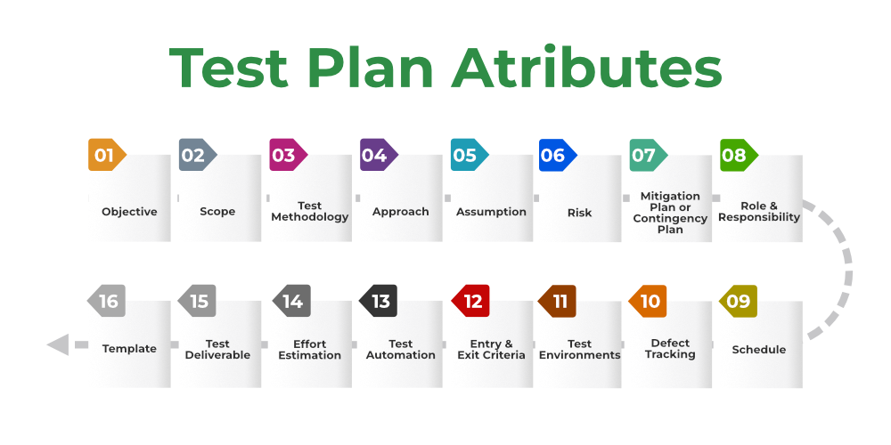:

 It describes the aim of the test plan. The overall objective of the test is to find as many defects as possible and to make software bug-free.

**2.Scope:**It consists of information that needs to be tested concerning an application. The scope can be divided into two parts:

* **In-Scope:** The modules that are to be tested rigorously.
* **Out Scope:** The modules that are not to be tested rigorously.

**3. Testing Methodology:**The methods that are going to be used for testing depend on application to application

**4.Approach:** The approach of testing different software is different. It deals with the flow of applications for future reference.

**5. Assumption:**In this phase, certain assumptions will be made.

**6. Risk:**All the risks that can happen if the assumption is broken.

**7. Mitigation Plan:**If any risk is involved then the company must have a backup plan, the purpose is to avoid errors.

**8. Roles and Responsibilities:** All the responsibilities and role of every member of a particular testing team has to be recorded.

**9. Schedule:**Under this, it will record the start and end date of every testing-related activity.

**10. Defect Tracking:**It is an important process in software engineering as lots of issue arises when you develop a critical system for business. If there is any defect found while testing that defect must be given to the developer team.

**1. Test Environments:**It is the environment that the testing team will use i.e. the list of hardware and software, while testing the application.

**12. Entry and Exit Criteria:**The set of conditions that should be met to start any new type of testing or to end any kind of testing.

**13. Test Automation:**It consists of the features that are to be automated and which features are not to be automated.

**14. Effort Estimation:**This involves planning the effort that needs to be applied by every team member.

**15. Test Deliverables:** It is the outcome from the testing team that is to be given to the customers at the end of the project.

**6. Template:**This is followed by every kind of report that is going to be prepared by the testing team. All the test engineers will only use these templates in the project to maintain the consistency of the product.