**DBMS Assignment – 4**

Formula 1 Database Management System

1. Dhruva A P - PES1UG19CS144
2. Dhruvansh R - PES1UG19CS145
3. Jeevan Samrudh L H - PES1UG19CS196

Task 2:

Additional Queries – Database schema has increased with new tables such as new_record, new_constructors, new_wdc, etc.

Task 3:

Data Migration – Earlier assignments were done on postgres, since we found mysql module in python easier to use we migrated it to a different type of RDBMS.

Task 5:

Flask is used for connectivity for the front end to back end.

Execution:

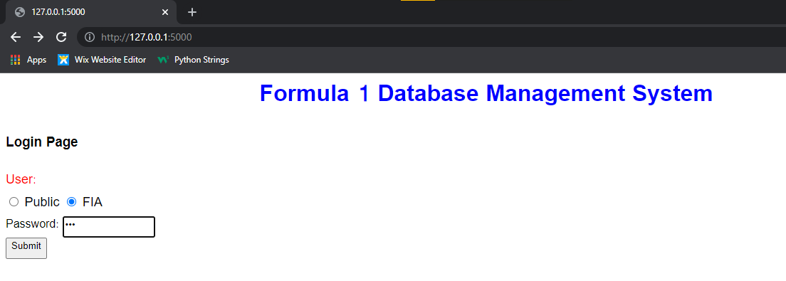

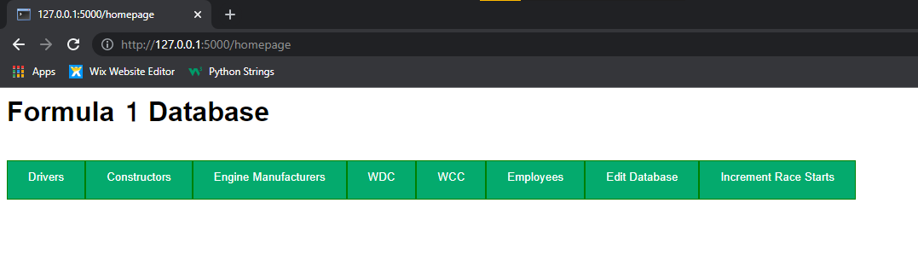

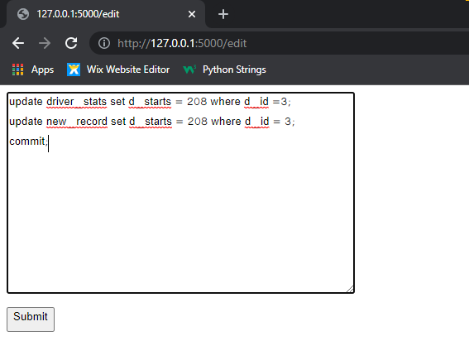

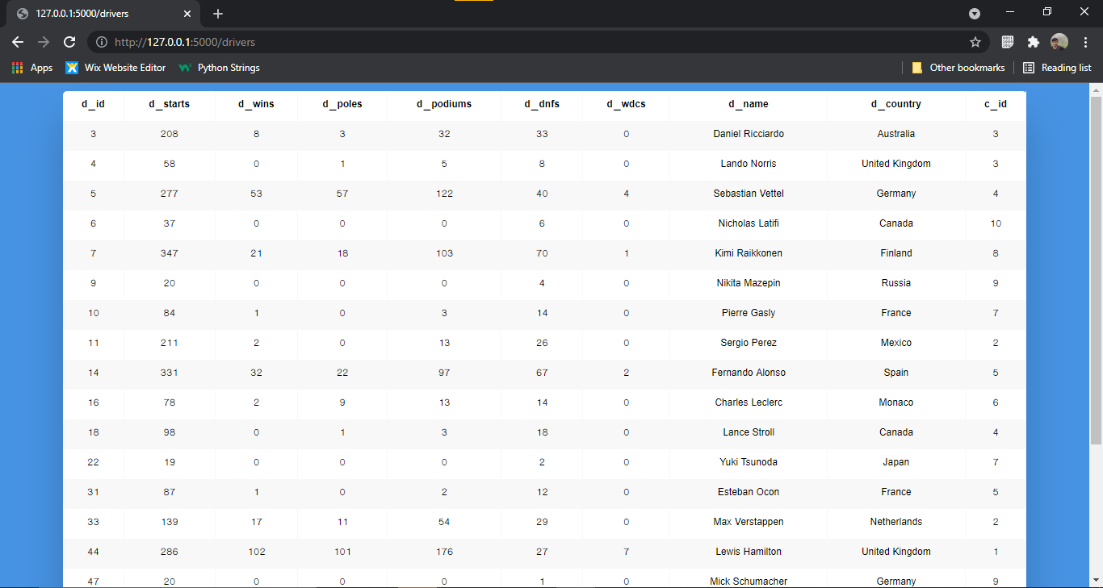

Mongo DB can be a preferred NoSQL for this database.

Contribution:

Dhruvansh: Frontend

Dhruva: Backend, Flask Connectivity

Jeevan: Backend, Flask Connectivity