Test-Plan   
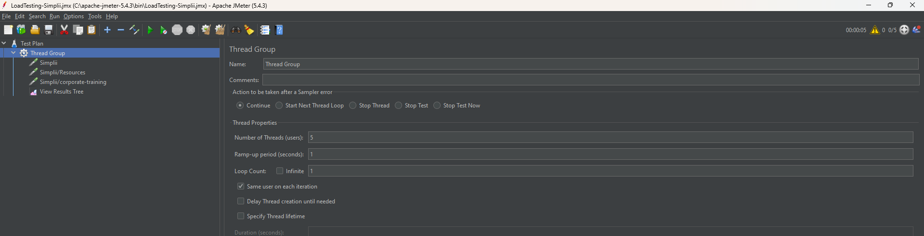  
Http Request 1 – Simplii-homepage  
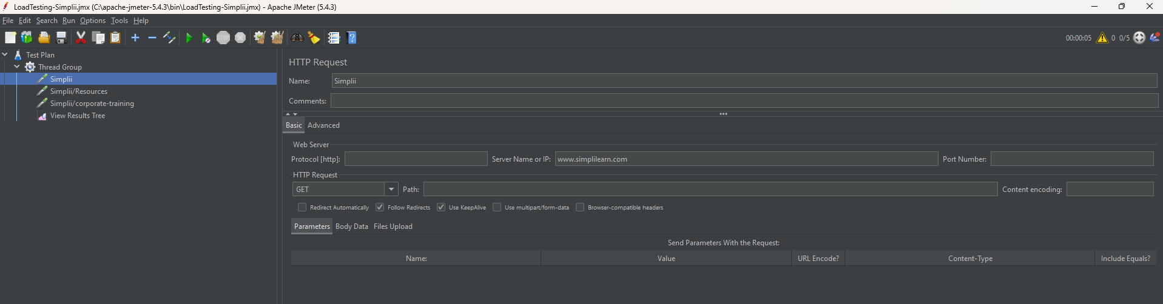  
Http Request 2 – Simplli-resources  
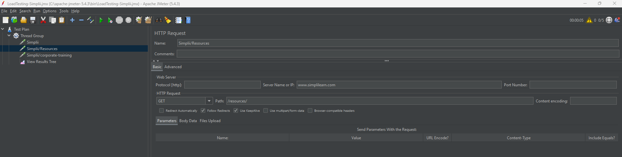  
Results Tree – Listening output  
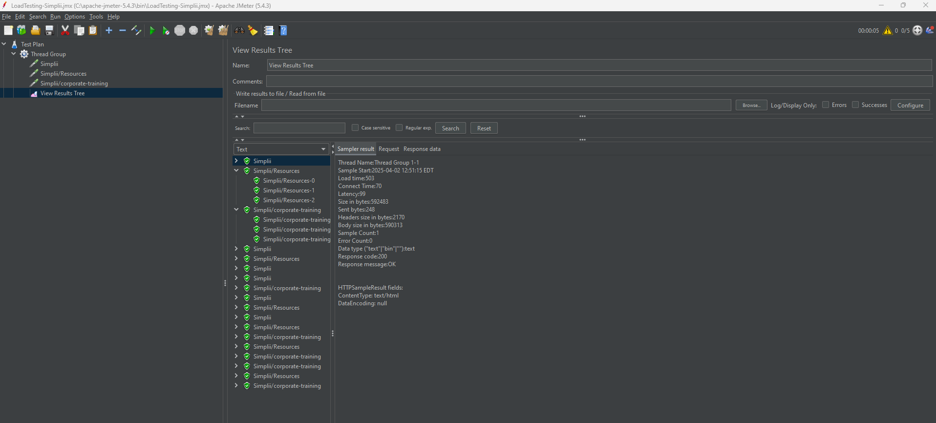  
  
  
  
  
NON-GUI i.e cmd   
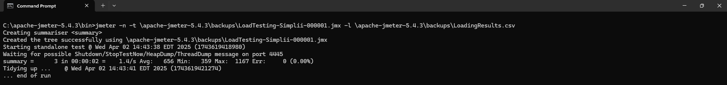  
o/p in csv excel file  
