___singlelinked list_______________________________________________________
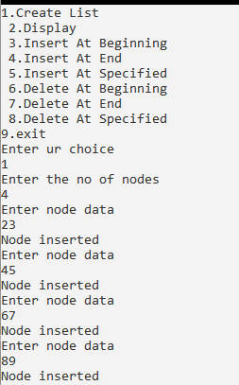 insert at beginning
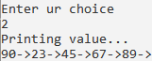
Insert at end
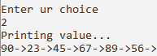
Insert at specific
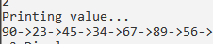
Delete at beginning
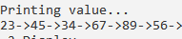
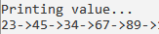
delete at end
delete at specific
