**Difference between Window objects and Document**

**JavaScript window**

☺ The window is at a root/top level at the JavaScript object hierarchy.

☺ It  is a global/root object in JavaScript and it is the root object of the Document object model(DOM)

☺ The first thing that gets loaded into the browser is the window and the properties related to that window are stored in the window object.

☺ Properties related to window objects are length, innerWidth, innerHeight, caches, etc.

**Syntax:**

* window object:

window.propertyname;

**Example :**Focus on the window object.

* Javascript

|  |
| --- |
| window.document.bgColor = "aqua";          const height = document.getElementById('innerheight');          const width = document.getElementById('innerwidth');          window.document.querySelector('h1').textContent =              "Welcome to window object";          height.textContent = "innerheight - " +              window.innerHeight;          width.textContent = "innerwidth - " +              window.innerWidth; |

**Output:**

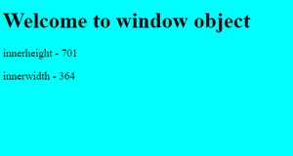

**JavaScript document**

☺ A document is an object inside the window object.

☺ We use a document object for manipulation inside the document.

☺ After the window gets loaded then there’s a document (HTML, PHP, or another document) loaded inside that window and the properties related to that document is stored in the document object.

☺ Properties related to document objects are title, URL, cookie, etc.

**Syntax:**

* document object:

document.propertyname

OR

window.document.propertyname

**Example :** Focus on the document object.

* HTML

|  |
| --- |
| <!DOCTYPE html>  <**html** lang="en">    <**head**>      <**meta** charset="UTF-8">      <**meta** http-equiv="X-UA-Compatible" content="IE=edge">      <**meta** name="viewport"            content="width=device-width, initial-scale=1.0">      <**title**>Document object</**title**>  </**head**>    <**body** style="color:white">      <**h1**></**h1**>      <**p** class="details"></**p**>        <**p** class="details"></**p**>        <**p** class="details"></**p**>        <**script**>          document.bgColor = "rgb(89, 135, 235)";          const text = prompt('enter the text to appear on screen');          const h1 = document.querySelector('h1');          h1.textContent = text;          const p = document.getElementsByClassName('details');          p[0].textContent = "document type:" +                document.contentType;          p[1].textContent = "url :" + document.bgColor;          p[2].textContent = "title :" + document.title;      </**script**>  </**body**>    </**html**> |

**Output:**

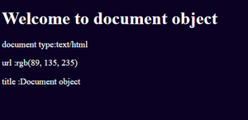

**Key points in short**

|  |  |
| --- | --- |
| **Document** | **Window** |
| It represents the document loaded inside the window or browser. | It represents the browser window in which you are seeing the content. |
| The properties related to it are stored in the document object. | The properties related to it are stored in the window object. |
| It is loaded after the loading window because the window contains a document. | It is loaded before the document because window container document. |
| It is the root element of the document object model. | The window is the global element for all objects, functions, etc. |
| It is an object of window. | It is an object of the browser. |
| We can not access windows objects properties inside the document. | We can access document object properties inside the window. |
| logic:  document:{ properties} | logic:      window:{         document:{properties}     } |
| Example: document.title will return the title of the document | Example: window.document.title will return the title of the document. |