SQL

Name : R Jeevanantham

Day-1

Step 1 -create CLIENT_MASTER Table

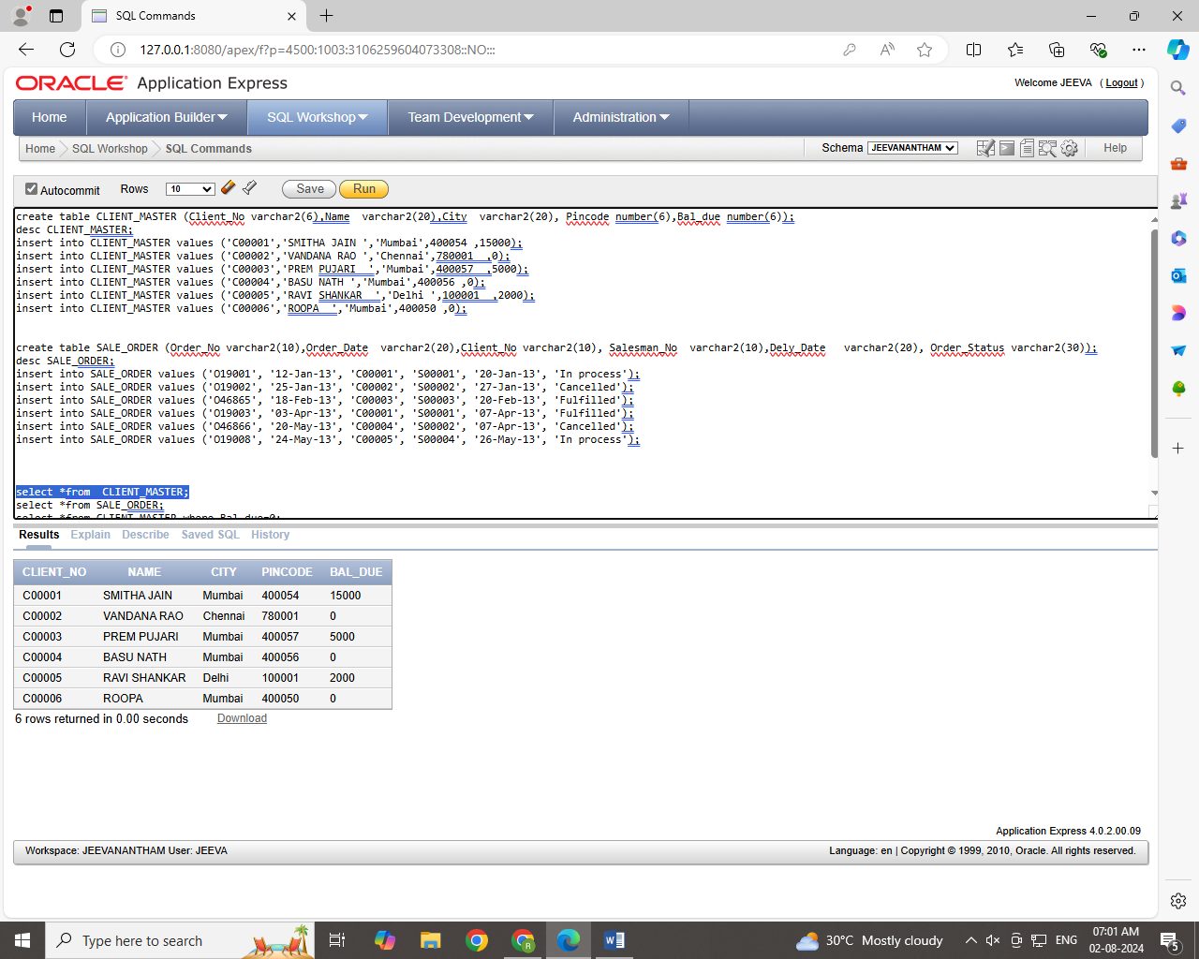

Step 2 –create SALE_ORDER Table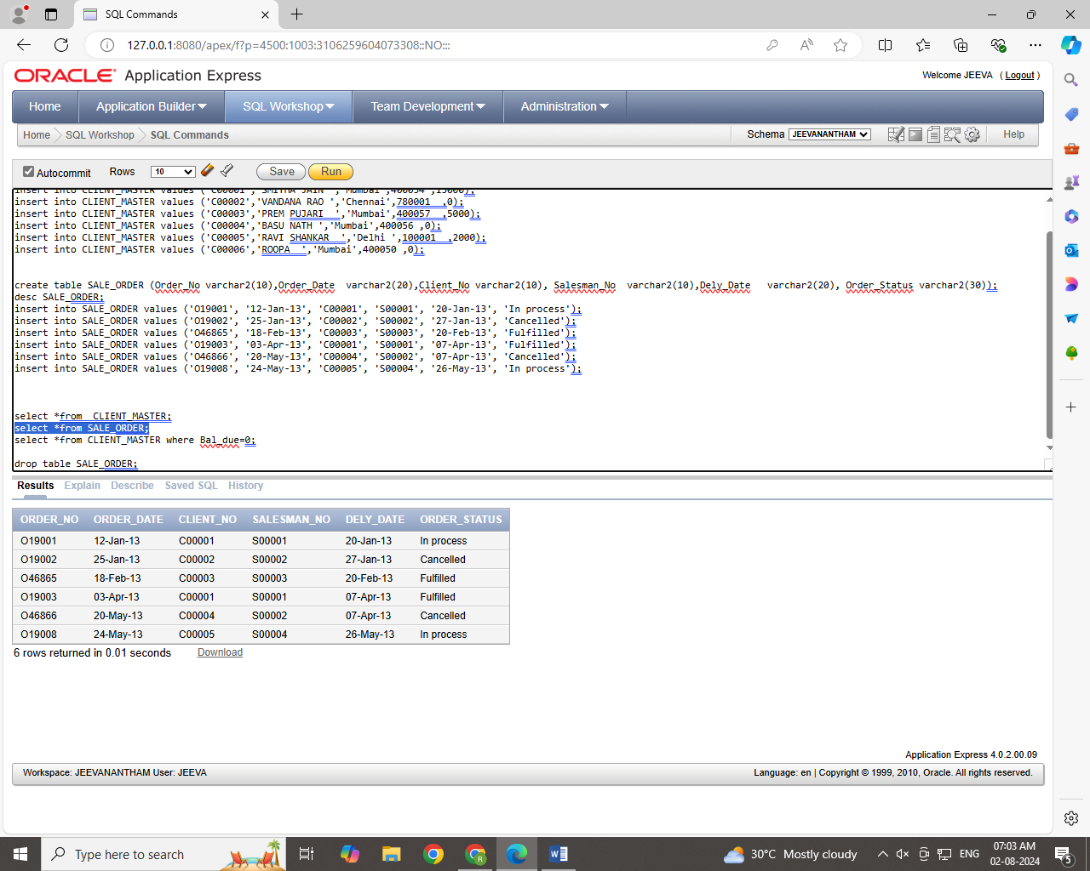

Step 3

List all details from the client_master table for clients whose Bal_due = 0.

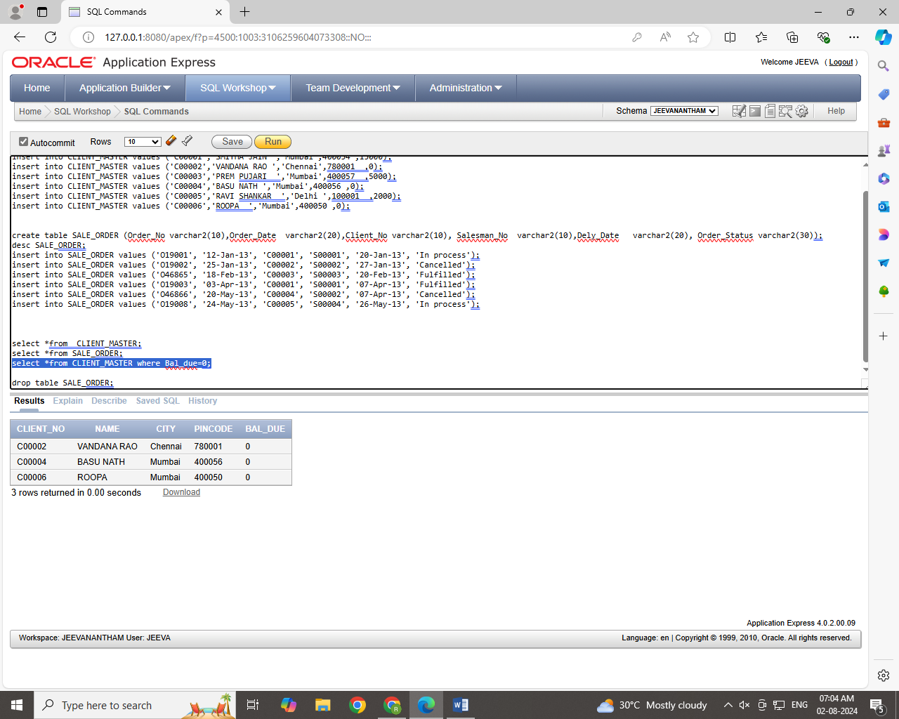

Step 4

Update table client_master, Change city of Client_no C00004 to Jaipur.

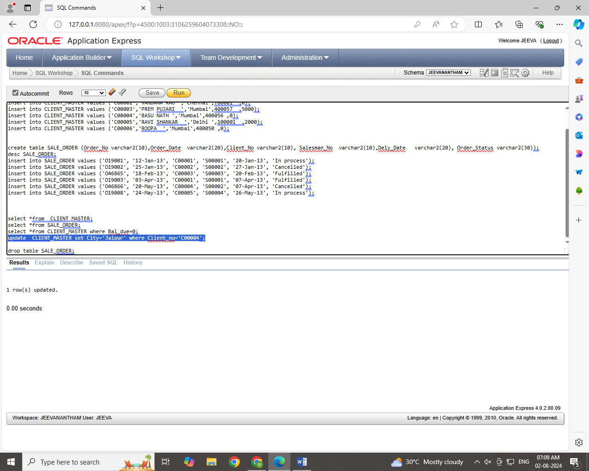

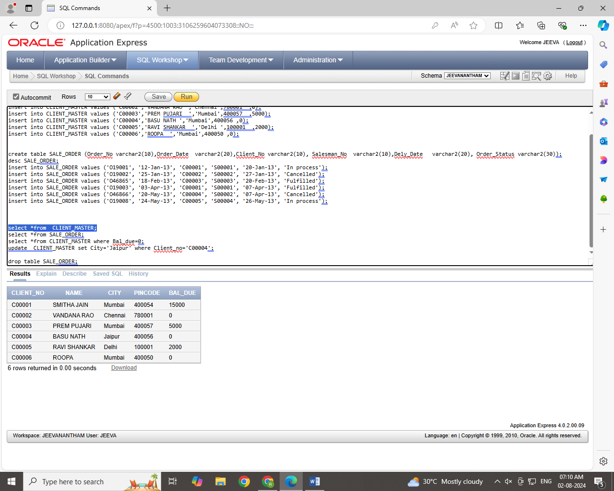

Step 5

Retrieve records of clients residing in Mumbai.

