SQL

Name : R Jeevanantham.

Regno : 73152115033

Date :8/8/2024

**Step 1**

Create the Sales table

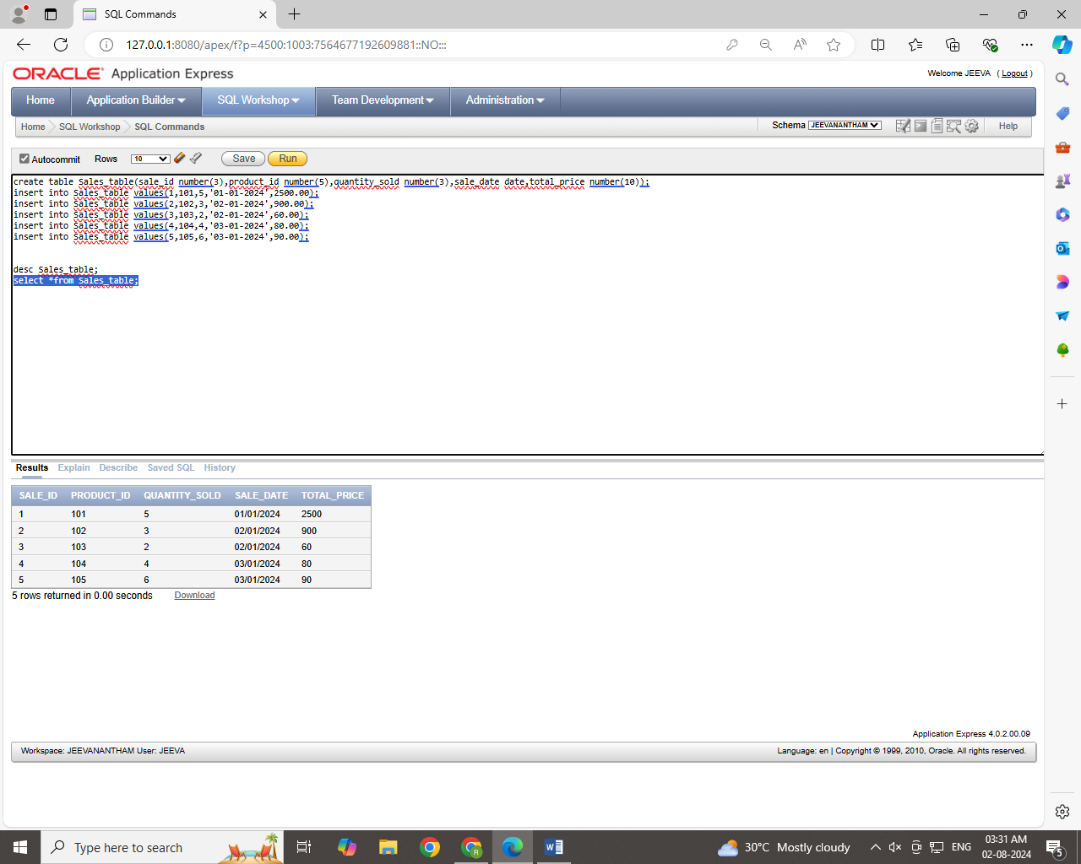

**Step 2**

**Retrieve all columns from the Sales table.**

**Step 3**

**Retrieve sale_id and quantity_sold from sales table.**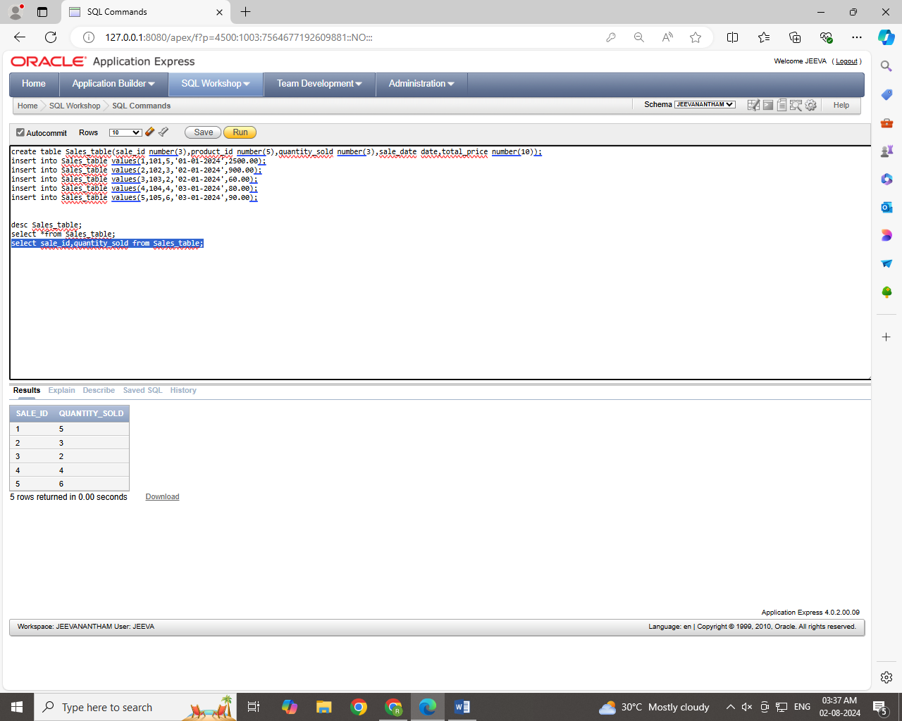

**Step 4**

**Retrieve the sale_id and sale_date from the Sales table.**

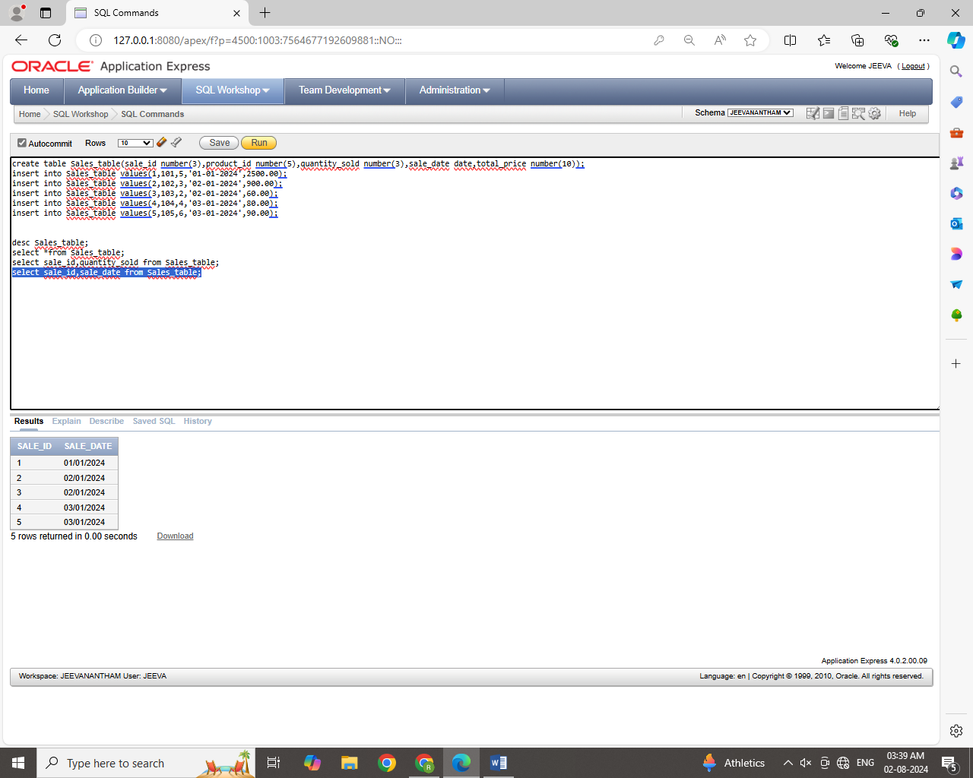

**Step 5**

**Filter the Sales table to show only sales with a total_price greater than $100.**

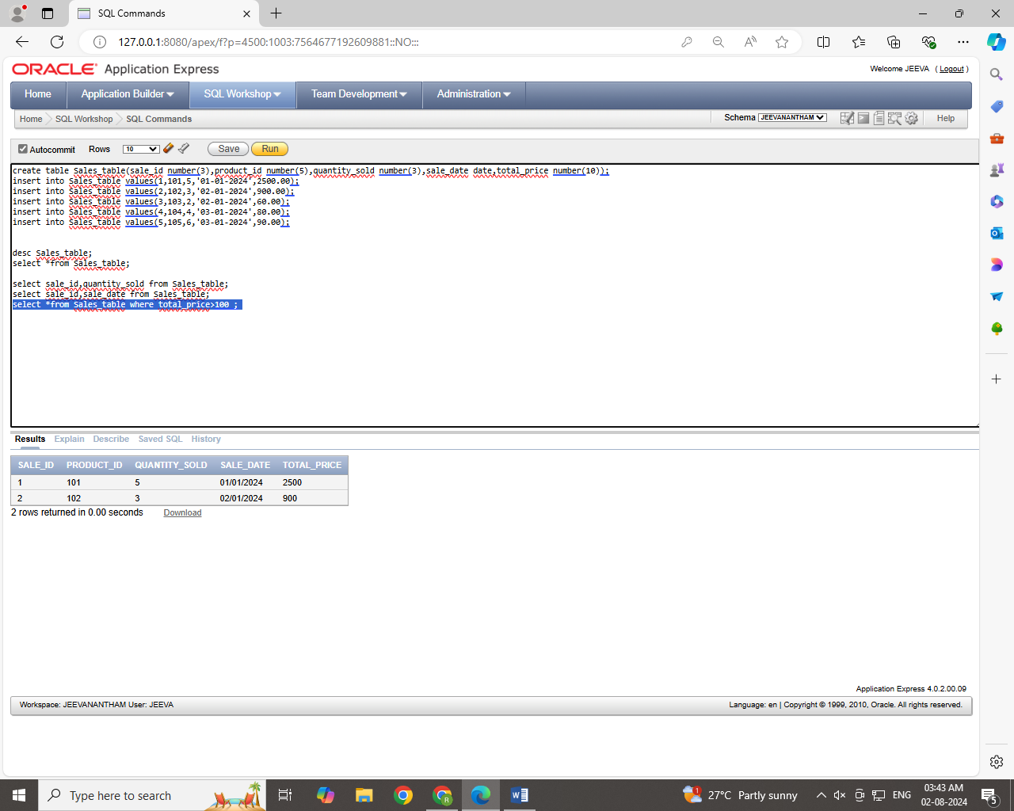

**Step 6**

**Retrieve the sale_id and total_price from the Sales table for sales made on January 3, 2024.**

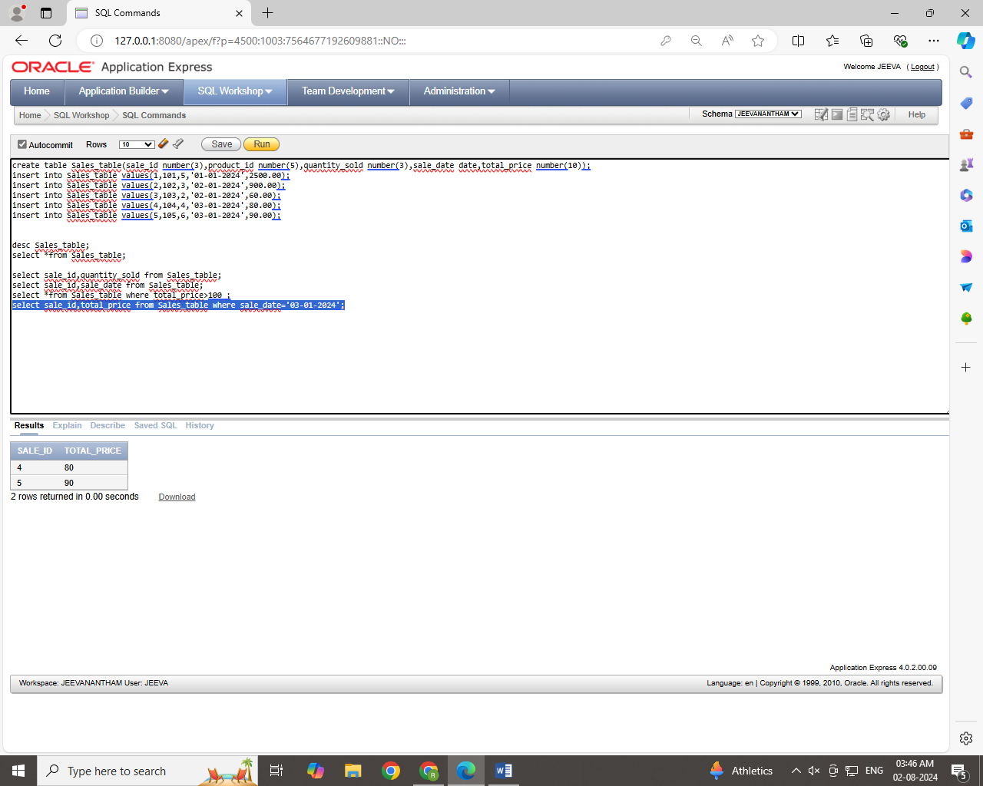

**Step 7**

**Retrieve the sale_id, product_id, and total_price from the Sales table for sales with a quantity_sold greater than 4.**

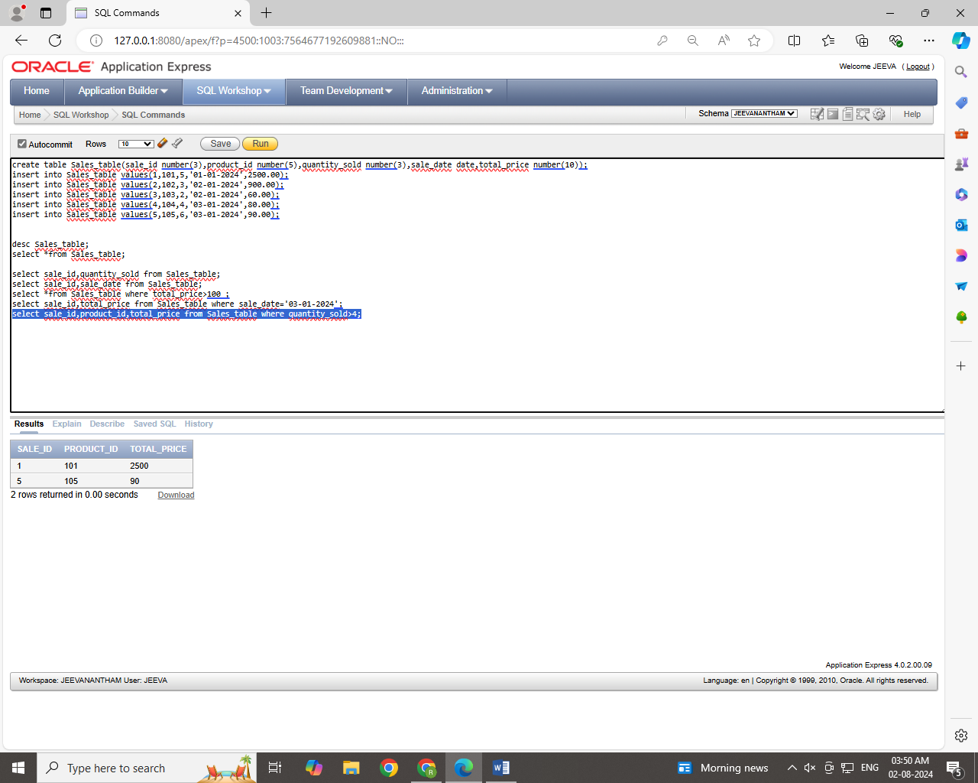

**Step 8**

**Retrieve all columns from the Sales table those sale_id are 1, 3 & 5.**

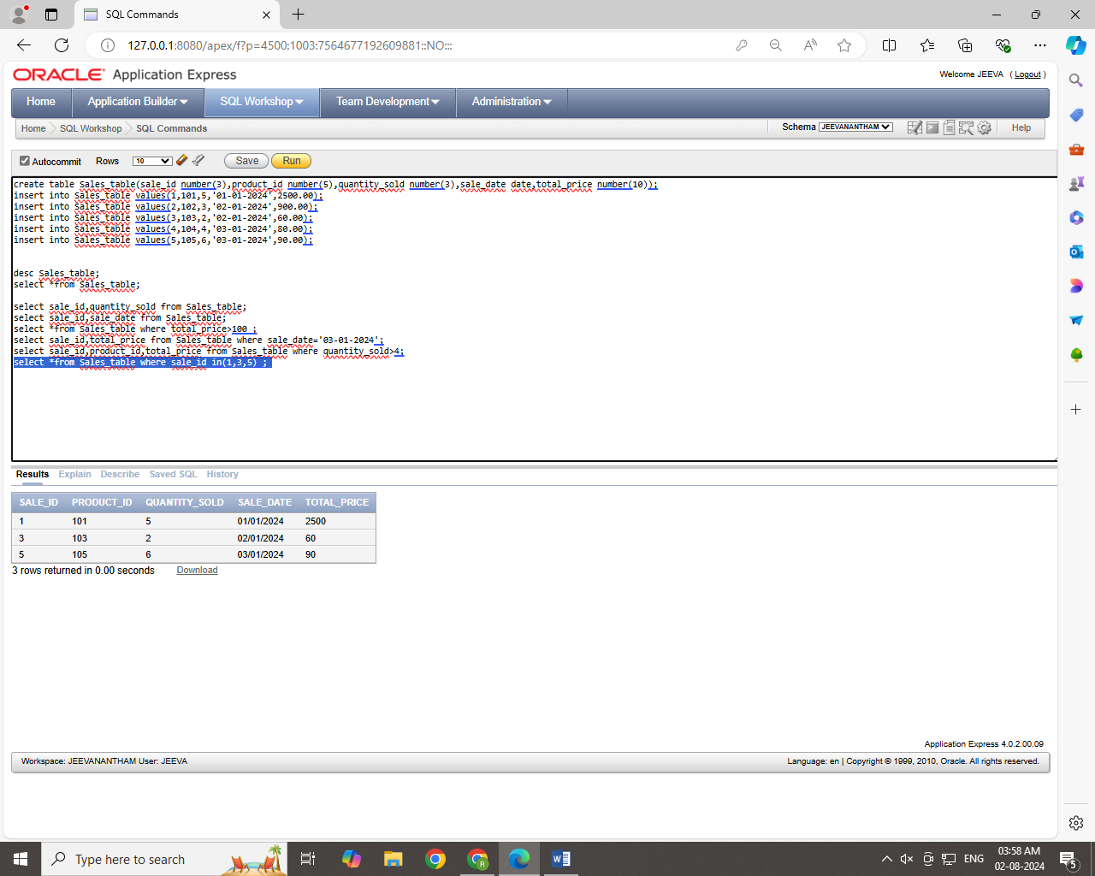

**Step 9**

**Retrieve all columns from the Sales table those total_price between 90 and 1000.**

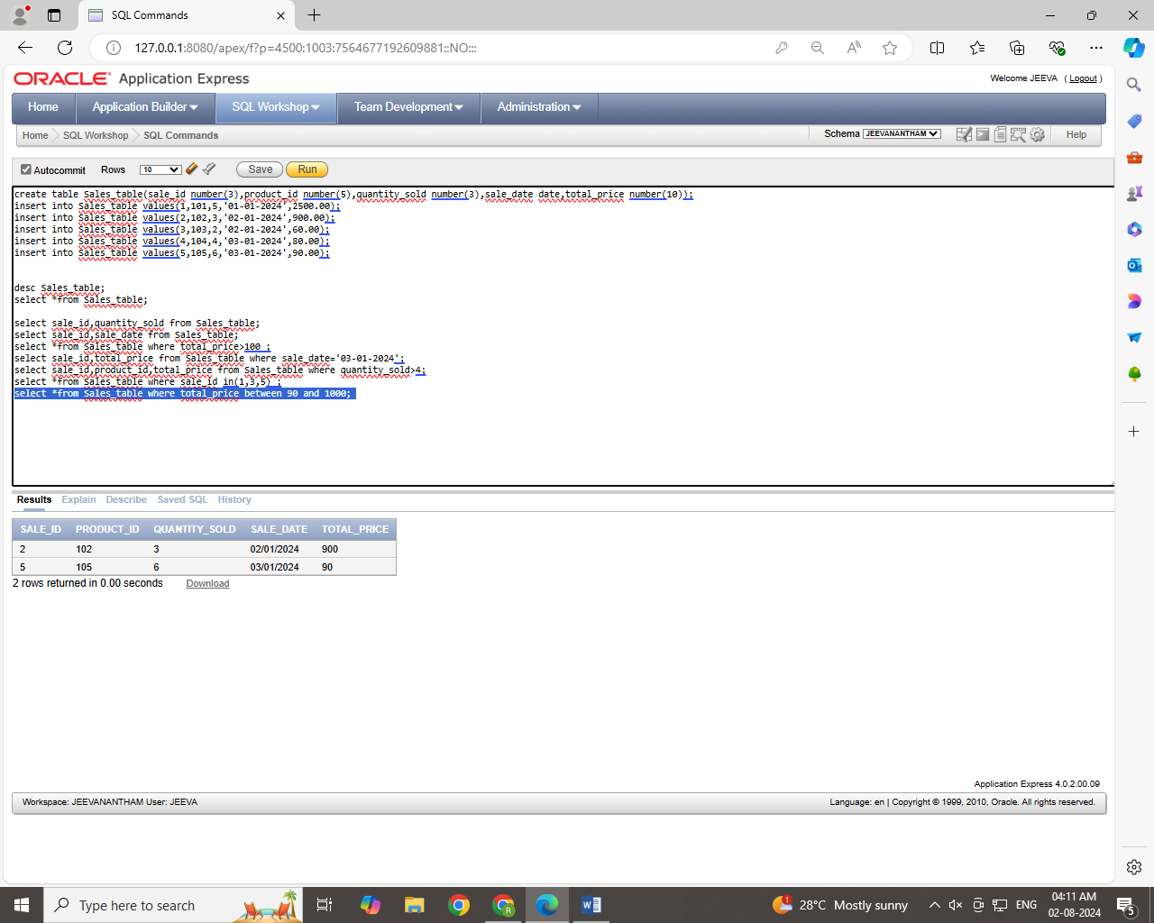

**Step 10**

**Retrieve all columns from the Sales table those total_price not between 90 and 1000.**

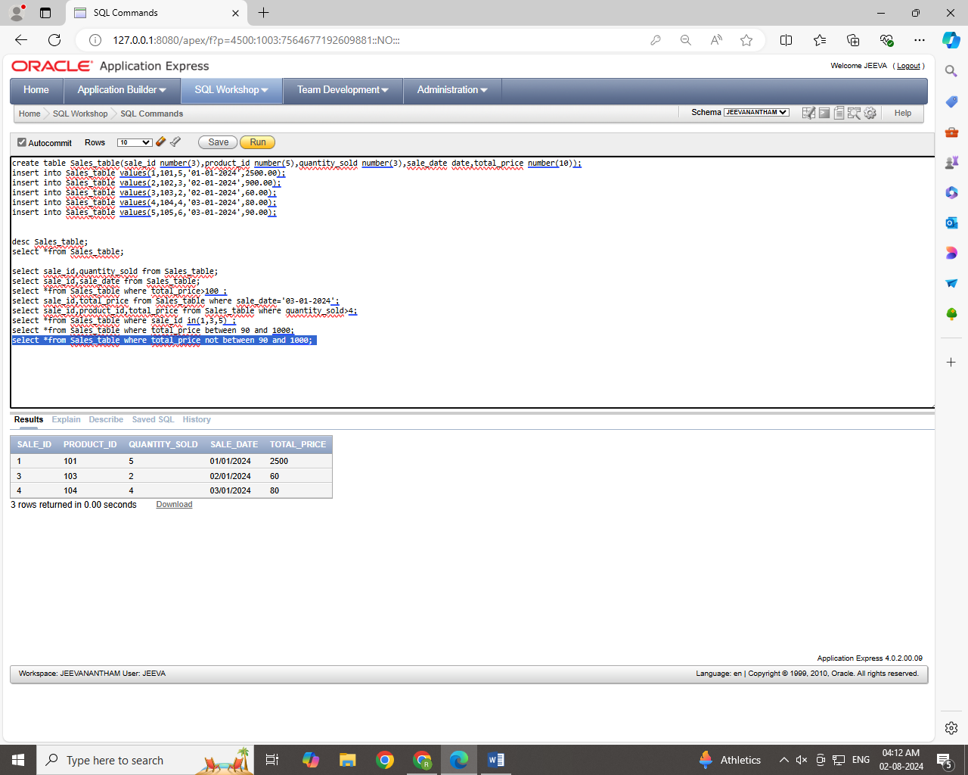

**Step 11**

**Retrieve all columns from the Sales table those sale_id are not in 1, 3 & 5.**

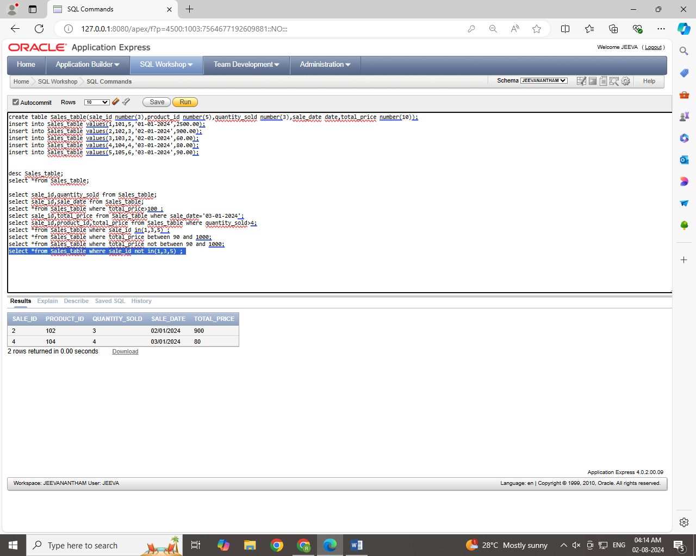

**Step 12**

**Update total_price as 500 in  the Sales table those sale_id are 1, 3 & 5.**

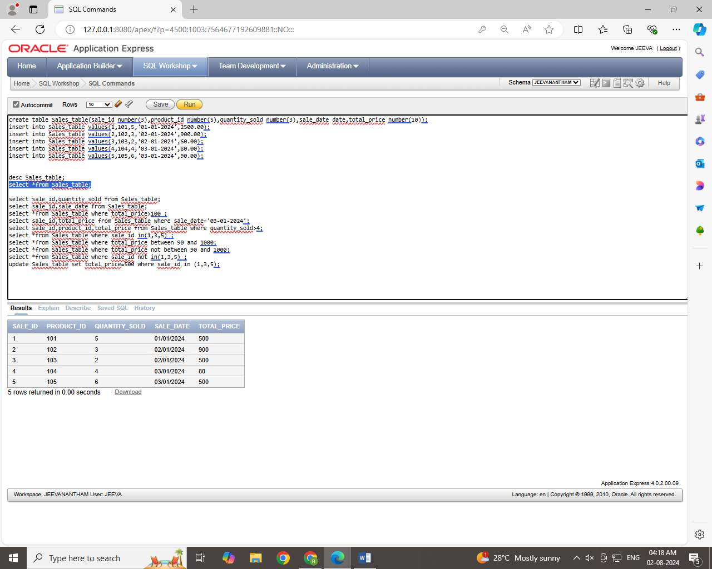

**Step 13**

**delete from the Sales table those total_price not between 90 and 1000.**

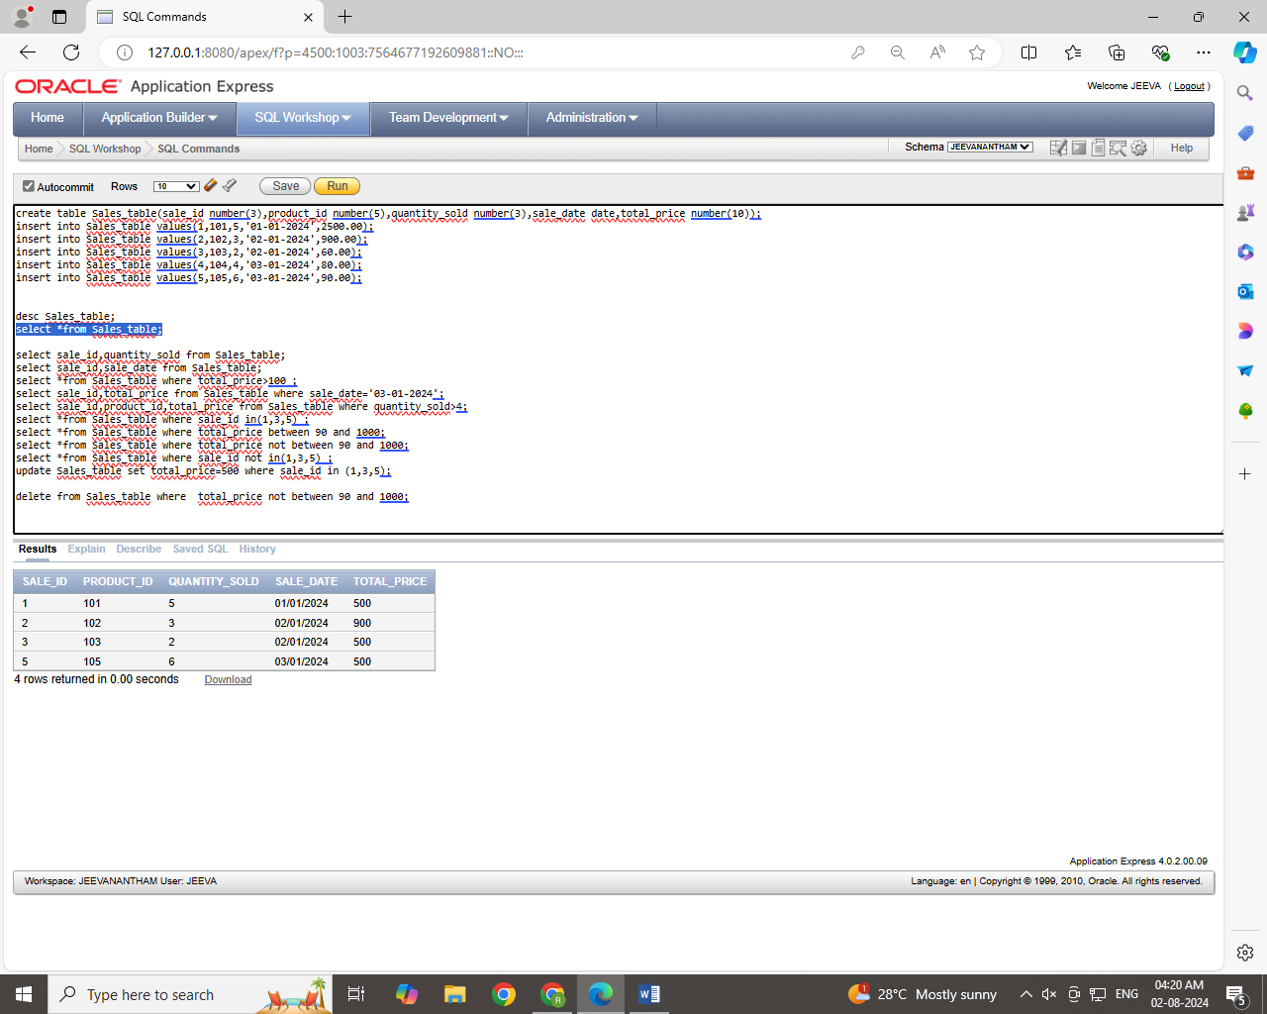

**Step 14**

**Sort all the records using sale_id column in ascending order.**

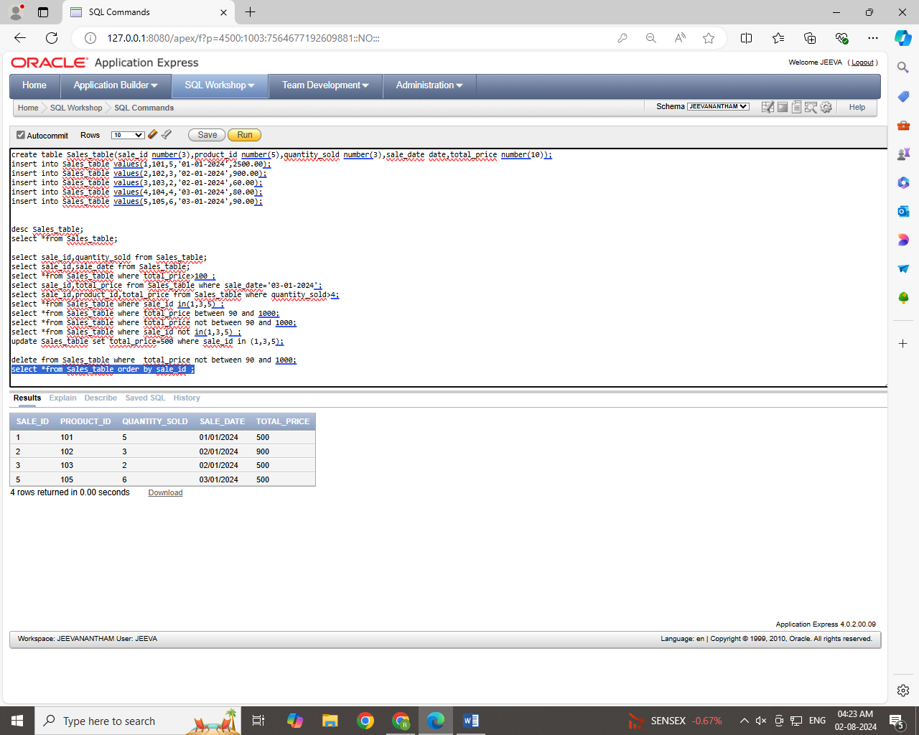

**Step 15**

**Sort all the records using sale_id column in descending order.**

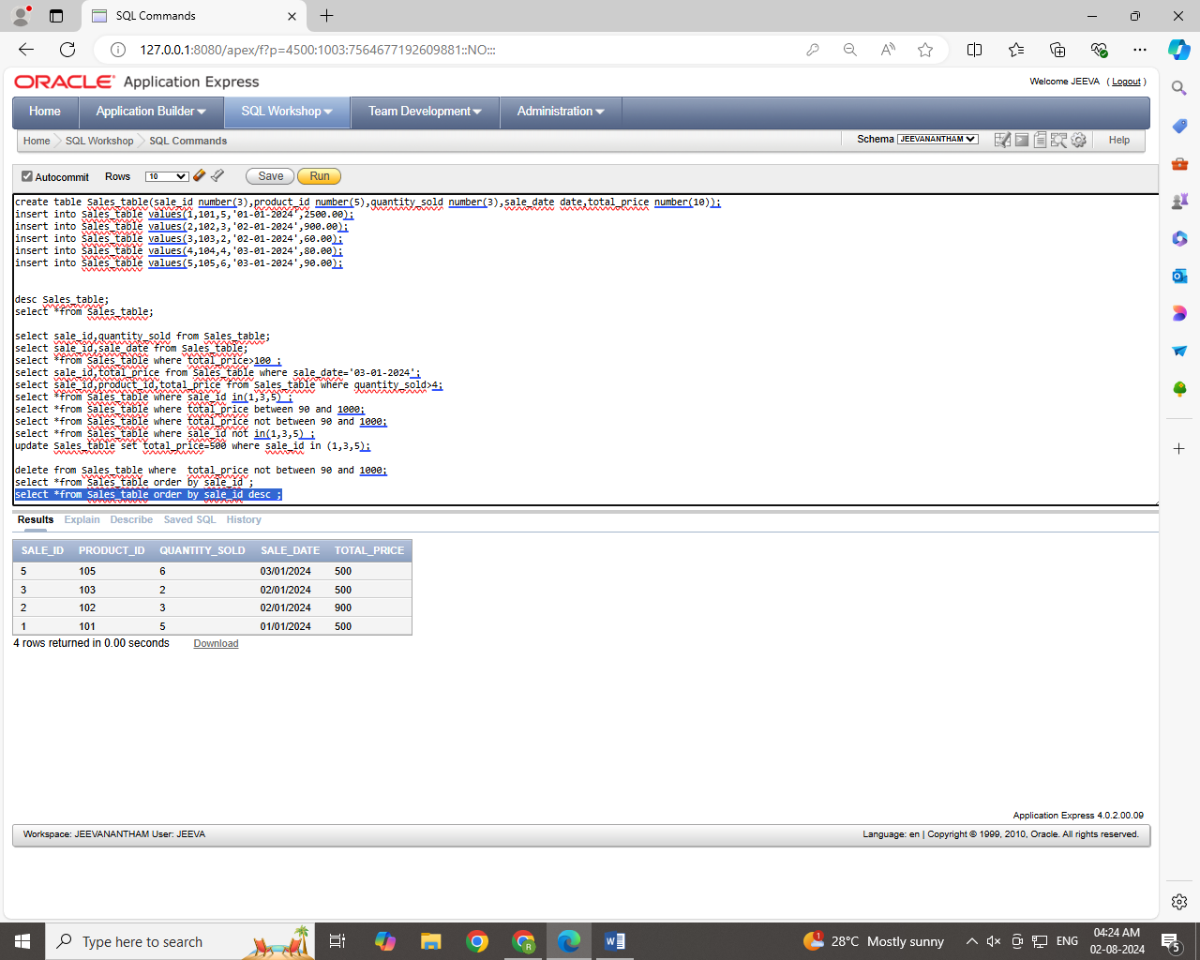

**Step 16**

**Rename the sale_id column as sales_id;**

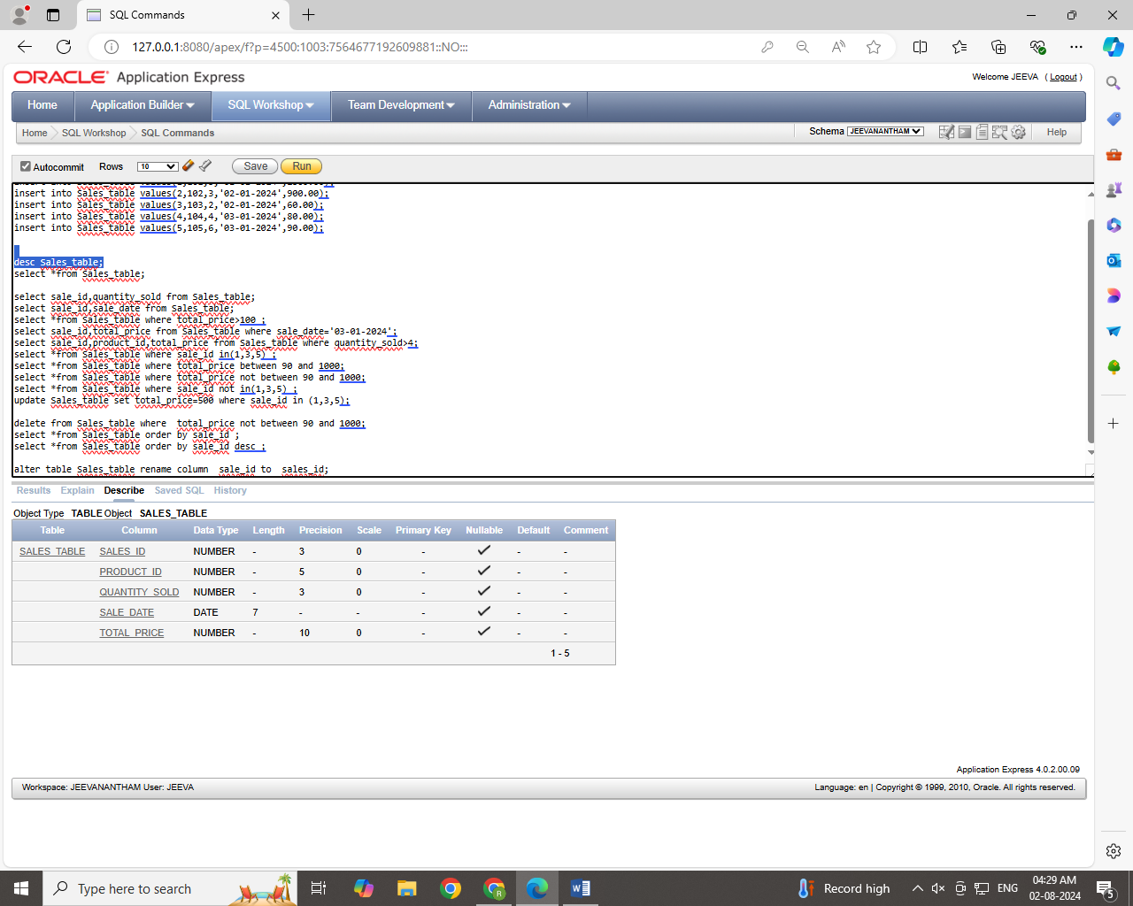

**Step 17**

**Drop the column sales_id.**

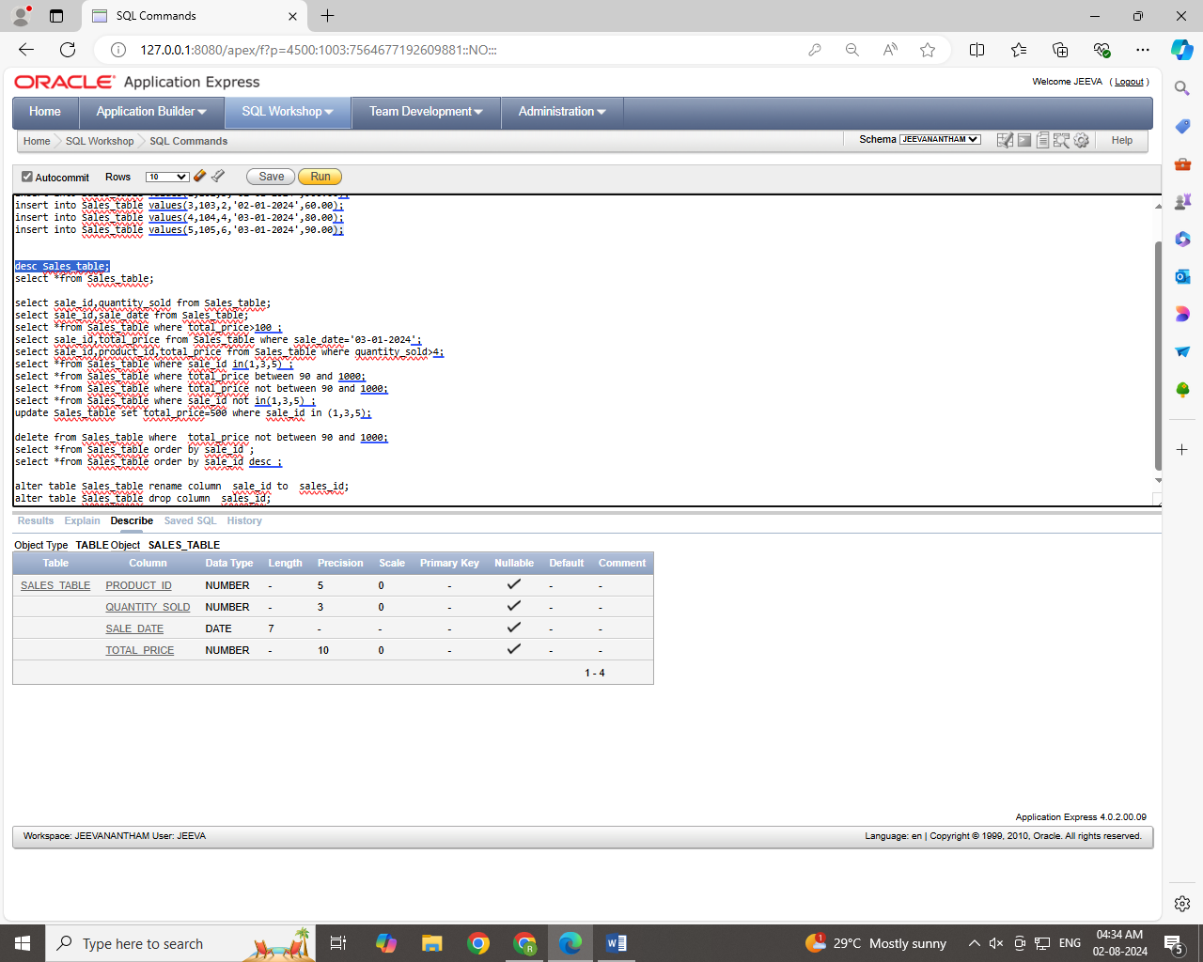

**Step 18**

**Rename the table as tbl_sales.** 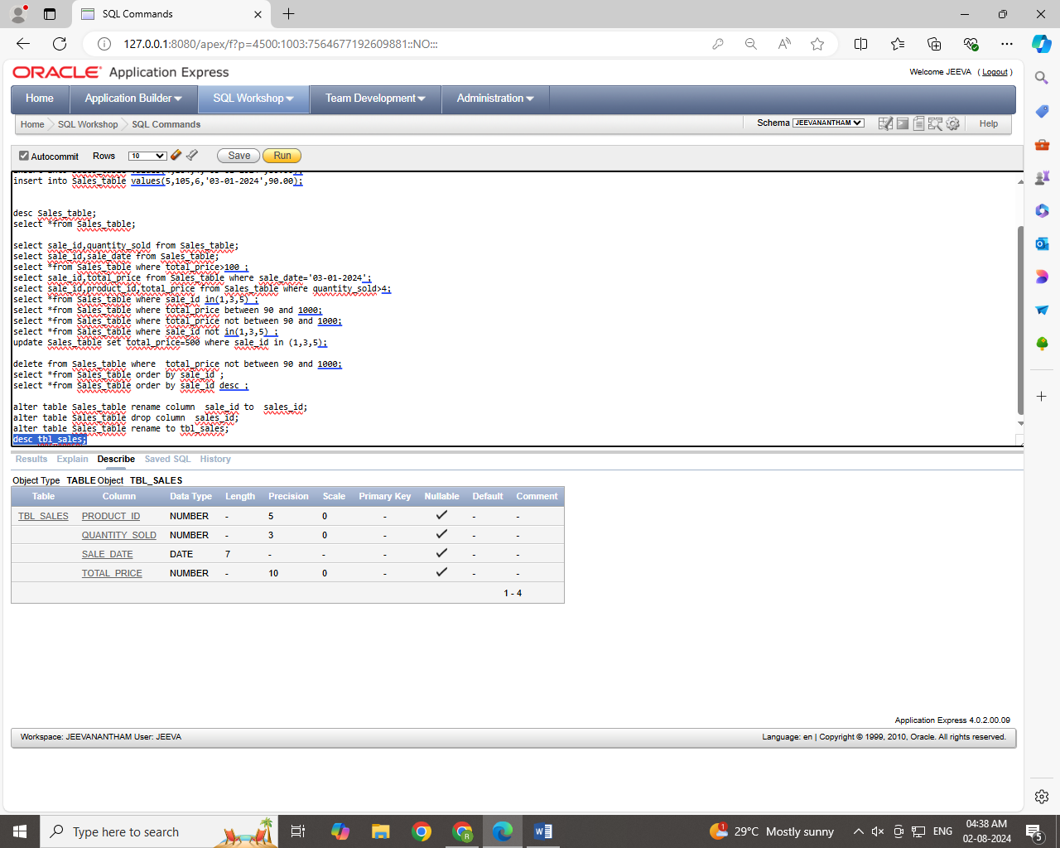

**Step 19**

**Drop the table.**

