**1.WELCOME Console:**

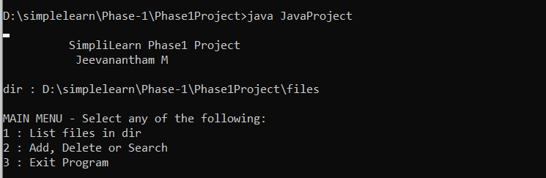

**2.Press 2 to Add ,Delete and Search option then press “a” to Add a file:**

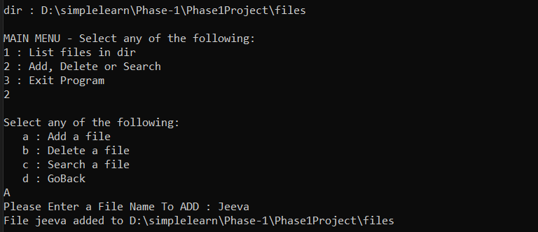

**3.File Names in an Ascending Order:**

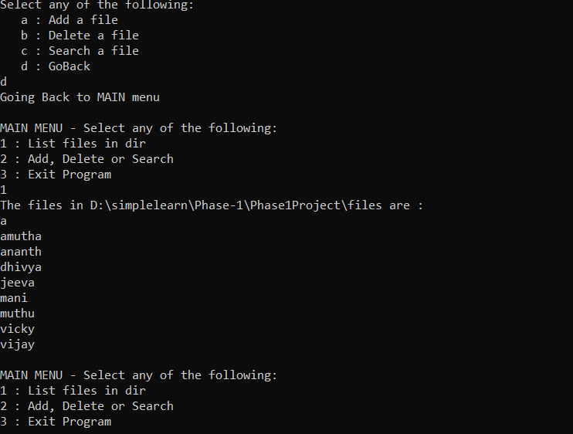

**4.Deleting a File:**

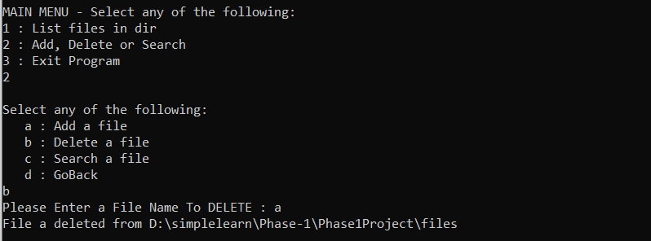

**5.Search a File:**

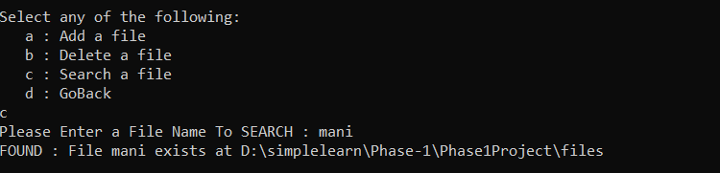

**6.Close the Application:**

