SQL Hands-On Questions: Index, Partition, Constraints, CTE, Temp Tables
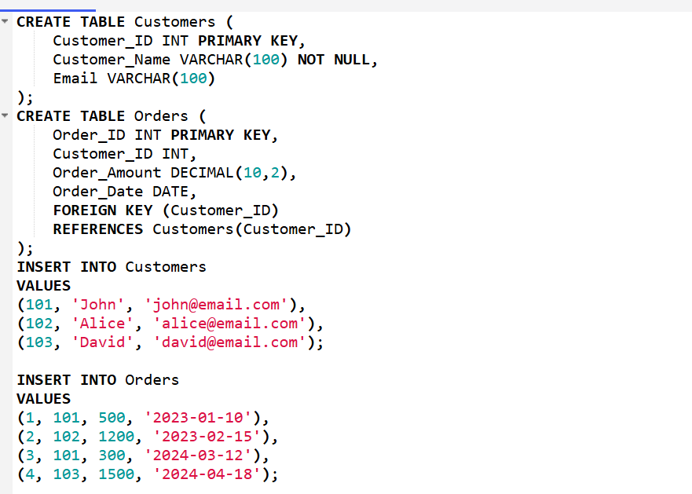

Indexing
1. Create an index on Customer_ID in the Orders table.
2. Write a query to test performance for searching a specific Customer_ID.
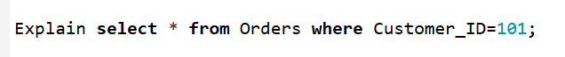
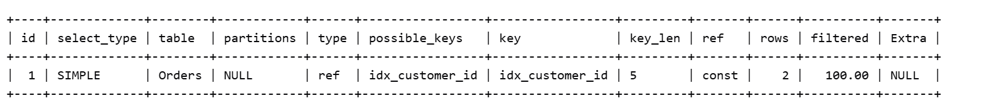
3. Identify which column should be indexed in a frequently joined table.
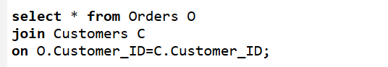
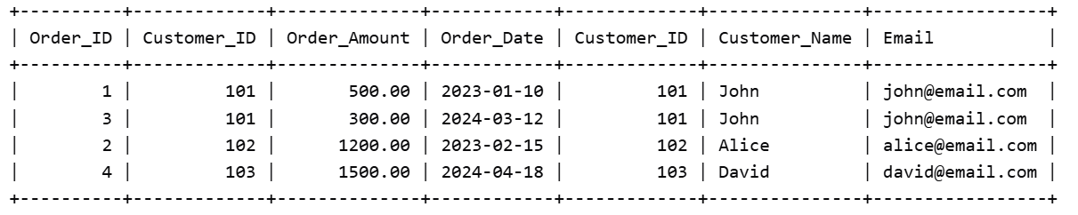
4. Create a composite index on (Customer_ID, Order_Amount).
5. Drop an existing index from a table.


Partitioning
6. Create a table partitioned by range on Order_Date.
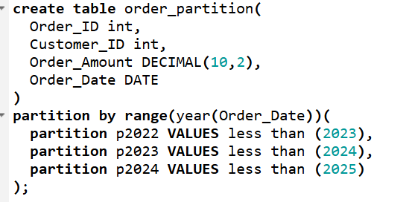
7. Insert data and verify partition placement.
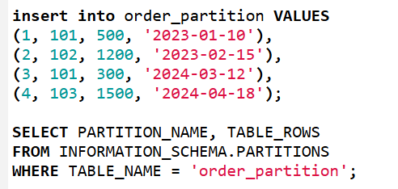
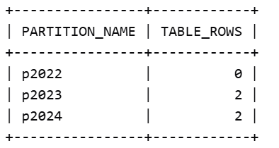
8. Query data from a specific partition.
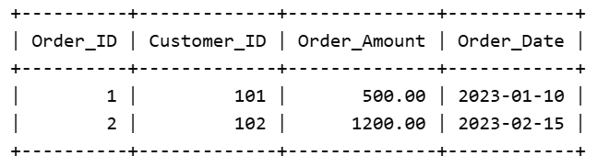
9. Create a hash partitioned table using Customer_ID.
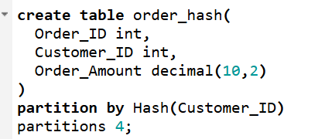
10. Demonstrate partition pruning with a query.
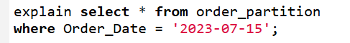

Constraints
11. Create Customer table with PRIMARY KEY and NOT NULL constraint.
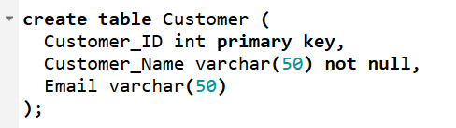
12. Add a FOREIGN KEY constraint linking Orders and Customer.
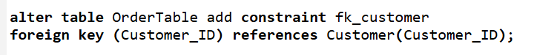
13. Add a UNIQUE constraint on Email column.
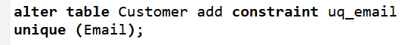
14. Add a CHECK constraint ensuring Order_Amount > 0.
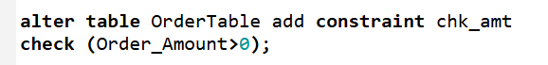
15. Drop a constraint from a table.
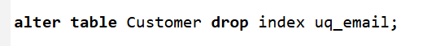

CTE
16. Write a CTE to filter orders greater than 200.
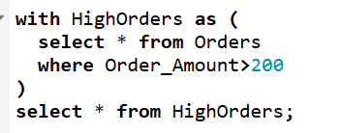
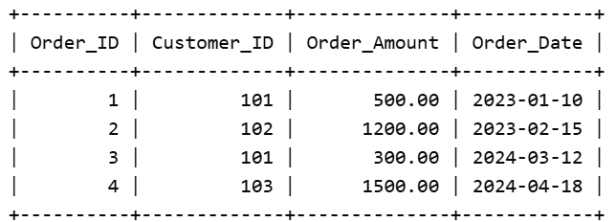
17. Use CTE to compute total order amount per customer.
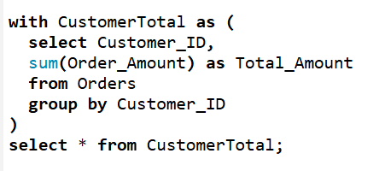
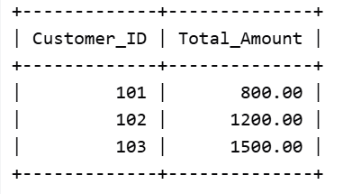
18. Use multiple CTEs for aggregation and filtering.
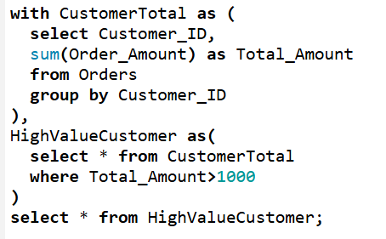
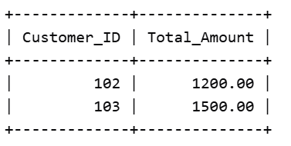
19. Write a recursive CTE to generate numbers 1 to 10.
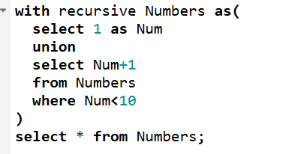
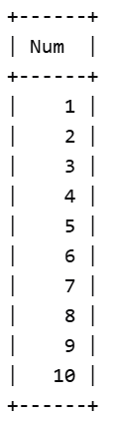
20. Use CTE in a JOIN query.
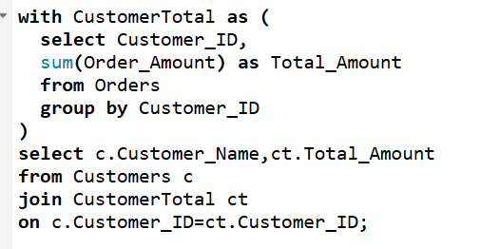
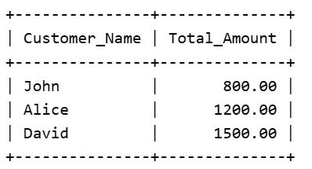

Temporary Tables
21. Create a temporary table for high-value orders.
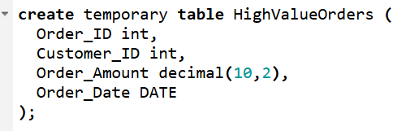
22. Insert filtered data into the temp table.
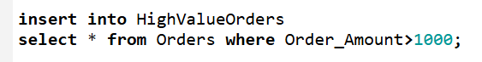
23. Query the temp table multiple times.
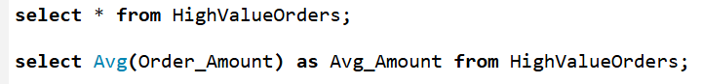
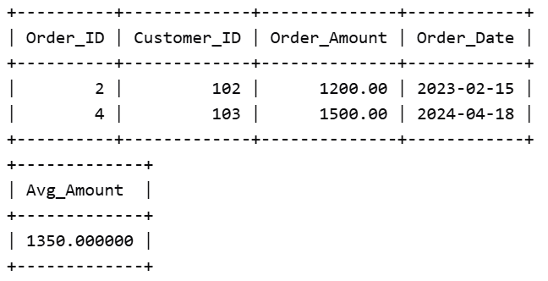
24. Compare results of CTE vs temp table.
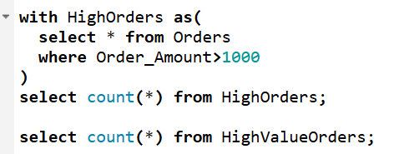
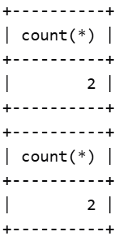
25. Drop the temporary table.
