SQL HANDS-ON
Create table Employees with columns emp_id, name, department_id, manager_id, salary, and join_date.
Create table Departments with columns department_id and department_name.
Create table Orders with columns order_id, customer_name, amount, and order_date.
Populate these tables with values

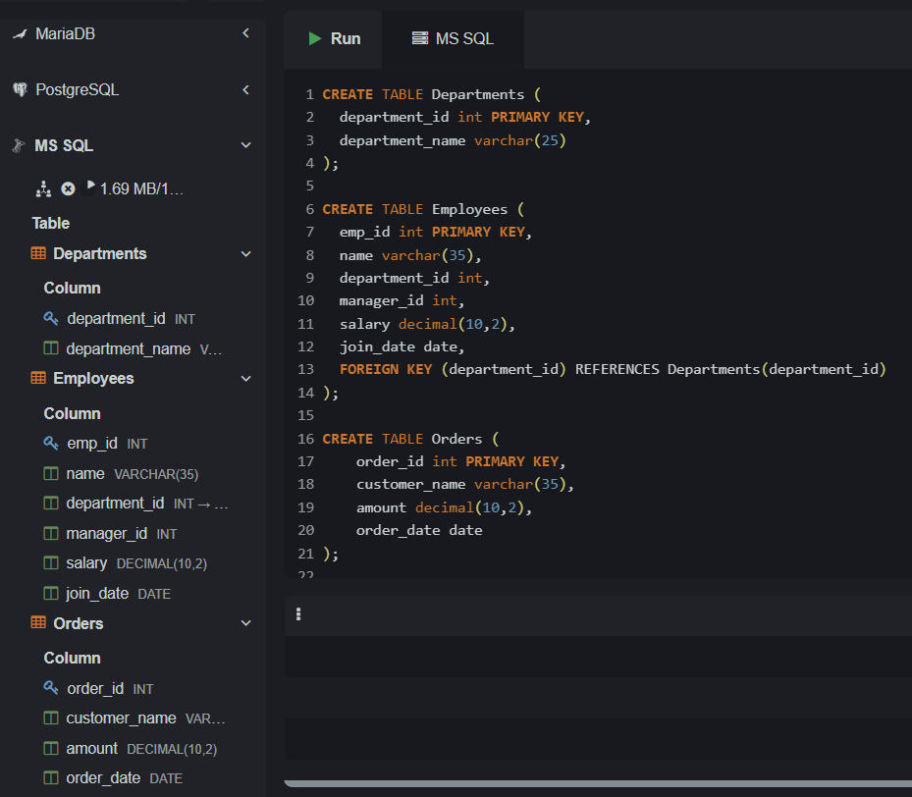

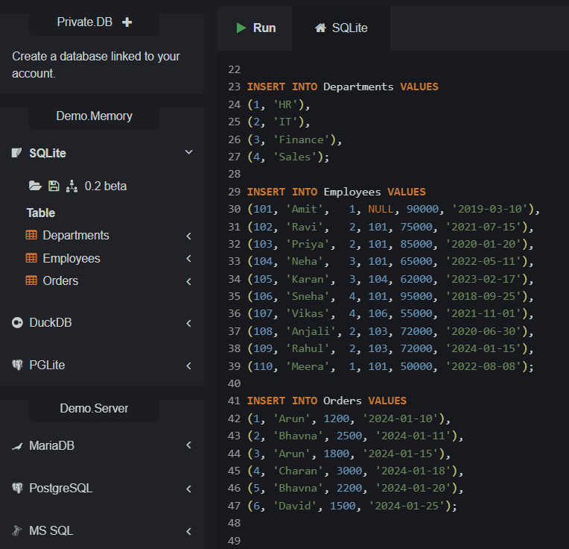

Questions
1.Find employees who earn more than their managers.

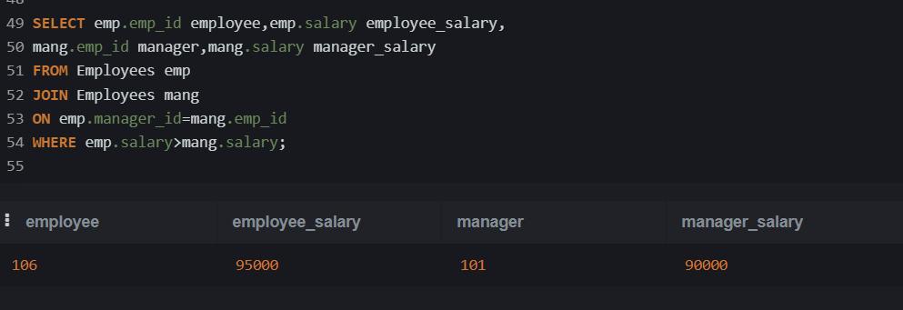

2.List employees who do not have a manager.

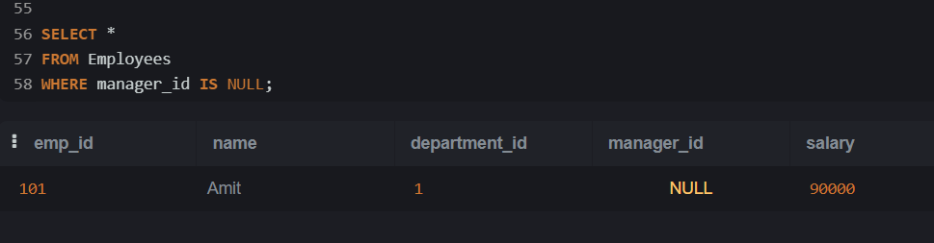

3.Create all possible pairs of employees (excluding self-pair).

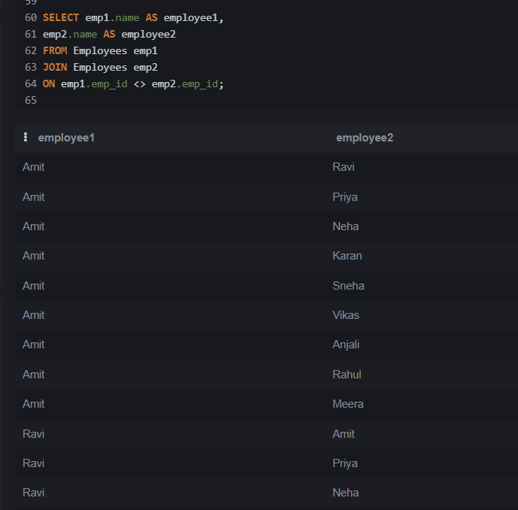

4.Find the highest salary in each department.

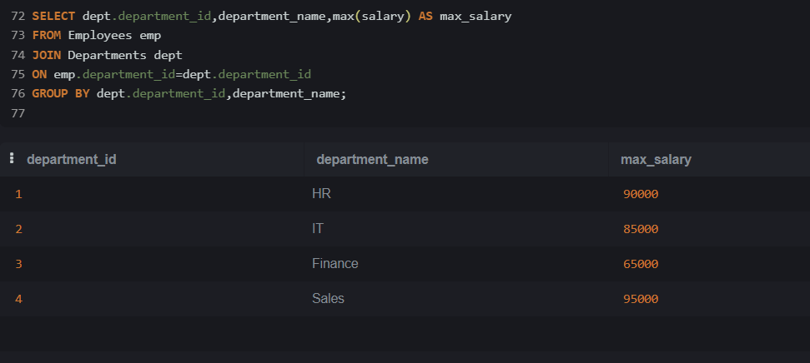

5.Find total salary paid in each department.

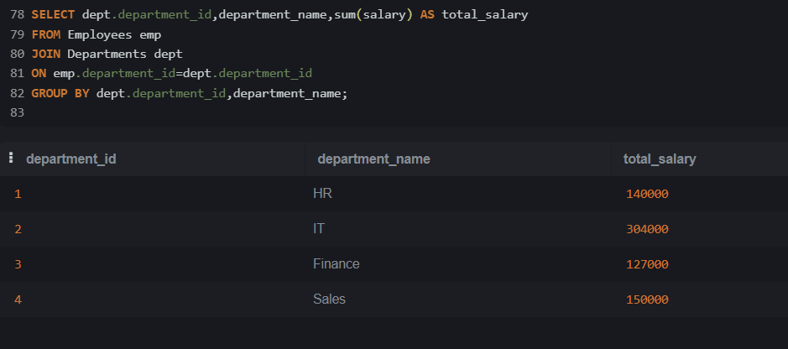

6.Find departments where total salary is greater than 120000.

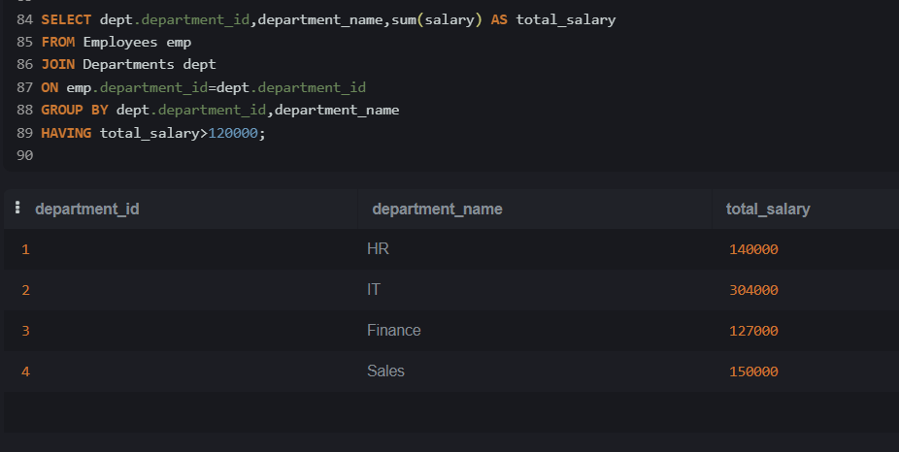

7.Find customers who placed more than 1 order.

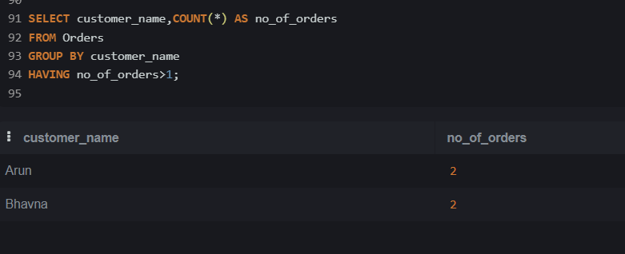

8.Find departments with average salary greater than 60000.

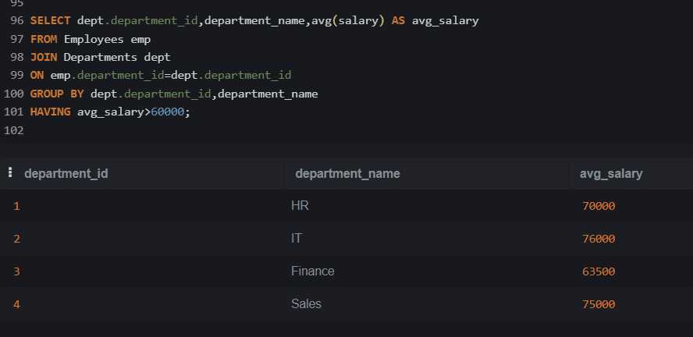

9.Find employees who earn more than the average salary of their department.

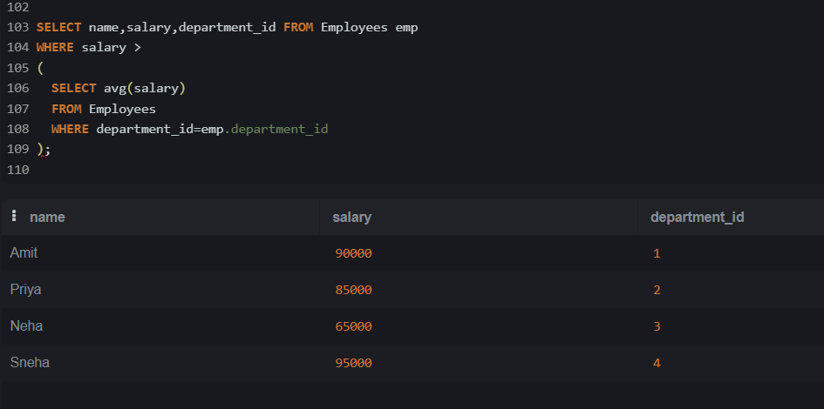

10.Find the second highest salary.
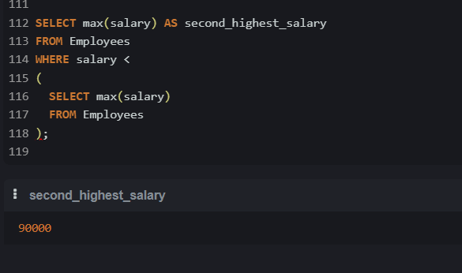

11.Show employee names with a column:
'Senior' if joined before 2021
'Junior' otherwise
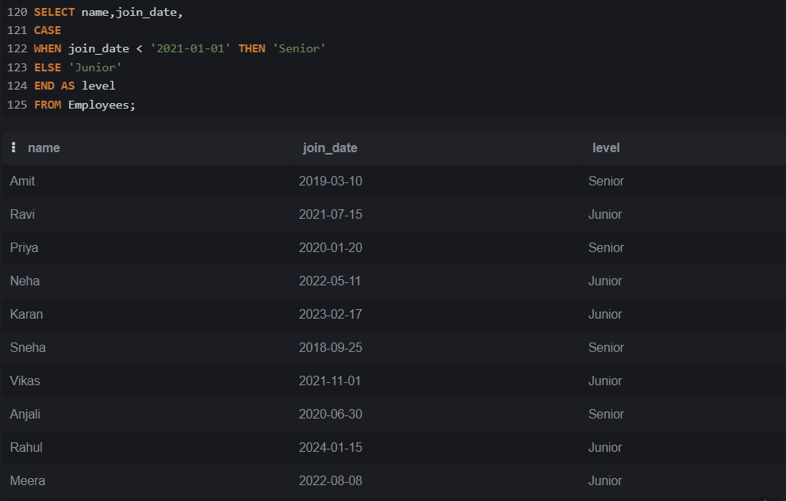

12.Find departments where:
total salary > 100000
and at least 2 employees

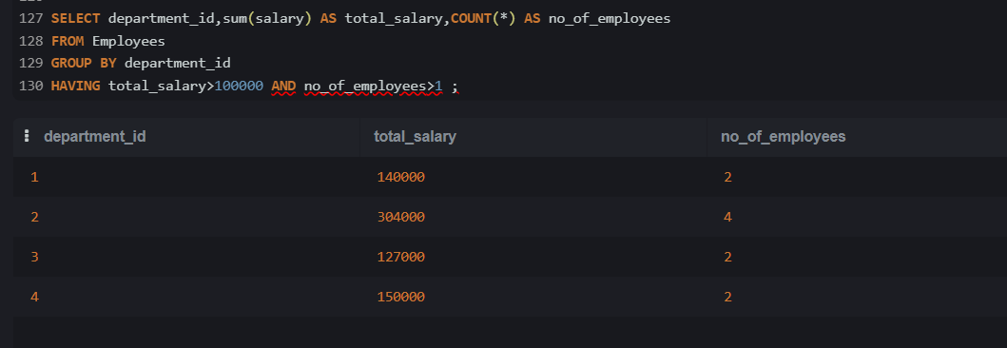

13.Find employees whose salary is the highest in their department.

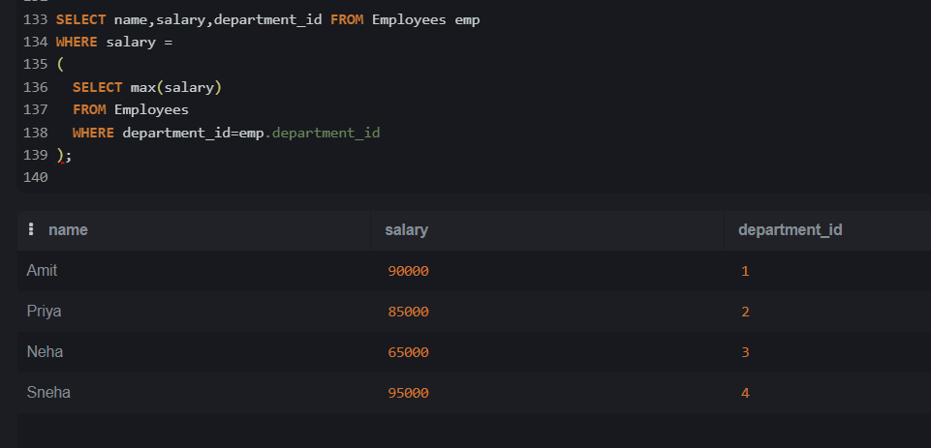

14.Find employees whose salary is unique in their department.

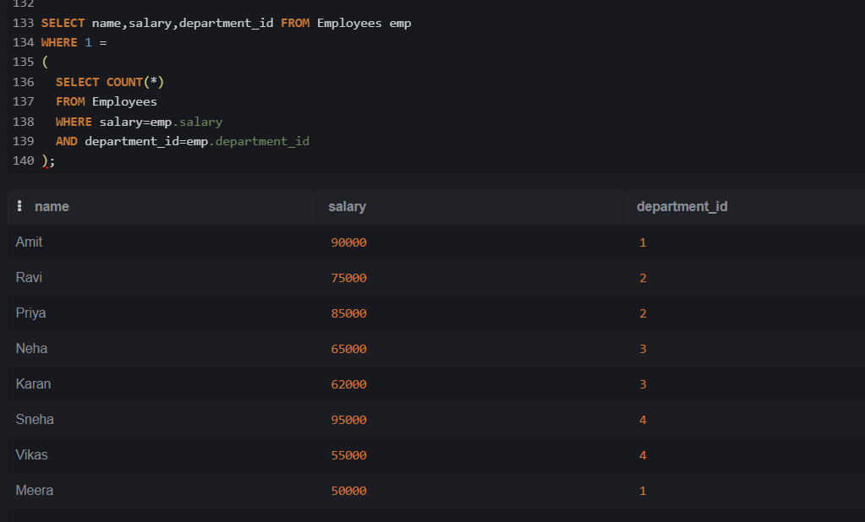

15.Find managers who manage more than 2 employees.

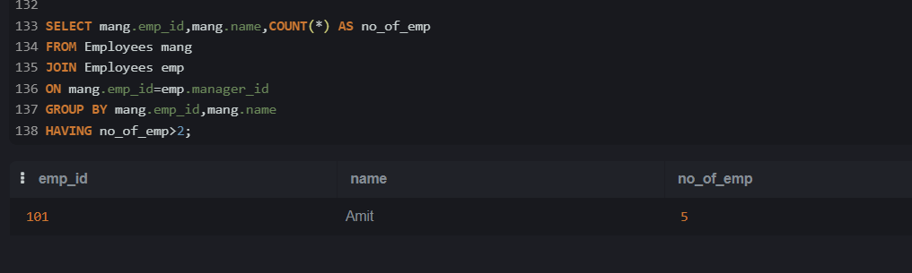

16. Find the 2nd highest salary in each department
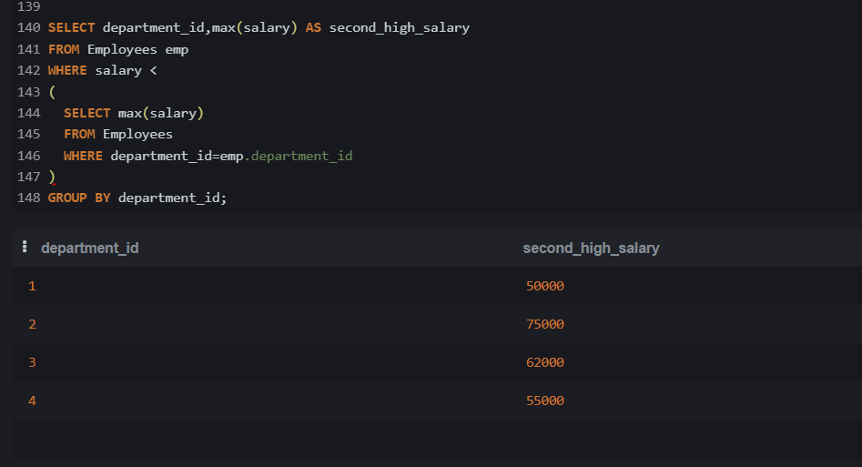

17. Find the top 3 highest-paid employees per department.
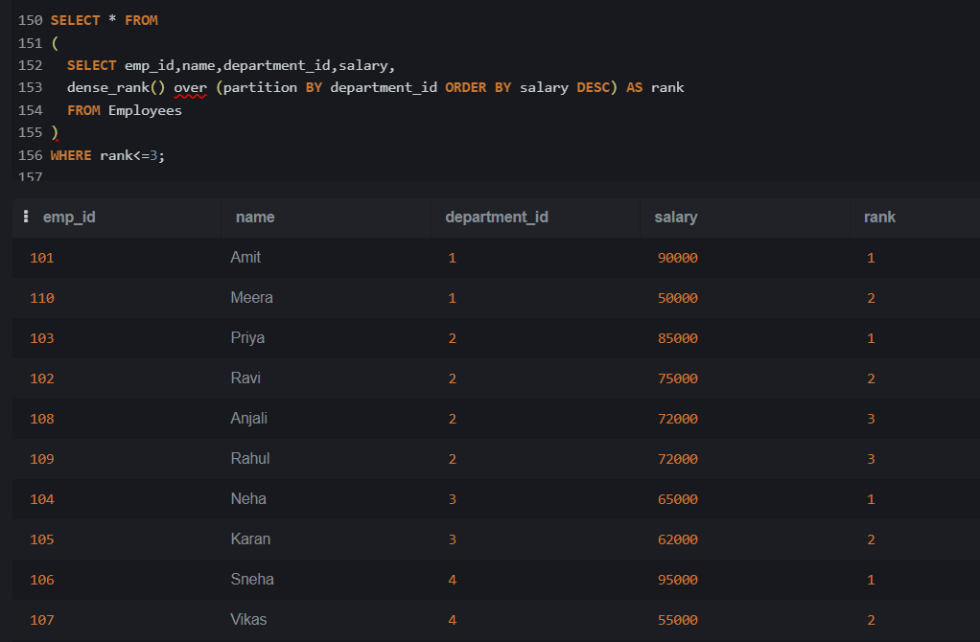
18. Find employees whose rank is exactly 3 in their department.

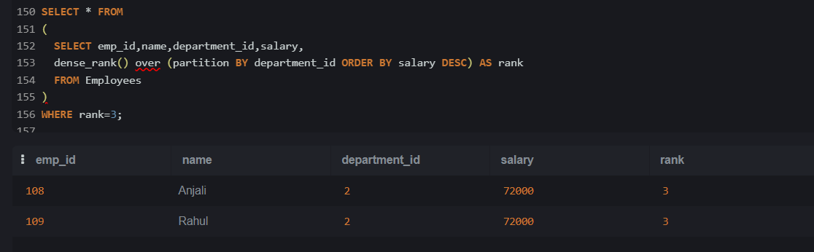

19. Find employees whose salary is greater than the previous employee.

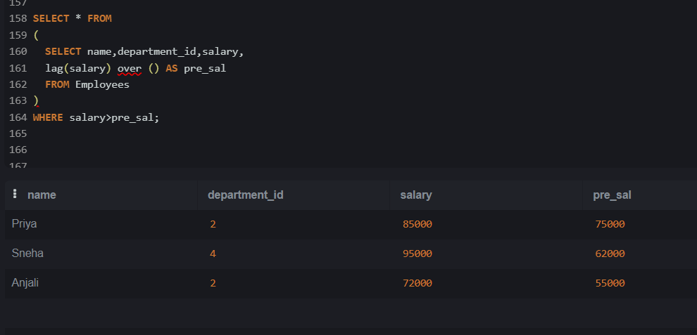

20. Calculate running total of salary per department.

