SQL Hands-On Practice Questions
1. Create a Customer table with columns: Customer_ID, Customer_Name, Email.
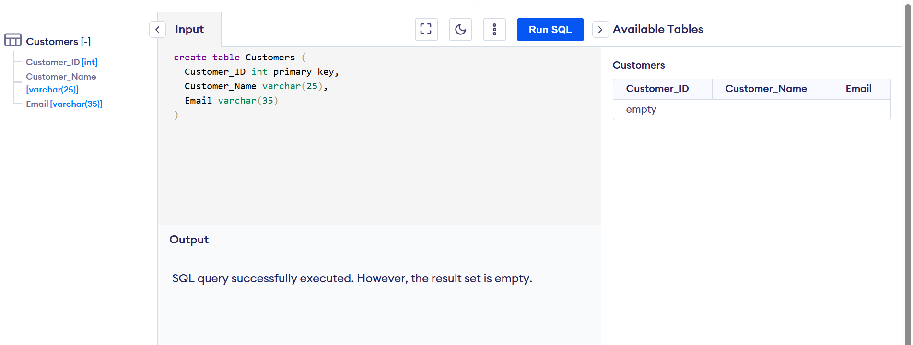

2. Insert at least 3 records into the Customer table.
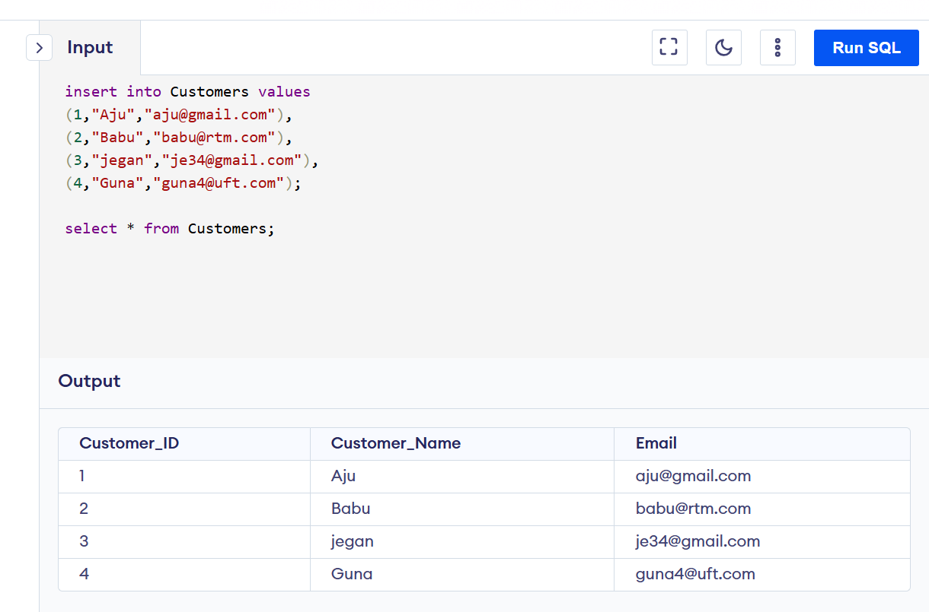

3. Create an Orders table with columns: Order_ID, Customer_ID, Order_Amount.
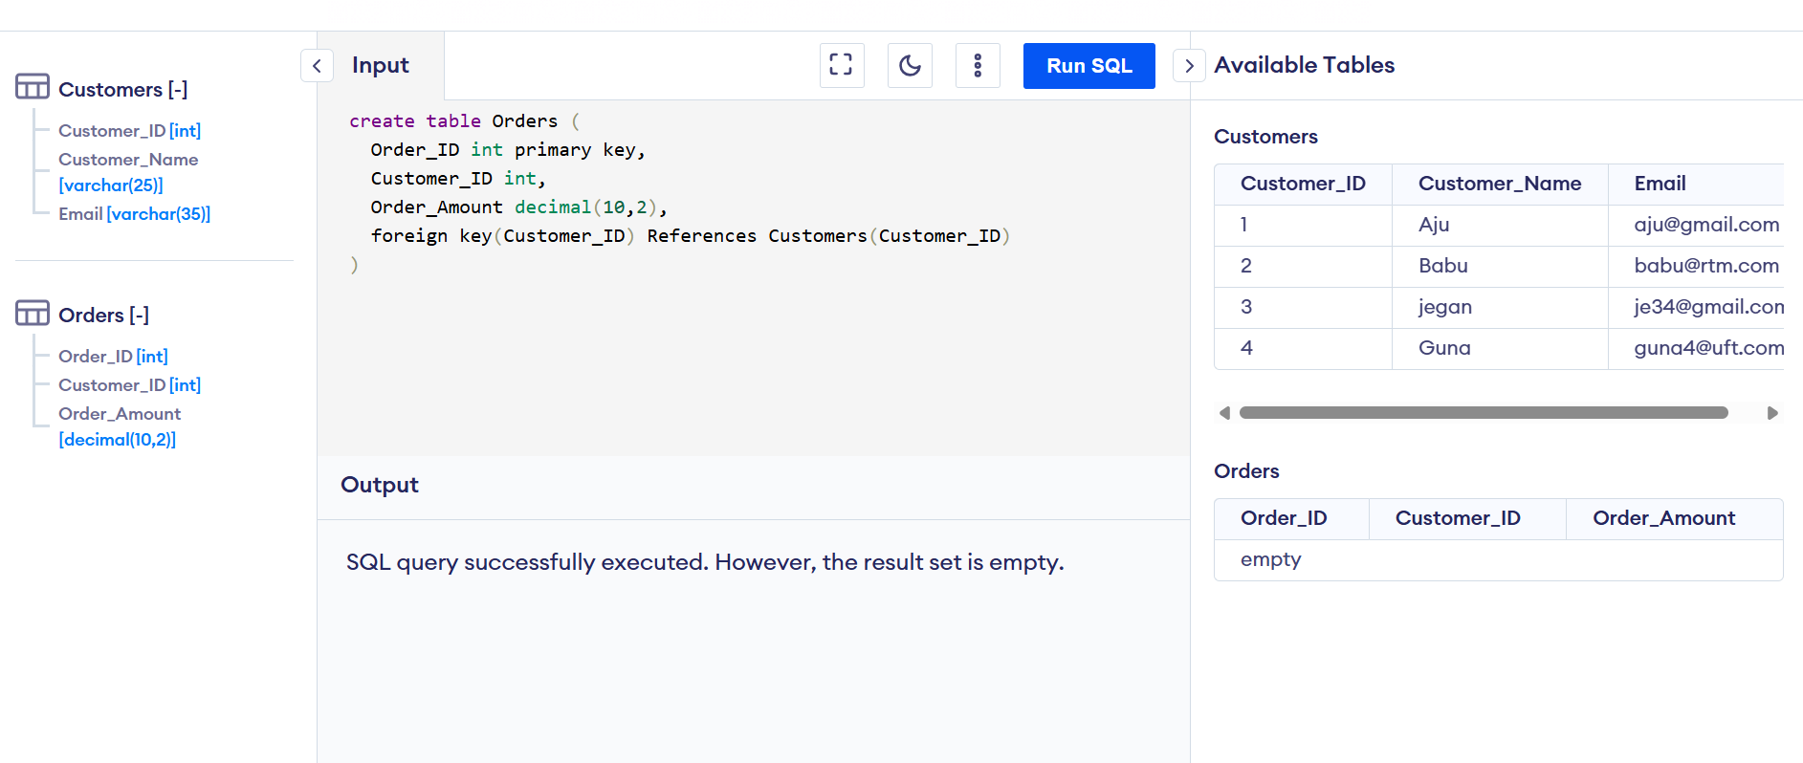

4. Insert at least 3 records into the Orders table.
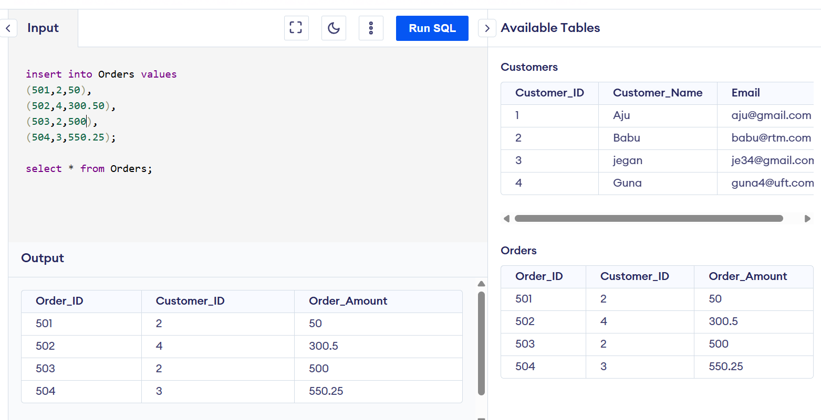

5. Display all data from the Customer table.
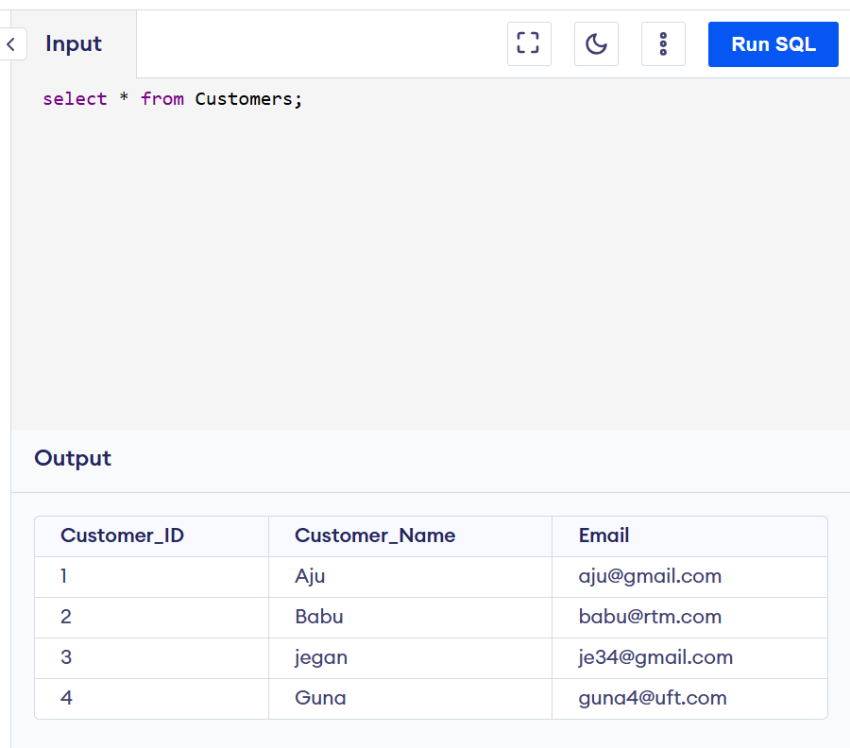

6. Retrieve only the Customer_Name column.
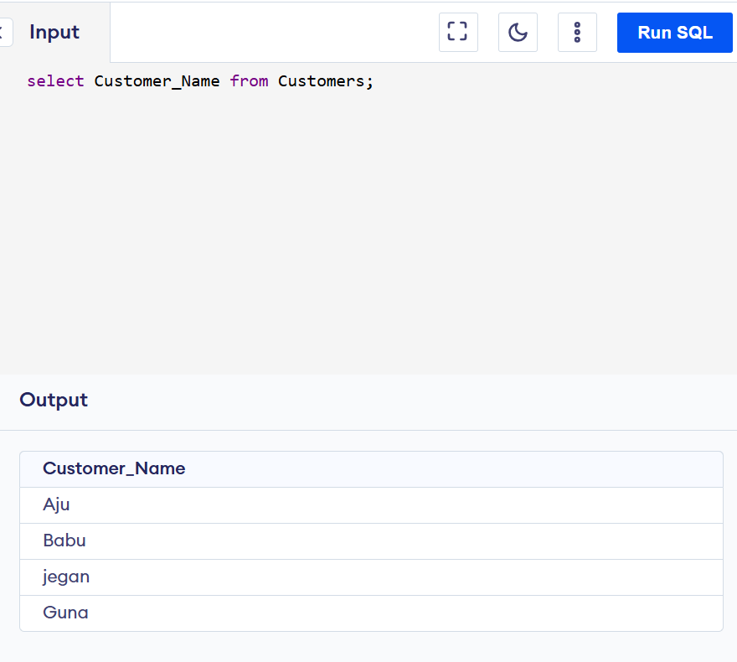

7. Insert one more record in customer table where Email is ‘NULL’
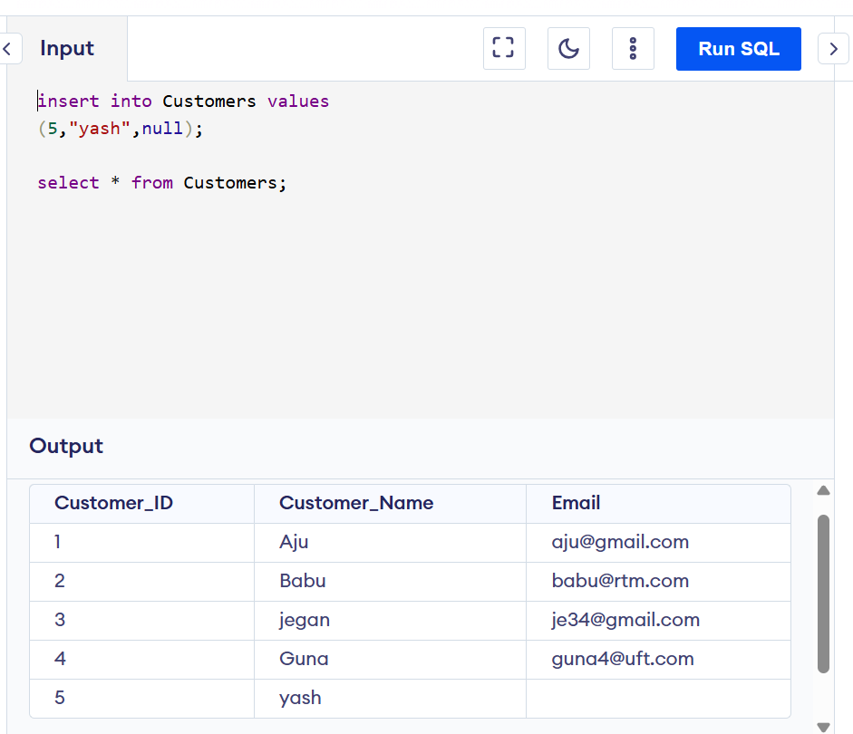

8. Find customers with Customer_ID = 1.
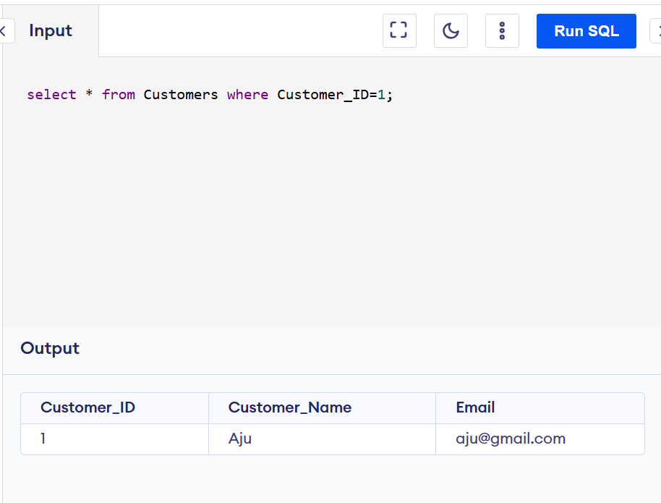

9. Retrieve customers whose Email is NULL.
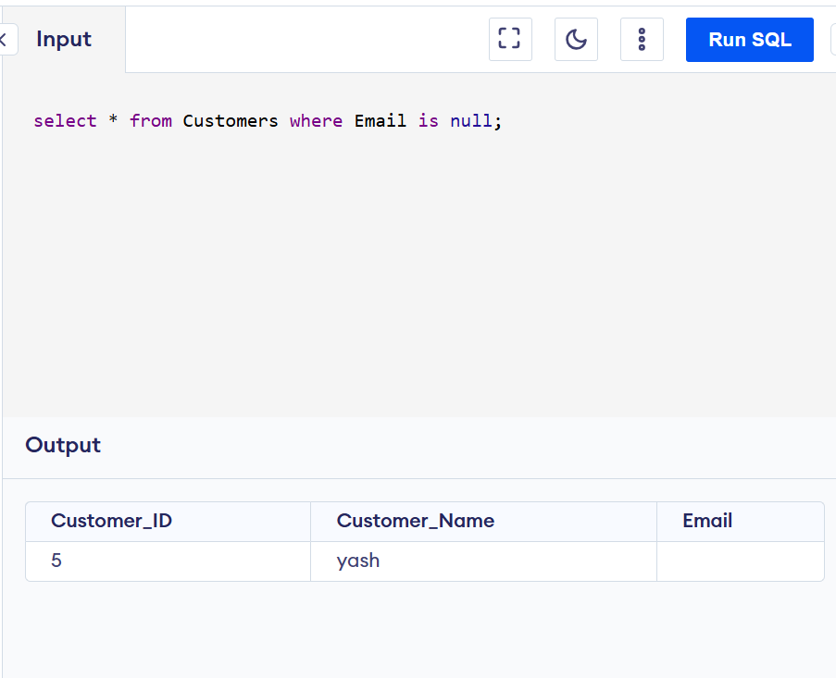

10. Get all orders where Order_Amount is greater than 200.
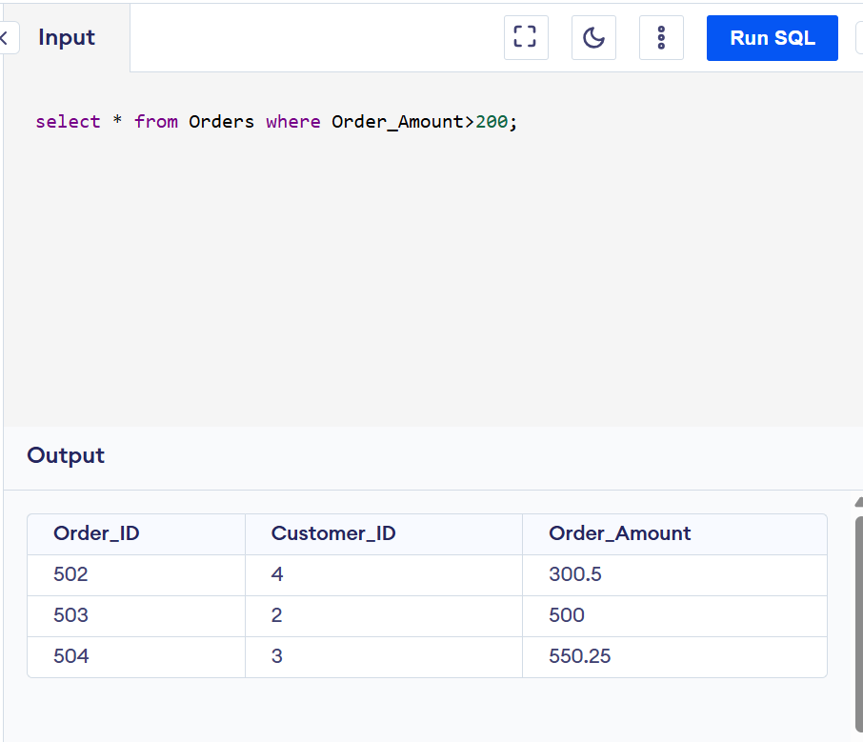

11. Display customers sorted by Customer_Name (ascending).
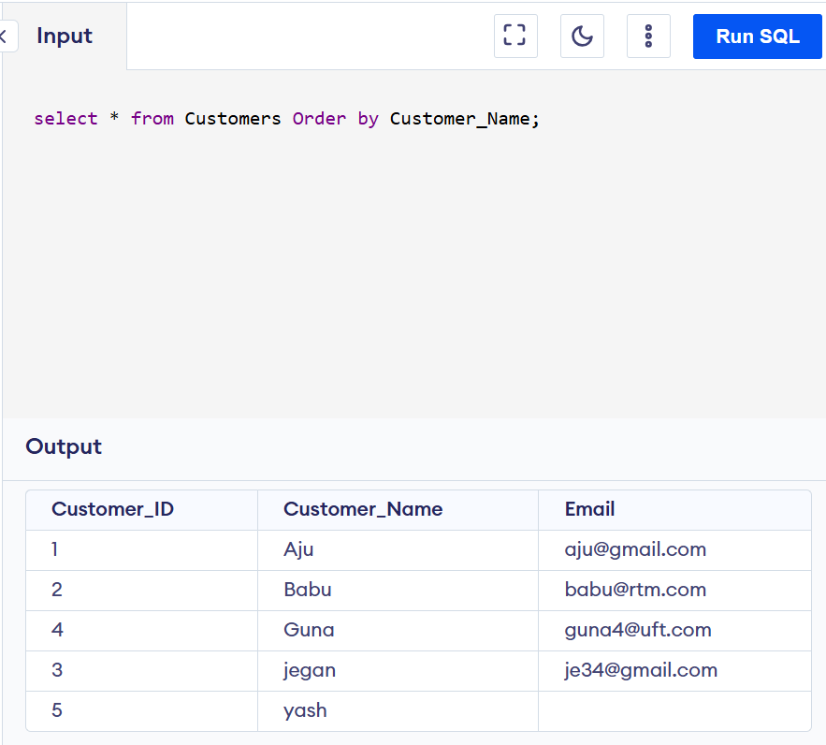

12. Retrieve orders sorted by Order_Amount (descending).
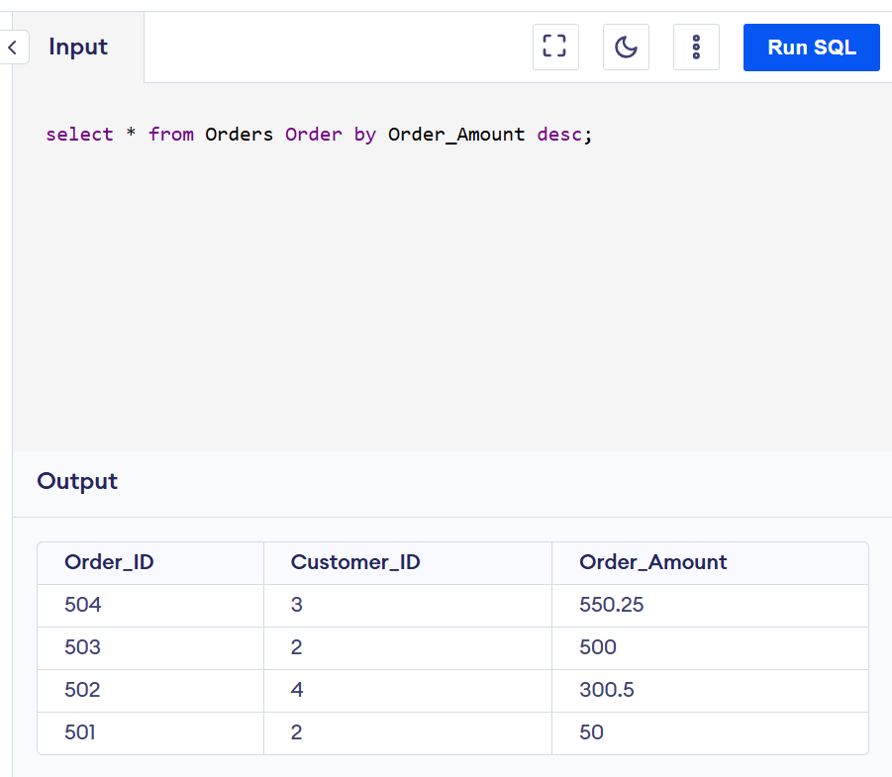

13. Display Customer_Name as Name using alias.
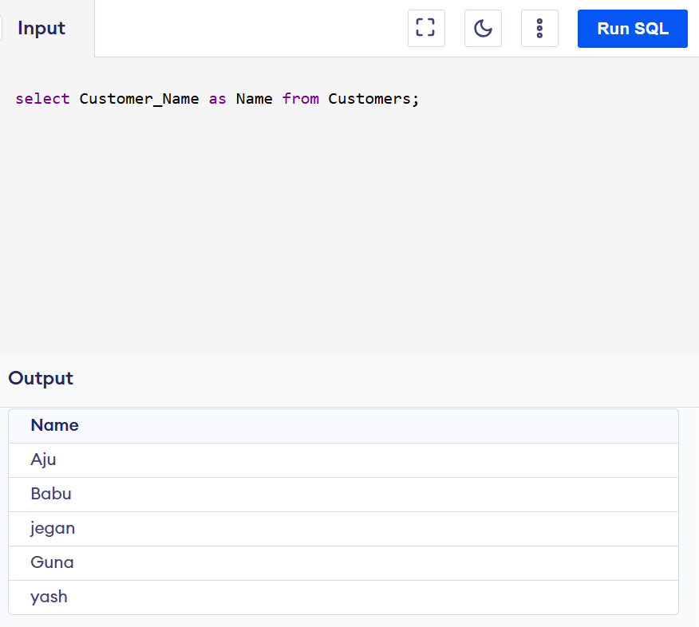

14. Use table aliases to display Customer_Name and Order_Amount from both tables.
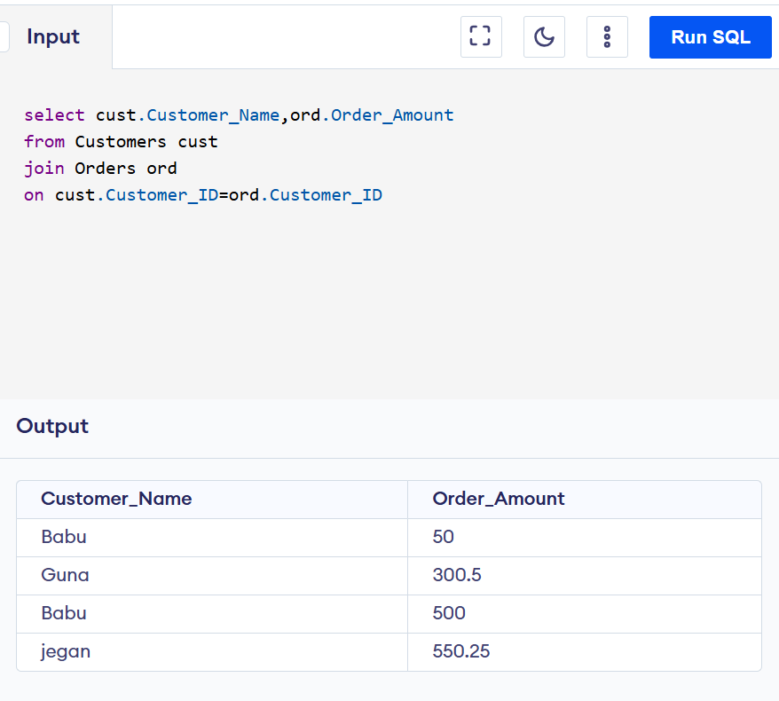

15. Display customers along with their orders using INNER JOIN.
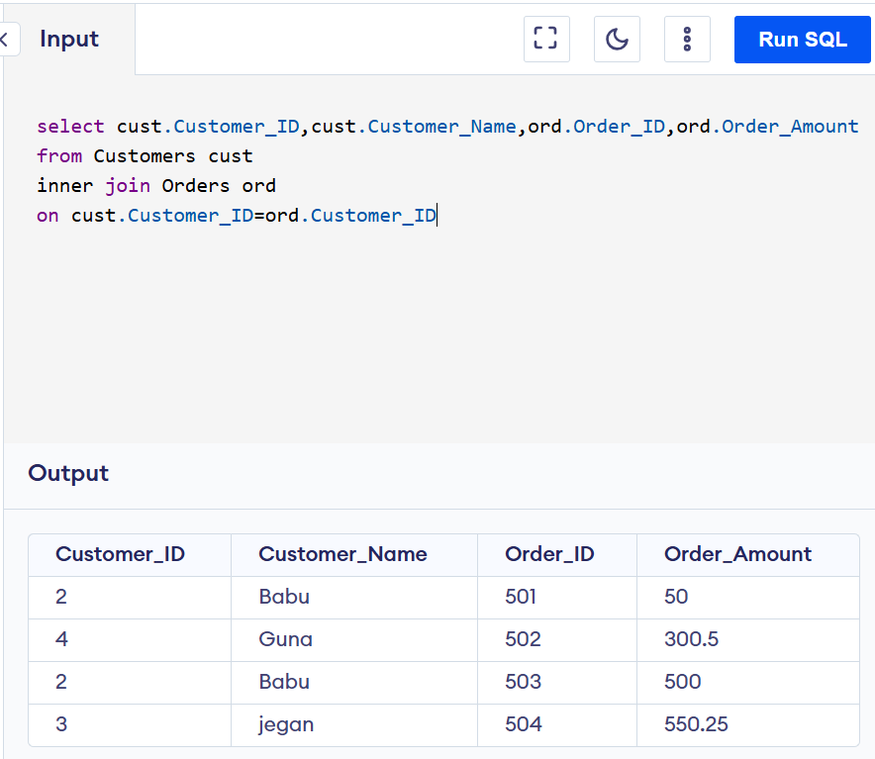
16. Display all customers even if they don’t have orders.
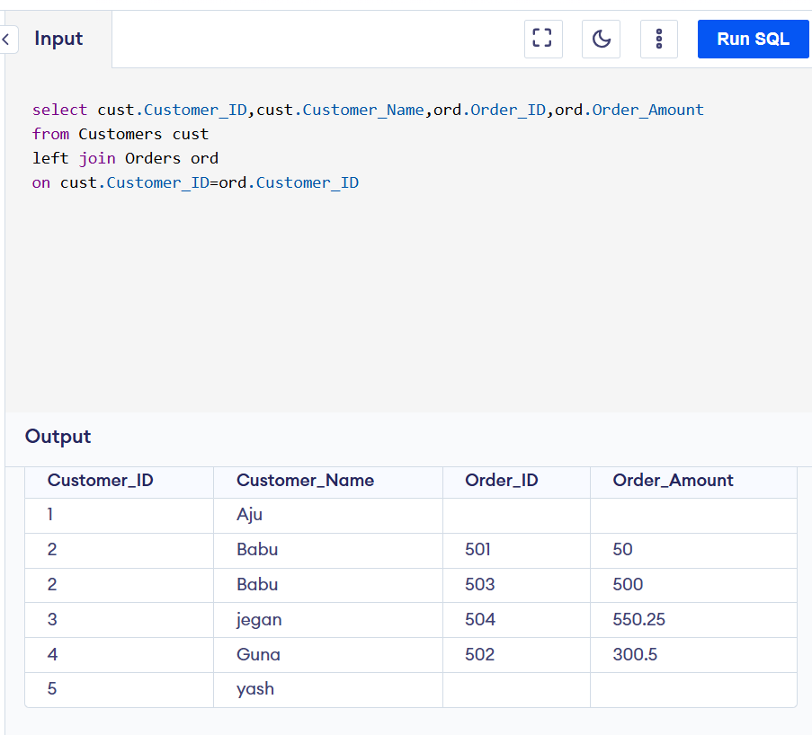
17. Display all orders even if customer details are missing.
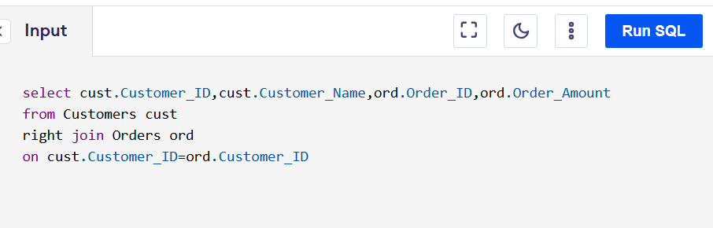

18. Replace NULL Email values with 'No Email' in output.
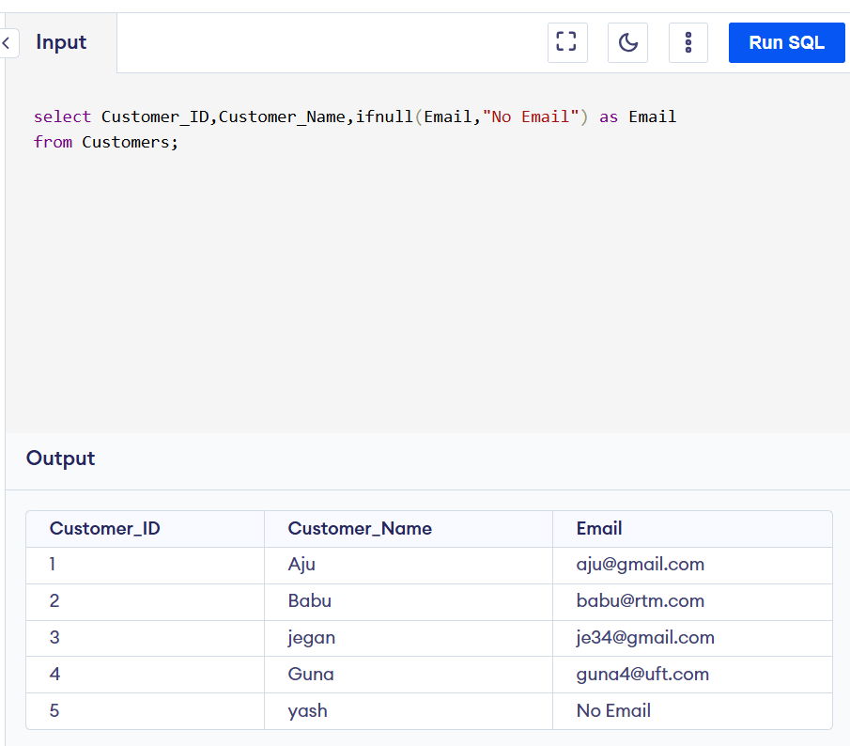

19. Update the email of a specific customer.
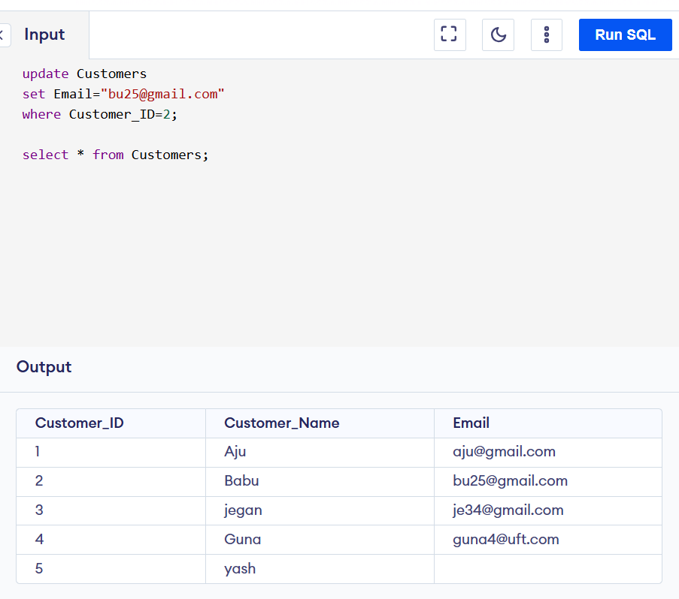

20. Delete a customer with a specific Customer_ID.
