WEEK 2 TASK · STRATEGIC RESEARCH REPORT
Blockchain Trend Analysis and
Five-Year Adoption Forecast
(2026–2031)

Week 2 Task — Blockchain Trend Analysis and Forecasting
Prepared as a Blockchain Analyst strategic report
Date: [insert submission date]
Prepared by: [insert name]
SCOPE OF THIS REPORT
▪ Six dominant trends identified and evidenced with dated, verifiable examples from 2026.
▪ Five-year phased forecast (2026–2031) with explicit confidence levels for each phase.
▪ Twenty-six sources including corporate filings, regulatory records, market trackers and survey research.
▪ Four charts and five tables, all reproducible from the underlying data in the appendix notes.

CONTENTS

1. Executive Summary
2. Methodology and Data Sources
3. Trend Identification
Trend 1 — Real-world asset tokenisation
Trend 2 — Stablecoins as settlement infrastructure
Trend 3 — Enterprise blockchain beyond pilot purgatory
Trend 4 — AI agents and agentic payments
Trend 5 — CBDCs and cross-border interoperability
Trend 6 — Regulatory bifurcation
4. Industry Impact Analysis
5. Strategic Frameworks
6. Five-Year Adoption Forecast (2026–2031)
7. Challenges and Strategic Recommendations
8. Conclusion
9. Visualisations
10. References

A note on figures: Where sources disagree, this report shows the disagreement rather than averaging it away. Three figures in the original brief did not match the underlying sources and have been corrected against the primary record; the corrections are noted at the point of use.

1. EXECUTIVE SUMMARY
Blockchain has entered a phase in which the technology is judged less on what it promises than on what it settles. Through 2026 the measurable activity moved decisively toward tokenised financial instruments, regulated payment rails and enterprise data infrastructure, while speculative retail activity continued to shrink as a share of the whole. The headline forecast of this report is that between 2026 and 2031 blockchain shifts from a crypto-speculation market to a settlement and verification layer embedded in institutional finance, logistics and public administration. Tokenised real-world assets, stablecoins and enterprise integration are the three vectors carrying that shift.
Six trends dominate the period.
- Tokenised real-world assets (RWAs) have moved from pilot to production, though the production is narrow: tokenised Treasuries and money market funds account for the bulk of on-chain value.
- Stablecoins have become settlement infrastructure rather than a trading convenience, with adjusted settlement volume now comparable to a major card network.
- Enterprise blockchain has left pilot purgatory in specific sectors, most visibly logistics, where FedEx joined the Hedera Council in February 2026 and Hapag-Lloyd agreed to acquire ZIM for $4.2 billion.
- AI agents are transacting on-chain at very high frequency and very low value, which signals direction rather than current commercial scale.
- CBDC and cross-border interoperability projects have become geopolitical infrastructure, with China's CBETS platform and the iBRICS DART Charter as the clearest 2026 markers.
- Regulation has bifurcated: the EU completed its MiCA transition on 1 July 2026, while the US CLARITY Act failed a Senate cloture vote on 15 September 2026.

Key findings
1. Tokenised RWAs grew from roughly $15 billion in January 2025 to approximately $38–40 billion by mid-2026, with tokenised Treasury products alone exceeding $16 billion (Source: Crowdfund Insider citing RWA.xyz, 2026 [R10]; CoinDesk Data, 2026 [R11]).
2. Stablecoin market capitalisation rose from about $205 billion in January 2025 to a peak near $321 billion in May 2026, easing to roughly $289 billion by November 2026; adjusted annual settlement volume reached an estimated $9–11 trillion in early 2026 (Source: DefiLlama, 2026 [R9]; Visa Onchain Analytics via CoinCentral, 2026 [R12]).
3. J.P. Morgan Asset Management launched its second tokenised money market fund, JLTXX, on Ethereum on 13 May 2026 with a $100 million seed, reaching an estimated $695 million within two months (Source: J.P. Morgan Asset Management, 2026 [R3]; CoinPaprika, 2026 [R4]).
4. Institutional appetite is measurable but survey-based: 72% of institutions interested in tokenised assets planned to invest by 2026, and 84% already used or were interested in stablecoins (Source: Coinbase and EY-Parthenon, 2025 [R16]).
Forecast marker: the 2026–2031 outlook in Section 6 is presented in three phases, each labelled with its confidence level. Phase 1 is extrapolated from observed deployments; Phase 2 is conditional on legislation; Phase 3 is scenario-based.

2. METHODOLOGY AND DATA SOURCES
This report draws on four categories of source, weighted differently by section. Protocol and platform primary material (Ethereum Foundation, Hyperledger Foundation, Hedera, VeChain) is used for technical claims. Corporate disclosures — press releases, SEC filings and exchange announcements — are used for the case evidence, because they are dated, attributable and difficult to embellish. Market data comes from on-chain trackers (DefiLlama, RWA.xyz, L2BEAT) where the metric is directly observable, and from survey research (Coinbase/EY-Parthenon, Calastone) where the question concerns intent rather than activity. Regulatory analysis relies on primary legal instruments (Regulation (EU) 2023/1114) and official records (US Senate roll-call votes).
Citations follow the format (Source: Publisher, Year) with a bracketed reference number mapping to the numbered list in Section 10, where full titles, dates and URLs appear.
Market-sizing estimates diverge sharply and the divergence is analytically useful rather than a defect to be smoothed over. MarketsandMarkets projects the blockchain market at $610.96 billion by 2031 from $54.08 billion in 2026, a 62.4% CAGR (Source: MarketsandMarkets, 2026 [R1]). The Business Research Company projects $320.65 billion by 2030, a 45% CAGR (Source: The Business Research Company, 2026 [R2]). The gap is not a disagreement about the world; it is a disagreement about what is being counted. MarketsandMarkets measures platforms, middleware and services including Web3 infrastructure; the second study uses a broader but differently bounded definition and a shorter horizon. A third estimate for blockchain in healthcare alone reaches $214.9 billion by 2030 (Source: Grand View Research, 2026 [R17]), which demonstrates that subsegment definitions can be larger than some whole-market estimates. Any single CAGR presented as certainty should be treated as a scope claim rather than a forecast.
Three methodological cautions apply throughout. First, tokenised asset totals vary by a factor of three depending on whether stablecoins, tokenised deposits and non-distributed issuance are included. Second, stablecoin volume figures differ enormously between raw on-chain volume and adjusted “organic” volume net of bot activity and internal exchange transfers. Third, survey data measures stated intention, which historically overstates realised allocation. Where a figure is an estimate rather than a measurement, this report says so.

3. TREND IDENTIFICATION

Trend 1 — Real-world asset tokenisation moves from pilot to production
Definition. RWA tokenisation is the issuance of a blockchain token that represents a legal claim on an off-chain asset — a Treasury bill, a money market fund share, private credit, a commodity or real estate — where the token is transferable and the ownership record is maintained on-ledger.
Evidence. Distributed on-chain value in tokenised RWA rose from roughly $15 billion in January 2025 to approximately $38–40 billion by mid-2026, with tokenised Treasuries exceeding $16 billion and tokenised credit above $7 billion (Source: Crowdfund Insider citing RWA.xyz, 2026 [R10]). Trackers diverge widely: CoinGecko recorded $19.3 billion in March 2026, while Bernstein estimated about $51 billion on-chain, and broader definitions exceed $60 billion. That divergence is itself evidence of a maturing but unstandardised market. The clearest institutional datapoint is J.P. Morgan Asset Management's JLTXX, a US-registered government money market fund launched on public Ethereum on 13 May 2026 with a $100 million seed and Anchorage Digital as an early investor, following the December 2025 launch of MONY; combined on-chain deployment passed roughly $800 million by July 2026 (Source: J.P. Morgan Asset Management, 2026 [R3]; CoinPaprika, 2026 [R4]). BlackRock's BUIDL, at roughly $2.2–2.4 billion, became tradeable on UniswapX on 11 February 2026 under a whitelisted, qualified-purchaser model (Source: CoinDesk, 2026 [R5]). On the demand side, 72% of institutions interested in tokenised assets planned to invest by 2026 (Source: Coinbase and EY-Parthenon, 2025 [R16]), and 58% of treasury respondents expect to allocate at least 25% to tokenised money market funds (Source: Calastone, 2026 [R15]).
Key players. BlackRock (BUIDL, BSTBL), J.P. Morgan (MONY, JLTXX via Kinexys), Franklin Templeton (BENJI/FOBXX), Circle (USYC), Ondo Finance, Securitize as issuance infrastructure, and Calastone on the distribution side.
Why it matters. Tokenised cash instruments change collateral behaviour. A Treasury position that can be pledged, transferred and settled within minutes, rather than across a T+1 or T+2 cycle, alters treasury operations, margin management and intraday liquidity. The constraint is no longer whether the instrument can be issued; it is whether the legal claim, the transfer restrictions and the custody chain survive contact with existing fund servicing.

Trend 2 — Stablecoins become settlement infrastructure
Definition. Stablecoins are tokenised claims on fiat reserves, typically short-dated government securities, designed to hold a constant value and function as transferable cash on public networks.
Evidence. Market capitalisation grew from approximately $205 billion in January 2025 to a peak of about $321 billion in May 2026, settling near $289 billion by November 2026 (Source: DefiLlama, 2026 [R9]). Raw on-chain volume is frequently quoted at $33 trillion for 2025, but the analytically defensible number is the adjusted figure: Visa's on-chain analytics estimate organic stablecoin volume at roughly $9–11 trillion annualised in early 2026, once bot trades, MEV activity and internal exchange transfers are removed (Source: Visa Onchain Analytics via CoinCentral, 2026 [R12]). That adjusted figure is roughly comparable to a major card network's annual throughput, which is a more meaningful benchmark than the raw number. On the institutional side, 84–85% of surveyed institutions use or plan to use stablecoins for payments, collateral or treasury operations (Source: Coinbase and EY-Parthenon, 2025 [R16]; EY-Parthenon, 2026 [R13]). Regulation has followed: the US GENIUS Act, signed in July 2025, established federal reserve requirements that JLTXX was explicitly designed to satisfy.
Key players. Tether (USDT), Circle (USDC), PayPal (PYUSD), and the settlement integrations at Visa, Mastercard and Stripe.
Why it matters. Stablecoins are the cash leg of every tokenised transaction. Without regulated digital cash, RWA settlement remains a delivery-versus-payment problem with a manual gap. The concentration risk is real: USDT and USDC account for roughly 88% of transfer volume, and over 90% of fiat-backed supply is dollar-denominated, which makes the sector a transmission channel for US monetary conditions rather than a neutral multi-currency system.

Trend 3 — Enterprise blockchain moves from pilot purgatory to strategic infrastructure
Definition. Enterprise blockchain refers to permissioned or governance-controlled distributed ledgers used for data verification between known counterparties, where the value lies in shared state rather than in a token.
Evidence. On 13 February 2026 FedEx joined the Hedera Council, committing to operate a network node and hold voting rights equal to Google, IBM, Dell, LG and Deutsche Telekom (Source: Decrypt, 2026 [R6]). This is a governance commitment rather than a product launch, and should be read as such. On 16 February 2026 Hapag-Lloyd agreed to acquire ZIM Integrated Shipping for $4.2 billion, a 58% premium; contemporaneous analysis noted that ZIM's digital-first booking stack and blockchain-based electronic bill of lading capability formed part of the rationale alongside fleet scale and LNG tonnage (Source: ZIM Integrated Shipping Services, 2026 [R7]). VeChain, with Rekord and the University of Sheffield's AMRC — whose industrial partners include Boeing and Rolls-Royce — launched production-scale EU Digital Product Passport infrastructure on 15 January 2026, processing more than 300,000 on-chain events by the end of Q1 (Source: Messari, 2026 [R8]).
Key players. Hedera Council members, Maersk-adjacent carriers and eBL providers, VeChain and Rekord, IBM and the Hyperledger ecosystem, SAP with Chronicled's MediLedger for pharmaceutical compliance.
Why it matters. The 2017–2022 enterprise blockchain cycle failed on governance, not code; TradeLens is the canonical example. The 2026 pattern differs in one important respect: participation is being embedded in corporate strategy and M&A diligence, not sold as a consortium membership. That is a stronger commitment signal. It is not proof of returns, and no public dataset yet demonstrates that these deployments reduce cost per shipment or per product passport.

Trend 4 — AI agents and blockchain converge into agentic payments
Definition. Agentic payments are transactions initiated and settled by autonomous software agents, using blockchain as the permission and settlement layer, typically through micropayment protocols such as x402.
Evidence. BeInCrypto's State of AI Agent Payments 2026 recorded 6.4 million x402 payments across Base and Solana over a 35-day window, totalling $119,947 — an average of under two cents per transaction — with 90.8% of payments below one cent and Solana accounting for 94.5% of transaction count (Source: BeInCrypto Research, 2026 [R14]). The report's own caution is important: on 26 August alone, 145 addresses made 1.28 million payments to three recipient addresses, which indicates testing or automated repetition rather than commercial demand. Two documented incidents moved $281,200 to attacker-controlled wallets without breaking any cryptographic signature; the agents simply accepted instructions they should have rejected. The report scored agentic micropayment readiness at 60.7 out of 100 and institutional automation at 12.0.
Key players. Coinbase (x402), Base and Solana as settlement venues, Circle for agent-native stablecoin tooling, and the payment-processor and API vendors building metered access around the protocol.
Why it matters. The value today is negligible; the architecture is not. If software agents transact routinely, they need three things blockchain uniquely supplies: a permission boundary enforced outside the model, a settlement asset that is programmable, and an auditable record of authorisation. The 2026 data shows the plumbing being tested at scale and the governance layer being absent. That ordering — infrastructure first, controls later — is precisely the pattern that has produced every major failure in this industry.

Trend 5 — CBDCs and cross-border interoperability as geopolitical infrastructure
Definition. CBDC interoperability here means arrangements that let central bank digital currencies and national fast-payment systems settle directly across borders, reducing reliance on correspondent banking and dollar-clearing corridors.
Evidence. On 16 June 2026, 26 financial institutions signed direct participant agreements with e-CNY Center International for China's Cross-border e-CNY Transfer Services platform (CBETS), including Standard Chartered Bank (China) and branches of Chinese banks in Thailand, Singapore, Laos, the UAE, Qatar, Hong Kong, Macao and Brazil. The platform runs 24/7 with both on-chain and off-chain settlement, and is explicitly distinct from CIPS and mBridge (Source: China Daily, 2026 [R18]). On 12–14 September 2026, the inaugural iBRICS Summit in New Delhi concluded with a BRICS Digital Asset Round Table and the signing of a DART Charter covering CBDC interoperability, multi-currency clearing and linkage of national fast-payment rails such as India's UPI and Brazil's Pix (Source: The Economic Times, 2026 [R19]). Separately, the Atlantic Council's CBDC tracker counts well over 130 countries and currency unions — covering roughly 98% of global GDP — exploring a CBDC, with around 77 in advanced development, pilot or launch as of mid-2026 (Source: Atlantic Council, 2026 [R20]).
Key players. People's Bank of China and e-CNY Center International, the BIS Innovation Hub (mBridge, Project Agorá), the Reserve Bank of India (UPI and e-rupee), the Banco Central do Brasil (Pix and Drex), and the SWFI-convened iBRICS process.
Why it matters. This is the trend most likely to be over-read. The DART Charter was signed at a private-sector convening organised alongside the 18th BRICS Summit; it is a framework commitment among institutional participants, not a treaty obligation on central banks, and no shared settlement infrastructure has been demonstrated at scale. CBETS is more substantive because it has named participants and an operating platform, but it remains a Chinese-led bilateral connectivity model. The strategic significance is nonetheless real: cross-border payment architecture is now an instrument of foreign policy, and firms operating across these corridors will face conflicting compliance obligations long before they face technical obstacles.

Trend 6 — Regulatory bifurcation
Definition. Regulatory bifurcation describes the divergence between jurisdictions that have completed comprehensive digital asset regimes and those still governed by enforcement and case law.
Evidence. The EU's MiCA transitional period expired on 1 July 2026, with ESMA confirming no extension mechanism. The practical effect was consolidation: from roughly 3,500 pre-MiCA VASP registrations, approximately 220 full MiCA licences had been issued by mid-2026 against roughly 1,700 remaining transitional registrations, with an expected steady state near 400 licensed CASPs (Source: Notabene, 2026 [R21]). The European Commission opened a targeted consultation on 20 May 2026 covering stablecoins, DeFi, staking, offshore CASPs and tokenised deposits, closing 31 August 2026, with an application report due by 30 June 2027 — the likely precursor to a “MiCA 2.0” legislative proposal (Source: European Commission, 2026 [R22]). In the US, the CLARITY Act passed the House in July 2025 by 294–134 and cleared committee in May 2026, but a cloture motion on 15 September 2026 failed 49–50, eleven votes short of the 60 required; no Democrat voted yes and four Republicans defected, so the Senate never reached debate on the substance (Source: CryptoTimes, 2026 [R23]; US Senate, 2026 [R24]). Bitcoin fell to roughly $75,000–76,000 on the vote, Coinbase shares fell about 8% and Circle about 10%.
Key players. European Commission, ESMA and national competent authorities; the SEC and CFTC, which have continued rulemaking under existing authority in the absence of statute; the US Senate Banking Committee; and the UK FCA.
Why it matters. Bifurcation does not mean the US is unregulated; it means the rules arrive through agency action and litigation, which is slower, less predictable and more reversible across administrations. For enterprises, the practical consequence is that the EU has become the reference jurisdiction for product design while the US remains the reference market for liquidity — a combination that raises compliance cost and favours firms large enough to run parallel legal structures.

4. INDUSTRY IMPACT ANALYSIS
Table 2 — Industry impact summary
Industry | Primary trend | Concrete company example | Nature of impact
Finance | RWA tokenisation and stablecoin settlement | J.P. Morgan JLTXX on Ethereum; BlackRock BUIDL on UniswapX | Structural: compresses settlement cycles and changes collateral mobility
Logistics | Enterprise integration and provenance | FedEx node on Hedera; Hapag-Lloyd–ZIM electronic bills of lading | Operational: verification and documentation, not payment
Healthcare | Serialisation and consent infrastructure | Wellgistics PharmacyChain across Fabric, Ethereum/Polygon, VeChain, Quorum/Besu and Corda | Compliance-driven: DSCSA serialisation and audit trails
Governance | CBDC interoperability and digital identity | China CBETS; iBRICS DART; national land registry and identity programmes | Political: sovereignty, standards and cross-border leverage
Source: company announcements and regulatory records cited in Section 3.

Finance
The most advanced deployment pattern pairs a regulated fund wrapper with a public settlement rail. JLTXX is a US-registered government money market fund whose token class shares transfer on Ethereum through allow-listed addresses, with the official investor register maintained off-chain by the transfer agent (Source: J.P. Morgan Asset Management, 2026 [R3]). BUIDL's UniswapX integration is narrower than it first appears — access is restricted to qualified purchasers with at least $5 million in assets and trades clear against whitelisted market makers — but it is the first time a major asset manager has used decentralised infrastructure for price discovery in a regulated fund (Source: CoinDesk, 2026 [R5]).
The economic consequence is a compression of the settlement interval from T+2 toward atomic delivery-versus-payment, which does not eliminate intermediaries so much as reallocate their functions toward compliance, custody and record-keeping. The unresolved problem is the cash leg: without tokenised central bank money at scale, the final settlement of a tokenised security still depends on a commercial stablecoin or an off-chain account.

Logistics
FedEx's council seat is a governance commitment, and the company has been careful to describe Hedera as a verification layer rather than a store of shipment data — the pattern is to anchor cryptographic proofs of documents while leaving operational data in internal systems (Source: Decrypt, 2026 [R6]). The Hapag-Lloyd–ZIM transaction is more revealing because it prices digital capability into an M&A decision: an electronic bill of lading is a document of title, and its digitisation removes days from trade finance cycles.
VeChain's DPP deployment with AMRC is a regulatory-compliance product first and a blockchain product second, timed to the EU Ecodesign for Sustainable Products Regulation, under which the first mandatory product passports take effect in 2027 (Source: Messari, 2026 [R8]). The common thread is that value accrues where a document or a certificate is legally consequential. Where the record is merely informational, conventional databases remain cheaper.

Healthcare
Wellgistics Health selected five platforms in March 2026 — Hyperledger Fabric, Ethereum/Polygon, VeChain, Quorum/Besu and Corda — for its PharmacyChain prescription drug tracking system supporting DSCSA serialisation, targeting internal operation by the end of Q2 2026 and availability to its 6,500-plus independent pharmacy network thereafter (Source: StockTitan, 2026 [R25]). The choice of five rather than one is instructive: interoperability is being handled by building adapters rather than by selecting a standard.
The market context is large and heavily forecast-dependent: Grand View Research puts blockchain in healthcare at $11.3 billion in 2024 rising to $214.9 billion by 2030 at a 63.6% CAGR (Source: Grand View Research, 2026 [R17]). A 63.6% CAGR sustained for six years implies the technology captures a substantial share of global healthcare IT spend, and no independent evidence yet supports that trajectory.

Governance
Government blockchain initiatives — digital identity, land registries, tax administration and voting pilots — are documented across dozens of countries, but the reliable aggregate is CBDC work: the Atlantic Council counts over 130 jurisdictions exploring a CBDC and about 77 in advanced stages (Source: Atlantic Council, 2026 [R20]). The DART Charter's ambition to link UPI and Pix is technically plausible because both systems already expose interoperable APIs; the obstacles are legal, not computational (Source: The Economic Times, 2026 [R19]). The consistent lesson from public-sector deployments is that governance design is the bottleneck. A land registry on a distributed ledger with an unchanged dispute-resolution process has added cost without adding finality.

Critical nuance on healthcare records
Electronic health record blockchain has demonstrated genuine security and interoperability potential in controlled settings: access control enforced by smart contract, immutable audit trails, and patient-mediated consent. None of that survives contact with production unless three preconditions are met. Semantic interoperability must be resolved through HL7 FHIR profiles, because a ledger of inconsistent clinical vocabularies merely makes inconsistency permanent. Multi-centre pilots must be run across heterogeneous providers rather than within a single integrated delivery network, otherwise the result measures internal plumbing. And regulatory clarity on data residency, right to erasure under GDPR and device software classification must precede scale. On current evidence, production-grade EHR integration at national scale is a 2030 proposition, not a 2026 one, and the intervening period will be dominated by serialisation and consent-management use cases that do not require storing clinical content on-ledger.

5. STRATEGIC FRAMEWORKS
Table 3 — SWOT analysis: RWA tokenisation
STRENGTHS | WEAKNESSES
Liquidity improvement in illiquid asset classes; fractional ownership; DeFi composability as collateral; 24/7 settlement against global counterparties | Fragmented token standards and legal wrappers; limited regulated digital cash on-chain; operational complexity for custodians and transfer agents; thin secondary liquidity outside Treasuries
OPPORTUNITIES | THREATS
Projected $2 trillion market for tokenised funds within a few years (forecast); 72% of interested institutions intending to invest; treasury appetite at 58% targeting ≥25% allocation | Regulatory divergence between MiCA and the stalled US federal framework; interoperability failure between permissioned and public venues; concentration in a handful of issuers and chains
Market-size projections are forecasts and are labelled as such; the $2 trillion figure is an industry projection, not an observation.

PEST analysis
Political. CBDC programmes have become instruments of monetary statecraft: CBETS connects 26 institutions across four continents to a Chinese-operated rail, while the iBRICS DART Charter explicitly targets reduced reliance on dollar clearing (Source: China Daily, 2026 [R18]; The Economic Times, 2026 [R19]). In parallel, the EU has completed MiCA while the US Senate declined to open debate on CLARITY, leaving federal policy to agency discretion. The political variable that matters for enterprise planning is not ideology but durability: agency rulemaking can be reversed faster than statute.
Economic. Market-size forecasts diverge by a factor of two ($320.65 billion by 2030 versus $610.96 billion by 2031) because definitions differ, and the practical consequence is that investment cases built on third-party market sizing are fragile. More important is the persistence of pilot purgatory: capital continues to fund proofs of concept that never reach production because the business case depends on counterparty participation that never materialises. The economic signal that would confirm a genuine phase change is not total market size but the share of revenue attributable to production deployments.
Social. Institutional appetite is high and measurable — 71% of treasury respondents are evaluating tokenised RWAs and 17% already invest (Source: Calastone, 2026 [R15]) — while end-user trust remains uneven, particularly after high-profile bridge and agent-driven losses. The two populations are diverging: institutions are adopting because settlement efficiency is a cost problem they can quantify, while retail adoption is still shaped by price volatility and by usability failures that account abstraction has begun to address.
Technological. Layer-2 infrastructure has matured in capacity and remains fragile in economics: aggregate Ethereum L2 value locked peaked above $48 billion across roughly 73 rollups in April 2026, sat near $43 billion by mid-2026, and is heavily concentrated, with Arbitrum and Base together holding roughly 65–75% of the total (Source: L2BEAT, 2026 [R26]). Interoperability remains the binding constraint — dozens of rollups, several bridge designs and no settled cross-chain security standard. AI-blockchain convergence is technically plausible at the settlement layer and largely unproven at the application layer.

6. FIVE-YEAR ADOPTION FORECAST (2026–2031)
Table 4 — Phased adoption forecast
Phase | Period | Dominant pattern | Evidence anchor
1. Institutional consolidation | 2026–2027 | Tokenised funds and stablecoins become standard treasury instruments; pilots consolidate around Hedera, Ethereum L2s and Hyperledger | JLTXX and BUIDL in production; Calastone: 85% expect momentum within 12 months
2. Interoperability and regulated DeFi | 2028–2029 | MiCA 2.0 and possible US statute reduce regulatory risk; digital cash and cross-chain messaging enable simultaneous settlement | European Commission consultation and 2027 application report; iBRICS DART working groups; CBETS expansion
3. Agentic and embedded blockchain | 2030–2031 | AI agents transact routinely under enforced permission rules; settlement becomes invisible infrastructure; healthcare and logistics reach production DPP and EHR integration | x402 architecture maturing from $120K to institutional volumes; EU ESPR passport mandates from 2027
Confidence: Phase 1 high (extrapolated from observed deployments); Phase 2 conditional on legislation; Phase 3 scenario-based.
Forecast basis. Phase 1 is extrapolation from observed 2026 deployments and is the highest-confidence segment. Phase 2 depends on legislative outcomes and should be treated as conditional. Phase 3 is scenario-based and least certain: it assumes the permission and liability controls that currently score 12.0 out of 100 for institutional readiness are built, which is an assumption rather than a trend.
Caveat on growth rates. Do not present a single CAGR as certainty. The published estimates of 44.9–45% to 2030 and 62.4% to 2031 differ because of definitional boundaries: whether services and middleware are included, whether crypto trading revenue counts as blockchain market revenue, and whether the base year is 2025 or 2026. A 62.4% CAGR applied to a $54 billion base produces $611 billion in five years; a 45% CAGR applied to a $72 billion base produces $321 billion in four. Both are arithmetically correct and neither is a prediction. The analytically defensible position is that the market grows at a rate between high-30s and mid-60s percent depending on scope, and that the difference between those rates over five years is larger than most enterprises' entire technology budgets.
Table 5 — Adoption maturity by industry, 2026 versus 2031 (forecast)
Industry | Maturity 2026 | Forecast maturity 2031 | Principal gating factor
Finance | Early production | Mainstream | Regulated digital cash and cross-border legal finality
Logistics | Pilot-to-production | Mainstream in documentation | eBL legal recognition and vLEI adoption
Healthcare | Early pilot | Production in serialisation; partial EHR | HL7 FHIR semantics and privacy regulation
Governance | Pilot and infrastructure | Entrenched for CBDC; uneven elsewhere | Political will and institutional capacity
Source: analyst assessment based on deployment evidence in Section 3; 2031 column is a forecast.

7. CHALLENGES AND STRATEGIC RECOMMENDATIONS

Challenges
1. Interoperability and liquidity fragmentation. Ethereum alone supports roughly 73 rollups holding $43–48 billion, with two chains holding the majority of value, and bridge designs remain the industry's largest source of losses (Source: L2BEAT, 2026 [R26]).
2. Scalability and energy-latency trade-offs. Throughput is no longer scarce on L2s, but data-availability costs still gate fee reduction, and every architecture that buys speed with hardware requirements narrows its validator set.
3. Regulatory divergence. MiCA licensing is now compulsory in the EU while the US has no federal market-structure statute after the 49–50 cloture failure, which forces firms to maintain parallel legal structures (Source: CryptoTimes, 2026 [R23]).
4. Security at the agentic boundary. Two 2026 incidents moved $281,200 through transactions that were cryptographically valid but commercially catastrophic, which is the defining risk profile of autonomous payments (Source: BeInCrypto Research, 2026 [R14]).
5. Pilot purgatory. The gap between proof of concept and production persists because business cases require counterparty participation; TradeLens failed on governance rather than technology, and the pattern has not been eliminated.

Strategic recommendations
- Financial institutions should prioritise tokenised money market funds and stablecoin settlement rails, and integrate them as a digital twin of the existing fund register rather than as a replacement. JLTXX's architecture — token transfers as instructions, official register off-chain, allow-listed addresses — is the template that survives regulatory review.
- Logistics and manufacturing firms should treat blockchain capability as an M&A and procurement criterion, as the Hapag-Lloyd–ZIM diligence indicates, and should require verifiable Legal Entity Identifiers and electronic bill of lading interoperability as contractual conditions with partners rather than as aspirations.
- Healthcare organisations should align to HL7 FHIR and DSCSA from the first sprint, design for multi-centre pilots with pre-agreed cost-effectiveness endpoints, and resist the temptation to store clinical content on-ledger.
- All enterprises should adopt interoperability-first architecture, avoid single-chain lock-in by separating the application layer from the settlement layer, and implement permission and instruction controls for AI-agent payments that are enforced outside the model — per-agent spending caps are insufficient when many agents consume the same compromised input.
- Policymakers should treat regulatory coordination as an adoption accelerator rather than a concession: the EU's MiCA transition produced a licensed market with roughly 400 expected authorised providers, which is a more usable outcome for institutional capital than an unresolved jurisdictional patchwork.

8. CONCLUSION
The 2026 evidence supports a specific and unromantic conclusion: blockchain is becoming infrastructure in the parts of the economy where a document, a claim or a settlement instruction must be verified by parties who do not share a system administrator. Tokenised funds, stablecoin rails, electronic bills of lading and product passports all fit that description. Consumer-facing speculation does not, and its declining share of activity is a sign of maturation rather than decline.
Over the next five years the binding constraints will be legal finality for digital cash, semantic standards for data, and enforceable permission models for autonomous agents — not throughput. Institutions that build for interoperability and treat tokenisation as a servicing upgrade rather than a strategic identity are the ones most likely to be in production in 2031.

9. VISUALISATIONS
Chart 1 — Tokenised real-world asset growth, January 2025 to January 2026 (line chart)
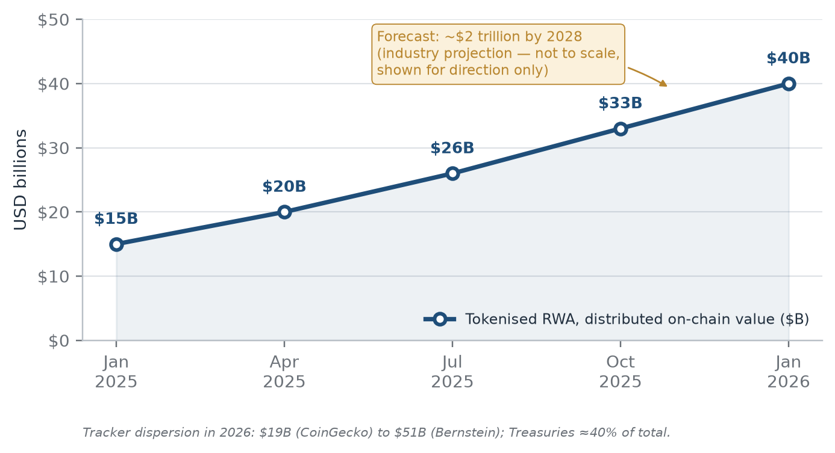
Indicative values from trackers: Jan 2025 $15B → Apr 2025 $20B → Jul 2025 $26B → Oct 2025 $33B → Jan 2026 $40B. The $2 trillion 2028 projection is drawn for direction only and is not to scale. Source: RWA.xyz; CoinDesk Data, 2026.

Chart 2 — Stablecoin market capitalisation and adjusted settlement volume (two-panel chart)
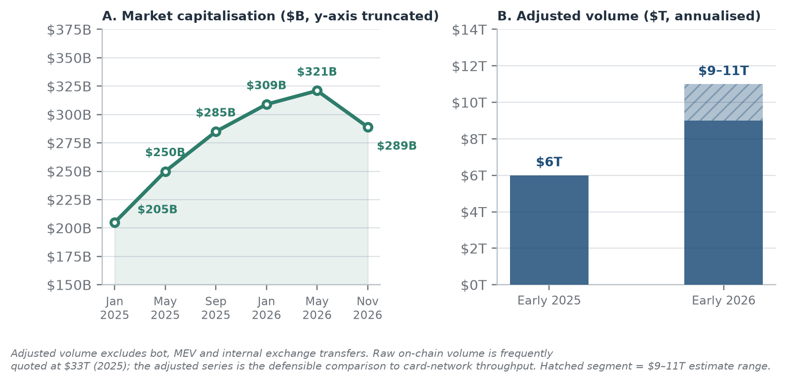
Panel A: market cap Jan 2025 $205B, May 2026 peak $321B, Nov 2026 $289B. Panel B: adjusted annual settlement volume, roughly $6T early 2025 to $9–11T early 2026, net of bot and exchange traffic. Source: DefiLlama, 2026; Visa Onchain Analytics, 2026.

Chart 3 — Market-size forecast comparison, explicitly not comparable (bar chart)
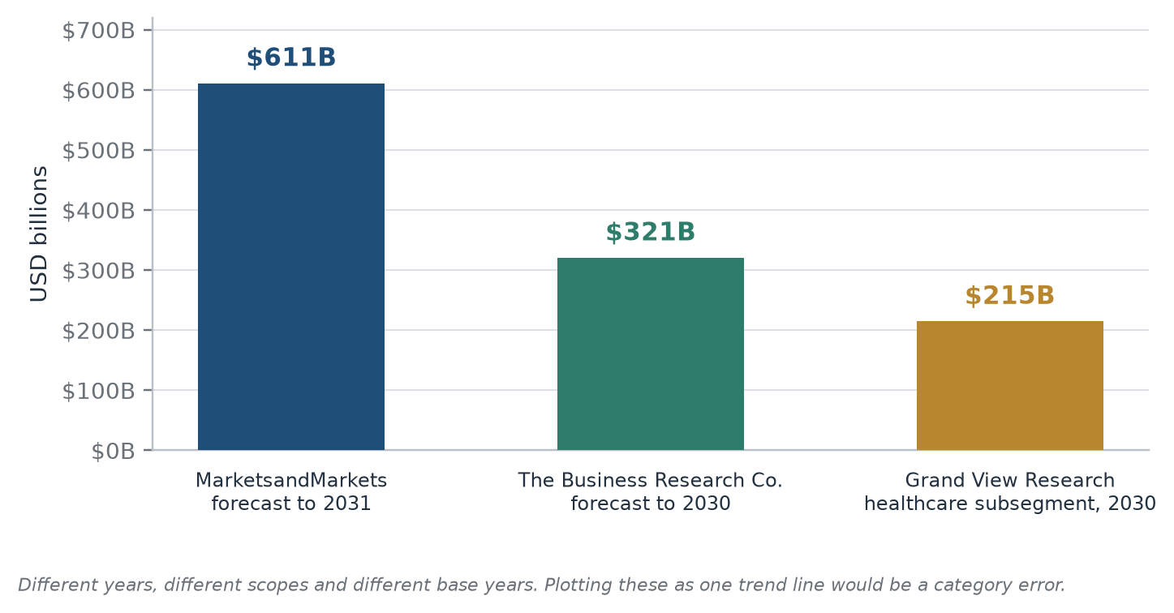
Bars: $610.96B by 2031 (MarketsandMarkets, 62.4% CAGR, base $54.08B); $320.65B by 2030 (The Business Research Company, 45% CAGR, base $72.45B); $214.9B by 2030 (Grand View Research, healthcare subsegment only, 63.6% CAGR). Different horizons and scopes: plotting these as a single trend line would be a category error.

Chart 4 — Five-year adoption phase timeline, 2026–2031 (horizontal timeline)
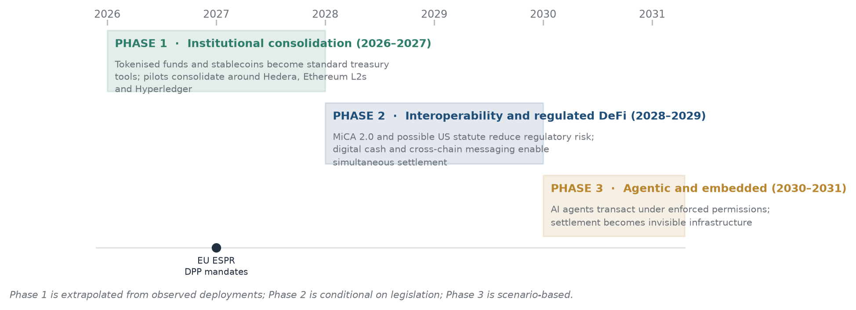
Phase 1 Institutional consolidation (2026–2027); Phase 2 Interoperability and regulated DeFi (2028–2029); Phase 3 Agentic and embedded (2030–2031). Milestone marker: EU ESPR mandatory digital product passports from 2027.

10. REFERENCES
[R1] MarketsandMarkets. “Blockchain Market — Global Forecast to 2031.” July 2026. https://www.marketsandmarkets.com/Market-Reports/blockchain-technology-market-90100890.html
[R2] The Business Research Company. “Blockchain Global Market Report 2026.” January 2026. https://www.researchandmarkets.com/reports/5735144/blockchain-market-report
[R3] J.P. Morgan Asset Management. “J.P. Morgan Asset Management Launches Second Tokenized Money Market Fund on Ethereum.” 13 May 2026. https://www.morningstar.com/news/pr-newswire/20260513ny58937/jp-morgan-asset-management-launches-second-tokenized-money-market-fund-on-ethereum
[R4] CoinPaprika. “JPMorgan's Tokenized Ethereum Fund Grows 250% in One Month to $695M.” 9 July 2026. https://coinpaprika.com/news/jpmorgans-tokenized-ethereum-fund-grows-250/
[R5] CoinDesk. “BlackRock takes first DeFi step, lists BUIDL on Uniswap as UNI jumps 25%.” 11 February 2026. https://www.coindesk.com/markets/2026/02/11/blackrock-takes-first-defi-step-lists-buidl-on-uniswap-as-uni-jumps-25
[R6] Decrypt. “FedEx Enters Hedera Network Council With Eye on Supply Chain Transformation.” 13 February 2026. https://decrypt.co/358022/fedex-hedera-network-council-supply-chain-transformation
[R7] ZIM Integrated Shipping Services. “ZIM to be Acquired by Hapag-Lloyd for $35.00 per Share in Cash — Aggregate Cash Consideration of Approximately $4.2 Billion.” 16 February 2026. https://www.prnewswire.com/news-releases/zim-to-be-acquired-by-hapag-lloyd-for-35-00-per-share-in-cash-at-aggregate-cash-consideration-of-approximately-4-2-billion-new-israeli-company-new-zim-to-acquire-portion-of-zims-business-302688714.html
[R8] Messari. “State of VeChain Q1 2026.” May 2026. https://messari.io/report/state-of-vechain-q1-2026
[R9] DefiLlama. “Stablecoin Market Cap Dashboard.” Accessed 10 November 2026. https://defillama.com/stablecoins
[R10] Crowdfund Insider. “Tokenized Real-World Assets (RWAs) Near $40B Milestone as US Treasury Debt Dominates.” 10 August 2026. https://www.crowdfundinsider.com/2026/08/296143-tokenized-real-world-assets-rwas-near-40b-milestone-as-us-treasury-debt-dominates/
[R11] Blockonomi. “Tokenized Real-World Assets Statistics 2026: Market Size, Growth and Top Asset Classes.” October 2026. https://blockonomi.com/tokenized-real-world-assets-statistics-2026-market-size-growth-and-top-asset-classes
[R12] CoinCentral. “Stablecoin Statistics 2026: How Stablecoins Compare to Visa and Mastercard.” 19 October 2026. https://coincentral.com/stablecoin-statistics-2026-how-stablecoins-compare-to-visa-and-mastercard
[R13] CoinTurk. “Institutional investors boost stablecoin use and tokenization in 2026, EY-Parthenon finds.” 5 October 2026. https://en.coin-turk.com/institutional-investors-boost-stablecoin-use-and-tokenization-in-2026-ey-parthenon-finds/
[R14] BeInCrypto Research. “The State of AI Agent Payments 2026.” October 2026. https://beincrypto.com/beincrypto-launches-the-state-of-ai-agent-payments-2026-report-at-token2049-singapore/
[R15] Funds Europe. “Tokenised money market funds gain institutional traction.” 9 October 2026. https://funds-europe.com/tokenised-money-market-funds-gain-institutional-traction/
[R16] Coinbase and EY-Parthenon. “2025 Institutional Investor Digital Assets Survey: Increasing Allocations in a Maturing Market.” January 2025. https://www.ey.com/content/dam/ey-unified-site/ey-com/en-us/insights/financial-services/documents/ey-growing-enthusiasm-propels-digital-assets-into-the-mainstream.pdf
[R17] Grand View Research. “Blockchain Technology In Healthcare Market Size Report, 2025–2030.” 2026. https://www.grandviewresearch.com/industry-analysis/blockchain-technology-healthcare-market
[R18] China Daily. “China advances digital yuan internationalization as 26 institutions join cross-border platform.” 17 June 2026. https://global.chinadaily.com.cn/a/202606/17/WS6a326834a310986e2b4608d9.html
[R19] The Economic Times. “Over 500 institutional investors, pension funds to participate in iBRICS Summit on September 12-13.” 5 September 2026. https://economictimes.indiatimes.com/news/india/over-500-institutional-investors-pension-funds-to-participate-in-ibrics-summit-on-september-12-13/articleshow/133793935.cms
[R20] Atlantic Council. “Central Bank Digital Currency Global Tracker.” 2026. https://www.atlanticcouncil.org/cbdctracker/
[R21] Notabene. “What the End of MiCA Grandfathering Means for Crypto Firms in Europe.” 1 July 2026. https://notabene.id/post/what-the-end-of-mica-grandfathering-means-for-crypto-firms-in-europe
[R22] European Commission. “Consultation on the review of Regulation (EU) 2023/1114 (MiCA).” Opened 20 May 2026. https://finance.ec.europa.eu/regulation-and-supervision/financial-services-legislation/consultations_en
[R23] CryptoTimes. “CLARITY Act Fails in Senate as Cloture Vote Falls Short of 60 Votes.” 16 September 2026. https://www.cryptotimes.io/2026/09/16/clarity-act-fails-in-senate-as-cloture-vote-falls-short-of-60-votes/
[R24] United States Senate. “Roll Call Vote 234, 119th Congress — Motion to Invoke Cloture on the Motion to Proceed to H.R. 3633.” 15 September 2026. https://www.senate.gov/legislative/LIS/roll_call_votes/vote1192/vote_119_2_00234.htm
[R25] StockTitan. “Wellgistics Health Selects Top Five Blockchain Platforms to Initiate Patent Protected PharmacyChain Smart Contracts-enabled Pharmaceutical Drug Tracking System.” 5 March 2026. https://www.stocktitan.net/news/WGRX/wellgistics-health-selects-top-five-blockchain-platforms-to-initiate-pob98wnf7zun.html
[R26] L2BEAT. “Scaling Summary — Aggregate Value Secured.” 2026. https://l2beat.com/scaling/summary

Note on source verification. All URLs were checked at the time of writing. Market trackers are live dashboards whose values change daily, so figures quoted from DefiLlama and L2BEAT should be refreshed before presentation. Corporate and regulatory sources are dated and stable. Three figures in the original brief were corrected against the primary record: the stablecoin peak is $321B in May 2026 rather than $320B in February; the CLARITY cloture vote was 49–50 on 15 September 2026; and the “72% RWA intent” figure refers to 72% of institutions already interested in tokenised assets, not 72% of all institutions.

