AUTOENCODER

DATASET DESCRIPTION
file.csv
['date', 'user', 'pc', 'filename','to_removable_media', 'from_removable_media', 'file_activity']
converted as
{ date, user, pc, is_exe, not_exe, to_removable_media, from_removable_media, writing, reading, open, delete }

email.csv
['date', 'user', 'pc', 'to', 'from', 'attachments']
converted as
{ date, user, pc, from_outside, to_outside, has_attachments }

device.csv
['date', 'user', 'pc', 'activity']
converted as
{ date, user, pc, connect, disconnect }

logon.csv
['date','user','pc','logon_activity']
converted as
{ date, user, pc, logon, logoff }

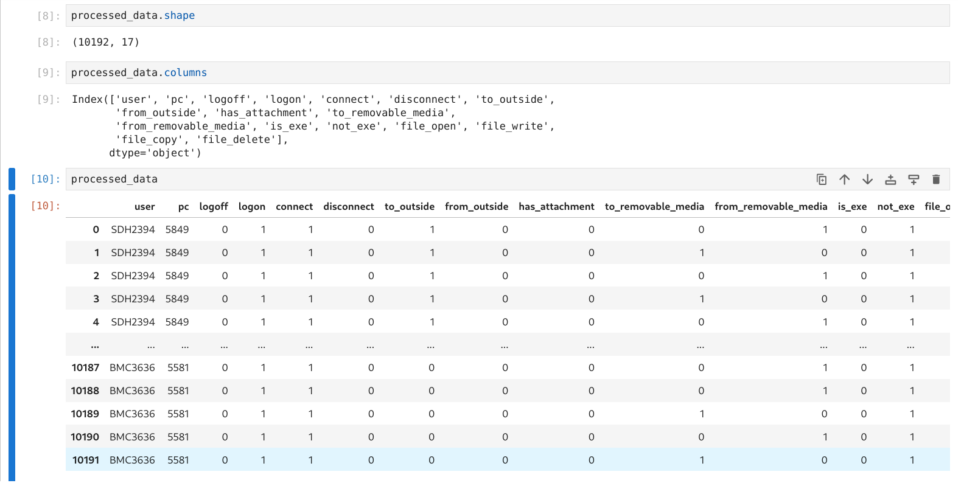Figure 1: processed dataset, input for autoencoder.
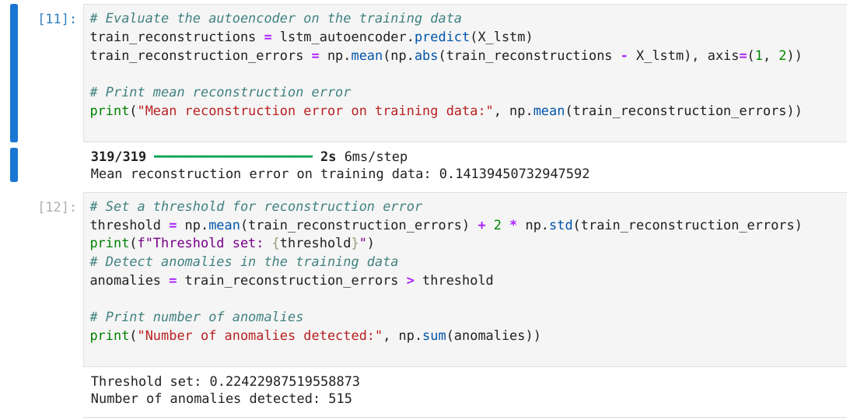Figure 2: Model results
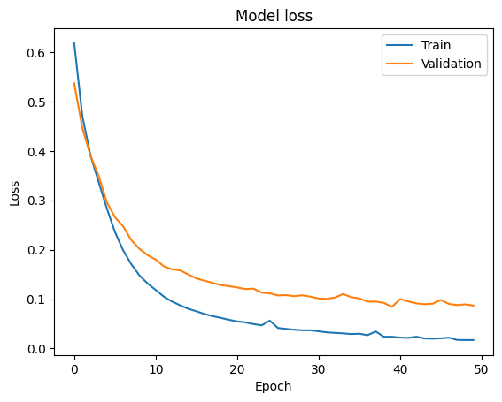Figure 3: model Loss Metric

