Defining Autoencoder:
The source code that I provided as attachment produces the output like this.
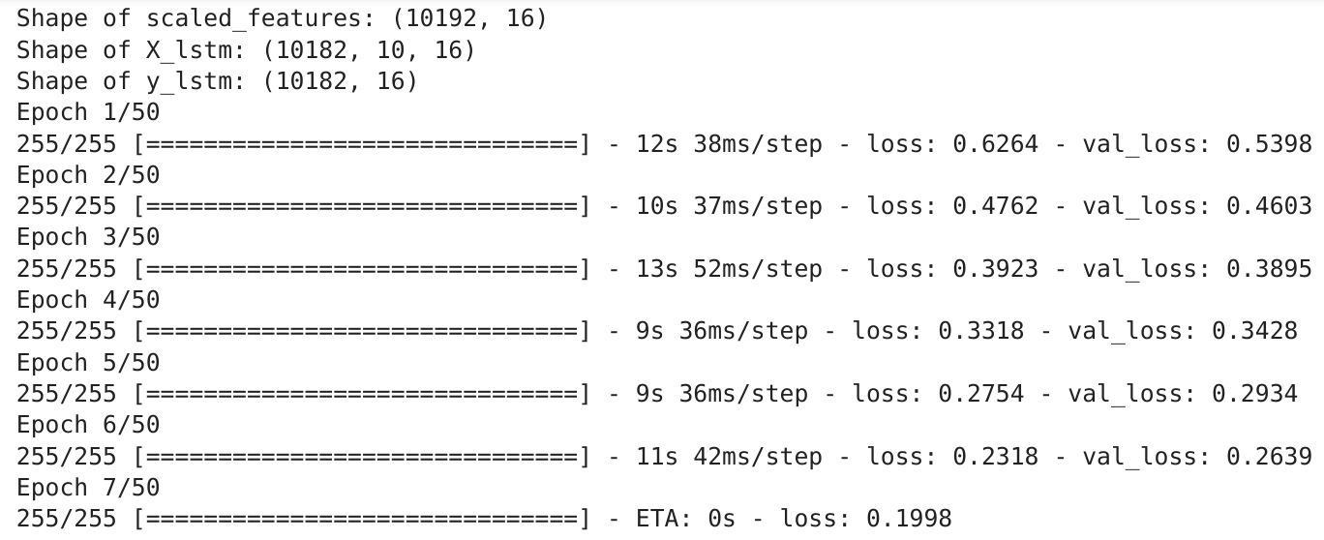
Figure 1: Training Iteration Output
I am saving model files for future use, with command lstm_autoencoder.save('lstm_autoencoder_model.h5')
keras.saving.save_model(lstm_autoencoder, 'phase-1.keras')
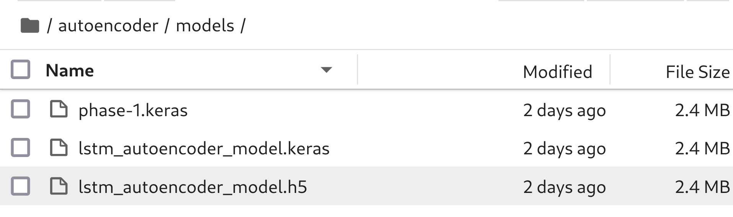
Figure 2: saving models in various format

Loading model files and analyzing.
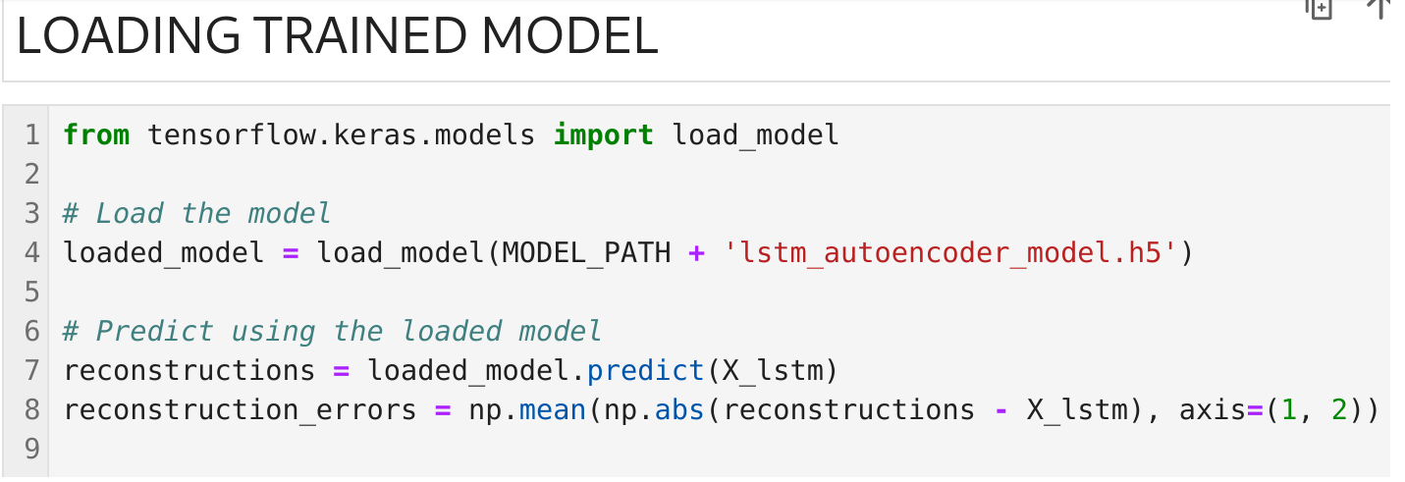
Figure 3: Model importing and using later

