1. Write a program for the Bisection method.
Source code:
#include<stdio.h>
#include<conio.h>
#include<math.h>
#define f(x) x*x+4*x-9
void main(){
float x0, x1, x2, f0, f1, f2, e;
int step = 1;
up:
printf("\nEnter two initial guesses:\n");
scanf("%f%f", &x0, &x1);
printf("Enter tolerable error:\n");
scanf("%f", &e);
f0 = f(x0);
f1 = f(x1);
if( f0 * f1 > 0.0){
printf("Incorrect Initial Guesses.\n");
goto up;
}
printf("\nStep\t\tx0\t\tx1\t\tx2\t\tf(x2)\n");
do{
x2 = (x0 + x1)/2;
f2 = f(x2);
printf("%d\t\t%f\t%f\t%f\t%f\n",step, x0, x1, x2, f2);
if( f0 * f2 < 0){
x1 = x2;
f1 = f2;
}else{
x0 = x2;
f0 = f2;
}
step = step + 1;
}
while(fabs(f2)>e);
printf("\nRoot is: %f", x2);
getch();
}

Input/Output:
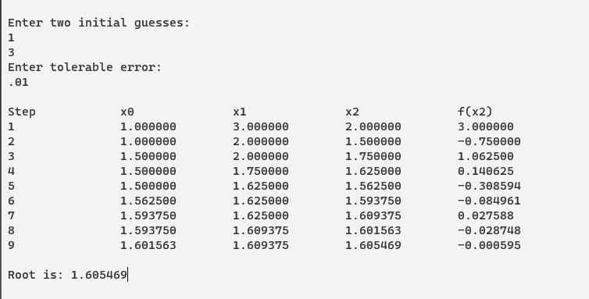

2. Write a program for Newton-Raphson Method.
Source code:
#include<stdio.h>
#include<math.h>
#define f(x) x*x+4*x-9
#define g(x) 2*x+4
void main(){
float x0, x1, f0, f1, g0, e;
int step = 1, N;
printf("\nEnter initial guess:\n");
scanf("%f", &x0);
printf("Enter tolerable error:\n");
scanf("%f", &e);
printf("Enter maximum iteration:\n");
scanf("%d", &N);
printf("\nStep\t\tx0\t\tf(x0)\t\tx1\t\tf(x1)\n");
do{
g0 = g(x0);
f0 = f(x0);
if(g0 == 0.0){
printf("Mathematical Error.");
exit(0);
}
x1 = x0 - f0/g0;
printf("%d\t\t%f\t%f\t%f\t%f\n",step,x0,f0,x1,f1);
x0 = x1;
step = step+1;
if(step > N){
printf("Not Convergent.");exit(0);
}
f1 = f(x1);
}
while(fabs(f1)>e);
printf("\nRoot is: %f", x1);
getch();
}

Input/Output:
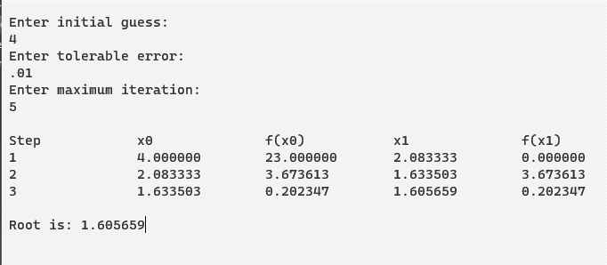

3. Write a program for the Regula-Falsi Method.
Source code:
#include<stdio.h>
#include<math.h>
#define f(x) x*log10(x) - 1.2
int main(){
float x0, x1, x2, f0, f1, f2, e; int step = 1;
up:
printf("\nEnter two initial guesses:\n");
scanf("%f%f", &x0, &x1);
printf("Enter tolerable error:\n");
scanf("%f", &e);
f0 = f(x0);
f1 = f(x1);
if( f0*f1 > 0.0){
printf("Incorrect Initial Guesses.\n"); goto up;
}
printf("\nStep\t\tx0\t\tx1\t\tx2\t\tf(x2)\n");
do{
x2 = x0 - (x0-x1) * f0/(f0-f1); f2 = f(x2);
printf("%d\t\t%f\t%f\t%f\t%f\n",step, x0, x1, x2, f2);
if(f0*f2 < 0){
x1 = x2; f1 = f2;
}
else{
x0 = x2; f0 = f2;
}
step = step + 1;
}
while(fabs(f2)>e);
printf("\nRoot is: %f", x2);
}

Input/Output:
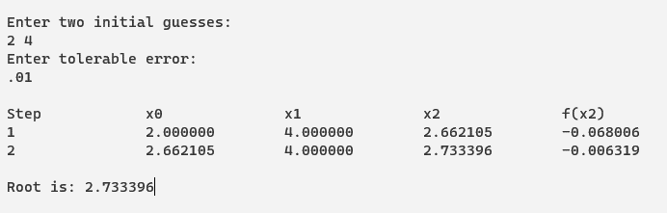
4. Write a program for the Fixed point Method.
Source code:
#include<stdio.h>
#include<conio.h>
#include<math.h>
#define f(x) cos(x)-3*x+1
#define g(x) (1+cos(x))/3
int main(){
int step=1, N;
float x0, x1, e;
printf("Enter initial guess: ");
scanf("%f", &x0);
printf("Enter tolerable error: ");
scanf("%f", &e);
printf("Enter maximum iteration: ");
scanf("%d", &N);
printf("\nStep\tx0\t\tf(x0)\t\tx1\t\tf(x1)\n");
do{
x1 = g(x0);
printf("%d\t%f\t%f\t%f\t%f\n",step, x0, f(x0), x1, f(x1));
step = step + 1;
if(step>N){
printf("Not Convergent.");
exit(0);
}
x0 = x1;
}
while( fabs(f(x1)) > e);
printf("\nRoot is %f", x1);
}

Input/Output:
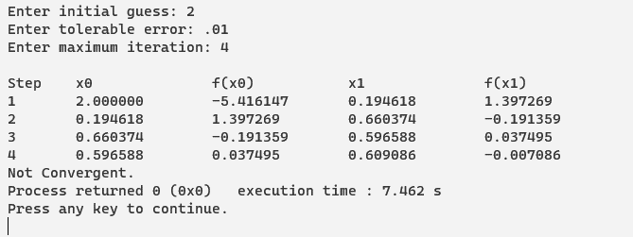

5. Write a program for Lagrange interpolation.
Source code:
#include<stdio.h>
#include<conio.h>
void main(){
float x[100], y[100], xp, yp=0, p;
int i,j,n;
printf("Enter number of data: ");
scanf("%d", &n);
printf("Enter data:\n");
for(i=1;i<=n;i++){
printf("x[%d] = ", i);
scanf("%f", &x[i]);
printf("y[%d] = ", i);
scanf("%f", &y[i]);
}
printf("Enter interpolation point: ");
scanf("%f", &xp);
for(i=1;i<=n;i++){
p=1;
for(j=1;j<=n;j++)
if(i!=j)
p = p* (xp - x[j])/(x[i] - x[j]);
yp = yp + p * y[i];
}
printf("Interpolated value at %.3f is %.3f.", xp, yp);
getch();
}
Input/Output:
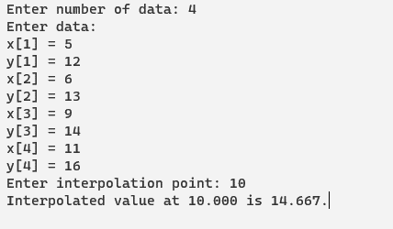

6. Write a program for Newton divided difference interpolation.
Source code:
#include<stdio.h>
#include<conio.h>
#include<math.h>
int main(){
float x[10],y[10][10],sum,p,u,temp;
int i,n,j,k=0,f,m;
float fact(int);
printf("how many record you will be enter: ");
scanf("%d",&n);
for(i=0; i<n; i++){
printf("enter the value of x%d: ",i);
scanf("%f",&x[i]);
printf("enter the value of f(x%d): ",i);
scanf("%f",&y[k][i]);
}
printf("Enter X for finding f(x): ");
scanf("%f",&p);
for(i=1;i<n;i++){
k=i;
for(j=0;j<n-i;j++){
y[i][j]=(y[i-1][j+1]-y[i-1][j])/(x[k]-x[j]);
k++;
}
}
printf("\n_____________________________________________________\n");
printf("\n x(i)\t y(i)\t y1(i) y2(i) y3(i) y4(i)");
printf("\n_____________________________________________________\n");
for(i=0;i<n;i++){
printf("\n %.3f",x[i]);
for(j=0;j<n-i;j++){
printf(" ");
printf(" %.3f",y[j][i]);
}
}
i=0;
do{
if(x[i]<p && p<x[i+1])
k=1;
else
i++;
}
while(k != 1);
f=i;
sum=0;
for(i=0;i<n-1;i++){
k=f;
temp=1;
for(j=0;j<i;j++){
temp = temp * (p - x[k]);
k++;
}
sum = sum + temp*(y[i][f]);
}
printf("\n f(%.2f) = %f ",p,sum);
getch();
}

Input/Output:
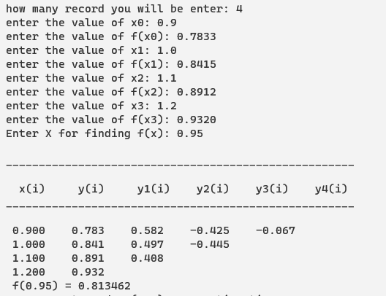

7. Write a program for Newton forward difference interpolation.
Source code:
#include<stdio.h>
#include<math.h>
int fact(int);
void main(){
float arr[10][11],x,h,p,y,px=1;
int i,j,n,ch=30;
printf("\nEnter the number of data:");
scanf("%d",&n);
printf("\nEnter the data");
for(i=0;i<n;i++)
{ printf("X%d=",i+1);
scanf("%f",&arr[i][0]);
printf("Y%d=",i+1);
scanf("%f",&arr[i][1]);
}
for(j=2;j<=n;j++)
for(i=0;i<n-1;i++)
arr[i][j]=arr[i+1][j-1]-arr[i][j-1];
printf("\nDifference table is:-");
printf("\n\tx\tY");
for(i=0;i<=n-2;i++)
printf("\t%c^%dY",ch,i+1);
for(i=0;i<n;i++)
{printf("\n");
for(j=0;j<n+1-i;j++)
printf("\t%.4f",arr[i][j]);
}
printf("\nEnter the value x for function f(x):");
scanf("%f",&x);
h=arr[1][0]-arr[0][0];
p=(x-arr[0][0])/h;
y=arr[0][1];
for(i=1;i<n;i++){
px=px*(p-(i-1));
y=y+(arr[0][i+1]*px)/fact(i);
}
printf("\nthe value of function at x=%f is %f",x,y);
}
int fact(int n){
int i,f=1;
for(i=1;i<=n;i++)
f=f*i;
return f;
}

Input/Output:
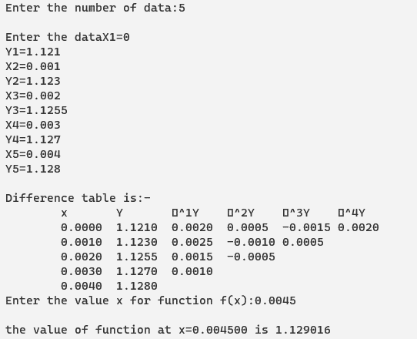

8. Write a program for Newton backward difference interpolation.

Source code:
#include<stdio.h>
int fact(int);
void main(){
int n,i,j,ch=30;
float arr[10][11],px=1,x,y,p,h;
printf("\nEnter the no of data:");
scanf("%d",&n);
printf("Enter the data:");
for(i=0;i<n;i++){
printf("X%d=",i+1);
scanf("%f",&arr[i][0]);
printf("Y%d=",i+1);
scanf("%f",&arr[i][1]);
}
for(j=2;j<=n;j++)
{for(i=0;i<n-1;i++)
arr[i][j]=arr[i+1][j-1]-arr[i][j-1];
}
printf("\nThe difference table");
printf("\n\tX \tY");
for(i=0;i<n-1;i++)
printf("\t%c^%d",ch,i+1);
for(i=0;i<n;i++){
printf("\n");
for(j=0;j<n+1-i;j++)
printf("\t%.4f",arr[i][j]);
}
printf("\nEnter the value of x for f(x)");
scanf("%f",&x);
h=arr[n-1][0]-arr[n-2][0];
p=(x-arr[n-1][0])/h;
y=arr[n-1][1];
for(i=1;i<n;i++)
{
px=px*(p+(i-1));
y=y+(arr[n-1-i][i+1]*px)/fact(i);
}
printf("\nthe value of f(x) at x=%f is %f",x,y);
}
int fact(int n)
{ int f=1,i;
for(i=1;i<=n;i++)
f=f*i;
return f;
}

Input/Output:
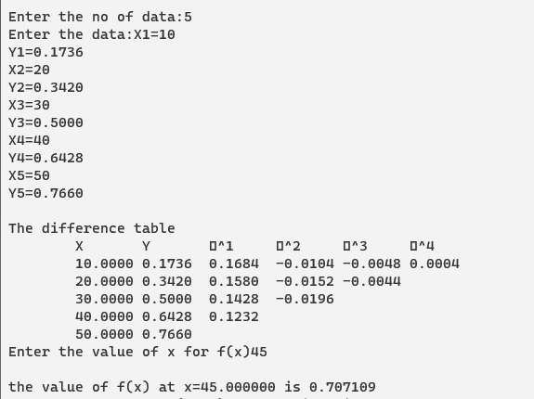

9. Write a program for Trapezoidal Rule.
Source code:
#include<stdio.h>
#include<conio.h>
#include<math.h>
float func(float x){
float a;
a=2*pow(x,2)+3*x;
return a;}
void main(){
int n,i; float a,b,h,sum,integral;
printf("\n Enter the upper limit: ");
scanf ("%f",&a);
printf("\n Enter the lower limit: ");
scanf ("%f",&b);
printf("\n Enter the interval: ");
scanf ("%d",&n);
h=(a-b)/n;
sum=func(a)+func(b);
i=2;
while(i<=n){
sum=sum+2*func(b+(i-1)*h); i++;}
integral=h*sum/2;
printf("\n Answer is: %f",integral);
getch();
}

Input/output:
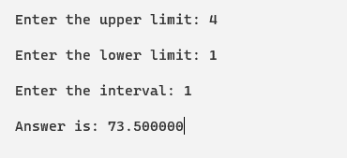

10. Write a program for Simpson’s 1/3 rule.
Source code:
#include<stdio.h>
#include<conio.h>
#include<math.h>
float func(float x){
float a;
a=2*pow(x,2)-3*x;
return (a);
}
void main(){
int n,i;
float a,b,h,sum,integral;
printf("Enter the uper limit: ");
scanf("%f",&a);
printf("Enter the lower limit: ");
scanf("%f",&b);
printf("Enter the interval: ");
scanf("%d",&n);
h=(a-b)/n;
sum=func(a)+func(b)+4*func(b-h);
for(i=1;i<=n-3;i=i+2){
sum=sum+4*func(a+i*h)+2*func(a+(i+1)*h);
}
integral=h*sum/3;
printf("Integral: %10.2f\n",integral);
getch();
}
Input/Output:
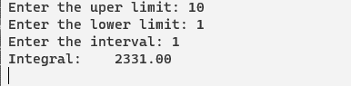

11. Write a program for Simpson’s 3/8 rule.
Source code:
#include<stdio.h>
#include<conio.h>
#include<math.h>
#define f(x) 2+cos(2*pow(x,1/2))
int main(){
float lower, upper, integration=0.0, h, k; int i, interval;
printf("Enter lower limit of integration: ");
scanf("%f", &lower);
printf("Enter upper limit of integration: ");
scanf("%f", &upper);
printf("Enter number of intervals: ");
scanf("%d", &interval);
h = (upper - lower)/interval;
integration = f(lower) + f(upper);
for(i=1; i<= interval-1; i++){
k = lower + i*h;
if(i%3 == 0)
integration = integration + 2 * f(k);
else
integration = integration + 3 * f(k);
}
integration = integration * h*3/8;
printf("\nRequired value of integration is: %.3f", integration);
getch();
return 0;
}

Output:
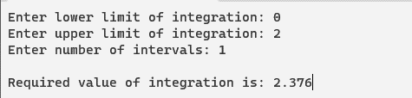

12. Write a program for derivative using forward difference formula.
Source code:
#include<stdio.h>
#include<stdlib.h>
#include<math.h>
int main(){
float x[20], y[20][20], xp, h, sum=0.0, term, first_derivative;
int i,j, n, index, flag = 0, sign=1;
printf("Enter number of data: ");
scanf("%d", &n);
printf("Enter data:\n");
for(i = 0; i < n ; i++)
{
printf("x[%d] = ", i);
scanf("%f", &x[i]);
printf("y[%d] = ", i);
scanf("%f", &y[i][0]);
}

printf("Enter at what value of x you want to calculate derivative: ");
scanf("%f", &xp);
for(i=0;i< n;i++)
{
if (fabs(xp - x[i])< 0.0001)
{
index = i;
flag = 1;
break;
}
}
if (flag==0)
{
printf("Invalid calculation point. Program exiting...");
exit(0);
}
for(i = 1; i < n; i++)
{
for(j = 0; j < n-i; j++)
{
y[j][i] = y[j+1][i-1] - y[j][i-1];
}
}
h = x[1] - x[0];
for(i=1; i< n-index; i++)
{
term = pow(y[index][i], i)/i;
sum = sum + sign*term;
sign = -sign;
}
first_derivative = sum/h;
printf("First derivative at x = %0.2f is %0.2f", xp, first_derivative);
return 0;
}

output:
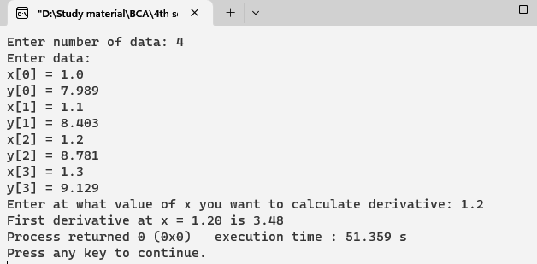

13. Write a program for derivative using backward difference formula.
Source code:
#include<stdio.h>
#include<stdlib.h>
#include<math.h>
int main()
{
float x[20], y[20][20], xp, h, sum=0.0, first_derivative, term;
int i,j, n, index, flag = 0;
printf("Enter number of data: ");
scanf("%d", &n);
printf("Enter data:\n");
for(i = 0; i < n ; i++)
{
printf("x[%d] = ", i);
scanf("%f", &x[i]);
printf("y[%d] = ", i);
scanf("%f", &y[i][0]);
}
printf("Enter at what value of x you want to calculate derivative: ");
scanf("%f", &xp);
for(i=0;i< n;i++)
{
if (fabs(xp - x[i])< 0.0001)
{
index = i;
flag = 1;
break;
}
}
if (flag==0)
{
printf("Invalid calculation point. Program exiting...");
exit(0);
}
for(i = 1; i < n; i++)
{
for(j = n-1; j > i-1; j--)
{
y[j][i] = y[j][i-1] - y[j-1][i-1];
}
}
h = x[1] - x[0];
for(i=1; i<=index; i++)
{
term = pow(y[index][i], i)/i;
sum = sum + term;
}
first_derivative = sum/h;
printf("First derivative at x = %0.2f is %0.2f", xp, first_derivative);
return 0;
}

Output:
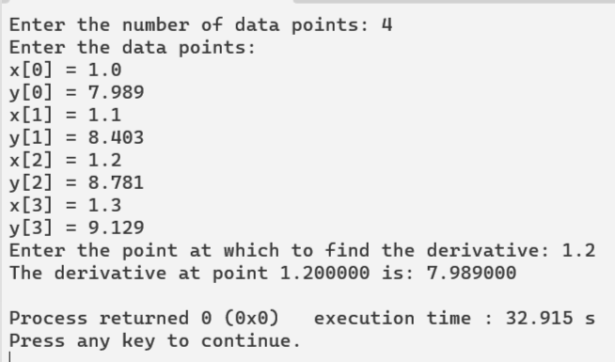

14. Write a program for Linear Regression.
Source code:
#include<stdio.h>
#include<conio.h>
#define S 50
void main(){
int n, i; float x[S], y[S], sumX=0, sumX2=0, sumY=0, sumXY=0, a, b;
printf("How many data points?\n");
scanf("%d", &n);
printf("Enter data:\n");
for(i=1;i<=n;i++){
printf("x[%d]=",i);
scanf("%f", &x[i]);
printf("y[%d]=",i);
scanf("%f", &y[i]);
}
for(i=1;i<=n;i++){
sumX = sumX + x[i];
sumX2 = sumX2 + x[i]*x[i];
sumY = sumY + y[i];
sumXY = sumXY + x[i]*y[i];
}
b = (n*sumXY-sumX*sumY)/(n*sumX2-sumX*sumX);
a = (sumY - b*sumX)/n;
printf("Values are: a=%0.2f and b = %0.2f",a,b);
printf("\nEquation of best fit is: y = %0.2f + %0.2fx",a,b);
}
output:
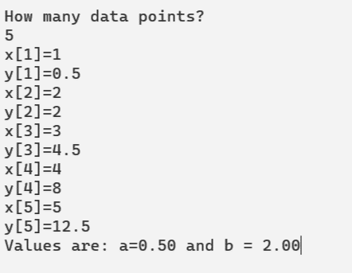

15. Write a program for Exponential Regression.
Source code:
#include<stdio.h>
#include<conio.h>
#include<math.h>
#define S 50
void main(){
int n, i; float x[S], y[S], sumX=0, sumX2=0, sumY=0, sumXY=0, a, b, A;
printf("How many data points?\n");
scanf("%d", &n);
for(i=1;i<=n;i++){
printf("x[%d]=",i);
scanf("%f", &x[i]);
printf("y[%d]=",i);
scanf("%f", &y[i]);
}
for(i=1;i<=n;i++){
sumX = sumX + log(x[i]);
sumX2 = sumX2 + log(x[i])*log(x[i]);
sumY = sumY + log(y[i]);
sumXY = sumXY + log(x[i])*log(y[i]);
}
b = (n*sumXY-sumX*sumY)/(n*sumX2-sumX*sumX);
A = (sumY - b*sumX)/n;
a = exp(A);
printf("Values are: a=%0.2f and b = %0.2f",a,b);
}
Input/Output:
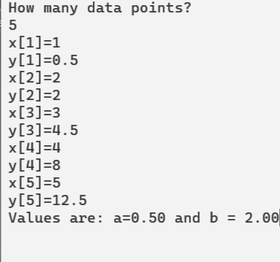

16. Write a program for Gauss Elimination Method.
Source code:
#include<stdio.h>
#include<conio.h>
#include<math.h>
#include<stdlib.h>
#define SIZE 10
int main()
{
float a[SIZE][SIZE], x[SIZE], ratio;
int i,j,k,n;

printf("Enter Order of matrix: ");
scanf("%d", &n);
for(i=1;i<=n;i++)
{
for(j=1;j<=n+1;j++)
{
printf("a[%d][%d] = ",i,j);
scanf("%f", &a[i][j]);
}
}
for(i=1;i<=n-1;i++)
{
if(a[i][i] == 0.0)
{
printf("Mathematical Error!");
exit(0);
}
for(j=i+1;j<=n;j++)
{
ratio = a[j][i]/a[i][i];

for(k=1;k<=n+1;k++)
{
a[j][k] = a[j][k] - ratio*a[i][k];
}
}
}
x[n] = a[n][n+1]/a[n][n];

for(i=n-1;i>=1;i--)
{
x[i] = a[i][n+1];
for(j=i+1;j<=n;j++)
{
x[i] = x[i] - a[i][j]*x[j];
}
x[i] = x[i]/a[i][i];
}
printf("\nSolution:\n");
for(i=1;i<=n;i++)
{
printf("x[%d] = %0.3f\n",i, x[i]);
}
getch();
return(0);
}
Input/Output:
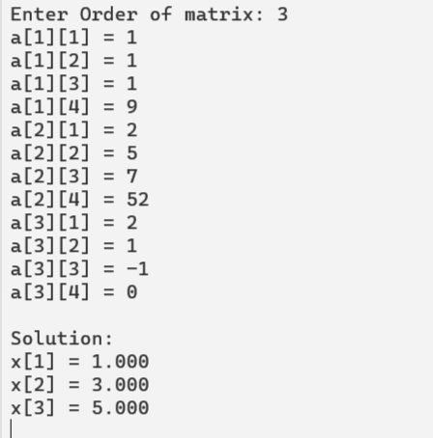

17. Write a program for Gauss Jordan Method.
Source code:
#include<stdio.h>
#include<conio.h>
#include<math.h>

#define SIZE 10

int main()
{
float a[SIZE][SIZE], x[SIZE], ratio;
int i,j,k,n;
printf("Enter order of matrix: ");
scanf("%d", &n);
printf("Enter coefficients of Augmented Matrix:\n");
for(i=1;i<=n;i++)
{
for(j=1;j<=n+1;j++)
{
printf("a[%d][%d] = ",i,j);
scanf("%f", &a[i][j]);
}
}
for(i=1;i<=n;i++)
{
if(a[i][i] == 0.0)
{
printf("Mathematical Error!");
exit(0);
}
for(j=1;j<=n;j++)
{
if(i!=j)
{
ratio = a[j][i]/a[i][i];
for(k=1;k<=n+1;k++)
{
a[j][k] = a[j][k] - ratio*a[i][k];
}
}
}
}
for(i=1;i<=n;i++)
{
x[i] = a[i][n+1]/a[i][i];
}
printf("\nSolution:\n");
for(i=1;i<=n;i++)
{
printf("x[%d] = %0.3f\n",i, x[i]);
}
getch();
return(0);
}
Input/Output:
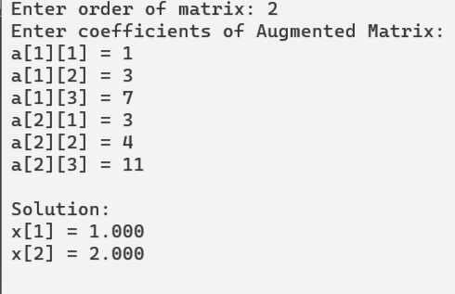

18. Write a program for Matrix Inversion using Gauss Jordan Method.
Source code:
#include<stdio.h>
#include<conio.h>
#include<math.h>
#define SIZE 10
void main(){
float a[SIZE][SIZE], x[SIZE], ratio;
int i,j,k,n;
printf("Enter order of matrix: ");
scanf("%d", &n);
printf("Enter coefficients of Matrix:\n");
for(i=1;i<=n;i++){
for(j=1;j<=n;j++){
printf("a[%d][%d] = ",i,j);
scanf("%f", &a[i][j]);
}
}
for(i=1;i<=n;i++){
for(j=1;j<=n;j++){
if(i==j)
a[i][j+n] = 1;
else
a[i][j+n] = 0;
}
}
for(i=1;i<=n;i++){
if(a[i][i] == 0.0){
printf("Mathematical Error!");
exit(0);
}
for(j=1;j<=n;j++){
if(i!=j){
ratio = a[j][i]/a[i][i];
for(k=1;k<=2*n;k++){
a[j][k] = a[j][k] - ratio*a[i][k];
}
}
}
}
for(i=1;i<=n;i++){
for(j=n+1;j<=2*n;j++)
a[i][j] = a[i][j]/a[i][i];
}
printf("\nInverse Matrix is:\n");
for(i=1;i<=n;i++){
for(j=n+1;j<=2*n;j++)
printf("%0.3f\t",a[i][j]);
printf("\n");
}
}

Input/Output:
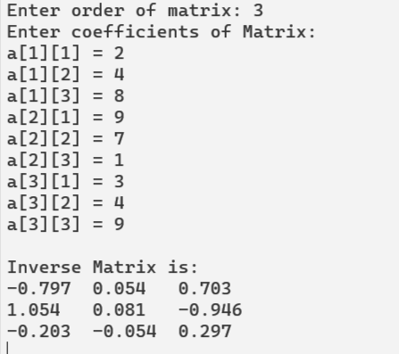

19. Write a program for Gauss Seidel Method.
Source code:
#include<stdio.h>
#include<math.h>
#define f1(x,y,z) (17-y+2*z)/20
#define f2(x,y,z) (-18-3*x+z)/20
#define f3(x,y,z) (25-2*x+3*y)/20
void main(){
float x0=0, y0=0, z0=0, x1, y1, z1, e1, e2, e3, e;
int count=1;
printf("Enter tolerable error:\n");
scanf("%f", &e);
printf("\nCount\tx\ty\tz\n");
do{
x1 = f1(x0,y0,z0);
y1 = f2(x1,y0,z0);
z1 = f3(x1,y1,z0);
printf("%d\t%0.4f\t%0.4f\t%0.4f\n",count, x1,y1,z1);
e1 = fabs(x0-x1);
e2 = fabs(y0-y1);
e3 = fabs(z0-z1);
count++;
x0 = x1;
y0 = y1;
z0 = z1;
}while(e1>e && e2>e && e3>e)
printf("\nSolution: x=%0.3f, y=%0.3f and z = %0.3f\n",x1,y1,z1);
}
Input/Output:
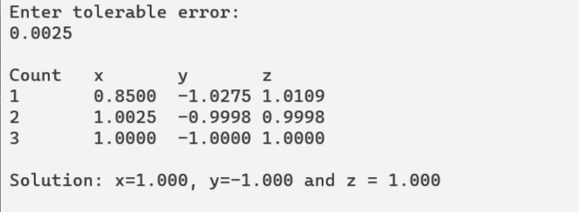

20. Write a program for Jacobi Method.
Source code:
#include<stdio.h>
#include<math.h>
#define f1(x,y,z) (17-y+2*z)/20
#define f2(x,y,z) (-18-3*x+z)/20
#define f3(x,y,z) (25-2*x+3*y)/20
void main(){
float x0=0, y0=0, z0=0, x1, y1, z1, e1, e2, e3, e;
int count=1;
printf("Enter tolerable error:\n");
scanf("%f", &e);
printf("\nCount\tx\ty\tz\n");
do{
x1 = f1(x0,y0,z0);
y1 = f2(x0,y0,z0);
z1 = f3(x0,y0,z0);
printf("%d\t%0.4f\t%0.4f\t%0.4f\n",count, x1,y1,z1);
e1 = fabs(x0-x1);
e2 = fabs(y0-y1);
e3 = fabs(z0-z1);
count++;
x0 = x1;
y0 = y1;
z0 = z1;
}while(e1>e && e2>e && e3>e);
printf("\nSolution: x=%0.3f, y=%0.3f and z = %0.3f\n",x1,y1,z1);
}
Input/Output:
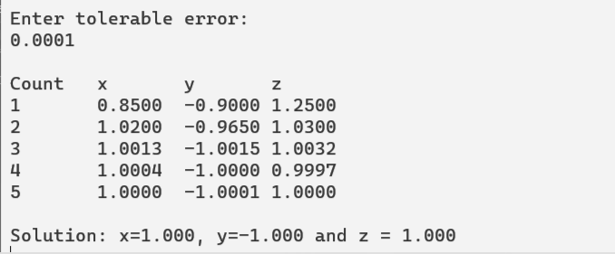

21. Write a program for Romberg Integration.
Source code:
#include<stdio.h>
#include<math.h>
#define f(x) 1/(x)
void main(){
float x0,xn,t[10][10],h,sm,sl,a; int i,k,c,r,m,p,q;
printf("Enter lower and upper limit:");
scanf("%f%f",&x0,&xn);
printf("enter p and q required T(p,q):");
scanf("%d%d",&p,&q);
h=xn-x0;
t[0][0]=h/2*((f(x0))+ (f(xn)));
for(i=1;i<=p;i++){
sl=pow(2,i-1);
sm=0;
for(k=1;k<=sl;k++){
a=x0+(2*k-1)*h/pow(2,i);
sm=sm+(f(a));
}
t[i][0]=t[i-1][0]/2+sm*h/pow(2,i);
}
for(c=1;c<=p;c++){
for(k=1;k<=c && k<=q;k++){
m=c-k;
t[m+k][k]=(pow(4,k)*t[m+k][k-1]-t[m+k-1][k-1])/(pow(4,k)-1);
}
}printf("Romberg estimate of integration =%f",t[p][q]);
}

Input/Output:
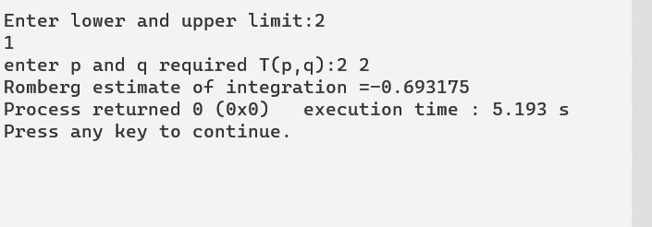

22. Write a program for Euler’s Method.
Source code:
#include<stdio.h>
float fun(float x,float y)
{
float f;
f=x+y;
return f;
}
main()
{
float a,b,x,y,h,t,k;
printf("\nEnter x0,y0,h,xn: ");
scanf("%f%f%f%f",&a,&b,&h,&t);
x=a;
y=b;
printf("\n x\t y\n");
while(x<=t)
{
k=h*fun(x,y);
y=y+k;
x=x+h;
printf("%0.3f\t%0.3f\n",x,y);
}
}
Input/Output:
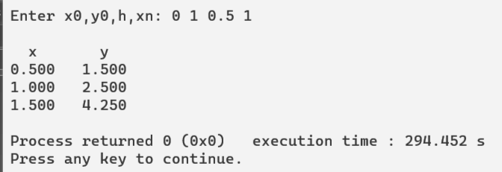

23. Write a program for Heun’s Method.
Source code:
#include<conio.h>
#include<stdio.h>
#define f(x,y) 2*y/x
void main(){
float x,y,h,xn,l;
printf("Program for Solution of Ordinary Differential Equation\nHeun's Method\n");
printf("Enter value for x and y\n");
scanf("%f%f",&x,&y);
printf("Enter value for h and last of x\n");
scanf("%f%f",&h,&xn);
while(x+h<=xn){
l=(h/2)*(f(x,y)+f(x+h,y+h*f(x,y)));
y=y+l;
x=x+h;
printf("y = %f\tx = %f\n",y,x);
}
}

Output:

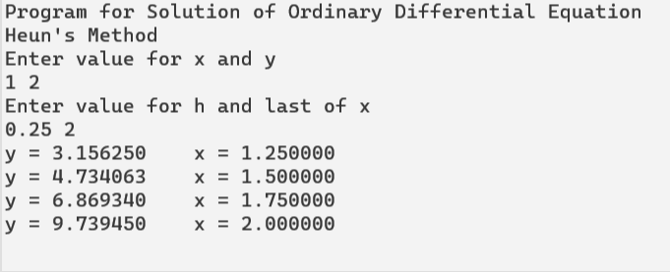

24. Write a program for Runge Kutta Method.
Source code:
#include<stdio.h>
#include<math.h>
#define f(x,y) x*x+y*y
void main(){
float x,y,m1,m2,m3,m4,h,xn,m;
printf("Program for Solution of Ordinary Differential Equation\Runge Kutta Method\n");
printf("Enter value for x0,y0\n");
scanf("%f%f",&x,&y);
printf("Enter value for h and last of x\n");
scanf("%f%f",&h,&xn);
printf("\nm1\tm2\tm3\tm4\tX\tY\n");
while(x<xn){
m1=f(x,y);
m2=f((x+h/2.0),(y+m1*h/2.0));
m3=f((x+h/2.0),(y+m2*h/2.0));
m4=f((x+h),(y+m3*h));
m=((m1+2*m2+2*m3+m4)/6);
y=y+m*h;
x=x+h;
printf("%.4f\t%.4f\t%.4f\t%.4f\t%.4f\t%.4f\n",m1,m2,m3,m4,x,y);
}
}
Output:
