WEEK-4

1.CONNECT TO CASSANDRA USING THE FOLLOWING COMMAND IN UBUNTU TERMINAL

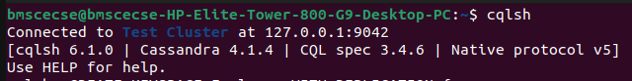

2. Create a keyspace by name Employee

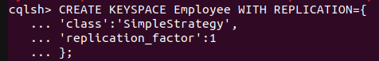

3. Create a column family by name

Employee-Info with attributes

Emp_Id Primary Key, Emp_Name,

Designation, Date_of_Joining, Salary,

Dept_Name

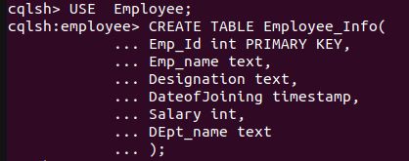

4. Insert the values into the table in batch

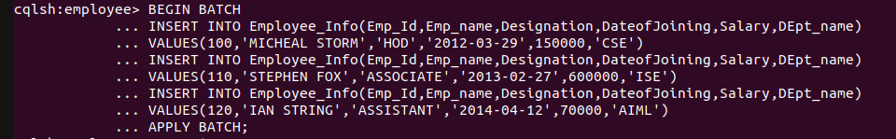

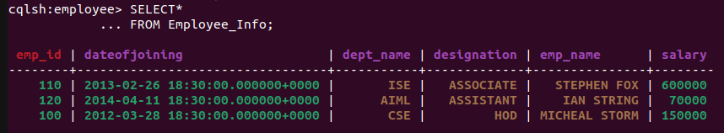

5. Update Employee name and Department of Emp-Id 121



