**Hadoop HDFS- Basic Commands** 1BM21CS080

First to start hadoop services give the following commands:

***start-all.sh***

***jps***



1. To make a new directory and display the directory contents

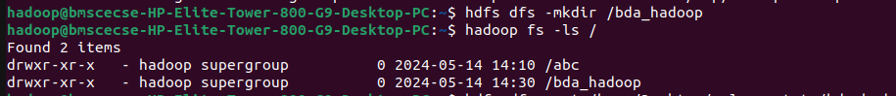

1. Command to use put to copy files from local to bda_hadoop folder
2. Command to use copyFromLocal to copy files from local to bda_hadoop folder
3.  Command to use get to copy files from hadoop folder to local
4.  Command to make a merged file from hadoop and store it in local desktop
5. 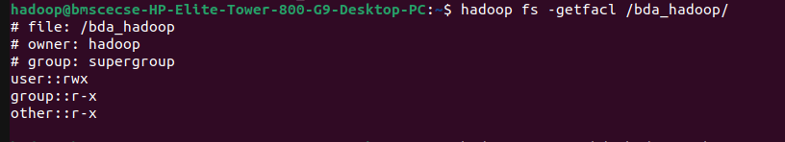 Command to use getfacl to show the access rights
6. 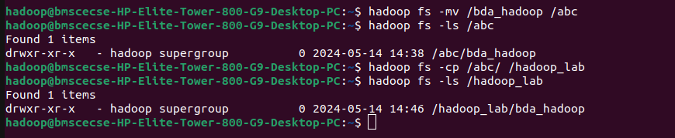 Command to move the contents of a directory to another directory in hadoop