Week 2

Connect Mongodb atlas to shell using the URL provided:

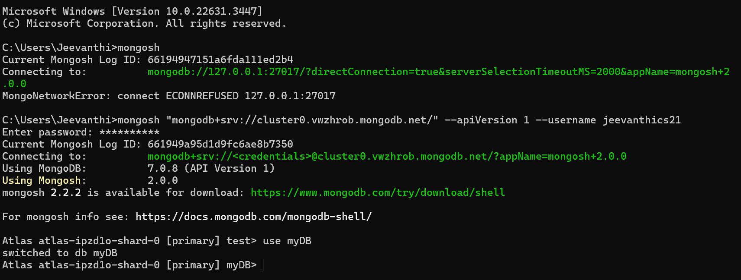

**I. Perform the following DB operations using MongoDB.**

**1. Create a database “Student” with the following attributes Rollno, Age, ContactNo, Email-**

**Id.**

**2. Insert appropriate values**

**3. Write query to update Email-Id of a student with rollno 10.**

**4. . Replace the student name from “ABC” to “FEM” of rollno 11**

Solution:

1. db.createCollection("Student");
2. db.Student.insert({RollNo:1,Age:21,Cont:9876,email:"antara.de9@gmail.com"});

db.Student.insert({RollNo:2,Age:22,Cont:9976,email:"anushka.de9@gmail.com"});

db.Student.insert({RollNo:3,Age:21,Cont:5576,email:"anubhav.de9@gmail.com"});

db.Student.insert({RollNo:4,Age:20,Cont:4476,email:"pani.de9@gmail.com"});

db.Student.insert({RollNo:10,Age:23,Cont:2276,email:"rekha.de9@gmail.com"});

db.Student.find()

OUTPUT:

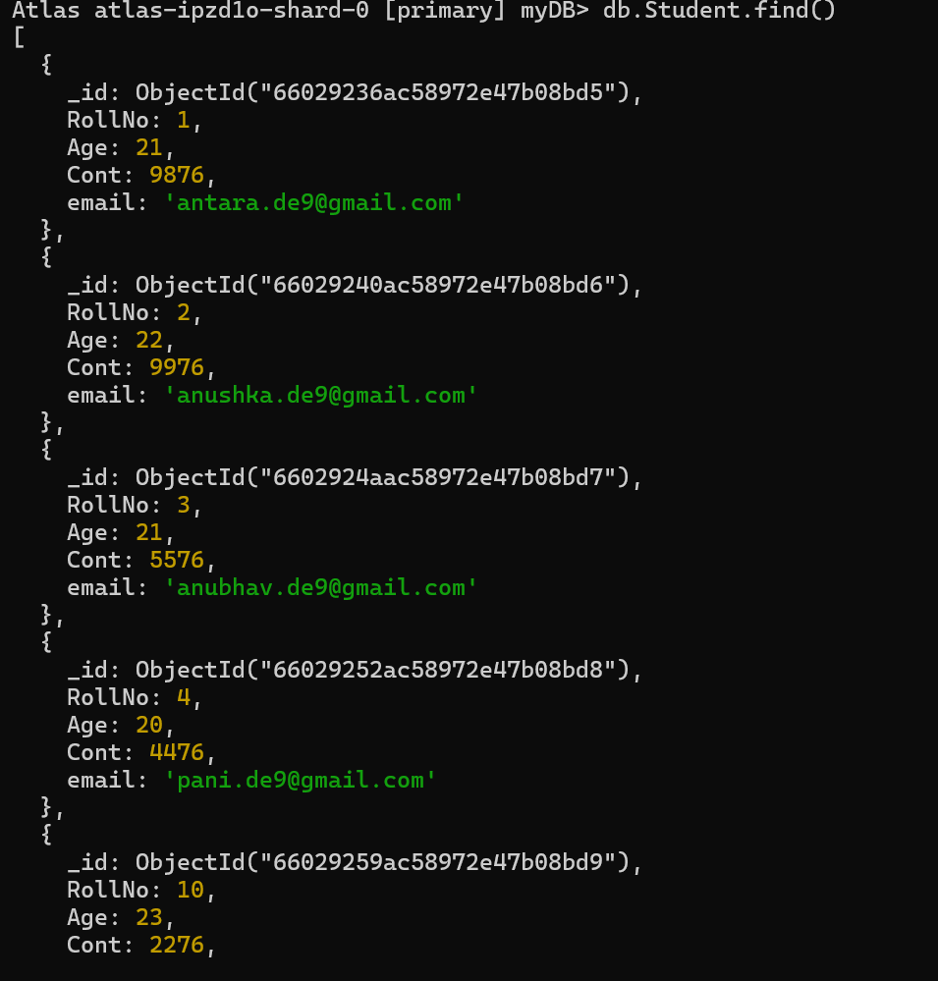

1. db.Student.update({RollNo:10},{$set:{email:"Abhinav@gmail.com"}})

OUTPUT:

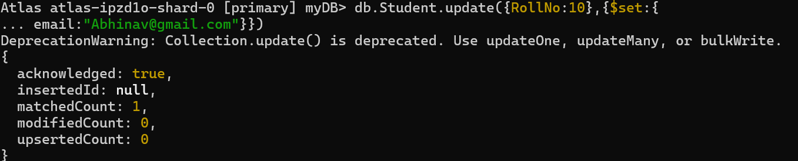

1. db.Student.insert({RollNo:11,Age:22,Name:"ABC",Cont:2276,email:"rea.de9@gmail.com"});

OUTPUT:

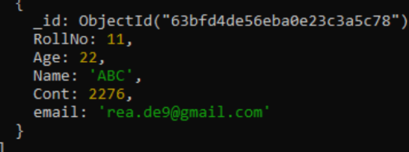

**II. Perform the following DB operations using MongoDB.**

**1. Create a collection by name Customers with the following attributes.**

**Cust_id, Acc_Bal, Acc_Type**

**2. Insert at least 5 values into the table**

**3. Write a query to display those records whose total account balance is greater than**

**1200 of account type ‘Z’ for each customer_id.**

**4. Determine Minimum and Maximum account balance for each customer_i**

**Solution:**

1. > db.createCollection("Customers");
2. db.Customers.insert({cust_id:1,Balance:200, Type:"S"});

db.Customers.insert({cust_id:1,Balance:1000, Type:"Z"})

db.Customers.insert({cust_id:2,Balance:100, Type:"Z"});

db.Customers.insert({cust_id:2,Balance:1000, Type:"C"});

db.Customers.insert({cust_id:2,Balance:500, Type:"C"});

db.Customers.insert({cust_id:2,Balance:50, Type:"S"});

db.Customers.insert({cust_id:3,Balance:500, Type:"Z"});

1. db.Customers.aggregate (

{$match:{Type:"Z"}},

{$group : { _id : "$cust_id",

TotAccBal :{$sum:"$Balance"} } },

{$match:{TotAccBal:{$gt:1200}}});

1. db.Customers.aggregate (

{$group : { _id : "$cust_id",

minAccBal :{$min:"$Balance"},

maxAccBal :{$max:"$Balance"} }});

OUPUTS:

