WEEK-2

**Use an appropriate data set for building the decision tree (ID3) and apply this knowledge to classify a new sample.**

Observation Screenshot:

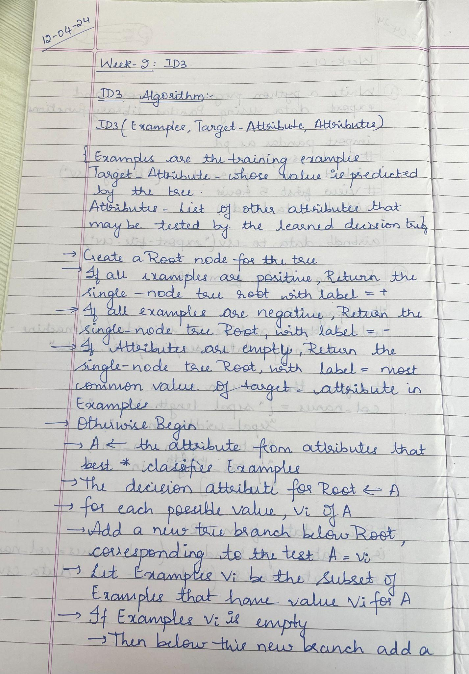

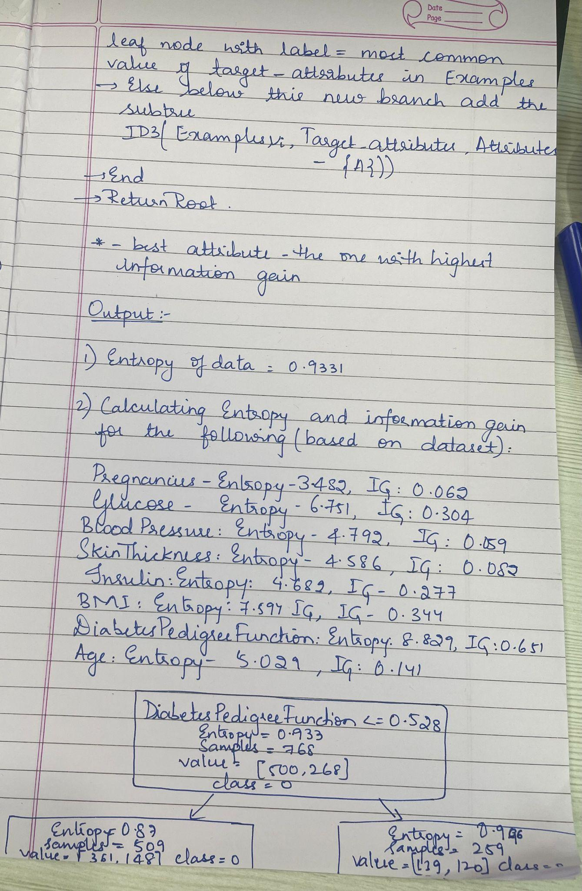

**Code and Output:**

import pandas as pd

from sklearn.tree import DecisionTreeClassifier, plot_tree

import matplotlib.pyplot as plt

import math

df = pd.read_csv('/content/diabetes.csv')

df.head()

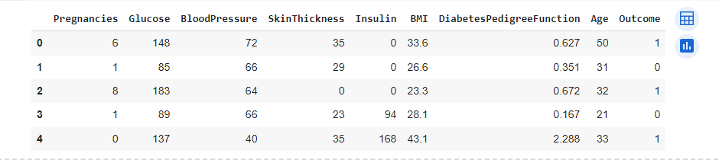

def calculate_entropy(data, target_column):

total_rows = len(data)

target_values = data[target_column].unique()

entropy = 0

for value in target_values:

# Calculate the proportion of instances with the current value

value_count = len(data[data[target_column] == value])

proportion = value_count / total_rows

entropy -= proportion * math.log2(proportion)

return entropy

entropy_outcome = calculate_entropy(df, 'Outcome')

print(f"Entropy of the dataset: {entropy_outcome}")



def calculate_entropy(data, target_column): # for each categorical variable

total_rows = len(data)

target_values = data[target_column].unique()

entropy = 0

for value in target_values:

# Calculate the proportion of instances with the current value

value_count = len(data[data[target_column] == value])

proportion = value_count / total_rows

entropy -= proportion * math.log2(proportion) if proportion != 0 else 0

return entropy

def calculate_information_gain(data, feature, target_column):

# Calculate weighted average entropy for the feature

unique_values = data[feature].unique()

weighted_entropy = 0

for value in unique_values:

subset = data[data[feature] == value]

proportion = len(subset) / len(data)

weighted_entropy += proportion * calculate_entropy(subset, target_column)

# Calculate information gain

information_gain = entropy_outcome - weighted_entropy

return information_gain

for column in df.columns[:-1]:

entropy = calculate_entropy(df, column)

information_gain = calculate_information_gain(df, column, 'Outcome')

print(f"{column} - Entropy: {entropy:.3f}, Information Gain: {information_gain:.3f}")

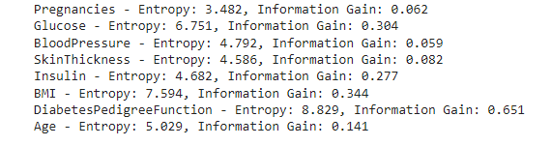

# Feature selection for the first step in making decision tree

selected_feature = 'DiabetesPedigreeFunction'

# Create a decision tree

clf = DecisionTreeClassifier(criterion='entropy', max_depth=1)

X = df[[selected_feature]]

y = df['Outcome']

clf.fit(X, y)

plt.figure(figsize=(8, 6))

plot_tree(clf, feature_names=[selected_feature], class_names=['0', '1'], filled=True, rounded=True)

plt.show()

