# POWERBI REPORT ANALYSIS



# Files

## s1

# s1

# SCHEMA

### TABLE NAME. : financials

|  |  |
| --- | --- |
| COLUMNS | DATA TYPES |
| Segment | string |
| Country | string |
| Product | string |
| Discount Band | string |
| Units Sold | double |
| Manufacturing Price | int64 |
| Sales | double |
| COGS | double |
| Profit | double |
| Date | dateTime |
| Month Number | int64 |
| Month Name | string |
| Year | int64 |

### MODE : import

### M CODE :

let

Source = Excel.Workbook(File.Contents("C:\Users\jeevan.v\Downloads\Financial Sample.xlsx"), null, true),

financials_Table = Source{[Item="financials",Kind="Table"]}[Data],

#"Changed Type" = Table.TransformColumnTypes(financials_Table,{{"Segment", type text}, {"Country", type text}, {"Product", type text}, {"Discount Band", type text}, {"Units Sold", type number}, {"Manufacturing Price", Int64.Type}, {" Sales", type number}, {"COGS", type number}, {"Profit", type number}, {"Date", type date}, {"Month Number", Int64.Type}, {"Month Name", type text}, {"Year", Int64.Type}})

in

#"Changed Type"

# REPORT NO. : 1

### REPORT NAME. : Page 1

# LAYOUT

### REPORT LAYOUT IMAGE

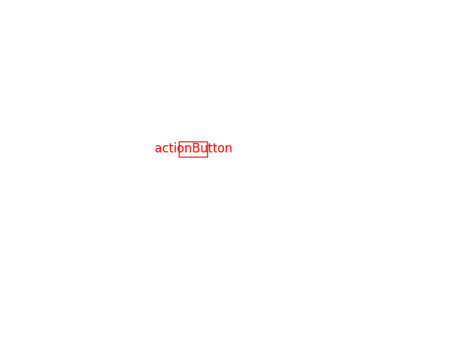

# Canvas settings

* **height :**  720
* **width :**  1280

# Wallpaper settings

## CONTAINER_1

* **CONTAINER_TITLE :**  actionButton_container
* **VISUAL_TYPE :**  actionButton
* **Size**
* **WIDTH :**  100.17186217524582
* **HEIGHT :**  39.79430141208395
* **POSITION**
* **X :**  426.75957721234863
* **Y :**  266.21015427394093
* **background_color_id :**  5
* **background_color_id_per :**  0
* **background_show :**  true
* **background_transparency :**  4D
* **border_color_id :**  8
* **border_color_id_per :**  0.2
* **border_radius :**  5D
* **border_show :**  true
* **dropShadow_angle :**  229D
* **dropShadow_color_id :**  4
* **dropShadow_color_id_per :**  -0.5
* **dropShadow_preset :**  'Custom'
* **dropShadow_shadowBlur :**  14D
* **dropShadow_shadowDistance :**  13D
* **dropShadow_shadowSpread :**  6D
* **dropShadow_show :**  true
* **dropShadow_transparency :**  73D
* **fill_fillColor_id :**  2
* **fill_fillColor_id_per :**  0
* **fill_image_name :**  'settings_icon.png'
* **fill_image_scaling :**  'Fit'
* **fill_image_url :**  settings_icon9775040535522799.png
* **fill_show :**  true
* **fill_transparency :**  52D
* **general_altText :**  'azwsxcdrfgvthbyju'
* **glow_color_id :**  6
* **glow_color_id_per :**  0.2
* **glow_shadowBlur :**  46D
* **glow_show :**  true
* **glow_transparency :**  8D
* **icon_bottomMargin :**  8L
* **icon_iconSize :**  20D
* **icon_leftMargin :**  7L
* **icon_lineColor_id :**  9
* **icon_lineColor_id_per :**  0
* **icon_lineTransparency :**  6D
* **icon_lineWeight :**  7L
* **icon_placement :**  'right'
* **icon_rightMargin :**  7L
* **icon_shapeType :**  'rightArrow'
* **icon_topMargin :**  7L
* **outline_lineColor_id :**  4
* **outline_lineColor_id_per :**  -0.25
* **outline_show :**  true
* **outline_transparency :**  7D
* **outline_weight :**  6D
* **rotation_angle :**  3L
* **rotation_shapeAngle :**  5L
* **rotation_textAngle :**  ['4L']
* **shadow_color_id :**  9
* **shadow_color_id_per :**  0
* **shadow_shadowBlur :**  22D
* **shadow_shadowPositionPreset :**  'bottom'
* **shadow_show :**  true
* **shadow_transparency :**  72D
* **shape_arrowStemWidth :**  28L
* **shape_arrowheadSize :**  52L
* **shape_chevronAngle :**  91L
* **shape_hexagonSlant :**  46L
* **shape_roundEdge :**  87L
* **shape_tileShape :**  'octagon'
* **text_bold :**  ['true']
* **text_bottomMargin :**  ['5L']
* **text_fontColor_id :**  [4]
* **text_fontColor_id_per :**  [-0.25]
* **text_fontFamily :**  ["'''Segoe UI Bold'', wf_segoe-ui_bold, helvetica, arial, sans-serif'"]
* **text_fontSize :**  ['12D']
* **text_horizontalAlignment :**  ["'center'"]
* **text_italic :**  ['true']
* **text_leftMargin :**  ['5L']
* **text_rightMargin :**  ['5L']
* **text_show :**  ['true']
* **text_text :**  ["'edeef'"]
* **text_topMargin :**  ['5L']
* **text_underline :**  ['true']
* **text_verticalAlignment :**  ["'top'"]
* **title_alignment :**  'center'
* **title_background_id :**  2
* **title_background_id_per :**  0
* **title_bold :**  true
* **title_fontColor_id :**  2
* **title_fontColor_id_per :**  0.6
* **title_fontFamily :**  '''Arial Black'''
* **title_fontSize :**  17D
* **title_heading :**  'Normal'
* **title_italic :**  true
* **title_show :**  true
* **title_text :**  ["'cggvbhjnmk,l'"]
* **title_underline :**  true
* **visualHeaderTooltip_bold :**  true
* **visualHeaderTooltip_fontFamily :**  '''Segoe UI Bold'', wf_segoe-ui_bold, helvetica, arial, sans-serif'
* **visualHeaderTooltip_fontSize :**  13D
* **visualHeaderTooltip_italic :**  true
* **visualHeaderTooltip_text :**  ["'tedxdcfvgybhnji'"]
* **visualHeaderTooltip_themedBackground_id :**  0
* **visualHeaderTooltip_themedBackground_id_per :**  -0.2
* **visualHeaderTooltip_themedTitleFontColor_id :**  3
* **visualHeaderTooltip_themedTitleFontColor_id_per :**  -0.25
* **visualHeaderTooltip_transparency :**  6D
* **visualHeaderTooltip_type :**  'Canvas'
* **visualHeaderTooltip_underline :**  true
* **visualHeader_background_id :**  5
* **visualHeader_background_id_per :**  0
* **visualHeader_border_id :**  0
* **visualHeader_border_id_per :**  -0.2
* **visualHeader_foreground_id :**  0
* **visualHeader_foreground_id_per :**  0
* **visualHeader_show :**  true
* **visualHeader_showTooltipButton :**  true
* **visualHeader_transparency :**  7D
* **visualLink_show :**  true
* **visualLink_tooltip :**  'utdftdyrdyr'
* **visualLink_type :**  'Bookmark'