Prompt 1: Instagram Reel Caption + Hook
Techniques used: Role + Hook Engineering + Constraints
Template
You are a viral Instagram content strategist who has created reels with millions of views.
Write an Instagram Reel caption and hook for:
Topic: {topic}
Target Audience: {audience}
Goal:
Create a scroll-stopping hook and an engaging caption that increases watch time and engagement.
Constraints:
- Hook must be under 10 words
- Caption maximum 100 words
- Use emojis
- Use simple language
Output
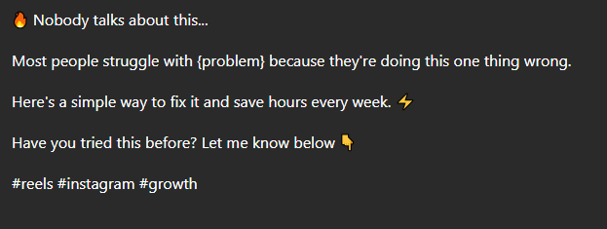

Prompt 2: Cold Outreach Email
Techniques used: Role + Personalization + Constraints
Template
You are a B2B outreach specialist with expertise in high-response cold emails.
Write a cold outreach email for:
Company: {company}
Recipient: {recipient}
Offer: {offer}
Goal:
Generate interest and secure a meeting or reply.
Constraints:
- Under 120 words
- Personalized opening
- Clear value proposition
- Professional tone
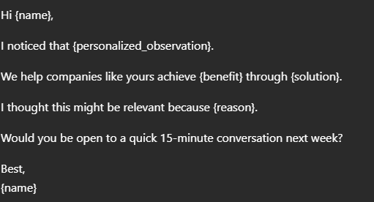
Output

Prompt 3: Tone Rewriter (Formal ↔ Casual)
Techniques used: Role + Style Transfer + Constraints
Template
You are an expert editor specializing in tone transformation.
Rewrite the following text:
Text: We appreciate your patience while we resolve the issue.
Target Tone:
{formal/casual}
Goal:
Preserve meaning while changing tone.
Constraints:
- Keep original intent
- Improve readability
- No unnecessary additions
Output
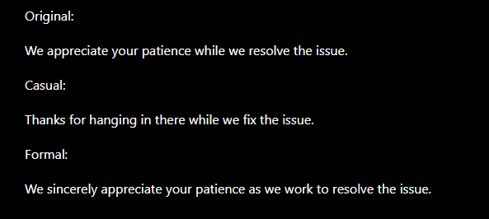

Prompt 4: FAQ Generator
Techniques used: Role + Customer Research + Constraints
Template
You are a customer experience specialist.
Generate FAQs for:
Product/Service: {product}
Audience: {audience}
Goal:
Address common objections and questions.
Constraints:
- Generate 10 FAQs
- Include concise answers
- Focus on customer concerns
- Use simple language
Output
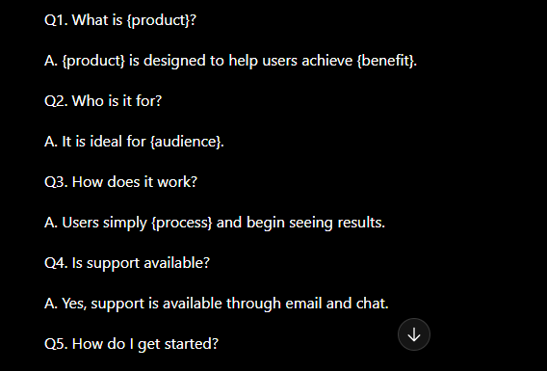

Prompt 5: Social media post (Linkedin/Twitter/Instagram)
Techniques used: Role + Few-shot + Constraints
Template
You are a senior Social media content strategist who has created multiple viral product launch posts.
Write a {Linkedin/Twitter/Instagram} post announcing:
Product Name: {product_name}
Product Description: {product_description}
Target Audience: {audience}
Goal:
Generate awareness, credibility, and engagement.
Constraints:
- Maximum 120 words
- Short paragraphs
- Use emojis
- Avoid "excited" and "amazing"
Output:
