**Experiment No:3**

**Aim**:

Familiarization of Linux Commands.

**CO2**:

Perform system administration tasks.

**Procedure**

1. pwd: print working directory

Output



1. ls: to view the contents of the directory

output



1. ls –R: list all the files in the subdirectory

Output

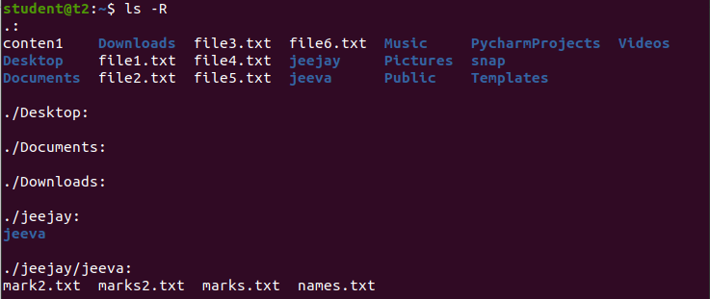

1. ls –l: long list details of the directory

Output

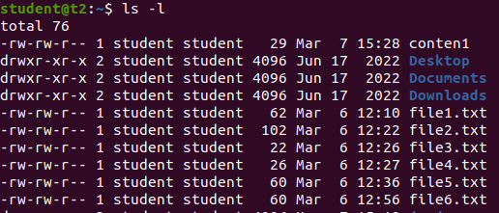

1. ls –a: to view the hidden files in the directory

Output



1. ls –al: list the files and directory with detailed information

Output

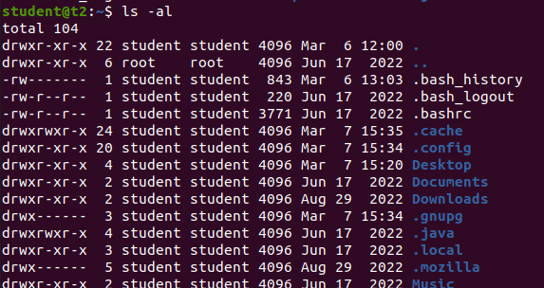

1. ls -t: to list the contents in the order of last modified.

Output



1. ls -r: to list the contents in the natural sorting order

Output

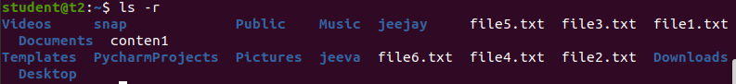

1. history: to view the history of the commands in a certain period of time.

Output

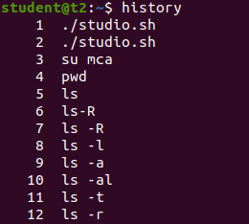

1. man ls: to list all the commands of ls. It is a supporting command

Output

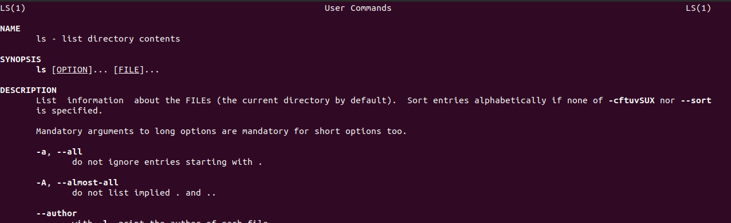

1. mkdir *directoryName* : make directory/to create new directory.

Output



1. rmdir *directoryName* : to remove the directory.

Output



1. touch: to create a new blank file.

Output



1. cat >>*filename*: to append new contents to a new or existing file.

Output

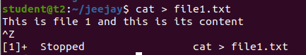

1. cat *file1 file2* > *file3*: to copy and add files from first two files to a new file.

Output

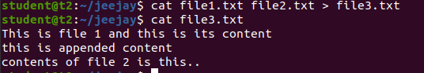

1. cat –n: to display the contents with line number.

Output



1. cat –b: to remove numbering for empty lines

Output

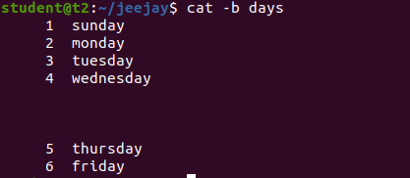

1. cat –e: to display $ character at the end of each line

Output

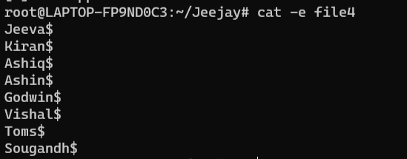

1. *filename |* tr a-z A-Z >*newfile*: to convert/ display all the contents in the capital/uppercase letters.

Output

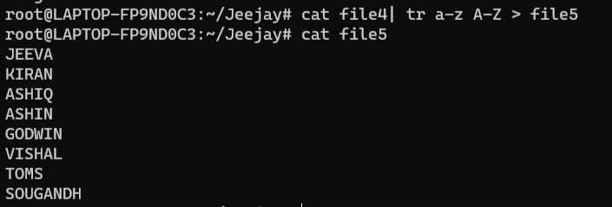

**Experiment No:4**

**Aim**:

Familiarization of Linux Commands.

**CO2**:

Perform system administration tasks.

**Procedure:**

1. cut –b1: to cut first bite letters

Output

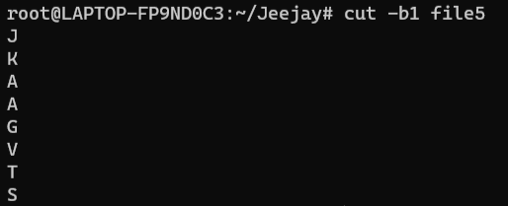

1. cut –d - -f1 filename: used d limiter to cut the contents at ‘-‘ in the first column which is given by –f1.

Output

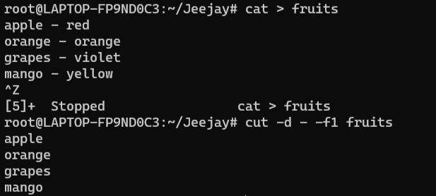

1. cut –c 1,3: to cut the letters or bites in a specified position.

Output

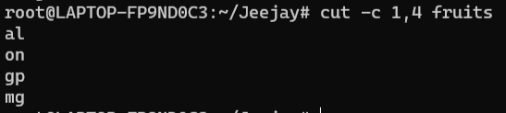

1. paste file1 file2: to paste the contents in file1 to file2.

Output

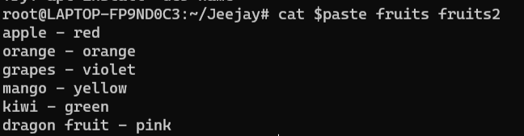

1. paste file1 file2 > file3: to paste the contents from first 2 files to a new file.

Output

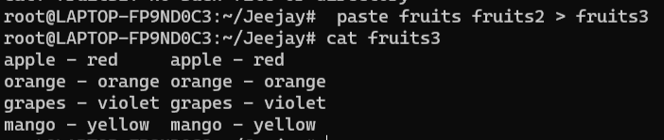

1. paste –d ‘%’ file1 file2: to paste % with d limiter in all the contents in the file.

Output

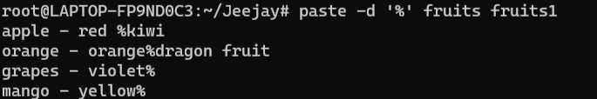

1. paste -s filename: to show all contents in a single line.

Output

