Core Security Concepts Explainer
The CIA Triad, Authentication vs Authorization, and Encryption vs Hashing — explained through real-world scenarios
This guide walks through five core cybersecurity concepts using concrete, step-by-step scenarios rather than one-line analogies. Every technical term is explained the moment it's used, so no prior security background is needed.

Introduct ion
Cybersecurity can sound like an alphabet soup of acronyms, but almost everything in the field traces back to a small set of core ideas. This document covers five of them:
- Confidentiality — keeping information away from people who shouldn't see it
- Integrity — keeping information accurate and unaltered
- Availability — keeping systems accessible to the people who legitimately need them
- Authentication vs Authorization — proving who you are, versus what you're allowed to do
- Encryption vs Hashing — two different ways of transforming data, for two different purposes
The first three together form what's known as the CIA Triad — a model security professionals use to reason about almost any risk. Instead of just defining each concept, this document walks through one detailed, concrete scenario per concept, showing exactly how it plays out (or breaks down) in practice, plus an original diagram for each.

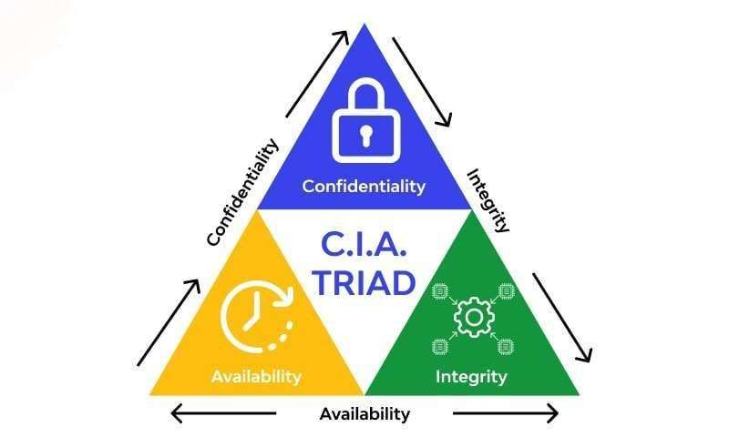

1. Confidentiality
2. Integrity
3.Availability

The CIA Triad
The CIA Triad is a foundational security model made up of three goals every secure system tries to balance: Confidentiality, Integrity, and Availability. A weakness in any one of the three counts as a security problem, even if the other two are fine.

1. Confidentiality

Confidentiality means information is only visible to the people who are supposed to see it. It's violated the moment an unauthorized party — whether an outside attacker or another regular user — can view data they have no right to.

Scenario: A hospital patient portal leaks other patients' records.
A hospital launches a patient portal so people can log in and view their own lab results, prescriptions, and doctor's notes online. Alice, a patient, logs in and sees her record loaded at a web address that looks like:
Out of curiosity, Alice edits the number in that address to id=1002 and presses Enter. Instead of an error message, another patient's full record — a stranger named Bob's diagnosis, medications, and Social Security number — loads right in front of her.

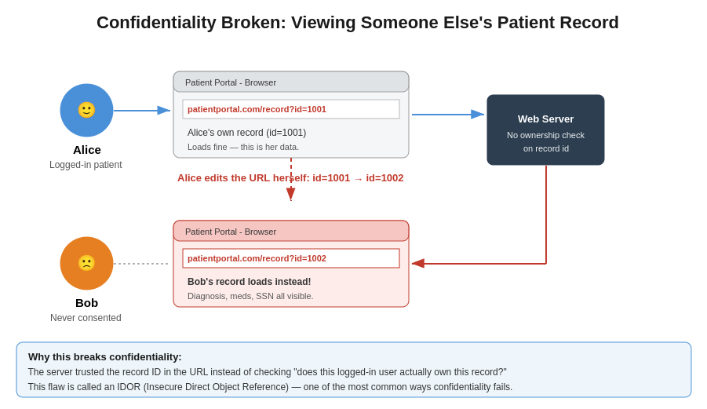
What went wrong: the server checked whether the request had a valid, logged-in session, but it never checked whether the specific record being requested actually belonged to the person asking for it. Any authenticated user could view any other user's data just by changing a number in the URL. Security professionals call this specific flaw an IDOR (Insecure Direct Object Reference) — one of the most common real-world causes of confidentiality breaches, and one that has affected real healthcare, banking, and government portals.

Figure 1 — How a missing ownership check lets Alice view Bob's private medical record simply by changing a URL parameter.
confidentiality failures like this don't require any hacking skill — just curiosity and a browser. That's exactly why they're so common and so damaging: sensitive health, financial, or personal data ends up exposed to anyone willing to try. The fix is for the server to always check "does the logged-in user actually own this specific piece of data?" before returning it — not just "is this user logged in at all?"

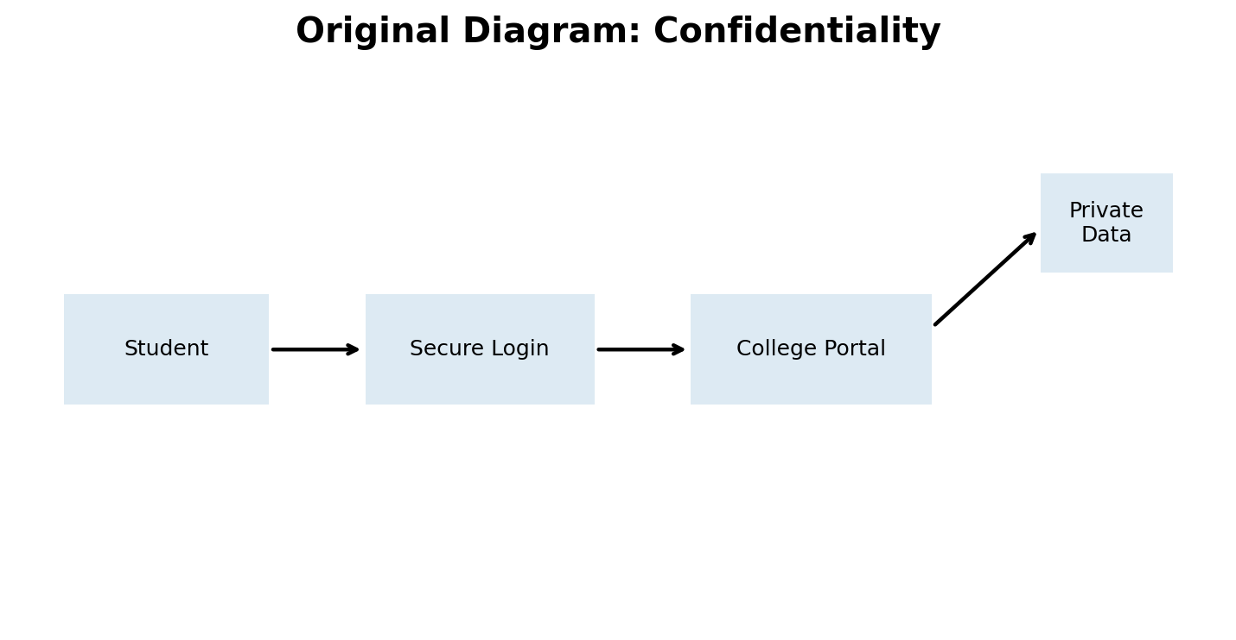

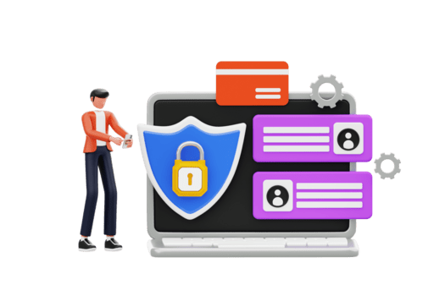
Why it matters
Loss of confidentiality can expose personal information and may lead to privacy problems, identity theft, or further attacks. Organizations therefore restrict access and protect sensitive information.

2. Integrity
Integrity means data stays accurate and unaltered as it moves or is stored — and that if it is changed, the change is detected. It's not about who can see the data (that's confidentiality); it's about whether the data can be trusted to be correct.

Scenario: A bank transfer is altered on public Wi-Fi
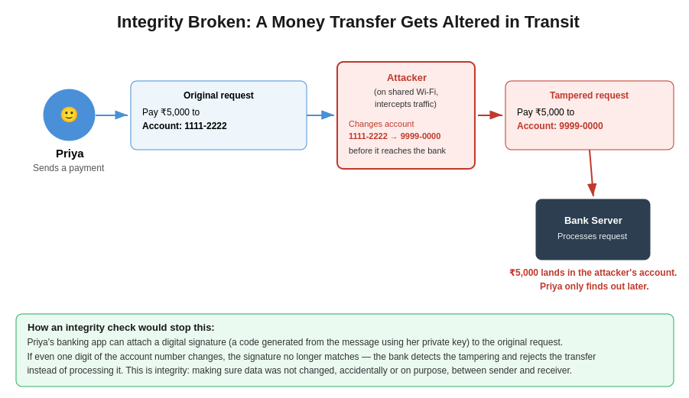
Priya sits in a coffee shop and uses the shop's free Wi-Fi to send a ₹5,000 payment to a friend's account, 1111-2222, through her bank's mobile app. Unknown to her, an attacker on the same Wi-Fi network is intercepting traffic between her phone and the bank's servers — a classic man-in-the-middle position. Before her transfer request reaches the bank, the attacker silently edits the destination account number in the request from 1111-2222 to their own account, 9999-0000.
The bank's server receives the request exactly as the attacker sent it, sees nothing unusual, and processes the ₹5,000 payment to the attacker's account instead of Priya's friend. Priya only discovers the problem later, when her friend says the money never arrived.
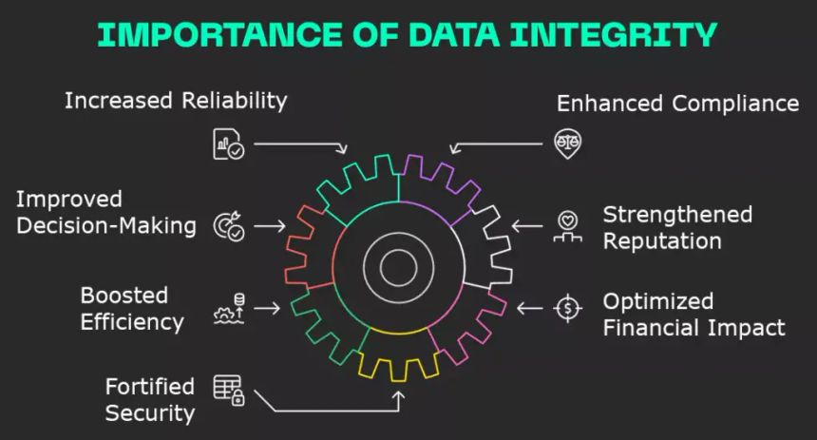
this scenario shows integrity being violated without confidentiality necessarily being broken at all — the attacker didn't need to read Priya's other private data, just tamper with one field in transit. Real systems defend against this with a digital signature: a unique code the sending app generates from the exact contents of the message, using a private key only Priya's app knows. If even a single digit of the account number changes after the signature is generated, recomputing the signature on the bank's end no longer matches, and the bank can reject the tampered request instead of processing it.

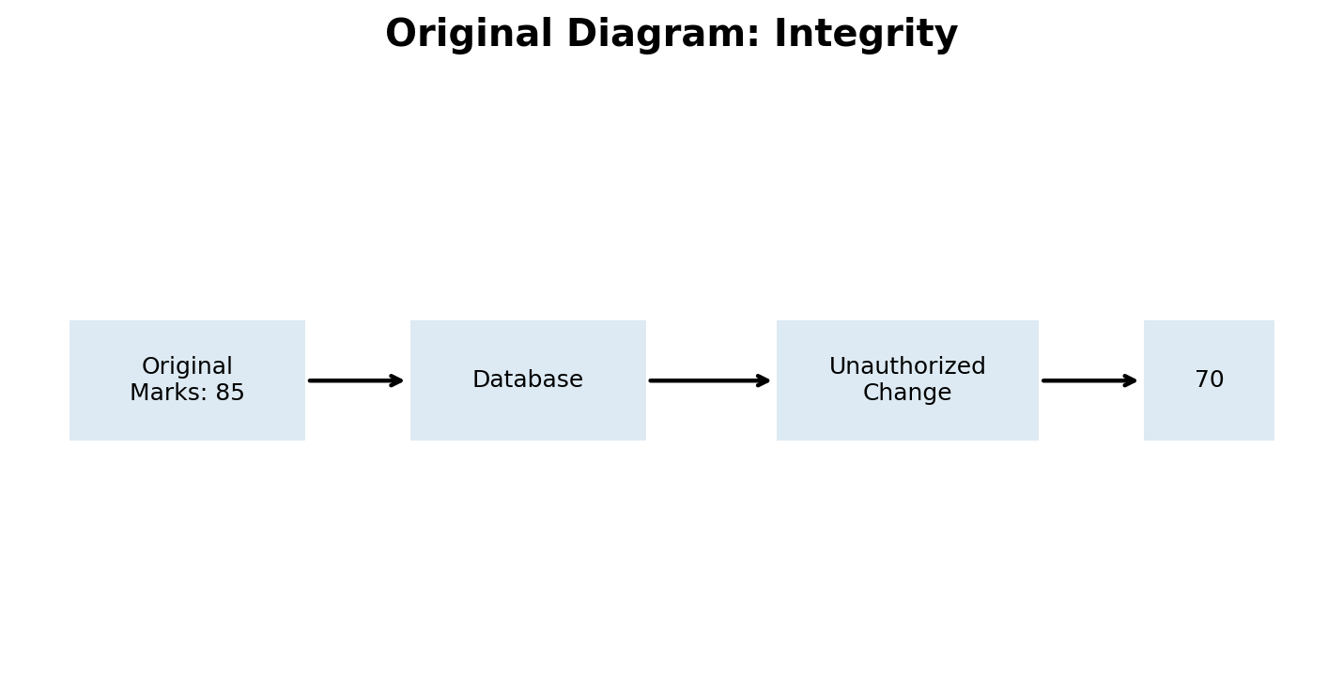

Why it matters
Integrity is important wherever decisions depend on correct information. Marks, bank balances, medical records, invoices, and configuration files all need to remain accurate. Access controls, audit logs, checksums, and hashing can help detect or prevent unauthorized changes.

3. Availability
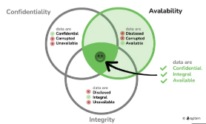
Availability means that systems, data, and services are accessible to legitimate users whenever they need them. A system can be perfectly confidential and have perfect integrity, and still fail this third goal if real users simply can't get in.

Scenario: An online store goes down during a Black Friday sale
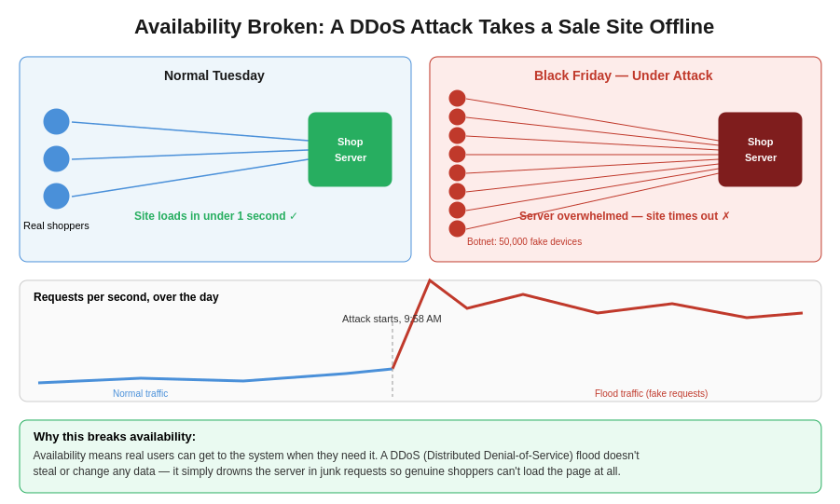
An e-commerce store normally handles a modest, steady stream of shoppers on an average Tuesday — a few hundred people browsing and checking out per minute, comfortably within what its servers can handle. On Black Friday morning, at 9:58 AM, traffic to the site suddenly spikes to levels far beyond anything a normal shopping rush could produce.
It turns out the spike isn't real customers — it's a DDoS attack (Distributed Denial-of-Service), where an attacker uses a botnet (a network of thousands of hijacked or fake devices) to flood the store's servers with junk requests all at once. The servers, unable to tell the flood apart from legitimate traffic quickly enough, become overwhelmed. Real shoppers trying to check out get spinning loading icons and timeout errors, and the site is effectively offline during its busiest — and most profitable — hour of the year.
Why it matters: notice that nothing was stolen and no data was altered — confidentiality and integrity are both intact. The only thing that failed is availability, but the business impact (lost sales, reputational damage) can be just as severe as a data breach. Defenses include content delivery networks (CDNs) that absorb and spread out traffic across many servers, rate limiting that caps how many requests a single source can make, and dedicated DDoS-mitigation services that can detect and filter out flood traffic before it reaches the real servers.

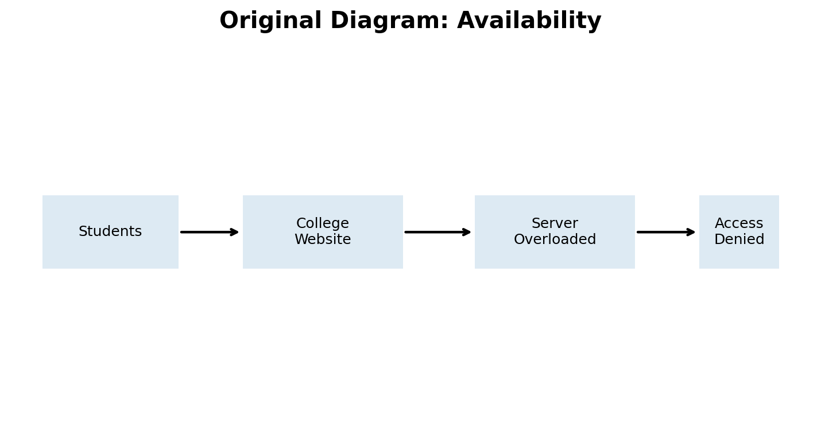

Why it matters
Availability matters for websites, online classes, banking, emergency services, and business systems. Backups, redundant servers, monitoring, capacity planning, and protection against denial-of-service attacks can help keep services running.

4. Authentication vs Authorization
These two terms get confused constantly because they usually happen back-to-back, but they answer completely different questions:
- Authentication asks: "Who are you?" — proving identity.
- Authorization asks: "What are you allowed to do?" — enforcing permissions, once identity is already known.
A system can authenticate someone perfectly and still fail badly if its authorization step is broken.

Scenario: An office keycard that identifies correctly but grants the wrong access
Rahul, a junior financial analyst, badges into his office building with his company keycard.
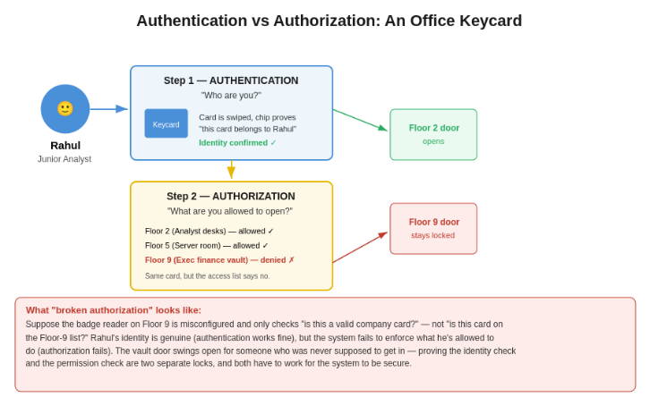
Step 1 — Authentication: The turnstile's card reader checks the chip embedded in Rahul's card and confirms "this card genuinely belongs to Rahul, a current employee" — his identity is verified against the company's records. This step succeeds.
Step 2 — Authorization: Once Rahul's identity is confirmed, a separate system checks an access list to decide which doors his card can actually open. Rahul's card is authorized for Floor 2 (his team's desks) and Floor 5 (the general server room), but explicitly denied for Floor 9, which houses the executive finance vault.
Now imagine the Floor 9 door's badge reader is misconfigured: instead of checking Rahul's card against the Floor-9 access list, it only checks "is this a valid, currently active company card at all?" Since Rahul's card passes that weaker check, the vault door swings open for him — even though he was never supposed to have access. His identity was never in question; the system's failure was entirely in enforcing what he was permitted to do. This is called a broken access control or privilege escalation vulnerability, and it's a distinct failure from anything to do with authentication.

Why it matters:
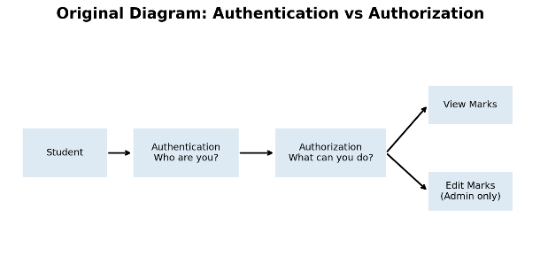
this distinction shows up everywhere in software, not just physical buildings. Logging into a website with a username and password is authentication. Whether that logged-in account can view its own profile, or an admin dashboard, or another user's private messages, is authorization. A huge share of real-world data breaches happen not because attackers broke the login, but because a properly logged-in, low-privilege account was ableto reach data or actions it should never have been authorized for.

Why it matters
Keeping the two ideas separate helps organizations enforce least privilege, meaning users receive only the access they need. Strong authentication protects accounts, while correct authorization prevents legitimate accounts from performing actions they should not be able to perform.

5. Encryption vs Hashing
Both encryption and hashing scramble data into something unreadable, which is why beginners often mix them up — but they exist for opposite purposes:
- Encryption is reversible: anyone holding the right key can turn the scrambled data back into the original. Used when the original data legitimately needs to be recovered later.
- Hashing is one-way: the scrambled output (a "hash") cannot be turned back into the original input, by design — there is no key that reverses it. Used when you only ever need to check whether two pieces of data match, never recover the original.

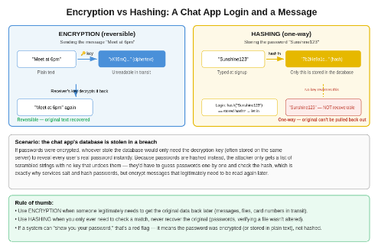
Scenario: A chat app protects a login password and a live message differently
A messaging app needs to handle two very different pieces of sensitive data, and it treats them differently on purpose.
Sending a message (encryption): When someone types "Meet at 6pm" and hits send, the app encrypts it into unreadable ciphertext, something like "xK9$mQ...", using a key shared with the recipient's device. This ciphertext travels across the internet looking like gibberish to anyone intercepting it. When it reaches the recipient's phone, their matching key decrypts it back into the original readable text, "Meet at 6pm". This has to be reversible, because the whole point is for the recipient to read the real message.
Storing a password (hashing): When a user signs up with the password "Sunshine123", the app never stores that password directly. Instead, it runs it through a hash function that produces a fixed-length scrambled string, something like "7b2f4e9a1c...", and only that hash is saved in the database. There is no key anywhere that turns "7b2f4e9a1c..." back into "Sunshine123" — the transformation is deliberately one-directional. When the user logs in later, the app just hashes whatever password they type and checks if it matches the stored hash; it never needs to know or recover the actual original password.
Why the difference matters — a data breach scenario: suppose an attacker steals the app's entire database. If passwords had been encrypted instead of hashed, the attacker would only need to also get hold of the decryption key (which is often stored somewhere accessible to the server itself) to instantly reveal every single user's real password. Because passwords are hashed, the attacker instead gets a list of one-way scrambled strings with no key that undoes them; the only way to guess a matching password is to try candidate passwords one at a time and see if their hash matches, which well-designed hashing (with extra techniques like salting, adding random data to each password before hashing) makes slow and expensive at scale.
A simple rule of thumb: if a service can ever email you your existing password or display it back to you in plain form, that's a red flag — it means your password was encrypted or, worse, stored in plain text, not properly hashed.

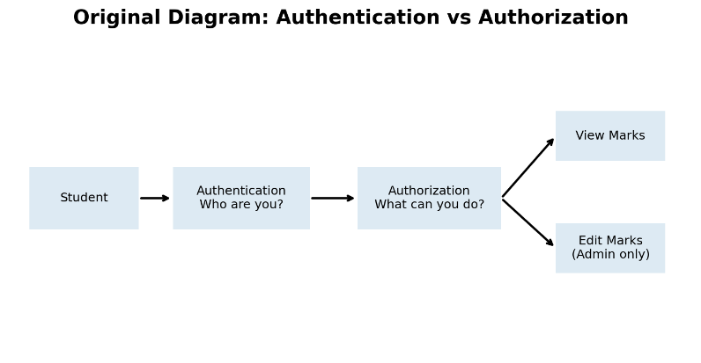
Why it matters
Encryption is useful when data needs to be recovered by an authorized party, such as a message that must be read later. Hashing is useful when a system needs to verify data without storing the original value, especially for passwords. They solve different security problems and should not be treated as interchangeable.

Summary
Quick reference
Confidentiality — only the right people can see the data (broken by the hospital portal's missing ownership check).
Integrity — data can't be silently changed (broken by the attacker altering Priya's transfer in transit).
Availability — legitimate users can access the system (broken by the DDoS flood on Black Friday).
Authentication vs Authorization — proving who you are is not the same as controlling what you can do (Rahul's keycard).
Encryption vs Hashing — reversible scrambling for data you need back (messages) vs. one-way scrambling for data you only need to check (passwords).

Conclusion
The CIA Triad provides a simple foundation for understanding cybersecurity: protect information from unauthorized viewing, prevent unauthorized changes, and keep systems available to legitimate users. Authentication and authorization control identity and permissions, while encryption and hashing provide different ways to protect and verify information. Understanding these concepts makes it easier to understand more advanced cybersecurity topics later.

