TryHackMe – Networking Fundamentals

Task 1: CTF Challenge Walkthroughs (TryHackMe)

Student Name: Jeeva vijayan
Department: CSE – AI & ML
reg.no.RA2611026020314
Date: 19 September 2026
TryHackMe Profile: tryhackme.com/p/jeevavijayan2102

1. Introduction
This report provides my walkthrough and learning experience of two networking rooms available on TryHackMe platform, namely "What is Networking?" and "Intro to Networking?". The objective of the exercise was to learn some basic principles of networking and their application in a virtual cybersecurity lab.
Through the practical activities, I got the opportunity to combine the theory with practice in terms of networking and cybersecurity. This report has distinguished the actions that I did from concepts that I learned.

2. Objectives
- Understand the basic concepts of computer networking.
- Learn how devices communicate and exchange information over networks.
- Understand IP addresses, MAC addresses, ports, packets, and protocols.
- Become familiar with common networking protocols and their purposes.
- Understand the basic roles of DNS, HTTP/HTTPS, TCP, and UDP.
- Gain practical experience using the TryHackMe platform.
- Improve technical documentation and cybersecurity problem-solving skills.

3. Room 1 – What is Networking?

3.1 Room Overview
In the room 1 “what is networking?” basic networking principles are introduced. The way devices communicate and exchange information on a network is described. Also, the basics of networks, IP addresses, MAC addresses, packets, protocols, and network testing are introduced.

3.2 What I Did – Step-by-Step
1.I logged into my TryHackMe account and clicked on the specific room that I was to work on: “What is Networking?”.
2.I went through the information provided in the room. 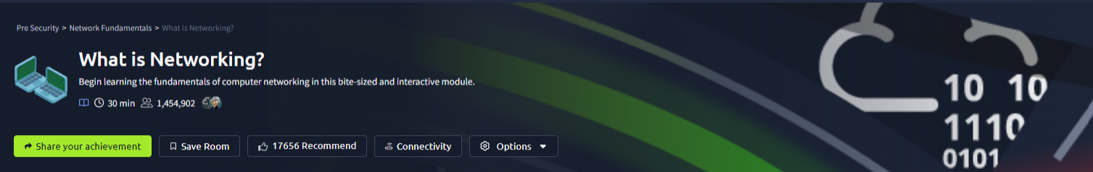
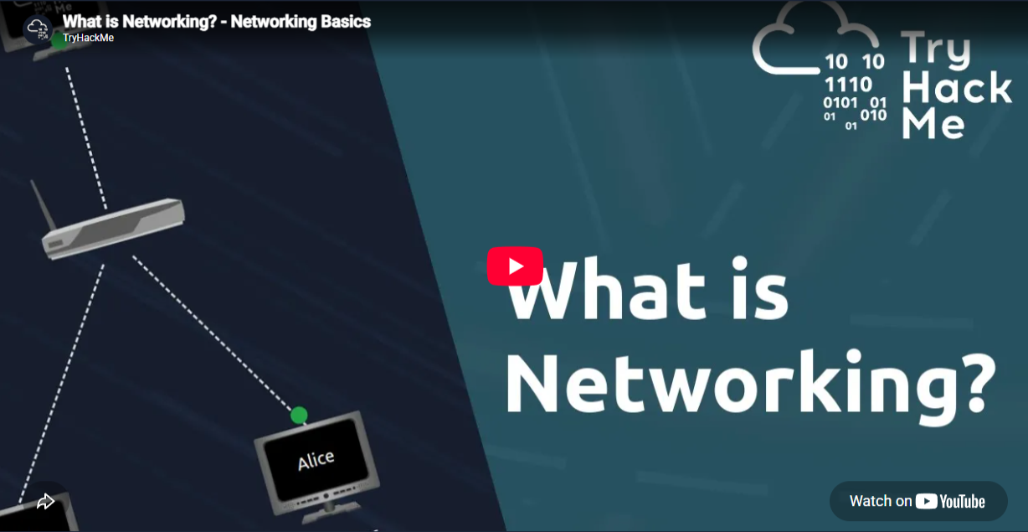
3I watched the embedded YouTube video covering fundamental networking concepts
4. I analyzed the network concepts provided in the beginning section.
5. I analyzed how different devices were connected with each other and how they communicate
6.I analyzed the basics of IP addresses and what they are meant for.
7.I gained information regarding IPv4 and IPv6 addresses and their characteristics. I also learned the purpose of MAC addresses in network communication.

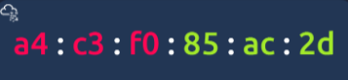
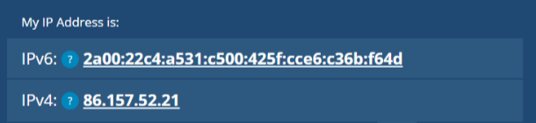

8. I researched how data is divided into small packets and sent over the network. I studied the protocols that are used in networks and what they are meant for.
9. I used the information provided in the room to answer the questions. I answered the tasks provided in the room.
10.I confirmed my answers and moved ahead to the other sections.

3.3 Screenshots – Key Progress

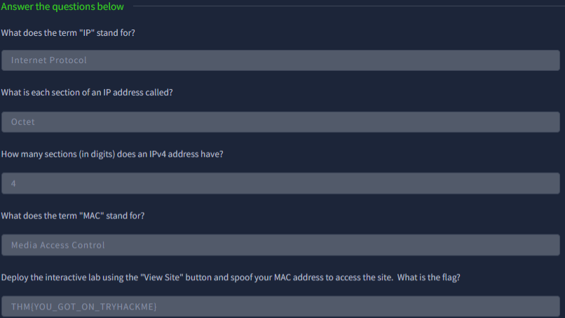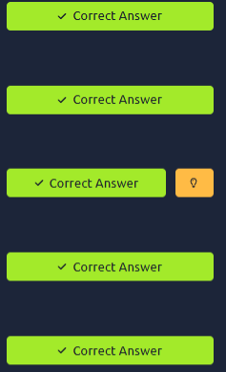
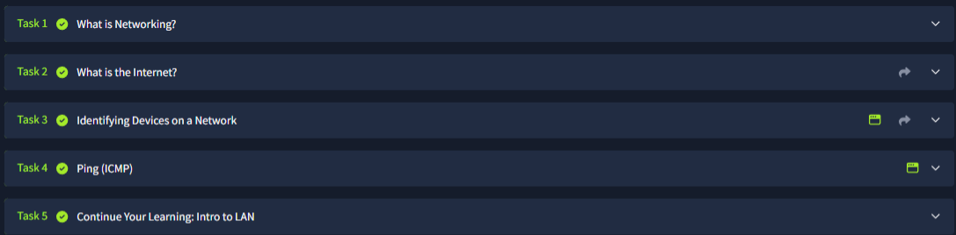

3.4 What I Learned
- From this discussion, it was apparent to me that a computer network helps in connecting multiple devices to allow communication between them. I understood that IP addresses help in providing logical addressing for network communication, and that MAC addresses are specific to network interfaces. Further, I learned that protocols help in defining the rules of communication and that packets are the data units used in communication.
- This reinforced and expanded upon foundational concepts I had previously studied
- - A network helps in connecting multiple devices for communication.
- - IP addresses help in logical addressing for network communication.
- - MAC addresses are specific to network interfaces.
- - Protocols define the rules of communication.
- - Packets are the data units used in network communication.
- ICMP Echo request (Ping) can be used to check communication between the networked devices.

Completion of room screenshot
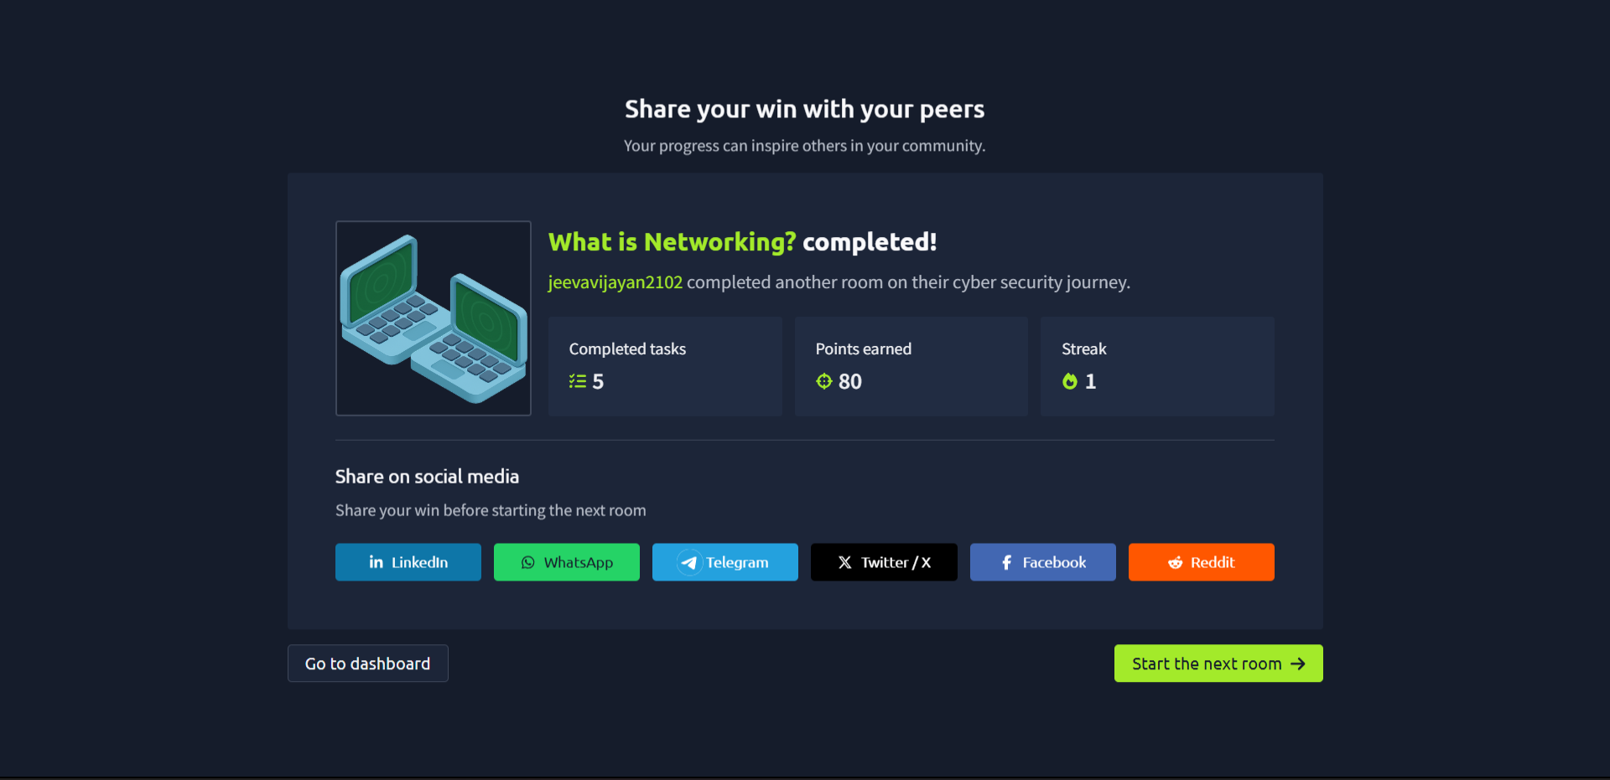
Completion of room screenshot

4. Room 2 – Intro to Networking

4.1 Room Overview
The “Intro to Networking” room builds on basic networking knowledge and introduces additional concepts used in everyday network communication. The room covers networking models, protocols, ports, DNS, web communication, TCP, UDP, and other fundamental concepts.

4.2 What I Did – Step-by-Step
1.I opened the Intro to Networking room on TryHackMe.
2.I started the room and read the instructions given at the beginning.
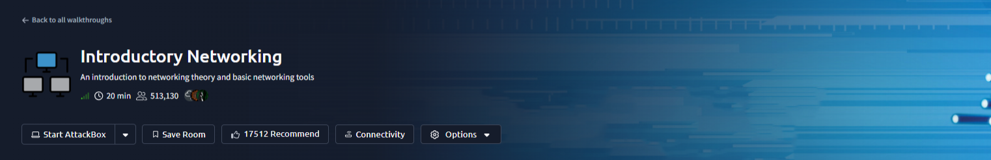
3.I went through the sections one by one.
4.I read the information provided before attempting each question.
5.I followed the instructions given for each task. I entered the required answers in the answer fields.
6.I submitted each answer and checked whether it was accepted.
7.I used the information provided in the room to work through the tasks.
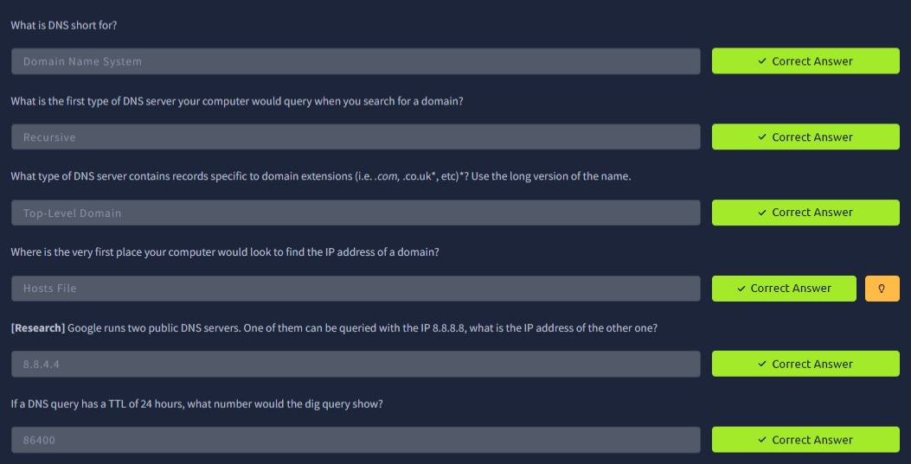
8.I completed the interactive activities included in the room. I checked my progress while moving through the different sections. I continued until all the required questions were answered. I verified that the required activities were completed successfully.
9.I reviewed the completed sections once more to make sure nothing was left incomplete.
10.I finished the room after completing all the required tasks.

4.3 Screenshots – Key Progress
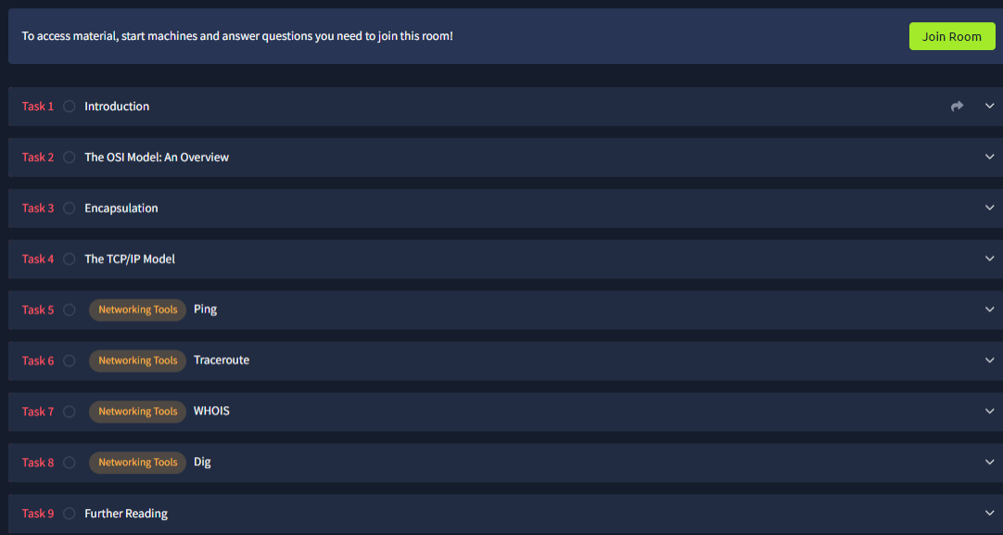
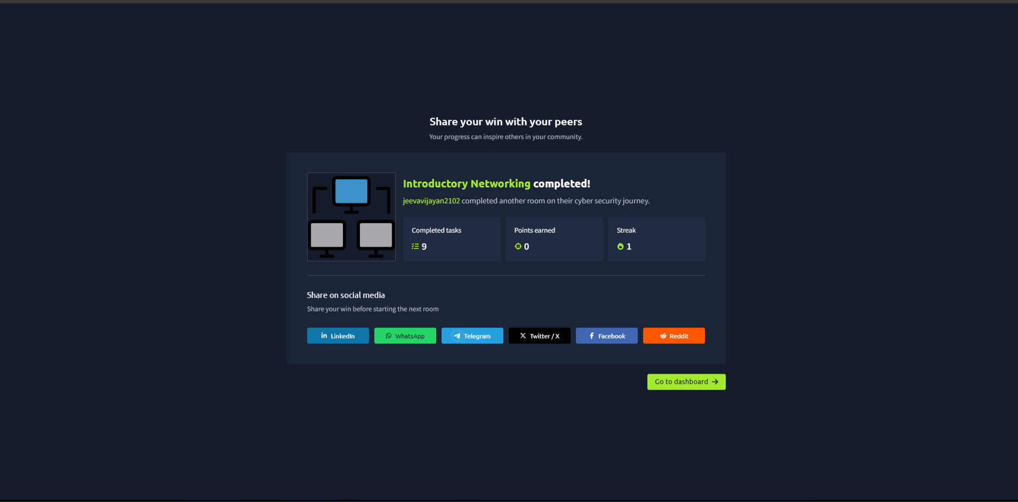

4.4 What I Learned
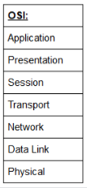
This room helped me understand how different networking protocols work together and the seven layers. I learned that DNS helps translate human-readable domain names into IP addresses.
- The basic idea behind computer networking was learned as well as how devices communicate over a network.
- The OSI Model and its 7 layers with the unique functions of each layer for network communication were studied.
- How the data travels across the layers of the OSI model in communication was learned.
- Encapsulation, which is the process of adding information to the data as it travels down through the networking layers before being transmitted, was studied.
- The TCP/IP Model and its layers for network communication were learned.
- The Ping networking utility was learned, which can be used for testing if a destination can be reached.
- Traceroute, which can be used to view the different network hops made by the packets while traveling to a destination, was learned.
- WHOIS was learned, which can be used to acquire information on registration of a domain.
- DIG command for querying DNS information was learned.
- Different types of information about a domain are provided by DNS records.
- The tools like Ping, Traceroute, WHOIS, and DIG can be useful for network investigation and information gathering.
- The difference between various networking protocols and tools and their application was clear to me.
- The use of OSI and TCP/IP models in organizing network communication was comprehended.
- I also had hands-on practice in applying networking principles through the various questions and exercises in the TryHackMe room.

5. Important Terms Learned
Term | Meaning
Network | A group of connected devices that can communicate with one another.
IP Address | A logical address used to identify a device or network interface.
MAC Address | An address associated with a network interface at the data-link level.
Protocol | A set of rules that controls communication between devices.
Packet | A unit of data transmitted across a network.
DNS | A system that resolves domain names to IP addresses.
Port | A logical endpoint used to identify a network service or application.
TCP | A connection-oriented transport protocol designed for reliable delivery.
UDP | A connectionless transport protocol with lower overhead.
HTTP | A protocol commonly used for communication between web clients and servers.
HTTPS | The secure version of HTTP, using encryption for web communication.

6. Practical Skills Gained
- Working through the interactive learning modules for cybersecurity.
- Grasping the basics of networking terminologies.
- Being familiar with the different networking protocols and their purposes.
- Being aware of the connection between IP addresses, ports, services, and protocol
- Applying the theory to real problem-solving situations.
- - Reporting the technical work with relevant screenshots and explanations

7. Challenges Faced

Networking terminology was something that I found difficult at first, but more specifically in Room 2, where multiple new concepts like OSI, encapsulation, TCP/IP, and networking tools were introduced at once. Reading the explanations carefully and applying the learned information in the interactive questions helped.

8. Overall Learning

The completion of both labs served to give me an understanding of computer networking. It is quite clear that networking forms an important aspect of cybersecurity, since it is important for security professionals to understand how devices, services, and data connect to each other. This forms the basis for learning more complex aspects like network security, etc.

9. Conclusion
Networking and cybersecurity were the two rooms in TryHackMe that gave me an introductory experience about Networking and cybersecurity basics .This involved learning about networks, IP addresses, MAC addresses, packets, protocols, ports, DNS, TCP, UDP, and web communications. This practical experience helped gain a better insight into the concepts, and learn how to use the cybersecurity education platform to solve technical issues.

