CREATE DATABASE T ;

CREATE TABLE T1 (a1 INT );

CREATE TABLE T2 (a2 INT );

CREATE TABLE T3 (a3 INT );

CREATE TABLE T4 (a4 INT , b4 INT );

**Queries And Output:**

1. Create 4 tables with attribute mentioned in the brackets : Table1(a1) , table2(a2) ,table3(a3) , table4(a4 , b4).

Create a trigger on table1 to insert , delete , update tables.

1. Whenever we insert a value in table1 , the same value should be inserted in table 2
2. If the number is present in table3 , it should be deleted from table3.
3. If the number is present in table4 (a1) then b4 should be incremented by 1.

DELIMITER &&

CREATE TRIGGER TRIG1

AFTER INSERT ON T1

FOR EACH ROW

BEGIN

INSERT INTO T2 VALUES(NEW.A1);

DELETE FROM T3 WHERE A3 = NEW.A1;

UPDATE T4 SET B4 = B4+1 WHERE A4 = NEW.A1;

END &&

DELIMITER ;

INSERT INTO T1 VALUES(8);

Output:

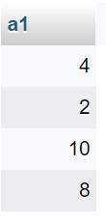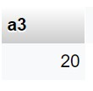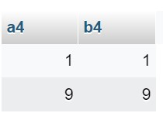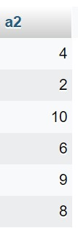

1. Create a table borrower_count with attributes card_no, number of books borrowed. Whenever we insert an entry in the book_loans table respective changes must be done to the newly created table.

DELIMITER //

CREATE TRIGGER TRIG2

AFTER INSERT ON book_issue

FOR EACH ROW

BEGIN

IF EXISTS (SELECT CARD_NO FROM BORROWER_COUNT WHERE CARD_NO = NEW.CARD_NO) THEN

UPDATE BORROWER_COUNT SET NO_OF_BOOKS = NO_OF_BOOKS + 1 WHERE CARD_NO = NEW.CARD_NO;

ELSE

INSERT INTO BORROWER_COUNT (CARD_NO, NO_OF_BOOKS) VALUES (NEW.CARD_NO, 1);

END IF;

END &&

DELIMITER ;

Output:

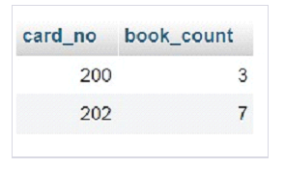

**Conclusion**

Triggers were studied and the queries were executed successfully.