1] select user();



2] select user from mysql.user;

## Dumping data for table user

|  |
| --- |
| root |
| root |
| pma |
| root |

3] create user test1@localhost, test2@localhost, test3@localhost;

4] grant all privileges on company.employee to test1@localhost;

show grants for test1@localhost;

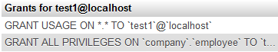

5] grant select (Fname, Lname, Bdate), update(Fname, Lname, Bdate) on company.employee to test2@localhost;

show grants for test2@localhost;

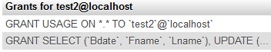

6, 7] GRANT ALL PRIVILEGES ON *.* to 'alexander'@'localhost' WITH GRANT OPTION;

show grants for test3@localhost;



8] revoke create view on company.employee from test1@localhost;

show grants for test1@localhost;

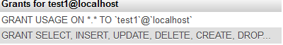

9] show grants for test2@localhost;

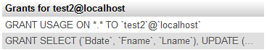

10] create index empId on employee (id)

**Conclusion:**

Users and Authorization was studied and the queries were implemented successfully.