**Introduction to Computer Networks**

**Experiment No: 1** **DATE: 5/2/2024**

**Aim:** To study OSI model and different types of Network Devices.

**Theory:**

**Q1) Explain computer network concepts.**

**ANS)** Computer networking refers to interconnected computing devices that can exchange data and share resources with each other. These networked devices use a system of rules, called communications protocols, to transmit information over physical or wireless technologies.  
A computer network is a system that connects numerous independent computers in order to share information (data) and resources. The integration of computers and other different devices allows users to communicate more easily.

A computer network is a collection of two or more computer systems that are linked together. A network connection can be established using either cable or wireless media. Hardware and software are used to connect computers and tools in any network.

A computer network consists of various kinds of nodes. Servers, networking hardware, personal computers, and other specialized or general-purpose hosts can all be nodes in a computer network. Host names and network addresses are used to identify them.

Computer Networks are one of the important aspects of Computer Science. In the early days, it is used for data transmission on telephone lines and had a very limited use, but nowadays, it is used in a variety of places.

Computer Networks help in providing better connectivity that helps nowadays. Modern computer networks have the following functionality like

1. Computer Networks help in operating virtually.
2. Computer Networks integrate on a large scale.
3. Computer Networks respond very quickly in case of conditions change.

**Types of Computer Networks**

**Division Based on the Communication Medium**

* **Wired Network:**Communication done in a wired medium**.** Copper wire, twisted pair, or fiber optic cables are all options. A wired network employs wires to link devices to the Internet or another network, such as laptops or desktop PCs.
* **Wireless Network:**“Wireless” means without wire, media that is made up of electromagnetic waves (EM Waves) or infrared waves. Antennas or sensors will be present on all wireless devices. For data or voice communication, a wireless network uses radio frequency waves rather than wires.

**Division Based on Area Covered**

* **Local Area Network (LAN):** A [LAN](https://www.geeksforgeeks.org/lan-full-form/) is a network that covers an area of around 10 kilometers. For example, a college network or an office network. Depending upon the needs of the organization, a LAN can be a single office, building, or Campus. We can have two PCs and one printer in-home office or it can extend throughout the company and include audio and video devices. Each host in LAN has an identifier, an address that defines hosts in LAN. A packet sent by the host to another host carries both the source host’s and the destination host’s address.
* **Metropolitan Area Network (MAN):**[MAN](https://www.geeksforgeeks.org/man-full-form-in-computer-networking/) refers to a network that covers an entire city. For example: consider the cable television network.
* **Wide Area Network (WAN):** [WAN](https://www.geeksforgeeks.org/wan-full-form/) refers to a network that connects countries or continents. For example, the Internet allows users to access a distributed system called www from anywhere around the globe.WAN interconnects connecting devices such as switches, routers, or modems. A LAN is normally privately owned by an organization that uses it. We see two distinct examples of WANs today: point-to-point WANs and Switched WANs
  + **Point To Point**: Connects two connecting devices through transmission media.
  + **Switched:** A switched WAN is a network with more than two ends.

**Based on Types of Communication**

* **Point To Point networks:** Point-to-Point networking is a type of data networking that establishes a direct link between two networking nodes. A direct link between two devices, such as a computer and a printer, is known as a point-to-point connection
* **Multipoint**: is the one in which more than two specific devices share links. In the multipoint environment, the capacity of the channel is shared, either spatially or temporally. If several devices can use the link simultaneously, it is a spatially shared connection.
* **Broadcast networks:**In broadcast networks, a signal method in which numerous parties can hear a single sender. Radio stations are an excellent illustration of the “Broadcast Network” in everyday life. The radio station is a sender of data/signal in this scenario, and data is only intended to travel in one direction. Away from the radio transmission tower, to be precise.

**Based on the Type of Architecture**

* **P2P Networks:**Computers with similar capabilities and configurations are referred to as peers.  
  The “peers” in a peer-to-peer network are computer systems that are connected to each other over the Internet. Without the use of a central server, files can be shared directly between systems on the network.
* **Client-Server Networks:**Each computer or process on the network is either a client or a server in a client-server architecture (client/server). The client asks for services from the server, which the server provides. Servers are high-performance computers or processes that manage disc drives (file servers), printers (print servers), or network traffic (network servers)
* **Hybrid Networks:**The hybrid model uses a combination of client-server and peer-to-peer architecture. Eg: Torrent.

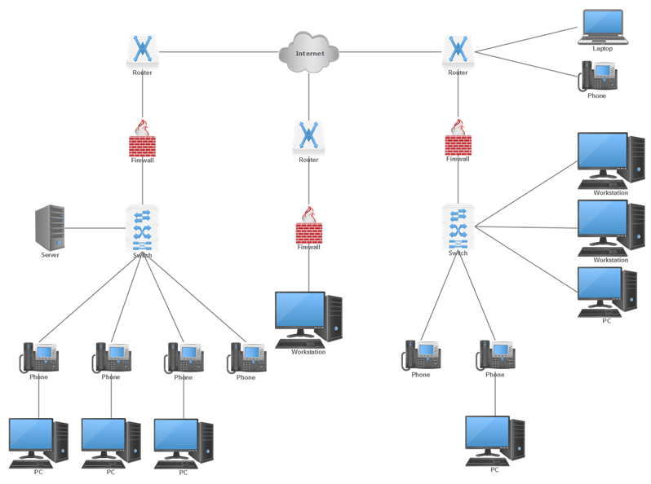

**Q2) Describe OSI Reference Model.**

**Ans)** According to the ISO standards, networks have been divided into 7 layers depending on the complexity of the functionality each of these layers provide. Layers are application, presentation, session, transport, network, data-link and physical.

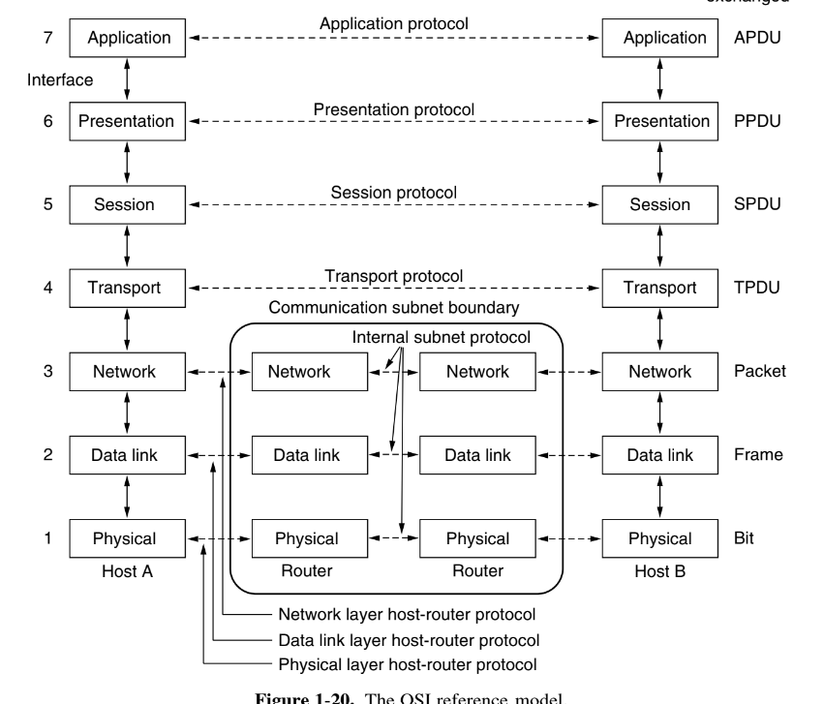

**i)** **Application Layer**

The seventh layer contains the application protocols with which the user gains access to the network.

Functions are:

Mail Services: This layer provides the basis for E-mail forwarding and storage.

Network Virtual Terminal: lt allows a user to log on to a remote host. The application creates software emulation of a terminal at the remote host. User/s computer talks to the software terminal which in turn talks to the host and vice versa. Then the remote host believes it is communicating with one of its own terminals and allows user to log on.

Directory Services: This layer provides access for global information about various services.

File Transfer, Access and Management (FTAM): lt is a standard mechanism to access files and manages it.

Users can access files in a remote computer and manage it. They can also retrieve files from a remote computer.

For example commonly used protocols are HTTP (Hyper Text Transfer Protocol for web browsing), FTP (File Transfer Protocol for file transfer) etc

**ii) Presentation Layer**

This layer is concerned with the syntax and semantics of the information transmitted. The primary goal of this layer is to take care of the syntax and semantics of the information exchanged between two communicating systems Presentation layer takes care that the data is sent in such a way that the receiver will understand the information (data) and will be able to use the data. Languages (syntax) can be different of the two communicating systems Under this condition presentation layer plays a role translator.

Functions are:

1. Translation: Before being transmitted, information in the form of characters and numbers should be changed to bit streams. The presentation layer is responsible for interoperability between encoding methods as different computers use different encoding methods. lt translates data between the formats the network requires and the format the computer uses.

2.Encryption/Decryption: lt carries out encryption at the transmitter and decryption at the receiver.

3.Compression/De-compression: lt carries out data compression to reduce the bandwidth of the data to be transmitted. The primary role of Data compression is to reduce the number of bits to be transmitted. lt is important in transmitting multimedia such as audio, video, text etc.

**iii) Session Layer**

Functions are:

1.Sessions: lts main aim is to establish, maintain and synchronize the interaction between communicating systems. Session layer manages and synchronize the conversation between two different applications.

2.Authentication: lt deals with the concept of Sessions i.e. when a user logins to a remote server he should be authenticated before getting access to the files and application programs. lf during the transfer of data between two machines the session breaks down, it is the session layer which re-establishes the connection.

3.Synchronization using Checkpoints: lt also ensures that the data transfer starts from where it breaks keeping it transparent to the end user. e.g. In case of a session with a database server, this layer introduces check points at various places so that in case the connection is broken and reestablished, the transition running on the database is not lost even if the user has not committed. This activity is called Synchronization.

4.Dialogue Control: lt determines whose turn is it to speak in a session. lt is useful in video conferencing.

**iv) Transport Layer**

The main aim of transport layer is to be delivered the entire message from source to destination. Transport layer ensures whole message arrives intact and in order, ensuring both error control and flow control at the source to destination level. lt decides if data transmission should be on parallel path or single path. Transport layer breaks the message (data) into small units so that they are handled more efficiently by the network layer and ensures that message arrives in order by checking error and flow control.

Functions are:

1.Service Point Addressing: Transport Layer header includes service point address which is port address. This layer gets the message to the correct process on the computer unlike Network Layer, which gets each packet to the correct computer.

2. Multiplexing / De-multiplexing: Normally the transport layer will create distinct network connection for each transport connection required by the session layer. The transport layer may either create multiple network connections (to improve throughput) or it may multiplex several transport connections onto the same network connection (because creating and maintaining networks may be expensive). In the latter case, de-multiplexing will be required at the receiving end. A point to note here is that communication is always carried out between two processes and not between two machines. This is also known as processto-process communication.

3.Segmentation and Re-assembling: A message is divided into segments; each segment contains sequence number, which enables this layer in reassembling the message. Message is reassembled correctly upon arrival at the destination and replaces packets which were lost in transmission.

4.Connection Control : lt includes 2 types :

a. Connectionless Transport Layer: Each segment is considered as an independent packet and delivered to the transport layer at the destination machine.

b. Connection Oriented Transport Layer: Before delivering packets, connection is made with transport layer at the destination machine.

5.Flow Control: In this layer, flow control is performed end to end.

6.Error Control: Error Control is performed end to end in this layer to ensure that the complete message arrives at the receiving transport layer without any error. Error Correction is done through retransmission.

**v) Network Layer**

The main aim of this layer is to deliver packets from source to destination across multiple links (networks). lf two computers (system) are connected on the same link then there is no need for a network layer. lt routes the signal through different channels to the other end and acts as a network controller. It also divides the outgoing messages into packets and to assemble incoming packets into messages for higher levels.

Its basic functions are routing and congestion control.

Routing: This deals with determining how packets will be routed (transferred) from source to destination. lt can be of three types:

Static: Routes are based on static tables that are "wired into" the network and are rarelv changed.

Dynamic: All packets of one application can follow different routes depending upon the topology ofthe network, the shortest path and the current network load.

Semi-Dynamic: A route is chosen at the start of each conversation and then all the packets of the application follow the same route. Congestion Control: A router can be connected to 4-5 networks. lf all the networks send packet at the same time with maximum rate possible then the router may not be able to handle all the packets and may drop some/all packets. In this context the dropping of the packets should be minimized and the source whose packet was dropped should be informed. The control of such congestion is also a function of the network layer. Other issues related with this layer are transmitting time, delays, jittenng.

**vi) Data Link layer**

This layer provides reliable transmission of a packet by using the services of the physical layer which transmits bits over the medium in an unreliable fashion.

Functions are:

1. Framing: Breaking input data into frames and caring about the frame boundaries and the size of each frame.

2. Acknowledgment: Sent by the receiving end to inform the source that the frame was received without any error.

3. Sequence Numbering: To acknowledge which frame was received.

4. Error Detectaon: The frames may be damaged, lost or duplicated leading to errors. The error control is on link to link basis.

5. Retransmission: The packet is retra nsmitted if the source fails to receive acknowledgment.

6. Flow Control: Necessary for a fast transmitter to keep pace with a slow receiver.

7. Access Control: Protocols of this layer determine which of the devices has control over the link at any given time, when two or more devices are connected to the same link.

**vii) Physical Layer**

This layer is the lowest layer in the OSI model. lt helps in the transmission of data between two machines that are communicating through a physical medium, which can be optical fibers, copper wire or wireless etc.

Functions of the physical layer are:

1] Hardware Specification: The details of the physical cables, network interface cards, wireless radios, etcare a part of this layer.

2] Encoding and Signaling: How are the bits encoded in the medium is also decided by this layer. For example, on the copper wire medium, we can use different voltage levels for a certain time interval to represent '0' and '1'. We may use +5mV for Lnsec to represent'1'and -5mV for lnsec to represent '0'. All the issues of modulation are dealt with in this layer. Eg. We may use Binary phase shift keying for the representation of '1' and '0' rather than using different voltage levels if we have to transfer in RF waves.

3] Data Transmission and Reception: The transfer of each bit of data is the responsibility of this layer. This layer assures the transmission of each bit with a high probability. The transmission of the bits is not completely reliable as there is no error correction in this layer.

4] Topology and Network Design: The network design is the integral part of the physical layer. Which part of the network is the router going to be placed, where the switches will be used, where we will put the hubs and how many machines is each switch going to handle, what server is going to be placed where, and many such concerns are to be taken care of by the physical layer. The various kinds of network topologies that we decide to use may be ring, bus, star or a hybrid of these topologies depending on our reouirements.

5] Transmission Modes: Physical Layer defines the direction of transmission between two devices: Simplex, Half Duplex, and Full Duplex.

6] Line Configuration: This layer connects devices with the medium: Point to Point configuration and Multipoint configuration.

7] Data Rate: This layer defines the rate of transmission which is the number of bits per second.

8] Synchronization: lt deals with the synchronization of the transmitter and receiver. The sender and receiver are synchronized at bit level.

**Q3) Study Various Networking Devices.**

**ANS)** **1) Hubs**

- The basic function of a hub is to take data from one of the connected devices and forward it to all the other ports regardless of the intended recipient. This is called broadcasting.

- This method of operation is inefficient because, in most cases, the data is intended for only one of the connected devices and not for all other connected devices.

- On busy networks, broadcast communications can significantly reduce overall network performance by consuming the bandwidth unnecessarily.

- Most hubs are referred to as either Active or Passive.

Active Hubs regenerate a signal before forwarding it to all the ports on the device and requires a power supply. Built-in power supply or an external power adapter can be used to supply the power.

Passive Hubs, which today are seen only on older networks, do not need power and they don’t regenerate the data signal.

Due to the inefficiencies of the hub system and the constantly increasing demand for more bandwidth, hubs are slowly but surely being replaced with switches. As you will see in the next section, switches offer distinct advantages over hubs

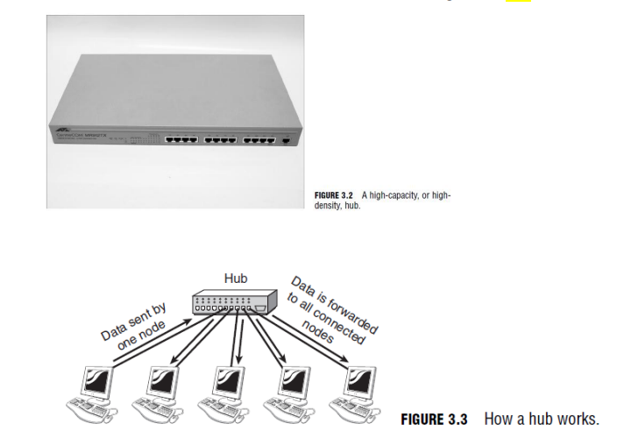

**2) Switches**

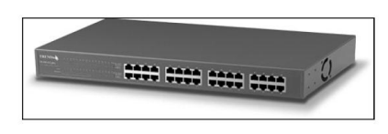

- On the surface, a switch looks much like a hub. Despite their similar appearance, switches are far more efficient than hubs and are far more desirable for today’s network environments.

- As with a hub, computers connect to a switch via a length of twisted-pair cable.

- Despite their similarity in appearance and their identical physical connections to computers, switches offer significant operational advantages over hubs.

- As discussed earlier, a hub forwards data to all ports, regardless of whether the data is intended for the system connected to the port. This arrangement is inefficient;

however, it requires little intelligence on the part of the hub, which is why hubs are inexpensive.

- Rather than forwarding data to all the connected ports, a switch forwards data only to the port on which the destination system is connected.

- It looks at the Media Access Control (MAC) addresses of the devices connected to it to determine the correct port. A MAC address is a unique number that is stamped into every NIC.

**3) Bridges**

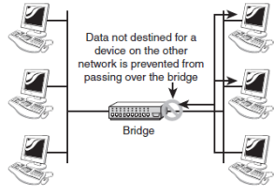

- Bridges are networking devices that connect networks.

- Sometimes it is necessary to divide networks into subnets to reduce the amount of traffic on each larger subnet or for security reasons. Once divided, the bridge connects the two subnets and manages the traffic flow between them.

- A bridge functions by blocking or forwarding data, based on the destination MAC address written into each frame of data.

- If the bridge believes the destination address is on a network other than that from which the data was received, it can forward the data to the other networks to which it is connected.

- If the address is not on the other side of the bridge, the data is blocked from passing.

- Bridges “learn” the MAC addresses of devices on connected networks by “listening” to network traffic and recording the network from which the traffic originates.

**4) Routers**

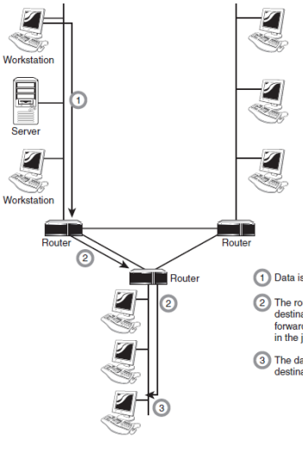

- Routers are network devices that literally route data around the network.

- By examining data as it arrives, the router can determine the destination address for the data; then, by using tables of defined routes, the router determines the best way for the data to continue its journey.

- Unlike bridges and switches, which use the hardware-configured MAC address to determine the destination of the data, routers use the software-configured network address (IP address) to make decisions. This approach makes routers more functional than bridges or switches, and it also makes them more complex because they have to work harder to determine the information.

**5) Gateways**

- The term gateway is applied to any device, system, or software application that can perform the function of translating data from one format to another.

- The key feature of a gateway is that it converts the format of the data, not the data itself.

- You can use gateway functionality in many ways. For example, a router that can route data from an IPX network to an IP network is, technically, a gateway. The same can be said of a translational bridge that, as described earlier in this chapter, converts from an Ethernet network to a Token Ring network and back again.

- Software gateways can be found everywhere. Many companies use an email system such as Microsoft Exchange or Novell GroupWise. These systems transmit mail internally in a certain format. When email needs to be sent across the Internet to users using a different email system, the email must be converted to another format, usually to

Simple Mail Transfer Protocol (SMTP). This conversion process is performed by a software gateway.

**6) Repeater**

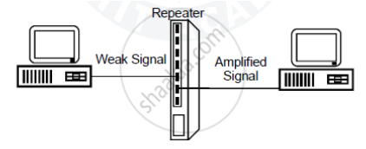

- A repeater operates at the physical layer. Its job is to regenerate the signal over the same network before the signal becomes too weak or corrupted so as to extend the length to which the signal can be transmitted over the same network.

- When an electrical signal is transmitted via a channel, it gets attenuated depending upon the nature of the channel or the technology. This poses a limitation upon the length of the LAN or coverage area of cellular networks. This problem is alleviated by installing repeaters at certain intervals.

- Repeaters amplifies the attenuated signal and then retransmits it. Digital repeaters can even reconstruct signals distorted by transmission loss. So, repeaters are popularly incorporated to connect between two LANs thus forming a large single LAN.

**Conclusion**

The concept of OSI model and different Networking devices were studied successfully.