# ROUTING INFORMATION PROTOCOL

**Experiment No : 10 DATE:22-04-2024**

**Aim**: Construct a network with at least 5 routers connected with a suitable topologies where each network connected with 5 PC’s . Implement RIP( Routing Information Protocol) also known as Distance Vector Protocol Algorithm

Theory:

Routing Information Protocol (RIP), also known as a distance vector routing protocol, is one of the oldest routing protocols used in computer networks. It operates by sharing routing information between neighboring routers, which helps in determining the best path for data packets to reach their destination.

Working of RIP:

1. **Distance Vector Algorithm**: RIP uses the Bellman-Ford algorithm as its basis. Each router maintains a routing table that contains information about the distance (number of hops) to reach each destination network. These distances are periodically exchanged with neighboring routers.
2. **Routing Updates**: Routers running RIP periodically broadcast their entire routing table to their neighboring routers. These updates contain information about the network addresses and the number of hops required to reach them. By comparing the received information with their own routing tables, routers update their route entries accordingly.
3. **Hop Count Metric**: RIP uses hop count as its metric for determining the best path to a destination. A hop is counted as each router that a packet passes through. RIP limits the maximum hop count to 15; routes with a hop count greater than this are considered unreachable.
4. **Routing Table Maintenance**: RIP routers maintain their routing tables dynamically. Whenever a change in network topology occurs (e.g., a link failure), routers detect the change through periodic updates or triggered updates and adjust their routing tables accordingly. However, RIP doesn't immediately react to topology changes; instead, it relies on periodic updates to eventually converge on the best paths.
5. **Convergence Time**: One notable drawback of RIP is its slow convergence time. When there is a change in the network, it can take some time for all routers to update their routing tables and converge on the new best paths. This can lead to transient routing loops or suboptimal routing paths during the convergence period.
6. **Split Horizon and Poison Reverse**: RIP uses techniques like split horizon and poison reverse to prevent routing loops. Split horizon prevents a router from advertising routes back out of the interface from which they were learned, while poison reverse involves advertising a route with an infinite metric (hop count of 16) to indicate that the route is unreachable.

**Procedure:**

**Open Cisco Packet Tracer**: Launch Cisco Packet Tracer on your computer.

1. **Create Network Topology**: Design your network topology by adding routers and connecting them using Ethernet cables. You can also add PCs or other devices if needed.
2. **Access Router Configuration**: Double-click on a router to open its configuration dialog box.
3. **Configure Router Interfaces**: In the router configuration dialog box, navigate to the "Config" tab. Here, you can configure the router interfaces by selecting an interface and assigning IP addresses to them. Make sure to enable the interfaces by checking the "Status" checkbox.
4. **Enable RIP Routing Protocol**: Still in the router configuration dialog box, navigate to the "Routing" tab. Here, you'll find the option to enable RIP. Check the box next to "RIP" to enable the RIP routing protocol on the router.
5. **Specify Networks**: After enabling RIP, you'll have the option to specify the networks that should be advertised by RIP. Click on the "Add" button to add network addresses. Enter the network address and subnet mask, then click "OK" to save.
6. **Repeat for Each Router**: Repeat steps 3 to 6 for each router in your network topology. Configure interfaces, enable RIP, and specify the networks to be advertised by RIP on each router.
7. **Test Connectivity**: Once you have configured RIP on all routers, test connectivity between devices in your network using Packet Tracer's simulation mode. You can use the "Ping" tool to verify that routers are correctly routing traffic between networks.
8. **Save Configuration**: Save your Packet Tracer project to preserve the configuration.

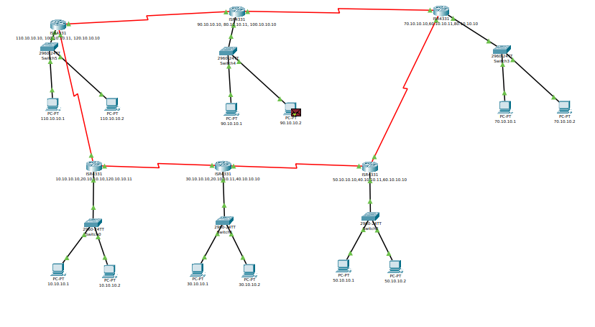

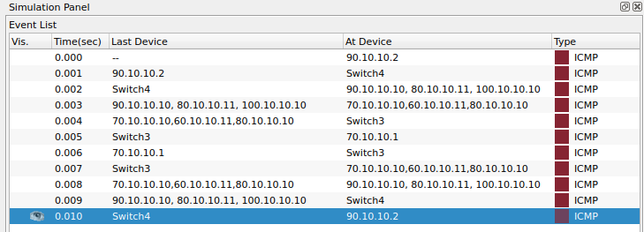

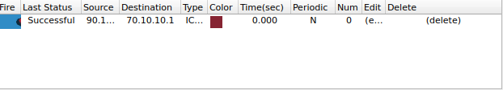

**Conclusion:**

RIP (Routing Information Protocol) routing algorithm was studied and implemented in Cisco Packet Tracer.