# WIRELESS NETWORK

**Experiment No : 5 DATE:06-05-2024**

**Aim**: Create a wireless network of multiple PC’s using appropriate Access Point using CISCO Packet Tracer.

# Theory:

**Introduction to Creating a Wireless Network with Access Points:**

Creating a wireless network with access points (APs) allows multiple PCs to connect to a local area network (LAN) or the internet without the need for physical cables. Access points act as central hubs that wirelessly transmit and receive data between connected devices and the wired network infrastructure. This setup provides flexibility, mobility, and convenience for users, making it ideal for both home and business environments.

**Advantages of Wireless Networks with Access Points:**

1. **Mobility:** Users can connect to the network from anywhere within the coverage area of the access points, enabling seamless mobility and flexibility in device placement.
2. **Scalability:** Wireless networks can easily scale to accommodate additional devices by adding more access points to expand coverage areas or increase capacity.
3. **Cost-Efficiency:** Setting up a wireless network can be cost-effective compared to installing and maintaining wired infrastructure, especially in environments where cabling is impractical or expensive.
4. **Convenience:** Wireless networks eliminate the need for physical cables, simplifying installation and allowing for easy reconfiguration or relocation of devices.

**Disadvantages of Wireless Networks with Access Points:**

1. **Interference:** Wireless networks are susceptible to interference from other electronic devices, neighboring networks, and physical obstacles, which can degrade performance and reliability.
2. **Security Concerns:** Wireless networks may be vulnerable to security threats such as unauthorized access, eavesdropping, and data interception if proper security measures such as encryption and access control are not implemented.
3. **Limited Bandwidth:** Wireless networks typically have lower bandwidth compared to wired connections, which can lead to slower data transfer rates, especially in crowded or congested environments.
4. **Coverage Limitations:** The coverage area of access points is limited, and signal strength may weaken over distance or be obstructed by walls, buildings, or other obstacles, requiring careful placement of access points for optimal coverage.

**Real-World Application of Wireless Networks with Access Points:**

1. **Home Networks:** Wireless networks are commonly used in homes to connect PCs, laptops, smartphones, and other devices to the internet and share resources such as printers and file servers.
2. **Enterprise Networks:** Businesses deploy wireless networks with access points to provide connectivity to employees, guests, and IoT devices in office buildings, warehouses, and other facilities.
3. **Public Wi-Fi Hotspots:** Access points are deployed in public places such as cafes, airports, hotels, and shopping malls to offer wireless internet access to customers and visitors.

**Example:**

A small business office implements a wireless network using access points to provide connectivity for multiple PCs. The office space is divided into different areas, each served by strategically placed access points to ensure adequate coverage and performance. Employees can seamlessly connect their laptops and desktop PCs to the network, access shared files and printers, and collaborate with colleagues without being tethered to a wired connection. The network is secured using encryption and access control measures to protect sensitive data and prevent unauthorized access.

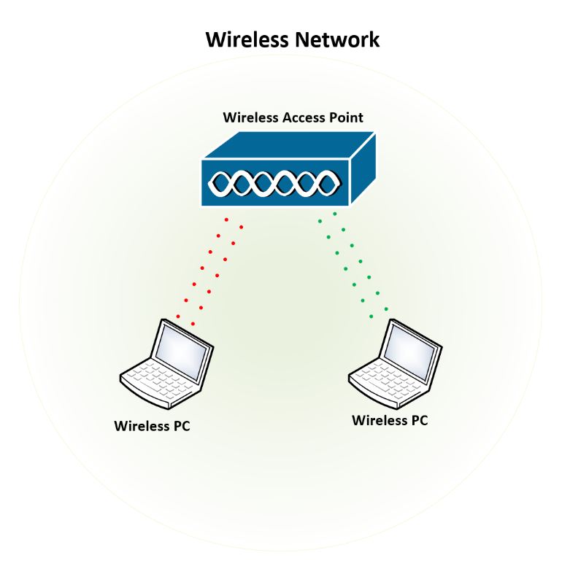

**Network Structure for Wireless Network using Access Point**

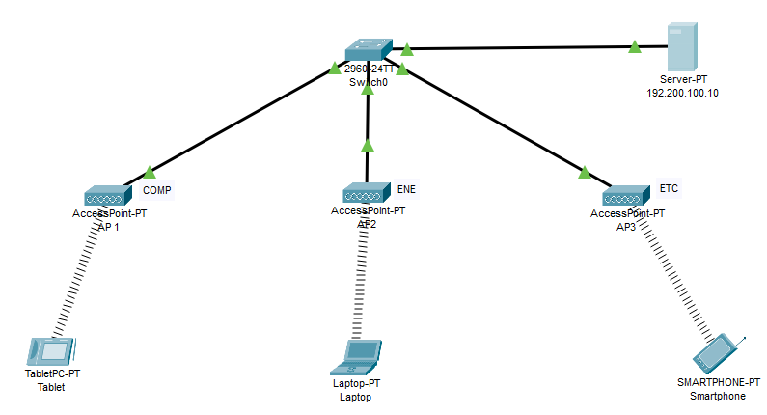

**Configuration of Router**

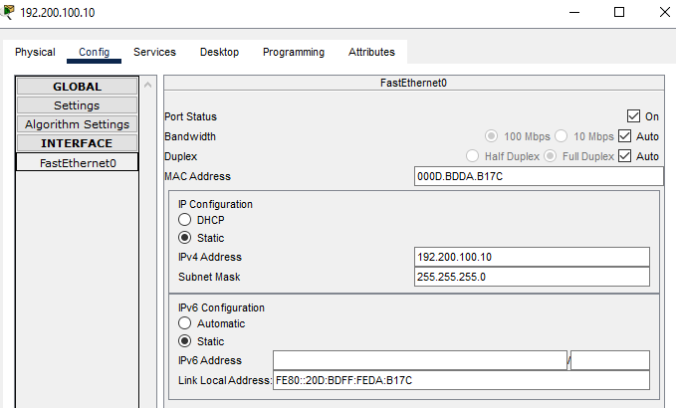

**Configuration of Access Point for COMP**

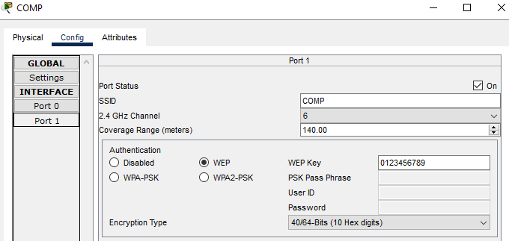

**Configuration of Access Point for ENE**

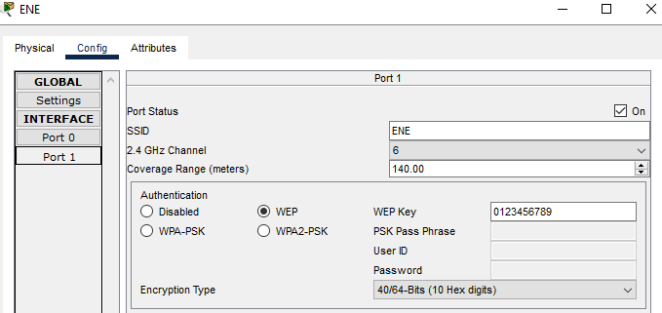

**Configuration of Access Point for ETC**

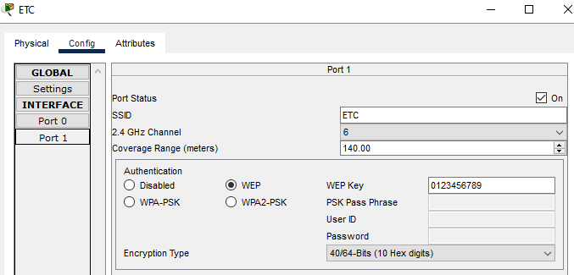

**Configuration of End Device Tablet**

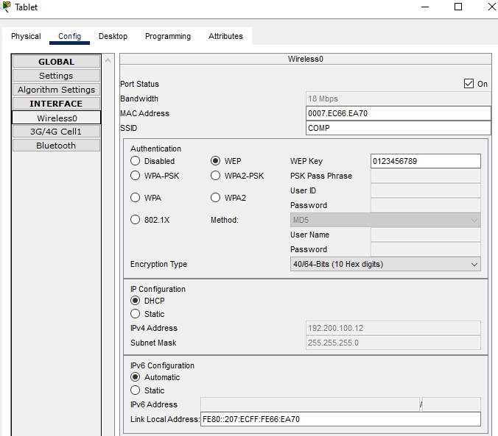

**Configuration of End Device Laptop**

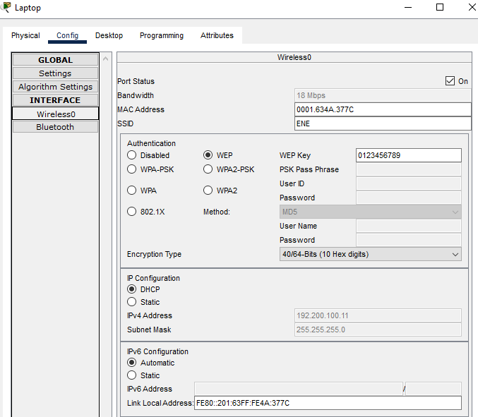

**Configuration of End Device Smartphone**

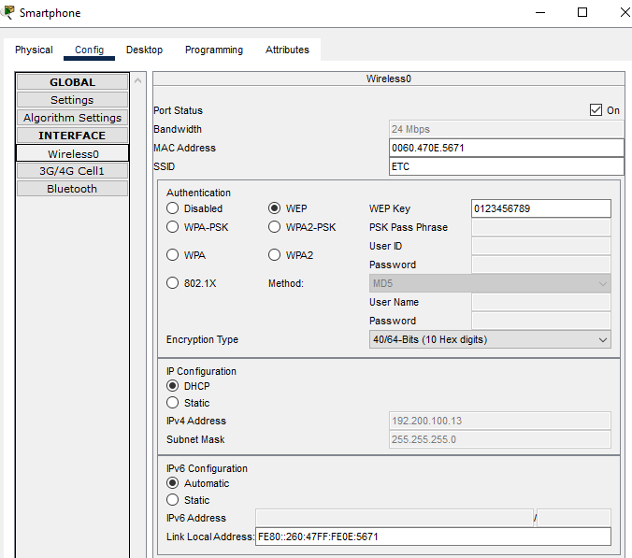

**Verification of Connectivity**

Sending a Simple PDU from Tablet to Smartphone

**Step1:**

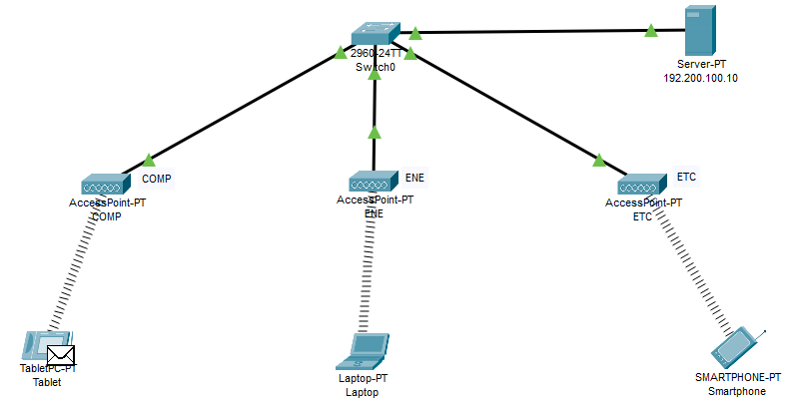

**Step2:**

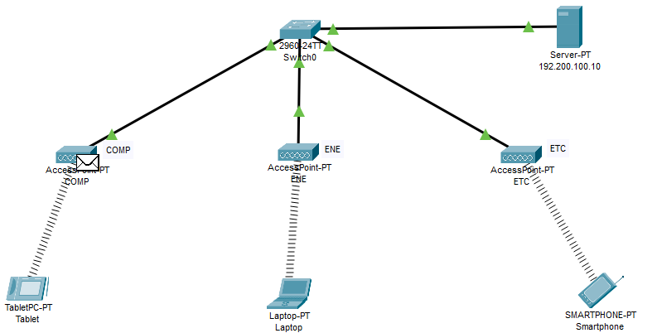

**Step3:**

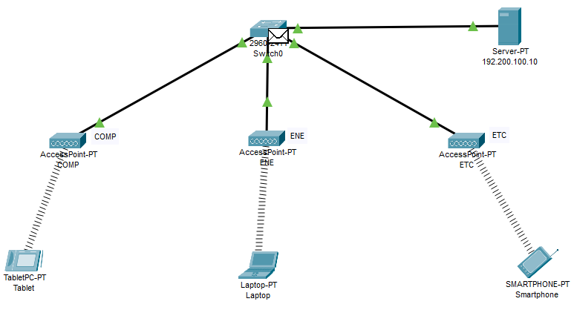

**Step4:**

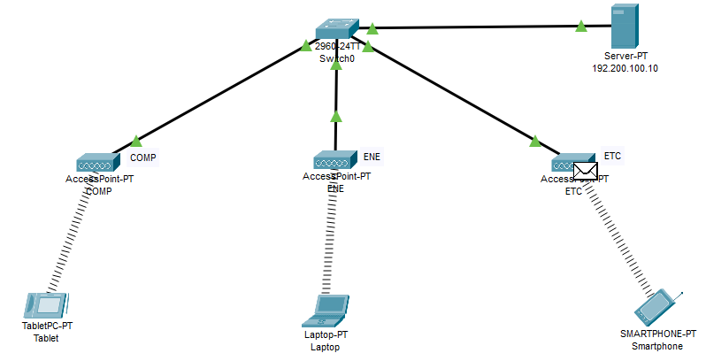

**Step5:**

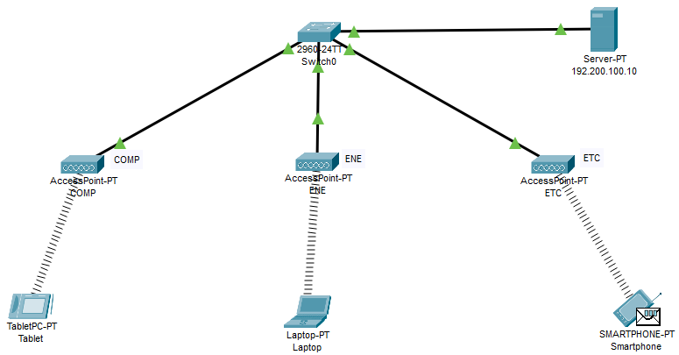

A Simple PDU was sent successfully from Tablet to Smartphone.

**CONCLUSION:**

The Creation of a wireless network of multiple PC’s using appropriate Access Point using CISCO Packet Tracer was studied, created and verified successfully.