**Experiment No: 2 Date: 8/2/2024**

**Aim:** Study of different cabling types and standards for data communication and the procedure for crimping RJ 45 connectors used in LAN.

**Theory:**

Different types of cables

1. Coaxial Cables:

A coaxial cable is an electrical cable with a copper conductor and an insulator shielding around it and a braided metal mesh that prevents signal interference and cross talk. Coaxial cable is also known as coax.

The core copper conductor is used for the transmission of signals and the insulator is used to provide insulation to the copper conductor and the insulator is surrounded by a braided metal conductor which helps to prevent the interference of electrical signals and prevent cross talk. This entire setup is again covered with a protective plastic layer to provide extra safety to the cable.

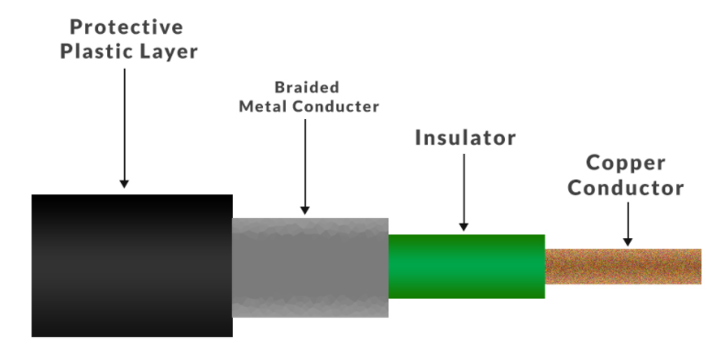

1. Twisted Pair cables:

These are a type of guided media. Twisted pair cables have two conductors that are generally made up of copper and each conductor has insulation. These two conductors are twisted together, thus giving the name twisted pair cables.

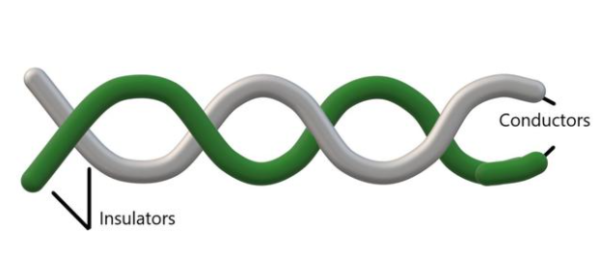One of the conductors is used to carry the signal and the other is used as a ground reference only. The receiver uses the difference of signals between these two conductors. The noise or crosstalk in the two parallel conductors is high but this is greatly reduced in twisted pair cables due to the twisting characteristic. In the first twist, one conductor is near to noise source and the other is far from the source but in the next twist the reverse happens and the resultant noise is very less and hence the balance in signal quality is maintained and the receiver receives very less or no noise. The quality of signal in twisted pair cables greatly depends upon the number of twists per unit length of the cable.

1. Fiber Optics:

An Optical Fibre is a cylindrical fibre of glass which is hair thin size or any transparent dielectric medium. The fibre which is used for optical communication is waveguides made of transparent dielectrics.

Main element of Fibre Optics:

1.   Core:  
It is the central tube of very thin size made of optically transparent dielectric medium and carries the light transmitter to receiver and the core diameter may vary from about 5um to 100 um.

2.   Cladding:  
It is outer optical material surrounding the core having reflecting index lower than core and cladding helps to keep the light within the core throughout the phenomena of total internal reflection.

3.   Buffer Coating:  
It is a plastic coating that protects the fibre made of silicon rubber. The typical diameter of the fibre after the coating is 250-300 um.

Types of Fibre optics: Generally optical fibre is classified into two categories based on: the number of modes, and the refractive index.  
1. On the basis of the Number of Modes:

(a). Single-mode Fibre:  
In single-mode Fibre, only one type of ray of light can propagate through the Fibre.

(b) Multi-mode Fibre:  
Multimode Fibre allows a large number of modes for the light ray traveling through it.

2. On the basis of Refractive Index:

(a) Step-index optical Fibre:  
The refractive index of core is constant. The refractive index of the cladding is also constant.

(b) Graded index optical Fibre:  
In this type of Fibre, the core has a non-uniform refractive index that gradually decreases from the centre towards the core-cladding interface. The cladding has a uniform refractive index.

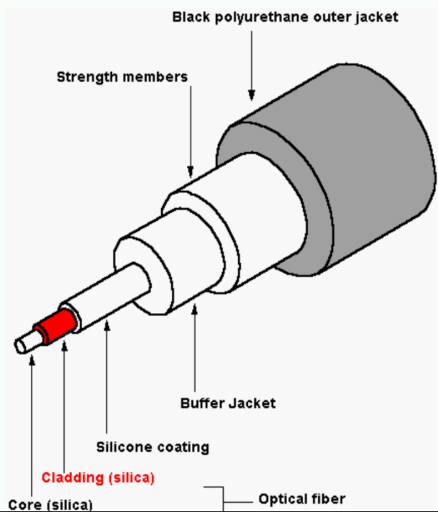

1. USB Cables:

Universal Serial Bus (USB) is an industry-standard that establishes specifications for connectors, cables, and protocols for communication, connection, and power supply between personal computers and their peripheral devices. There have been 3 generations of USB specifications:

1. USB 1.x

2. USB 2.0

3. USB 3.x

USB was designed to standardize the connection of peripherals like pointing devices, keyboards, digital still, and video cameras. But soon devices such as printers, portable media players, disk drives, and network adaptors to personal computers used USB to communicate and to supply electric power. It is commonplace to many devices and has largely replaced interfaces such as serial ports and parallel ports. USB connectors have replaced other types of battery chargers of portable devices with themselves.

Advantages of USB –

1. The USB interface is self-configuring.

2. USB connectors are standardized at the host, so any peripheral can use any available receptacle.

3. The USB interface is hot pluggable or plug and plays, meaning devices can be exchanged without rebooting the host computer.

Disadvantages of USB –

1. USB cables are limited in length.

2. USB has a strict “tree” topology and “master-slave” protocol for addressing peripheral devices.

3. Some very high-speed peripheral devices require sustained speeds not available in the USB standard.

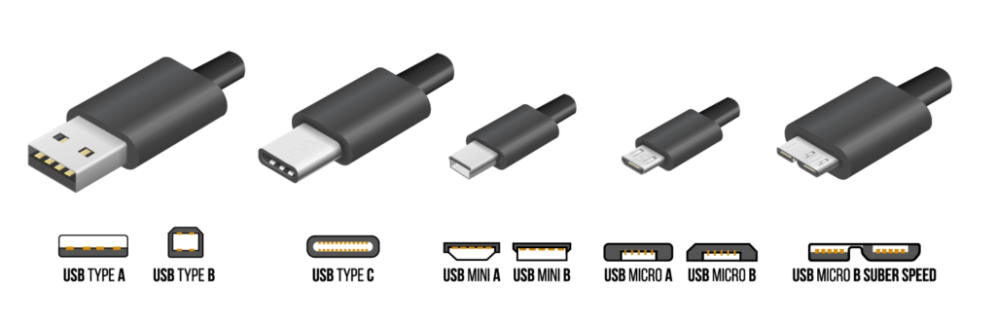

1. Serial and Parallel Cables:

Serial & Parallel ports have historically been used as computer peripheral interfaces. Although USB is now more common for this purpose both are still widely used in many industrial applications and of course are critical where legacy devices are still necessary.

The 25 pin D type and 9 pin D type, often referred to as DB25 and DB9 are both common serial interface types with the DB25 also common to Parallel. Connections also used for parallel interfaces include the 36 way Centronics and Micro 36 way Centronics.

Serial & Parallel ports can also be employed in file transfer applications and amongst our ranges we have a section dedicated to each type.

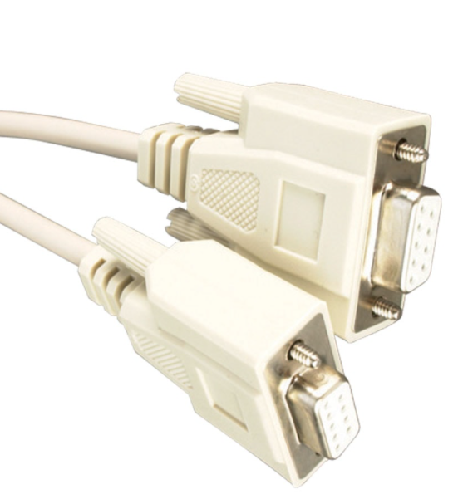 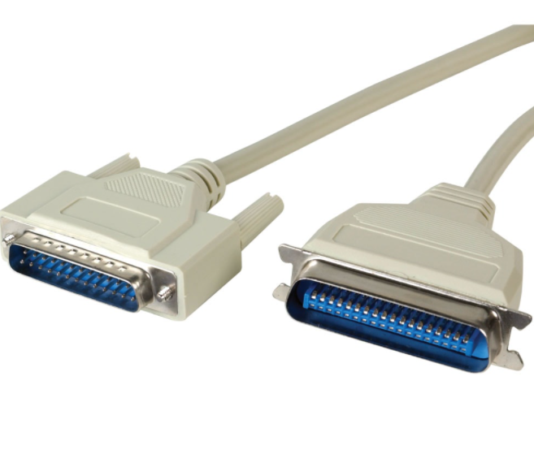

Serial file transfer cable Parallel Printer cables

1. Ethernet Cables:

An Ethernet cable is something that will connect your electronic device (computer, tablet, gaming console, etc.) to a network, which, in turn, will allow you to have internet access and interact with shared network resources. The reason that Ethernet cables are used is because wireless connections are not infallible. You may have found that the Wi-Fi can be down or damaged by some interfering factor. It could be something related to the distance between you and the network, an interfering object such as a brick wall, something that is messing up the connection speed, and a host of other problems. The Ethernet cable gives you the guarantee of being connected to the network (short of an internal problem within the cable’s wiring).

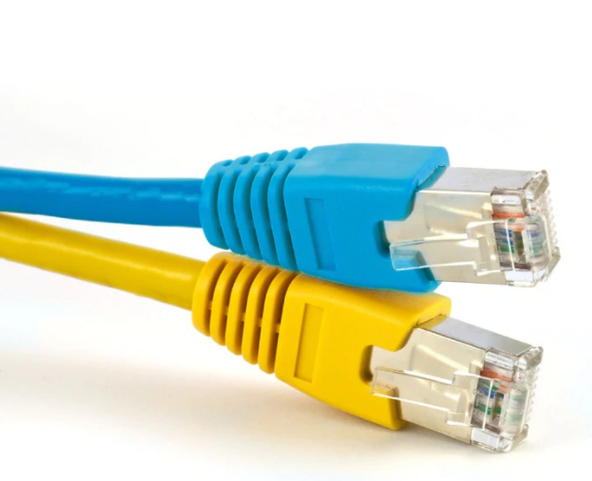

**Apparatus (Components):**

RJ 45 connector, crimping tool, twisted pair cable

**Procedure**:

To do these practical following steps should be done:

1. Start by stripping off about 2 inches of the plastic jacket off the end of the cable. Be very careful at this point, as to not nick or cut into the wires, which are inside. Doing so could alter the characteristics of your cable, or even worse render is useless. Check the wires, one more time for nicks or cuts. If there are any, just whack the whole end off, and start over.

2. Spread the wires apart, but be sure to hold onto the base of the jacket with your other hand. You do not want the wires to become untwisted down inside the jacket. Category 5 cable must only have 1/2 of an inch of 'untwisted' wire at the end; otherwise it will be 'out of spec'. At this point, you obviously have ALOT more than 1/2 of an inch of untwisted wire.

3. You have 2 end jacks, which must be installed on your cable. If you are using a pre-made cable, with one of the ends whacked off, you only have one end to install - the crossed over end. Below are two diagrams, which show how you need to arrange the cables for each type of cable end. Decide at this point which end you are making and examine the associated picture below.

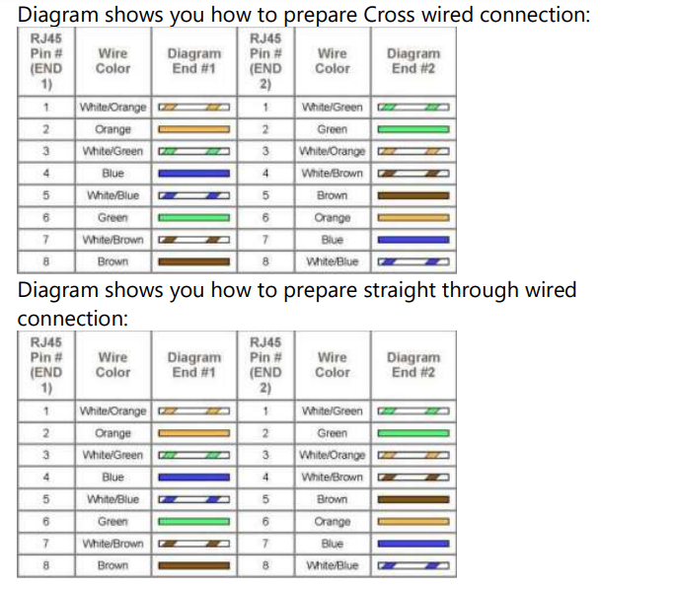

**Conclusion**:

Different Cabling types and standards for data communication and the procedure for crimping RJ 45 connectors used in LAN were studied.