# CISCO PACKET TRACER BASICS

**Experiment No : 8B DATE:08-04-2024**

**Aim**: Verify various connections for the following network topologies.

* 1. Ring Topology
  2. Bus Topology
  3. Star Topology
  4. Mesh Topology

# Theory:

**a) Ring Topology:**

In a ring topology, devices are connected in a circular manner, forming a closed loop. Each device is connected to exactly two neighbouring devices, creating a unidirectional pathway for data transmission. Data travels around the ring from one device to the next until it reaches its destination. Ring topologies were popular in early networking technologies like Token Ring, where devices passed a token to gain access to the network. While less common today, ring topologies offer unique advantages and challenges in network design and implementation.

**Advantages:**

1. **Uniform Data Transmission:** Data travels in a single direction around the ring, ensuring uniform transmission rates without contention.
2. **Simple Structure:** Ring topologies are relatively simple to implement and maintain, making them suitable for small networks.
3. **Fault Isolation:** Isolating faults is easier as the failure of one node or link doesn't affect the entire network.

**Disadvantages:**

1. **Single Point of Failure:** If the ring is broken at any point, the entire network may become inaccessible.
2. **Limited Scalability:** Expanding a ring topology can be challenging as adding new nodes may disrupt the ring's integrity.
3. **Performance Degradation:** As the number of devices increases, the overall network performance may degrade due to increased latency

**Real-World Application:**

**Ring Topology:** Commonly used in token ring networks for connecting devices in a small office environment.

**b) Bus Topology:**

A bus topology consists of a single communication line, often referred to as a bus, to which all devices in the network connect. Each device shares the same communication medium, and data transmitted by one device is received by all others. Devices on the bus topology have unique addresses, and data packets contain destination addresses to ensure that only the intended recipient processes the information. Bus topologies are simple to implement and were prevalent in early Ethernet networks, although they have become less common with the rise of more sophisticated architectures.

**Advantages:**

1. **Cost-Effective:** Bus topologies require minimal cabling, making them cost-effective for small to medium-sized networks.
2. **Easy to Extend:** Adding new devices to the network involves connecting them to the main bus, simplifying network expansion.
3. **Decentralized:** Each device on the bus has equal access to network resources, promoting decentralized communication.

**Disadvantages:**

1. **Limited Bandwidth:** Bandwidth is shared among all devices on the bus, leading to potential congestion and reduced performance.
2. **Difficult Fault Isolation:** Identifying faults in a bus topology can be challenging as the failure of the main bus affects all connected devices.
3. **Limited Cable Length:** The length of the bus is limited, and adding too many devices or extending the cable may degrade signal quality.

**Real-World Application:**

**Bus Topology:** Historically used in Ethernet networks for small to medium-sized office setups.

**c) Star Topology:**

In a star topology, each device in the network connects to a central hub or switch, forming a centralized structure. All communication between devices passes through the central hub, which manages data transmission and routing. This architecture simplifies network management, as adding or removing devices involves connecting or disconnecting them from the central hub. Star topologies are widely used in modern Ethernet LANs and are known for their ease of setup, scalability, and fault tolerance.

**Advantages:**

1. **Centralized Management:** The central hub in a star topology facilitates easy network management and troubleshooting.
2. **Scalability:** Star topologies support easy expansion by adding new devices directly to the central hub.
3. **Fault Tolerance:** If one device fails, it doesn't affect the rest of the network, ensuring high reliability.

**Disadvantages:**

1. **Dependency on Central Hub:** The central hub is critical for network operation, and its failure can render the entire network inaccessible.
2. **Cost of Implementation:** Setting up a star topology requires additional hardware (central hub), increasing initial setup costs.
3. **Single Point of Congestion:** All data traffic passes through the central hub, potentially leading to congestion and performance issues.

**Real-World Application:**

**Star Topology:** Widely adopted in modern LANs, including Ethernet and Wi-Fi networks in homes, offices, and institutions.

**d) Mesh Topology:**

Mesh topology is characterized by multiple interconnections between devices, creating a network where each node is connected to every other node. This arrangement provides redundancy and multiple communication paths, enhancing fault tolerance and reliability. Mesh networks can be either fully connected, where every node has a direct link to every other node, or partially connected, where only certain nodes are directly connected. Mesh topologies are commonly used in wireless networks, sensor networks, and large-scale distributed systems where resilience and flexibility are critical.

**Advantages:**

1. **Redundancy:** Mesh networks offer high redundancy as each node is connected to multiple other nodes, ensuring alternative paths for data transmission.
2. **Fault Tolerance:** Mesh networks can withstand node or link failures without disrupting overall network connectivity.
3. **High Performance:** With multiple paths for data transmission, mesh networks offer high throughput and low latency.

**Disadvantages:**

1. **Complexity:** Mesh networks can be complex to design, configure, and manage, especially as the number of nodes increases.
2. **Cost:** The high redundancy of mesh networks often comes with increased hardware and maintenance costs.
3. **Bandwidth Consumption:** Maintaining multiple connections between nodes consumes more bandwidth compared to other topologies, potentially affecting network performance.

**Real-World Application:**

**Mesh Topology:** Deployed in wireless mesh networks for large-scale coverage, such as city-wide Wi-Fi networks and sensor networks in industrial environments.

**Examples:**

a)Ring Topology

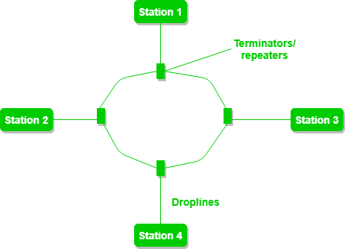

b)Bus Topology

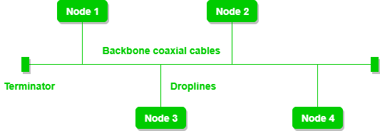

c) Star Topology

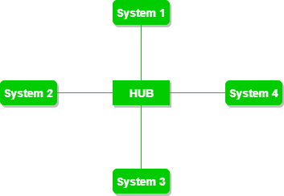

d)Mesh Topology

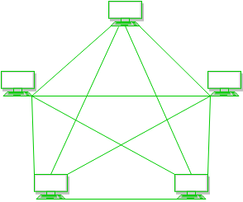

**Ring Topology:**

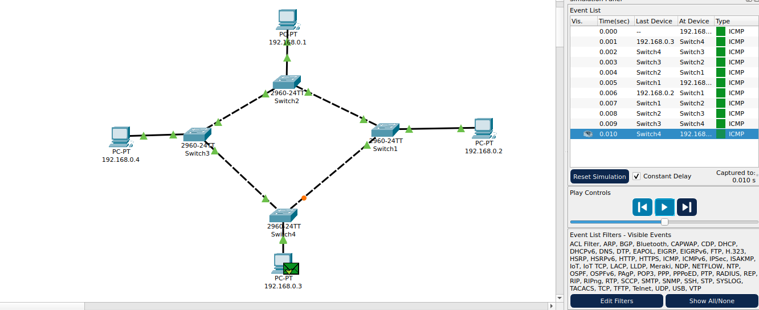



**Bus Topology:**

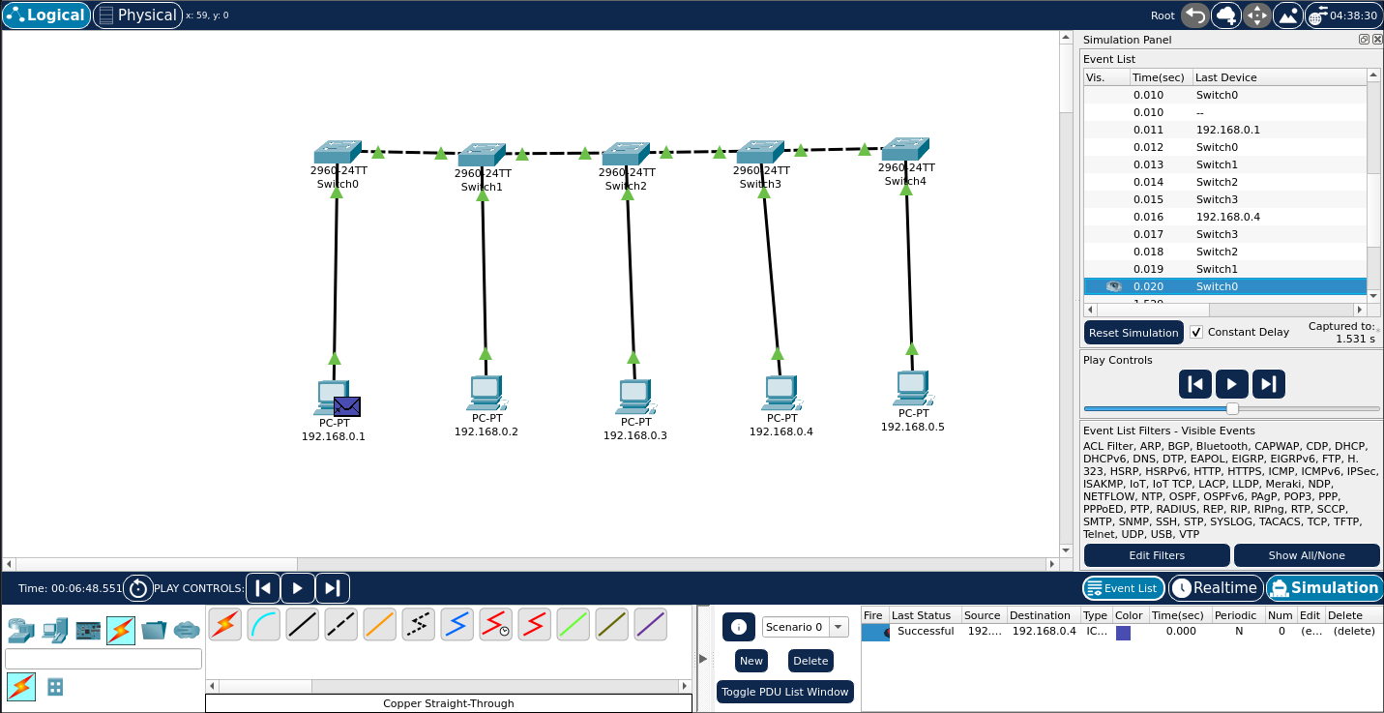

**Star Topology:**

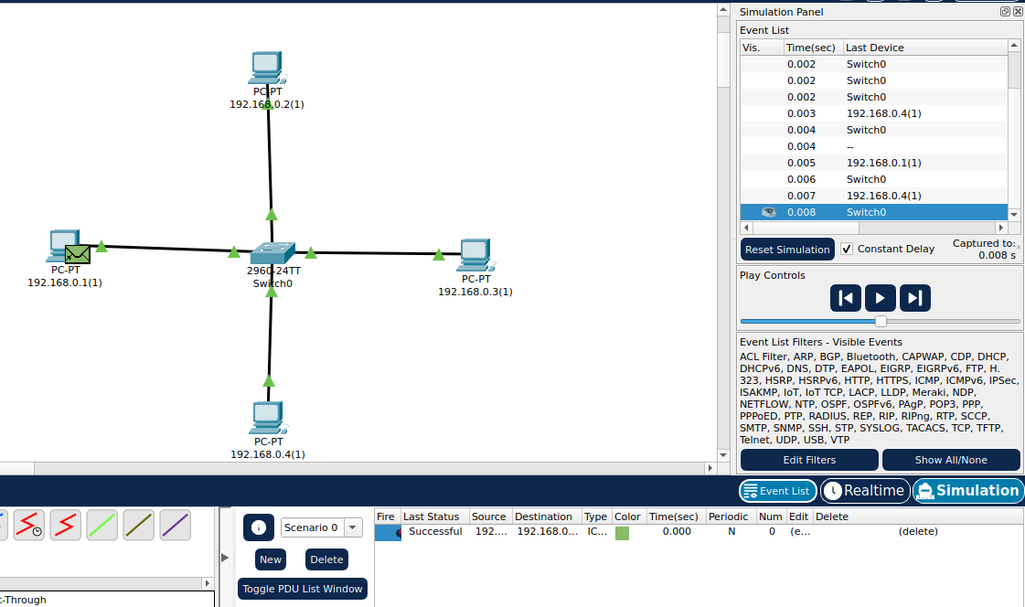

**Mesh Topology:**

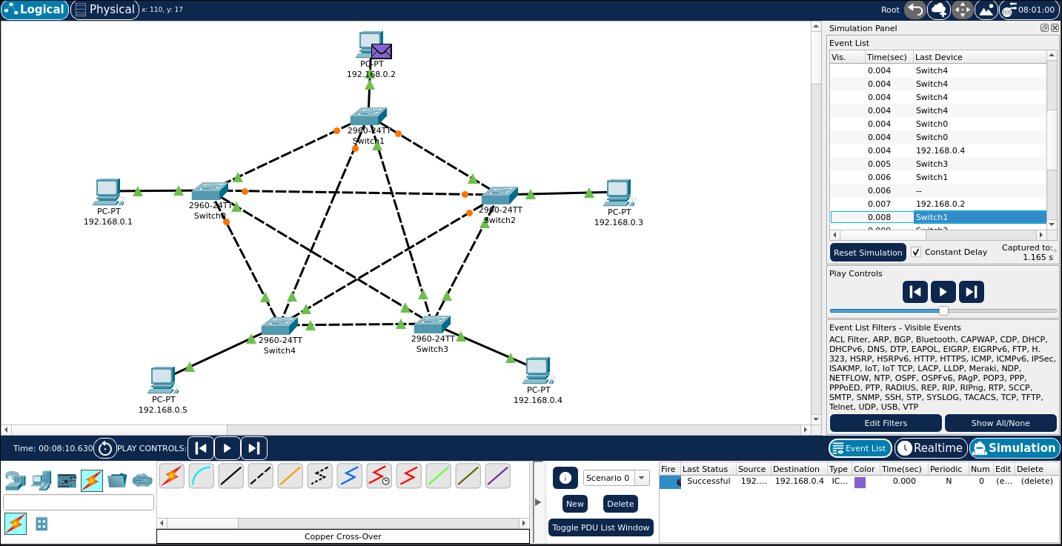

**Conclusion:**

A basic network was created in Cisco Packet Tracer using Static IP. Different network topologies (mesh, star, bus, ring) were successfully implemented using Cisco Packet Tracer simulator.